south coast air quality management district

Final Environmental Assessment:
Proposed Amended Rules 1303 – Requirements, 2005 – New Source Review for RECLAIM, 1302 - Definitions and 1309.1 - Priority Reserve

April 9, 2001

SCAQMD No. 021401MK

Executive Officer
Barry R. Wallerstein, D.Env.
Assistant Deputy Executive Officer
Planning, Rule Development and Area Sources
Elaine Chang, DrPH
Planning and Rules Manager
CEQA, Socioeconomic Analysis and PM/AQMP Control Strategies
Alene Taber, AICP

Author: Michael A. Krause Air Quality Specialist

Technical Assistance: Shams Hasan Air Quality Engineer II
Thomas Chico Program Supervisor

Reviewed by: Barbara Baird District Counsel
Steve Smith, Ph.D. Program Supervisor
Laki Tisopulos, Ph.D. Planning and Rules Manager
Robert Pease Air Quality Analysis and Compliance Supervisor
William Wong Senior Deputy District Counsel
South coast air quality management district
governing board

Chairman: WILLIAM A. BURKE, Ed.D.
Speaker of the Assembly Appointee

Vice Chairman: NORMA J. GLOVER
Councilmember, City of Newport Beach
Cities Representative, Orange County

MEMBERS:

MICHAEL D. ANTONOVICH
Supervisor, Fifth District
Los Angeles County Representative

HAL BERNSON
Councilmember, City of Los Angeles
Cities Representative, Los Angeles County, Western Region

JANE W. CARNEY
Senate Rules Committee Appointee

BEATRICE J.S. LAPISTO-KIRTLEY
Mayor, City of Bradbury
Cities Representative, Los Angeles County, Eastern Region

RONALD O. LOVERIDGE
Mayor, City of Riverside
Cities Representative, Riverside County

JON D. MIKELS
Supervisor, Second District
San Bernardino County Representative

LEONARD PAULITZ
Councilmember, City of Montclair
Cities Representative, San Bernardino County

JAMES SILVA
Supervisor, Second District
Orange County Representative

CYNTHIA VERDUGO-PERALTA
Governor's Appointee

S. ROY WILSON, Ed.D.
Supervisor, Fourth District
Riverside County Representative

EXECUTIVE OFFICER:

BARRY R. WALLERSTEIN, D.Env.
Table of contents

Chapter 1 - Project Description

Introduction 1-1
California Environmental Quality Act 1-2
Project Location 1-3
Project Background 1-3
Project Description 1-8

Chapter 2 - Environmental Checklist

Introduction 2-1
General Information 2-1
Potentially Significant Impact Areas 2-2
Determination 2-3
Environmental Checklist and Discussion 2-3

List of Figures

Figure 1: South Coast Air Quality Management District 1-4

List of Tables

Table 1: Rule 1303's Table A-2: Most Stringent Ambient Air Quality
Standard and Allowable Change in Concentration For Each Air
Contaminant/Averaging Time Combination 1-5
Table 2: Priority Reserve Allocations 1-6
Table 3: NSR Balance (for activity between August 1, 1998 - July 31,
1999) 1-7

Appendix A: Proposed Amended Rules 1303, 2005, 1302 and 1309.1
Appendix B: Comments to the Draft EA and Responses to the Comments

Preface

This document constitutes the Final Environmental Assessment (EA) for the amendments to Proposed Amended Rules 1303 – Requirements, 2005 – New Source Review for RECLAIM, 1302 - Definitions and 1309.1 - Priority Reserve. The Draft EA was released for a 30-day public review and comment period from February 14, 2001 to March 15, 2001. Five comment letters were received from the public. Since the release of the Draft EA, the SCAQMD has decided not to define Electrical Generating Facilities (EGFs) as an essential public service and thus Rule 1302 - Definitions will not be amended at this time.
Minor modifications have been made to the Draft such that it is now a Final EA. Deletions and additions to the text of the EA are denoted using strikethrough and italicized, respectively.

C H A P T E R 1 - P R O J E C T D E S C R I P T I O N

Introduction
California Environmental Quality Act
Project Location
Project Background
Project Description

introduction
The California Legislature created the South Coast Air Quality Management District (SCAQMD) in 1977 as the agency responsible for developing and enforcing air pollution control rules and regulations in the South Coast Air Basin (Basin) and portions of the Salton Sea Air Basin and Mojave Desert Air Basin. By statute, the SCAQMD is required to adopt an air quality management plan (AQMP) demonstrating compliance with all federal and state ambient air quality standards for the district. Furthermore, the SCAQMD must adopt rules and regulations that carry out the AQMP. The 1997 AQMP concluded that major reductions in emissions of volatile organic compounds (VOCs) and oxides of nitrogen (NO_{x}) are necessary to attain the air quality standards for ozone and particulate matter (PM10).
As part of the strategy to achieve ambient air quality standards, federal and state laws require the development and implementation of air quality permitting programs, commonly known as New Source Review (NSR) programs. Local NSR programs must, at a minimum, comply with the requirements established pursuant to federal and state law. The general requirements of NSR programs include: (1) pre-construction review; (2) the installation of Best Available Control Technology (BACT); and, (3) the mitigation of emission increases by providing emission offsets.
The proposed amendments to Rules 1303 and 2005 will affect the first two NSR requirements above. To satisfy requirement (1) listed above, the SCAQMD requires computer modeling for any new or modified source that is increasing emissions. The modeling requirement has been part of NSR since its inception on October 8, 1976. The form of the modeling requirement has varied over the years.
Currently, all applicants for new or modified sources of emissions must substantiate with modeling that the new facility or modification will not cause a significant increase in an air quality concentration as specified in Rule 1303 (Table A-2, Appendix A). The proposed amendments to Rules 1303 and 2005 would revise the modeling standard for sources locating in an attainment sub-region of the district such that the proposed new emissions plus the measured background could not create a violation of the standard. In sub-regions that do not meet the ambient standards, the modeling criteria will remain the same; the new emissions may not cause a significant increase in air quality concentration as set forth in Rule 1303 Table A-2.
Proposed amendments to Rules 1302 and 1309.1 would affect the third NSR requirement above. There is currently a shortage of electric generating capacity in the District and there is a limited supply of PM10 emission reduction credits (ERC) offsets available in the open market at this time. Electric power is critical for maintaining essential public services and for the operation of clean air technologies. In order to streamline the permitting of new electric generating facilities (EGF) to provide electricity and minimize use of diesel fired electric power generation, proposed amendments to Rules 1302 and 1309.1 will provide temporary access to the District's Priority Reserve PM10 account for new EGFs with applications deemed complete between 2001 and 2003, provided they have met all other requirements and paid the appropriate mitigation fee.

california environmental quality act
The proposed amendments to Rules 1303, 2005, 1302 and 1309.1 are a “project’ as defined by the California Environmental Quality Act (CEQA) Guidelines §15378. California Public Resources Code §21080.5 allows public agencies with regulatory programs to prepare a plan or other written document in lieu of an environmental impact report once the Secretary of the Resources Agency has certified the regulatory program. The SCAQMD's regulatory program was certified by the Secretary of the Resources Agency on March 1, 1989, and is codified as SCAQMD Rule 110. Pursuant to Rule 110 (the rule which implements the SCAQMD's certified regulatory program), SCAQMD has prepared this Environmental Assessment (EA) to evaluate potential adverse environmental impacts from amending Rules 1303, 2005, 1302 and 1309.1.
CEQA requires that the potential adverse environmental impacts of proposed projects be evaluated and that feasible methods to reduce or avoid identified significant adverse environmental impacts of these projects be identified. To fulfill the purpose and intent of CEQA, the SCAQMD has prepared this EA with no significant adverse environmental impacts to address the potential environmental impacts associated with the proposed amendments to Rules 1303, 2005, 1302 and 1309.1. Because the environmental analysis of PAR 1303, 2005, 1302 and 1309.1 concluded that the project would not have any significant or potentially significant effects on the environment, identification, and comparison of project alternatives, or identification of mitigation measures, are not required (CEQA Guidelines §15252).
The purpose of this Draft EA with no significant adverse environmental impacts is to identify, analyze, and evaluate the potential significant adverse environmental impacts of proposed project. This Draft EA with no significant adverse environmental impacts is a public disclosure document intended to: (a) provide the lead agency, responsible agencies, decision makers and the general public with detailed information on the environmental effects of the proposed project; and, (b) to be used as a tool by decision makers to facilitate decision making on the proposed project.
All comments received during the public comment period on the analysis presented in this Draft EA, which identified no significant adverse environmental impacts, will be responded to and included in the Final EA. Prior to making a decision on the proposed amendments, the SCAQMD Governing Board must review and certify the Final EA with no significant adverse environmental impacts which complies with CEQA as providing adequate information on the potential adverse environmental impacts of the proposed amended rules.

project location
Existing Rules 1303, 2005, 1302 and 1309.1 applies to SCAQMD’s entire jurisdiction. The SCAQMD has jurisdiction over an area of approximately 10,743 square miles, consisting of the four-county South Coast Air Basin (Basin) (Orange County and the non-desert portions of Los Angeles, Riverside and San Bernardino counties), and the Riverside County portions of the Salton Sea Air Basin (SSAB) and Mojave Desert Air Basin (MDAB). The Basin, which is a subarea of the SCAQMD’s jurisdiction, is bounded by the Pacific Ocean to the west and the San Gabriel, San Bernardino, and San Jacinto mountains to the north and east. It includes all of Orange County and the nondesert portions of Los Angeles, Riverside, and San Bernardino counties. The Los Angeles County portion of MDAB (known as north county or Antelope Valley) is bounded by the San Gabriel Mountains to the south and west, the Los Angeles/Kern county border to the north, and the Los Angeles/San Bernardino county border to the east. The Riverside County portion of the SSAB is bounded by the San Jacinto Mountains in the west and spans eastward up to the Palo Verde Valley. The federal nonattainment area (known as the Coachella Valley Planning Area) is a subregion of the Riverside County and the SSAB that is bounded by the San Jacinto Mountains to the west and the eastern boundary of the Coachella Valley to the east (Figure 1).

PROJECT background
New Source Review and Modeling
Federal and state laws require the development and implementation of NSR programs to ensure that the operation of new, modified, or relocated stationary emission sources in nonattainment areas does not interfere with the attainment and maintenance of National Ambient Air Quality Standards (NAAQS). Local NSR programs must, at a minimum, comply with the requirements established pursuant to federal and state law. The general requirements of NSR programs include: (1) pre-construction review; (2) the installation of air pollution control equipment; and, (3) the mitigation of emission increases by providing emission offsets.

Figure 1
South Coast Air Quality Management District

To satisfy requirement (1) listed above, the SCAQMD requires all applicants for new or modified sources of emissions must substantiate with modeling that the new facility or modification will not cause a significant increase in an air quality concentration. The modeling requirement has been part of NSR since its inception on October 8, 1976. The form of the modeling requirement has varied over the years.
The modeling requirement was originally included in Rule 213 – Standards for Permit to Construct: Air Quality Impact (Rule 213 has subsequently been rescinded). As originally crafted, the modeling requirement in Rule 213 required that the emission increases not cause a violation of or interfere with the attainment or maintenance of any air quality standard. This language was modified in the original version of Regulation XIII (October 23, 1979) to require that the new emissions will not cause a violation or make measurably worse an existing violation of an air quality standard. The modeling requirement for new or modified sources was changed on May 3, 1991, to the current standard of substantiating with modeling that new emissions will not exceed the SCAQMD criteria for a significant increase as set forth in Rule 1303's Appendix A, Table A-2 (Table 1).

Table 1
Rule 1303's Table A-2: Most Stringent Ambient Air Quality Standard and Allowable Change in Concentration For Each Air Contaminant/Averaging Time Combination
Air Contaminant | Averaging Time | Most Stringent Air Quality Standard |  |  | Significant Change in Air Quality Concentration
Nitrogen  Dioxide | 1-hour  Annual | 25 pphm  5.3 pphm | 500 ug/m³  100 ug/m³ | 1 pphm  0.05 pphm |  | 20 ug/m³  1 ug/m³
Carbon  Monoxide | 1-hour  8-hour | 20 ppm  9.0 ppm | 23 mg/m³  10 mg/m³ | 1 ppm  0.45 ppm |  | 1.1 mg/m³  0.50 mg/m³
Suspended  Particulate  Matter -<10um  (PM10) | 24-hour  Annual Geometric Mean | 50 ug/m³  30 ug/m³` |  |  |  | 2.5 ug/m³  1 ug/ m³  1 ug/m³
Sulfate | 24-hour | 25 ug/m³
pphm = parts per hundred million, ug/m³ = microgram per cubic meter, ppm = parts per million,mg/m³ = milligram per cubic meter

There has been substantial improvement in air quality in recent years. In 1999, there were no exceedances of the NO_{x} standard and the breadth and severity of the ozone non-exceedance has been dramatically improved. Similar improvement can been seen for both PM10 and CO.
Essential Public Service
Currently, Rule 1302 lists types of facilities defined as an essential public service. These include sewage treatment facilities, prisons, police facilities, fire fighting facilities, schools, hospitals, landfills, water operations and public transit. Electric generating facilities (EGFs) are not listed as an essential public service. Rule 1309.1 allows essential public services to draw from a pool of emission credits established every six months called the Priority Reserve.
Priority Reserve
A priority reserve is established to provide credits for specific priority sources, including essential public services, innovative technology and research operations. If an essential public service, in order to qualify to draw from a pool of credits, the applicant must provide all required offsets available by modifying sources to Best Available Retrofit Control Technology (BARCT) levels at the same facility, and demonstrate that no sources within the facility could be modified to BARCT levels to provide offsets. If a subject facility holds an ERC, then that ERC must be used before access to the priority reserve is allowed.
According to the current Rule 1309.1, the funding of the Priority Reserve is made biannually on June 30 and December 31 and the amount of this allocation does not exceed the amounts listed in Table 2.
Table 2
Priority Reserve Allocations
Air Contaminant | Quarterly Allocation  (pounds per day)
Volatile Organic Compounds | 500
Nitrogen Oxides (NO_{x}) | 250
Sulfur Dioxide (SOx) | 60
Particulate Matter (PM10) | 125
Carbon Monoxide (CO) | 250

The funding of the Priority Reserve, as well as other similar programs and exemptions, is provided by sources of creditable emission reductions, such as orphan shutdowns and Best Available Control Technology (BACT) discounts for ERCs, as well as the NSR balance from the previous year. An annual report is released which focuses on the supply and demand for creditable emission reductions and required offsets for sources which the SCAQMD has taken responsibility to provide offsets (i.e., Priority Reserve, etc.). The information in that report is derived from the SCAQMD's NSR Tracking system and most recently was presented to the SCAQMD's Governing Board on August 18, 2000. The balance of creditable emission reductions available for future compliance with Federal offset requirement is listed in Table 3.
Table 3
NSR Balance (for activity between August 1998 - July 1999)
Source | VOC  (tons/day) | NO_{x}  (tons/day) | SOx  (tons/day) | CO  (tons/day) | PM10  (tons/day)
Creditable Emission Reductions (due to orphan shutdowns, BACT discount of ERCs, previous NSR balance) | 106.82 | 22.94 | 18.70 | 32.04 | 44.76
Total Emission Increases (used by Rule 1304 offset sources, priority reserve, community bank, etc.) | 1.74 | 1.55 | 0.06 | 4.34 | 0.07
NSR Balance | 105.08 | 21.39 | 18.64 | 27.70 | 44.69

Electric Shortage
There currently exists an extreme price fluctuation of natural gas that, coupled with the deregulation of the electric utilities market, has caused an economic hardship on some electricity providers in California. The higher costs of natural gas and imported electricity cannot be passed onto consumers as state law limits the price that the utilities can charge their customers. As a result of the financial shortfall, some electricity providers are offering voluntary or imposing forced rolling blackouts onto their industrial, commercial and residential customers. This phenomenon is being urgently addressed at both the state and federal levels.
The California Energy Commission (CEC) staff report, “California Natural Gas Analysis and Issues” (P200-00-006, November 2000) made the following key observations and conclusions:
- About 85 percent of natural gas used in California is imported.
- Current high natural gas prices are a short-term phenomenon.
- At current consumption levels, the substantial natural gas resources available in North America can meet the nation’s demand for at least the next 50 years.
- The physical capacity of interstate pipelines appears adequate, when used in conjunction with in-state storage capability, though local constraints could still be a problem.
- Normally, winter peaking demand leads to tight natural gas supplies. During the summer months in year 2000, the natural gas demand for electric power generation led to tight supplies within California.
- Low natural gas prices over the last few years reduced drilling activity, causing wellhead production capability to lag behind growing demand. Higher natural gas prices have spurred an increase in drilling activity in known gas fields. Natural gas prices should decline to long-term market equilibrium levels as these new well start producing.
- Current high electricity prices are substantially above the incremental cost increase attributable to recent natural gas price increases.

project description
PAR 1303 and 2005
PAR 1303 and 2005 are proposed to recognize that air quality in several sub-regions of the district is in attainment for the state and federal ambient air quality standards. In those sub-regions, the modeling criteria used to detect potential localized air quality impact would be amended to provide for increases up to the ambient air quality standard (i.e., new emissions plus the measured background could not create a violation of the standard). In sub-regions that are not in attainment, the modeling criteria will remain the same; the new emissions may not cause an allowable change a significant increase in pollutant concentrations. The proposed amendments do not affect BACT standards or requirements, nor will it affect offset requirements. Pursuant to NSR, sources increasing emissions anywhere in the district would still be required to utilize BACT and provide emissions offsets.
The proposed amendments were developed to recognize that much of the district is in attainment for some ambient air quality standards. The objective of the proposed project, therefore, is to ensure economic growth without impacting air quality by the adoption of an NSR pre-construction review process that recognizes the attainment status of sub-regions of the district.
PAR 1302 and 1309.1
Rule 1302 lists the types of facilities that are considered an essential public service. The amendments to the rule will include defining what is an EGF and adding EGF to the list of essential public services in subsection (k).
Due to the electric shortage detailed above, new EGFs, commonly referred to as power plants, are being planned for construction and operation. In order to construct and operate new EGFs, owner/operators will need to permit their air polluting and control equipment. The permits will not be issued until the applicant appropriately offsets the new emissions in accordance with Regulation XIII - New Source Review. There is a limited supply of PM10 ERCs available in the open market at this time. Recent PM10 credit generation has been very minimal (an annual average of 96 pounds per day generated over the last five years) and it is not anticipated the rate of generation of PM10 ERCs will increase.
Therefore, in order to minimize the use of standby emergency diesel fired electric power generators for electrical power generation and to streamline the permitting, Rule 1309.1 is proposed to be amended to allow EGFs temporary access, after a due diligence effort to secure publicly available PM10 ERCs, to the SCAQMD's Priority Reserve PM10 account provided they meet specific criteria and pay the appropriate mitigation fee. This fee will be used to fund future clean air projects and PM10 emission reduction programs, such as low-sulfur diesel and fuel cell technology, in order to create PM10 reductions. Eight new large power plant projects are currently being planned for development. Pursuant to Rule 1309.1(a)(4)(E), facilities holding ERCs are required to use them before accessing the Priority Reserve. After using the credits at the facilities and if they are unable to obtain any PM10 ERCs from the open market, the projects are estimated to require a total of 3800 pounds (1.9 tons) per day of PM10 to be offset in order to receive the necessary permits to construct and operate.
Proposed amended Rules 1303, 2005, 1302, and 1309.1 are included in this document as Appendix A.

C H A P T E R 2 - E N V I R O N M E N T A L C H E C K L I S T

Introduction
General Information
Potentially Significant Impact Areas
Determination
Environmental Checklist and Discussion

INTRODUCTION
The environmental checklist provides a standard evaluation tool to identify a project's adverse environmental impacts. This checklist identifies and evaluates potential adverse environmental impacts that may be created by the proposed amendments to SCAQMD Rules 1303 – Requirements, 2005 New Source Review for RECLAIM, 1302 - Definitions, and 1309.1 - Priority Reserve.

GENERAL INFORMATION
Project Title: | Proposed Amended Rules 1303 – Requirements, 2005 – New Source Review for RECLAIM, 1302 - Definitions, and 1309.1 - Priority Reserve
Lead Agency Name: | South Coast Air Quality Management District
Lead Agency Address: | 21865 E. Copley Drive  Diamond Bar, CA 91765
CEQA Contact Person: | Michael A. Krause (909) 396-2706
Rule Contact Person: | Henry Pourzand (909) 396-2414
Project's Sponsor Name: | South Coast Air Quality Management District
Project's Sponsor Address: | 21865 E. Copley Drive  Diamond Bar, CA 91765
General Plan Designation: | Not Applicable
Zoning: | Not Applicable
Description of Project: | The proposed amendments to Rules 1303 and 2005 would revise the modeling standard for sources locating in an attainment sub-region of the district such that the proposed new emissions plus the measured background could not create a violation of the standard. Rules 1302 and 1309.1 will provide temporary access to the District's Priority Reserve PM10 account for new EGFs with applications deemed complete between 2001 and 2003, provided they have met all other requirements and paid the appropriate mitigation fee.
Surrounding Land Uses and Setting | Not Applicable
Other Public Agencies Whose Approval is Required: | Not Applicable

POTENTIALLY SIGNIFICANT IMPACT AREAS
The following environmental impact areas have been assessed to determine their potential to be affected by the proposed project. As indicated by the checklist on the following pages, environmental topics marked with an "✓" may be adversely affected by the proposed project. An explanation relative to the determination of impacts can be found following the checklist for each area.
◻ | Land Use and Planning | ◻ | Transp./Circ. | ◻ | Public Services
◻ | Pop./Housing | ◻ | Biological Resources | ◻ | Solid/Hazardous Waste
◻ | Geophysical | ◻ | Energy/Mineral Resources | ◻ | Aesthetics
◻ | Water | ◻ | Hazards | ◻ | Cultural Resources
☑ | Air Quality | ◻ | Noise | ◻ | Recreation
 |  |  |  | ◻ | Mandatory Findings

DETERMINATION
On the basis of this initial evaluation:
☑ | I find the proposed project, in accordance with those findings made pursuant to CEQA Guideline §15252, could NOT have a significant effect on the environment, and that an ENVIRONMENTAL ASSESSMENT with no significant impacts will be prepared.
◻ | I find that although the proposed project could have a significant effect on the environment, there will NOT be significant effects in this case because the mitigation measures described on an attached sheet have been added to the project. an ENVIRONMENTAL ASSESSMENT with no significant impacts will be prepared.
◻ | I find that the project MAY have a significant effect(s) on the environment, and an ENVIRONMENTAL ASSESSMENT will be prepared.

Date February 13, 2001 Signature:
Steve Smith, Ph.D.
Program Supervisor

ENVIRONMENTAL CHECKLIST AND DISCUSSION
As discussed in Chapter 1, the proposed amendments to Rules 1303 and 2005 modifies the NSR pre-construction review modeling requirements for those sources in attainment sub-regions of the district. Currently, all applicants for new or modified sources of emissions must substantiate with modeling that the new facility or modification will not cause a significant increase in an air quality concentration as specified in Rule 1303 (Appendix A - Table A-2). The proposed amendments would revise the modeling standard for sources locating in an attainment sub-region of the district such that the proposed new emissions plus the measured background could not create a violation of the standard. In sub-regions that do not meet the ambient standards, the modeling criteria will remain the same; the new emissions may not cause a significant increase in air quality as set forth in Rule 1303 Table A-2.
It is assumed that the proposed amendments to Rules 1303 and 2005 would not result in a substantive increase in the number of project applicants receiving operating permits from the SCAQMD. However, the size and capacity of the projects could be larger than what would otherwise be without the rule amendments. Currently, applicants whose projects do not pass the NSR modeling requirement typically modify the proposal and subsequently receive the permit.
Amendments to Rules 1302 and 1309.1 are being proposed because of the expectation of new power plant construction. Due to the current energy crisis in the state of California, these new projects are necessary for a number of reasons, including public safety, and are inevitable. New power plants are not anticipated to be built as a result of the amendments to Rules 1302 and 1309.1. The amendments to Rule 1309.1 are not anticipated to be the sole incentive to construct a new power plant. Power plant projects are technically complex, so there are a number of factors controlling why a power producing business would be constructed besides an allowance to tap into the priority reserve to comply with a PM10 offset requirement. The amendments were developed due to the limited supply of PM10 in the open market. The amendments are also a means to reduce the burden of the permitting process and minimize the use of emergency standby diesel generators that would be used as an alternative power source. Nevertheless, each new power plant would be considered a "project" and subject to the requirements of CEQA. A CEQA review and analysis would be required by the local land use agency or the California Energy Commission (CEC).
In the event the proposed amendments result in projects being permitted that otherwise would not, it is assumed that proposed projects that require an air quality permit for an emission source located in a new facility (as opposed to the installation or modification of an emission source at an existing facility) would be reviewed for CEQA applicability by the local land use agency or the CEC. Therefore, potential impacts associated with the siting of a new facility would be analyzed and mitigated as necessary pursuant to CEQA by the local land use agency or the CEC. In the event that the local land use agency or the CEC does not assume CEQA responsibility, SCAQMD permit process procedures would ensure these projects would be analyzed for CEQA applicability.
Finally, as discussed in response to some of the questions in the checklist, evaluations of potential adverse environmental impacts from unknown future projects that may receive air quality permits under an amended NSR regulation would be speculative and are not included herein. CEQA Guidelines § 15145 states: “If after thorough investigation, a lead agency finds that a particular impact is too speculative for evaluation, the agency should note its conclusion and terminate discussion of the impact.”

 | Potentially Significant Impact | Less Than Significant Impact | No Impact
I. AESTHETICS. Would the project:

- Have a substantial adverse effect on a scenic vista? | ◻ | ◻ | ☑
- Substantially damage scenic resources, including, but not limited to, trees, rock outcroppings, and historic buildings within a state scenic highway? | ◻ | ◻ | ☑
- Substantially degrade the existing visual character or quality of the site and its surroundings? | ◻ | ◻ | ☑
- Create a new source of substantial light or glare which would adversely affect day or nighttime views in the area? | ◻ | ◻ | ☑

Most permit applications received by the SCAQMD are for equipment (e.g., boilers, spray booths, storage tanks, etc.) at existing facilities in commercial or industrial settings and, therefore, the proposed amendments are not expected to result in any adverse aesthetic impacts.
Furthermore, the proposed amendments to Rule 1303 and 2005 would not result in a substantive increase in the number of permit applicants receiving operating permits from the SCAQMD. Currently, applicants whose projects do not pass the NSR modeling requirement typically modify the proposal and subsequently receive the permit. The temporary allowance of using Priority Reserve offsets for power plant projects, as proposed in the amendments to Rules 1302 and 1309.1, would have no direct or indirect impact on aesthetics. The aesthetic impact from the construction and operation of the new power plant will be analyzed in the appropriate CEQA document prepared by the local land use agency or the CEC.
In the event the proposed amendments result in projects being permitted that otherwise would not, those projects that require an air quality permit for an emission source located in a new facility would be reviewed for CEQA applicability by the local land use agency or the CEC. Each new power plant will also require a CEQA analysis by the local land use agency or the CEC. Therefore, potential aesthetics impacts associated with the siting of a new facility (e.g., obstructing scenic resources, adverse light and glare, etc.) would be analyzed and mitigated as necessary pursuant to CEQA by the local land use agency or the CEC. In the event that the local land use agency or the CEC do did not assume CEQA responsibility, SCAQMD permit process procedures would ensure such projects would be analyzed for CEQA applicability.
In conclusion, the proposed amendments are not expected to pose significant adverse aesthetic impacts for three reasons: 1) the type of projects receiving permit applications from the SCAQMD are typically for equipment used in commercial or industrial settings; 2) the number of project applicants receiving operating permits from the SCAQMD would not change appreciably if PARs 1303 and 2005 were implemented; and 3) all proposed projects which require an SCAQMD permit are analyzed for CEQA applicability.

 | Potentially Significant Impact | Less Than Significant Impact | No Impact
II. AGRICULTURE RESOURCES. Would the project:

a) Convert Prime Farmland, Unique Farmland, or Famrland of Statewide Importance (Farmland), as shown on the maps prepared pursuant to the Farmland mapping and Monitoring Program of the California Resources Agency, to non- agricultural use? | ◻ | ◻ | ☑
b) Conflict with existing zoning for agricultural use, or a Williamson Act contract? | ◻ | ◻ | ☑
c) Involve other changes in the existing environment which, due to their location or nature, could result in conversion of Farmland, to non-agricultural use? | ◻ | ◻ | ☑

There are no provisions in the proposed rules that would affect land use plans, policies, or regulations, or that would convert farmland to non-agricultural use or conflict with zoning for agricultural use or a Williamson Act contract. Land use and other planning considerations are determined by local governments and no land use or planning requirements will be altered by modifying modeling requirements for air quality permit applicants. Furthermore, most permit applications received by the SCAQMD are for equipment (e.g., boilers, spray booths, storage tanks, etc.) at existing commercial and industrial facilities and, therefore, the proposed amendments are unlikely to have any adverse impacts to agricultural resources.
Moreover, the proposed amendments to Rules 1303 and 2005 would not result in a substantive increase in the number of permit applicants receiving operating permits from the SCAQMD. Currently, applicants whose projects do not pass the NSR modeling requirement typically modify the proposal and subsequently receive the permit.
The temporary allowance of using Priority Reserve offsets for power plant projects, as proposed in the amendments to Rules 1302 and 1309.1, would have no direct or indirect impact on agricultural resources. The impacts to agricultural resources from the construction and operation of the new power plant will be analyzed in the appropriate CEQA document prepared by the local land use agency or the CEC.
In the event the proposed amendments result in projects being permitted that otherwise would not, those proposed projects that require an air quality permit for an emission source located in a new facility would be reviewed for CEQA applicability by the local land use agency or the CEC. Therefore, potential adverse impacts to agricultural resources associated with the siting of a new facility would be analyzed and mitigated as necessary pursuant to CEQA by the local land use agency or the CEC. In the event that the local land use agency or the CEC did not assume CEQA responsibility, SCAQMD permit process procedures would ensure such projects would be analyzed for CEQA applicability.
In conclusion, the proposed amendments are not expected to pose significant adverse impacts on agricultural resources for four reasons: 1) no land use or planning requirements will be altered by the proposed project; 2) the type of projects receiving permit applications from the SCAQMD are typically for equipment used in commercial and industrial settings; 3) the number of project applicants receiving operating permits from the SCAQMD would not change appreciably if PARs 1303 and 2005 were implemented; and 4) all proposed projects which require an SCAQMD permit are analyzed for CEQA applicability.

 | Potentially Significant Impact | Less Than Significant Impact | No Impact
III. AIR QUALITY. Would the project:

a) Conflict with or obstruct implementation of the applicable air quality plan? | ◻ | ◻ | ☑
b) Violate any air quality standard or contribute to an existing or projected air quality violation? | ◻ | ◻ | ☑
c) Result in a cumulatively considerable net increase of any criteria pollutant for which the project region is non-attainment under an applicable federal or state ambient air quality standard (including releasing emissions that exceed quantitative thresholds for ozone precursors)? | ◻ | ◻ | ☑
d) Expose sensitive receptors to substantial pollutant concentrations? | ◻ | ◻ | ☑
e) Create objectionable odors affecting a substantial number of people? | ◻ | ◻ | ☑
f) Diminish an existing air quality rule or future compliance requirement resulting in a significant increase in air pollutant(s)? | ◻ | ◻ | ☑

The proposed amended Rules 1303 and 2005 would modify the NSR pre-construction review modeling requirements for new or modified emission sources in certain sub-regions of the district. The proposed amendments would revise the modeling standard for sources locating in an attainment sub-region of the district such that the proposed new emissions plus the measured background could not create a violation of the standard. In sub-regions that do not meet the ambient standards, the modeling criteria will remain the same; the new emissions may not cause a significant change in air quality concentration as set forth in Rule 1303 Table A-2.
Since new and modified sources would be allowed to increase emissions (plus measured background) up to the ambient air quality standard rather than the smaller “significant change in air quality concentration” quantity, the proposed amendments may result in an increase in emissions from new and modified sources in attainment areas.
Proposed amendments to Rules 1302 and 1309.1 will provide temporary access to the District's Priority Reserve PM10 account for new EGFs with applications deemed complete between 2001 and 2003, provided they have met all other requirements and paid the appropriate mitigation fee. As demonstrated in Table 3 in Chapter 1 of this document, there is a sufficient NSR balance, including credits allocated for the Priority Reserve, to offset emission increases from essential public services, innovation technology and research operations. This NSR account has been derived from past PM10 emission reductions. No air quality programs would be sacrificed if power plants are were designated an essential public service and temporarily allowed PM10 offsets from the Priority Reserve. Additionally, the proposed amendments would not interfere with air quality attainment because there will be no increase in emissions.
Under the specific circumstances associated with these amendments, the potential increase in emissions is not considered significant for the reasons discussed below.
a) The proposed amendments would not conflict with or obstruct implementation of the applicable air quality plan. As required by Regulation 1303 (b)(2), all emission increases from new or modified permit units must be offset by either Emission Reduction Credits (ERCs) approved pursuant to Rule 1309, or by allocations from the Priority Reserve in accordance with the provisions of Rule 1309.1. Offset ratios shall be 1.2-to-1.0 for ERCs and 1.0-to-1.0 for allocations from the Priority Reserve, except for facilities not located in the South Coast Air Basin, where the offset ratio for ERCs only shall be 1.2-to-1.0 for VOC, NO_{x}, SO_{x} and PM10 and 1.0-to-1.0 for CO.
Since any increase in emissions associated with the proposed amendments would be offset by a ratio of at least a 1.0 to 1.0, the proposal is not expected to conflict with or obstruct implementation of the Air Quality Management Plan (AQMP). Furthermore, as with any modification to AQMD rules or other regulations that affect air quality, the proposed modification to NSR will be accounted for in the next AQMP. State law requires the AQMP to be updated every three years. The next update is scheduled for 2001.
The AQMD has adopted additional PM10 reduction rules that are not relied upon for attainment demonstration, such as Rule 431.2, Rule 1158 and the fleet rules. In addition, mitigation fees collected will be invested in PM10 reduction projects.
b) The proposed amendments would not violate any air quality standard or contribute to an existing or projected air quality violation. The proposed amendments to Rules 1303 and 2005 specifically require that an applicant whose project is in an attainment area demonstrate that the proposed emissions increase plus ambient background concentrations do not exceed any air quality standard. The amendments would not alter the NSR requirements for projects proposed in non-attainment areas.
Due to shortage of electrical power in the state of California, more EGF will need to be constructed. An estimated increase of 3800 pounds (1.9 tons) per day of PM10 emissions will be produced from the construction and operation of eight new power plant projects. In order to permit their equipment, the new facilities will have to comply with SCAQMD's Regulation XIII - New Source Review which will require increased emissions to be offset. There is an adequate amount of CO, NO_{x}, VOC and SOx ERCs in the open market for the facilities to offset those criteria pollutants. However, there is a limited supply of PM10 ERCs available in the open market at this time. Therefore, proposed amended Rules 1302 and 1309.1 will allow the PM10 emission increases to be offset from an existing PM10 supply in the SCAQMD's Priority Reserve. This allowance would be temporary for EGF projects with applications deemed complete between 2001 and 2003. As a subset of the total NSR balance outlined in Table 3, the Priority Reserve currently holds 3085 pounds (1.5 tons) per day of PM10 credits, and there is an estimate of 1000 pounds (0.5 tons) per day of PM10 ERCs in the Basin. As outlined in Table 2, there are quarterly allocations of 125 pounds per day of PM10 funded to the Priority Reserve. Therefore, assuming no withdraws from the Priority Reserve, the account will have 3585 pounds per day of PM10 by December 31, 2001, and 4085 pounds per day of PM10 by December 31, 2002, etc. As a result, there will be an adequate amount of PM10 credits to offset the emission increases from the power plant projects. The following are other reasons to allow EGF projects to tap into the PM10 account in the Priority Reserve:
- California is in an energy crisis situation whereby more electric power is needed and available emission offsets, as well as streamlined permitting, are necessary to construct and operate new power plants;
- Facilities would probably use high-polluting standby emergency diesel fired electric power generators for electrical power generation. Even if a facility chooses a cleaner fuel, such as natural gas, to power the standby emergency engines, the NO_{x} emissions would be substantially higher than operating a new controlled natural gas fired state of the art power plant. New emergency standby natural gas fired engines emit 4.4 pounds of NO_{x} for each megawatt-hour of electricity generated while the new controlled natural gas fired state of the art power plant emits 0.05 pounds of NO_{x} for each megawatt-hour of electricity generated;
- Recent PM10 credit generation has been very minimal (an annual average of 96 pounds per day generated over the last five years);
- There is little projection of substantial PM10 emission credit generation in the future;
- There is no law or program requiring private facilities to generate PM10 offsets to assist the power plants' permitting requirements;
- There is a time restraint for a private industry to reduce PM10 emissions and receive credit for those reductions;
- There has been very little activity in the NSR account. In the most recent account (please refer to the August 18, 2000 AQMD Governing Board Agenda Item No. 21) (August 1, 1998 to July 31, 1999) of NSR activity (Federal NSR Compliance), no essential public service requested offsets from the Priority Reserve in order to increase emissions from new and modified sources. During the period between August 1, 1997 to July 31, 1998, no PM10 offsets (for both Federal and State NSR Compliance) were requested from the priority reserve (please refer to the April 9, 1999 AQMD Governing Board Agenda Item No. 22). Then, according to the "Report on Effectiveness of Regulation XIII - New Source Review" to the Governing Board (please refer to the March 13, 1998 AQMD Governing Board Agenda Item No. 25), no PM10 priority reserve activity was recorded between August 1, 1996 to July 31, 1997 (Federal NSR Compliance). In the same report, no emission increases from the priority reserve were reported for State NSR compliance for the previous seven years (October 1990 to July 31, 1997);and
- A mitigation fee will be required which will be used to replenish the PM10 emission reduction account.
If the power plants were not getting PM10 offsets from the SCAQMD's Priority Reserve, facilities would need to search out PM10 emission reductions from other private industries. Currently, the open market is providing an amount of PM10 ERCs far less than what is needed to permit the eight new power plants. This is the primary reason for allowing these power plants to use PM10 ERCs from the SCAQMD's Priority Reserve. By offsetting their PM10 emissions, there will be no increase in potential PM10 emissions from the proposed amendments to Rules 1302 and 1309.1. Instead of the power plants purchasing PM10 emission reductions from other sources, the SCAQMD will seek to achieve those reductions. As a result, the rule proposes charging $25,000 per pound for each pound obtained from the Priority Reserve, an amount set to adequately replenish the account with PM10 emission reductions. The mitigation fees will contribute to the following programs and projects designed to reduce PM10 emissions:
- Usage of particulate traps and low sulfur diesel;
- Other mobile emission reduction programs (e.g. diesel switch engines, etc.)
- Usage of fuel cells and electrification with ships at the dock;
- Regional PM10 emission reduction programs (inter-pollutant - ammonia, NO_{x}, etc.), and
- Research, development and implementation of new PM10 reducing technology.
c) The proposed amendments would not result in a cumulatively considerable net increase of any criteria pollutant for which the project region is non-attainment under an applicable federal or state ambient air quality standard (including releasing of emissions that exceed quantitative thresholds for ozone precursors).
As discussed above, any increase in emissions associated with the proposed amendments would be offset by a ratio of at least a 1.0 to 1.0. Consequently, the proposed amendments are not considered to have a project-specific significant impact.
d) The proposed amendments would not expose sensitive receptors to substantial pollutant concentrations. As stated above, the proposed amendments to Rules 1303 and 2005 specifically require that an applicant whose project is in an attainment area demonstrate that the proposed emissions increase plus ambient background concentrations do not exceed any air quality standard. Since the air quality standards are health-based standards, the proposed amendments would not expose sensitive receptors to pollutant concentrations in quantities that would be expected to impair health. Rule 1401 - New Source Review for Toxic Air Contaminants still applies to all new, modified or relocated sources. Rule 1401 protects nearby receptors from toxic air contaminants by limiting both cancer and non-cancer exposure from new toxic sources. For new or modified power plant projects, the requirements of Rule 1401 would have to be satisfied before any permit is issued.
e) The proposed amendments would not create objectionable odors affecting a substantial number of people. The proposed project has no provisions that directly generate adverse odors. Further, most permit applications received by the SCAQMD are for equipment at existing commercial and industrial facilities. Therefore, the proposed amendments are not expected to result in any adverse odor impacts since odor associated with such equipment is expected to be negligible relative to ambient conditions. In addition, AQMD’s permit process includes an odor analysis of those proposed projects with potential odor impacts. Based on the analysis, permit conditions may be set forth to protect against an odor nuisance.
Moreover, it is assumed that the proposed amendments to Rules 1302 and 1309.1 would not result in a substantive increase in the number of applications receiving operating permits from the SCAQMD. Currently, applicants whose projects do not pass the NSR modeling requirement typically modify the proposal and subsequently receive the permit. In the event the proposed amendments result in projects being permitted that otherwise would not, those projects that require an air quality permit for an emission source located in a new facility, including new power plant projects, would be reviewed for CEQA applicability by the local land use agency or the CEC. Therefore, potential adverse odor impacts associated with the siting of a new facility would be analyzed and mitigated as necessary pursuant to CEQA by the local land use agency or the CEC. For those projects where the local land use agency or the CEC do does not assume CEQA responsibility, potential odor impacts from unknown potential future projects that may receive air quality permits under an amended NSR regulation would be speculative and are not evaluated herein. SCAQMD permit process procedures would ensure such projects would be analyzed for CEQA applicability at the time the application is received.
f) The proposed amendments would not diminish an existing air quality rule or future compliance requirement resulting in a significant increase in air pollutant(s). See responses to a, b, and c. Also, actual emission increases from each future affected facility would be too speculative to analyze beyond the above discussion since it is unknown what facility might use this rule.

 | Potentially Significant Impact | Less Than Significant Impact | No Impact
IV. BIOLOGICAL RESOURCES. Would the project:

a) Have a substantial adverse effect, either directly or through habitat modifications, on any species identified as a candidate, sensitive, or special status species in local or regional plans, policies, or regulations, or by the California Department of Fish and Game or U.S. Fish and Wildlife Service? | ◻ | ◻ | ☑
b) Have a substantial adverse effect on any riparian habitat or other sensitive natural community identified in local or regional plans, policies, or regulations, or by the California Department of Fish and Game or U.S. Fish and Wildlife Service? | ◻ | ◻ | ☑
c) Have a substantial adverse effect on federally protected wetlands as defined by §404 of the Clean Water Act (including, but not limited to, marsh, vernal pool, coastal, etc.) through direct removal, filling, hydrological interruption, or other means? | ◻ | ◻ | ☑
d) Interfere substantially with the movement of any native resident or migratory fish or wildlife species or with established native resident or migratory wildlife corridors, or impede the use of native wildlife nursery sites? | ◻ | ◻ | ☑
e) Conflicting with any local policies or ordinances protecting biological resources, such as a tree preservation policy or ordinance? | ◻ | ◻ | ☑
f) Conflict with the provisions of an adopted Habitat Conservation plan, Natural Community Conservation Plan, or other approved local, regional, or state habitat conservation plan? | ◻ | ◻ | ☑

No direct or indirect impacts from the proposed project were identified that could adversely affect plant or animal species in the jurisdiction of the SCAQMD. A conclusion of the 1997 AQMP EIR was that population growth in the region would have greater effects on plant species and wildlife dispersal or migration corridors than any air quality control measures. The current and expected future land use development to accommodate population growth is primarily due to economic considerations or local government planning decisions. The proposed project would not affect population growth or land use development decisions. Therefore, the proposed project would not create significant adverse direct or indirect impacts on biological resources.
See also Item II: Agricultural Resources, and Item X: Land Use.

 | Potentially Significant Impact | Less Than Significant Impact | No Impact
V. CULTURAL RESOURCES. Would the project:

- Cause a substantial adverse change in the significance of a historical resource as defined in §15064.5? | ◻ | ◻ | ☑
- Cause a substantial adverse change in the significance of an archaeological resource as defined in §15064.5? | ◻ | ◻ | ☑
- Directly or indirectly destroy a unique paleontological resource or site or unique geologic feature? | ◻ | ◻ | ☑
d) Disturb any human remains, including those interred outside a formal cemeteries? | ◻ | ◻ | ☑

Most permit applications received by the SCAQMD are for equipment (e.g., boilers, spray booths, storage tanks, etc.) at existing commercial or industrial facilities whose building pads have been previously disturbed. Therefore, the proposed amendments are not expected to physically change the environment or disturb paleontological or archaeological resources.
Furthermore, the proposed amendments to Rules 1303 and 2005 would not result in a substantive increase in the permit applicants receiving operating permits from the SCAQMD. Currently, applicants whose projects do not pass the NSR modeling requirement typically modify the proposal and subsequently receive the permit.
The temporary allowance of using Priority Reserve offsets for power plant projects, as proposed in the amendments to Rules 1302 and 1309.1, would have no direct or indirect impact on cultural resources. The impacts to cultural resources from the construction and operation of the new power plant will be analyzed in the appropriate CEQA document prepared by the local land use agency or the CEC.
In the event the proposed amendments result in projects being permitted that otherwise would not, those projects that require an air quality permit for an emission source located in a new facility would be reviewed for CEQA applicability by the local land use agency or the CEC. Therefore, potential adverse impacts to cultural resources associated with the siting of a new facility would be analyzed and mitigated as necessary pursuant to CEQA by the local land use agency or the CEC. In the event that the local land use agency or the CEC did not assume CEQA responsibility, SCAQMD permit process procedures would ensure such projects would be analyzed for CEQA applicability.
In conclusion, the proposed amendments are not expected to pose significant adverse impacts on cultural resources for three reasons: 1) the type of projects receiving permit applications from the SCAQMD are typically for equipment used at existing commercial and industrial facilities with previously disturbed ground surface areas; 2) the number of project applicants receiving operating permits from the SCAQMD would not change appreciably if PARs 1303 and 2005 were implemented; and 3) all proposed projects which require an SCAQMD permit are analyzed for CEQA applicability.

 | Potentially Significant Impact | Less Than Significant Impact | No Impact
VI. ENERGY. Would the project:

a) Conflict with adopted energy conservation plans? | ◻ | ◻ | ☑
b) Result in the need for new or substantially altered power or natural gas utility systems? | ◻ | ◻ | ☑
c) Create any significant effects on local or regional energy supplies and on requirements for additional energy? | ◻ | ◻ | ☑
d) Create any significant effects on peak and base period demands for electricity and other forms of energy? | ◻ | ◻ | ☑
e) Comply with existing energy standards? | ◻ | ◻ | ☑

The proposed amendments are not expected to conflict with energy conservation plans, use non-renewable resources in a wasteful manner, or result in the need for new or substantially altered power or natural gas systems since the proposed amendments to Rules 1303 and 2005 would not result in a substantive increase in the number of project applicants receiving operating permits from the SCAQMD. Currently, applicants whose projects do not pass the NSR modeling requirement typically modify the proposal and subsequently receive the permit. Nevertheless, in the event the proposed amendments result in projects being permitted that otherwise would not, those projects that require an air quality permit for an emission source located in a new facility would be reviewed for CEQA applicability by the local land use agency or the CEC.
Therefore, potential adverse impacts to energy resources associated with an SCAQMD permitted source that is part of a larger project would be analyzed and mitigated as necessary pursuant to CEQA by the local land use agency or the CEC. In the event that the local land use agency or the CEC did not assume CEQA responsibility, SCAQMD permit process procedures would ensure such projects would be analyzed for CEQA applicability.
The temporary allowance of using Priority Reserve offsets for power plant projects, as proposed in the amendments to Rules 1302 and 1309.1, would result in an indirect benefit to the energy resources. The eight new power plants are estimated to generate a total of 4,628 MW of electricity.

 | Potentially Significant Impact | Less Than Significant Impact | No Impact
VII. GEOLOGY AND SOILS. Would the project:

a) Expose people or structures to potential substantial adverse effects, including the risk of loss, injury, or death involving: | ◻ | ◻ | ☑
- Rupture of a known earthquake fault, as delineated on the most recent Alquist-Priolo Earthquake Fault Zoning Map issued by the State Geologist for the area or based on other substantial evidence of a known fault? | ◻ | ◻ | ☑
- Strong seismic ground shaking? | ◻ | ◻ | ☑
- Seismic–related ground failure, including liquefaction? | ◻ | ◻ | ☑
- Landslides? | ◻ | ◻ | ☑
b) Result in substantial soil erosion or the loss of topsoil? | ◻ | ◻ | ☑
c) Be located on a geologic unit or soil that is unstable or that would become unstable as a result of the project, and potentially result in on- or off-site landslide, lateral spreading, subsidence, liquefaction or collapse? | ◻ | ◻ | ☑
d) Be located on expansive soil, as defined in Table 18-1-B of the Uniform Building Code (1994), creating substantial risks to life or property? | ◻ | ◻ | ☑
e) Have soils incapable of adequately supporting the use of septic tanks or alternative waste water disposal systems where sewers are not available for the disposal of waste water? | ◻ | ◻ | ☑

Most permit applications received by the SCAQMD are for equipment (e.g., boilers, spray booths, storage tanks, etc.) at existing industrial and commercial facilities building pads have been previously disturbed. Therefore, the proposed amendments are not expected to physically change the environment or result in the disruption or overcovering of soil, changes in topography or surface relief features, the erosion of beach sand, or a change in existing siltation rates. In addition, the proposed project is not expected to expose people or property to geological hazards such as earthquakes, landslides, mudslides, ground failure, or other natural hazards.
Furthermore, the proposed amendments to Rules 1303 and 2005 would not result in a substantive increase in the number of project applicants receiving operating permits from the SCAQMD. Currently, applicants whose projects do not pass the NSR modeling requirement typically modify the proposal and subsequently receive the permit. Moreover, in the event the proposed amendments result in projects being permitted that otherwise would not, those projects that require an air quality permit for an emission source located in a new facility would be reviewed for CEQA applicability by the local land use agency or the CEC. Therefore, potential adverse geology and soils impacts associated with the siting of a new facility would be analyzed and mitigated as necessary pursuant to CEQA by the local land use agency or the CEC. In the event that the local land use agency or the CEC did not assume CEQA responsibility, SCAQMD permit process procedures would ensure such projects would be analyzed for CEQA applicability.
The temporary allowance of using Priority Reserve offsets for power plant projects, as proposed in the amendments to Rules 1302 and 1309.1, would have no direct or indirect impact on geological resources. The impacts to geology and soils from the construction and operation of the new power plant will be analyzed in the appropriate CEQA document prepared by the local land use agency or the CEC.
In conclusion, the proposed amendments are not expected to pose significant adverse geology and soils impacts for three reasons: 1) the type of projects receiving permit applications from the SCAQMD are typically for equipment used in commercial or industrial settings building pads have been previously disturbed; 2) the number of project applicants receiving operating permits from the SCAQMD would not change appreciably if PARs 1303 and 2005 were implemented; and 3) all proposed projects which require an SCAQMD permit are analyzed for CEQA applicability.

 | Potentially Significant Impact | Less Than Significant Impact | No Impact
VIII. HAZARDS AND HAZARDOUS MATERIALS. Would the project:

a) Create a significant hazard to the public or the environment through the routine transport, use, disposal of hazardous materials? | ◻ | ◻ | ☑
- Create a significant hazard to the public or the environment through reasonably foreseeable upset and accident conditions involving the release of hazardous materials into the environment? | ◻ | ◻ | ☑
- Emit hazardous emissions, or handle hazardous or acutely hazardous materials, substances, or waste within one-quarter mile of an existing or proposed school? | ◻ | ◻ | ☑
- Be located on a site which is included on a list of hazardous materials sites compiled pursuant to Government Code §65962.5 and, as a result, would create a significant hazard to the public or the environment? | ◻ | ◻ | ☑
- For a project located within an airport land use plan or, where such a plan has not been adopted, within two miles of a public airport or public use airport, would the project result in a safety hazard for people residing or working in the project area? | ◻ | ◻ | ☑
- For a project within the vicinity of a private airstrip, would the project result in a safety hazard for people residing or working in the project area? | ◻ | ◻ | ☑
- Impair implementation of or physically interfere with an adopted emergency response plan or emergency evacuation plan? | ◻ | ◻ | ☑
- Expose people or structures to a significant risk of loss, injury or death involving wildland fires, including where wildlands are adjacent to urbanized areas or where residences are intermixed with wildlands? | ◻ | ◻ | ☑
- Significantly increased fire hazard in areas with flammable materials? | ◻ | ◻ | ☑

There are no provisions in the proposed amendments that require an increased transport, storage, or use of hazardous materials. Furthermore, though proposed projects requiring a permit from the SCAQMD sometime utilize hazardous materials, the proposed amendments to Rules 1303 and 2005 would not appreciably change the number or types of applications receiving operating permits from the SCAQMD. Currently, applicants whose projects do not pass the NSR modeling requirement typically modify the proposal and subsequently receive the permit. Moreover, in the event the proposed amendments result in projects being permitted that otherwise would not, SCAQMD permit process procedures would ensure such projects would be analyzed for CEQA applicability.
The temporary allowance of using Priority Reserve offsets for power plant projects, as proposed in the amendments to Rules 1302 and 1309.1, would have no direct or indirect impact on hazards and hazardous materials. The impacts to hazards and hazardous materials from the construction and operation of the new power plant will be analyzed in the appropriate CEQA document prepared by the local land use agency or the CEC.
Additionally, the Uniform Fire Code and Uniform Building Code set standards intended to minimize risks from flammable or otherwise hazardous materials. Local jurisdictions are required to adopt the uniform codes or comparable regulations. Local fire agencies require permits for the use or storage of hazardous materials and permit modifications for proposed increases in their use. Permit conditions depend on the type and quantity of the hazardous materials at the facility. Permit conditions may include, but are not limited to, specifications for sprinkler systems, electrical systems, ventilation, and containment. The fire departments make annual business inspections to ensure compliance with permit conditions and other appropriate regulations. Consequently, local fire departments ensure that adequate permit conditions are in place to protect against potential risk of upset from the use of hazardous materials.
In conclusion, the proposed amendments are not expected to pose significant increased risks associated with the use of hazardous materials for three reasons: 1) the number of project applicants receiving operating permits from the SCAQMD would not change appreciably if PARs 1303 and 2005 were implemented; 2) all proposed projects which require an SCAQMD permit are analyzed for CEQA applicability; and 3) enforcement of Uniform Building and Fire Codes by local jurisdictions and fire departments ensure that adequate permit conditions are in place to protect against potential risk associated with the use of hazardous materials.

 | Potentially Significant Impact | Less Than Significant Impact | No Impact
IX. HYDROLOGY AND WATER QUALITY. Would the project:

a) Violate any water quality standards or waste discharge requirements? | ◻ | ◻ | ☑
- Substantially deplete groundwater supplies or interfere substantially with groundwater recharge such that there would be a net deficit in aquifer volume or a lowering of the local groundwater table level (e.g. the production rate of pre-existing nearby wells would drop to a level which would not support existing land uses or planned uses for which permits have been granted)? | ◻ | ◻ | ☑
c) Substantially alter the existing drainage pattern of the site or area, including through alteration of the course of a stream or river, in a manner that would result in substantial erosion or siltation on- or off-site? | ◻ | ◻ | ☑
d) Substantially alter the existing drainage pattern of the site or area, including through alteration of the course of a stream or river, or substantially increase the rate or amount of surface runoff in a manner that would result in flooding on- or off-site? | ◻ | ◻ | ☑
e) Create or contribute runoff water which would exceed the capacity of existing or planned stormwater drainage systems or provide substantial additional sources of polluted runoff? | ◻ | ◻ | ☑
f) Otherwise substantially degrade water quality? | ◻ | ◻ | ☑
g) Place housing within a 100-year flood hazard area as mapped on a federal Flood Hazard Boundary or Flood Insurance Rate Map or other flood hazard delineation map? | ◻ | ◻ | ☑
h) Place within a 100-year flood hazard area structures which would impede or redirect flood flaws? | ◻ | ◻ | ☑
i) Expose people or structures to a significant risk of loss, injury or death involving flooding, including flooding as a result of the failure of a levee or dam? | ◻ | ◻ | ☑
j) Inundation by seiche, tsunami, or mudflow? | ◻ | ◻ | ☑
k) Exceed wastewater treatment requirements of the applicable Regional Water Quality Control Board? | ◻ | ◻ | ☑
l) Require or result in the construction of new water or wastewater treatment facilities or expansion of existing facilities, the construction of which could cause significant environmental effects? | ◻ | ◻ | ☑
m) Require or result in the construction of new storm water drainage facilities or expansion of existing facilities, the construction of which could cause significant environmental effects? | ◻ | ◻ | ☑
n) Have sufficient water supplies available to serve the project from existing entitlements and resources, or are new or expanded entitlements needed? | ◻ | ◻ | ☑
o) Require in a determination by the wastewater treatment provider which serves or may serve the project that it has adequate capacity to serve the project's projected demand in addition to the provider's existing commitments? | ◻ | ◻ | ☑

The proposed amendments to Rules 1303 and 2005 would not result in a substantive increase in the number of applications receiving operating permits from the SCAQMD. Currently, applicants whose projects do not pass the NSR modeling requirement typically modify the proposal and subsequently receive the permit. Moreover, in the event the proposed amendments result in projects being permitted that otherwise would not, those projects that require an air quality permit for an emission source located in a new facility would be reviewed for CEQA applicability by the local land use agency or the CEC. Therefore, potential adverse hydrology and water quality impacts associated with the siting of a new facility would be analyzed and mitigated as necessary pursuant to CEQA by the local land use agency or the CEC. For those projects where the local land use agency or the CEC does not assume CEQA responsibility, potential water resource impacts from unknown potential future projects that may receive air quality permits under an amended NSR regulation would be speculative and are not evaluated herein. SCAQMD permit process procedures would ensure such projects would be analyzed for CEQA applicability at the time the application is received.
The temporary allowance of using Priority Reserve offsets for power plant projects, as proposed in the amendments to Rules 1302 and 1309.1, would have no direct or indirect impact on hydrology. The impacts to hydrology from the construction and operation of the new power plant will be analyzed in the appropriate CEQA document prepared by the local land use agency or the CEC.

 | Potentially Significant Impact | Less Than Significant Impact | No Impact
X. LAND USE AND PLANNING. Would the project:

a) Physically divide an established community? | ◻ | ◻ | ☑
b) Conflict with any applicable land use plan, policy, or regulation of an agency with jurisdiction over the project (including, but not limited to the general plan, specific plan, local coastal program or zoning ordinance) adopted for the purpose of avoiding or mitigating an environmental effect? | ◻ | ◻ | ☑
c) Conflict with any applicable habitat conservation or natural community conservation plan? | ◻ | ◻ | ☑

There are no provisions in the proposed amendments that would affect land use plans, policies, or regulations. Land use and other planning considerations are determined by local governments and no land use or planning requirements will be altered by modifying the pre-construction review modeling requirements for new or modified emission sources. Present or planned land uses in the region will not be affected as a result of the proposed amendments.
Further, it is assumed that the proposed amendments to Rules 1303 and 1309.1 would not result in a substantive increase in the number of applications receiving operating permits from the SCAQMD. Currently, applicants whose projects do not pass the NSR modeling requirement typically modify the proposal and subsequently receive the permit. Moreover, in the event the proposed amendments result in projects being permitted that otherwise would not, those projects that require an air quality permit for an emission source located in a new facility would be reviewed for CEQA applicability by the local land use agency or the CEC.
The temporary allowance of using Priority Reserve offsets for power plant projects, as proposed in the amendments to Rules 1302 and 1309.1, would have no direct or indirect impact on land use and planning. The impacts to land use and planning from the construction and operation of the new power plant will be analyzed in the appropriate CEQA document prepared by the local land use agency or the CEC.
In conclusion, the proposed amendments are not expected to pose significant adverse land use impacts for four reasons: 1) no land use or planning requirements will be altered by the proposed project; 2) the type of projects receiving permit applications from the SCAQMD are typically for equipment used in commercial and industrial settings; 3) the number of project applicants receiving operating permits from the SCAQMD would not change appreciably if PARs 1303 and 2005 were implemented; and 4) all proposed projects which require an SCAQMD permit are analyzed for CEQA applicability.

 |  | Potentially Significant Impact | Less Than Significant Impact | No Impact
XI. MINERAL RESOURCES. Would the project:

a) Result in the loss of availability of a known mineral resource that would be of value to the region and the residents of the state? |  | ◻ | ◻ | ☑
b) Result in the loss of availability of a locally-important mineral resource recovery site delineated on a local general plan, specific plan or other land use plan? | ◻ |  | ◻ | ☑

There are no provisions in the proposed amendments that would directly result in the loss of availability of a known mineral resource of value to the region and the residents of the state, or of a locally-important mineral resource recovery site delineated on a local general plan, specific plan or other land use plan.
Further, the proposed amendments to Rules 1303 and 2005 would not result in a substantive increase in the number of applications receiving operating permits from the SCAQMD. Currently, applicants whose projects do not pass the NSR modeling requirement typically modify the proposal and subsequently receive the permit. In the event the proposed amendments result in projects being permitted that otherwise would not, potential mineral resource impacts from unknown future projects that may receive air quality permits under an amended NSR regulation would be speculative and is not evaluated herein. SCAQMD permit process procedures would ensure such projects would be analyzed for CEQA applicability at the time an application is received.
The temporary allowance of using Priority Reserve offsets for power plant projects, as proposed in the amendments to Rules 1302 and 1309.1, would have no direct or indirect impact on mineral resources. The impacts to mineral resources from the construction and operation of the new power plant will be analyzed in the appropriate CEQA document prepared by the local land use agency or the CEC.

 | Potentially Significant Impact | Less Than Significant Impact | No Impact
XII. NOISE. Would the project result in:

a) Exposure of persons to or generation of noise levels in excess of standards established in the local general plan or noise ordinance, or applicable standards of other agencies? | ◻ | ◻ | ☑
b) Exposure of persons to or generation of excessive groundborne vibration or groundborne noise levels? | ◻ | ◻ | ☑
c) A substantial permanent increase in ambient noise levels in the project vicinity above levels existing without the project? | ◻ | ◻ | ☑
d) A substantial temporary or periodic increase in ambient noise levels in the project vicinity above levels existing without the project? | ◻ | ◻ | ☑
e) For a project located within an airport land use plan or, where such a plan has not been adopted, within two miles of a public airport or public use airport, would the project expose people residing or working in the project area to excessive noise levels? | ◻ | ◻ | ☑
f) For a project within the vicinity of a private airship, would the project expose people residing or working in the project area to excessive noise levels? | ◻ | ◻ | ☑

The proposed project has no provisions that directly require noise-producing equipment or otherwise generate noise. Further, most permit applications received by the SCAQMD are for equipment (e.g., boilers, spray booths, storage tanks, etc.) at existing commercial and industrial facilities. Therefore, the proposed amendments are not expected to result in any adverse noise impacts since noise form such equipment is expected to be negligible relative to ambient conditions. In addition, facilities must comply with local noise ordinances and OSHA regulations.
Moreover, it is assumed that the proposed amendments to Rules 1303 and 2005 would not result in a substantive increase in the number of applications receiving operating permits from the SCAQMD. Currently, applicants whose projects do not pass the NSR modeling requirement typically modify the proposal and subsequently receive the permit. In the event the proposed amendments result in projects being permitted that otherwise would not, those projects that require an air quality permit for an emission source located in a new facility would be reviewed for CEQA applicability by the local land use agency or the CEC. Therefore, potential adverse noise impacts associated with the siting of a new facility would be analyzed and mitigated as necessary pursuant to CEQA by the local land use agency or the CEC. For those projects where the local land use agency or the CEC do does not assume CEQA responsibility, potential noise impacts from unknown potential future projects that may receive air quality permits under an amended NSR regulation would be speculative and are not evaluated herein. SCAQMD permit process procedures would ensure such projects would be analyzed for CEQA applicability at the time the application is received.
The temporary allowance of using Priority Reserve offsets for power plant projects, as proposed in the amendments to Rules 1302 and 1309.1, would have no direct or indirect impact on noise. The noise impacts from the construction and operation of the new power plant will be analyzed in the appropriate CEQA document prepared by the local land use agency or the CEC.

 | Potentially Significant Impact | Less Than Significant Impact | No Impact
XIII. POPULATION AND HOUSING. Would the project:

a) Induce substantial growth in an area either directly (for example, by proposing new homes and businesses) or indirectly (e.g. through extension of roads or other infrastructure)? | ◻ | ◻ | ☑
b) Displace substantial numbers of existing housing, necessitating the construction of replacement housing elsewhere? | ◻ | ◻ | ☑
c) Displace substantial numbers of people, necessitating the construction of replacement housing elsewhere? | ◻ | ◻ | ☑

There are no provisions in the proposed amendments that alter land use decisions or would directly result in the creation of new industries that would affect population growth or induce the construction of single- or multiple-family units. The proposed amendments are not expected to appreciably affect employment opportunities, so no population relocation or growth inducement is expected from the proposed project’s implementation.
Further, it is assumed that the proposed amendments to Rules 1303 and 2005 would not result in a substantive increase in the number of applications receiving operating permits from the SCAQMD. Currently, applicants whose projects do not pass the NSR modeling requirement typically modify the proposal and subsequently receive the permit. Moreover, potential population and housing impacts from unknown potential future projects that may receive air quality permits under an amended NSR regulation would be speculative and is not evaluated herein.
Nevertheless, in the event the proposed amendments result in projects being permitted that otherwise would not, those projects that require an air quality permit for an emission source located in a new facility would be reviewed for CEQA applicability by the local land use agency or the CEC. Therefore, potential adverse population and housing impacts associated with a new facility would be analyzed and mitigated as necessary pursuant to CEQA by the local land use agency or the CEC. In the event that the local land use agency or the CEC did not assume CEQA responsibility, SCAQMD permit process procedures would ensure such projects would be analyzed for CEQA applicability.
The temporary allowance of using Priority Reserve offsets for power plant projects, as proposed in the amendments to Rules 1302 and 1309.1, would have no direct or indirect impact on population and housing. The population impacts from the construction and operation of the new power plant will be analyzed in the appropriate CEQA document prepared by the local land use agency or the CEC.
In conclusion, the proposed amendments are not expected to pose significant adverse population and housing impacts for four reasons: 1) the proposed amendments are not expected to appreciably affect employment opportunities; 2) no land use or planning requirements will be altered; 3) the number of project applicants receiving operating permits from the SCAQMD would not change appreciably if PARs 1303 and 2005 were implemented; and 4) all proposed projects which require an SCAQMD permit are analyzed for CEQA applicability.

 | Potentially Significant Impact | Less Than Significant Impact | No Impact
XIV. PUBLIC SERVICES. Would the proposal result in substantial adverse physical impacts associated with the provision of new or physically altered governmental facilities, need for new or physically altered government facilities, the construction of which could cause significant environmental impacts, in order to maintain acceptable service ratios, response times or other performance objectives for any of the following public services:

a) Fire protection? | ◻ | ◻ | ☑
b) Police protection? | ◻ | ◻ | ☑
c) Schools? | ◻ | ◻ | ☑
d) Parks? | ◻ | ◻ | ☑
e) Other public facilities? | ◻ | ◻ | ☑

As shown by the responses to the other checklist topics, the proposed project does not have any requirements that would directly result in adverse effects to public services. The proposal would not result in the need for new or physically altered government facilities in order to maintain acceptable service ratios, response times or other performance objectives.
Further, it is assumed that the proposed amendments to Rules 1303 and 2005 would not result in a substantive increase in the number of applications receiving operating permits from the SCAQMD. Currently, applicants whose projects do not pass the NSR modeling requirement typically modify the proposal and subsequently receive the permit. Moreover, potential public service impacts from unknown potential future projects that may receive air quality permits under an amended NSR regulation would be speculative and are not evaluated herein.
Nevertheless, in the event the proposed amendments result in projects being permitted that otherwise would not, it is assumed that proposed projects that require an air quality permit for an emission source located in a new facility would be reviewed for CEQA applicability by the local land use agency or the CEC. Therefore, potential adverse public service impacts associated with a new facility would be analyzed and mitigated as necessary pursuant to CEQA by the local land use agency or the CEC. In the event that the local land use agency or the CEC did not assume CEQA responsibility, SCAQMD permit process procedures would ensure such projects would be analyzed for CEQA applicability.
The temporary allowance of using Priority Reserve offsets for power plant projects, as proposed in the amendments to Rules 1302 and 1309.1, would have no direct or indirect impact on public services. The impacts on public services from the construction and operation of the new power plant will be analyzed in the appropriate CEQA document prepared by the local land use agency or the CEC.

 | Potentially Significant Impact | Less Than Significant Impact | No Impact
XV. RECREATION.

a) Would the project increase the use of existing neighborhood and regional parks or other recreational facilities such that substantial physical deterioration of the facility would occur or be accelerated.? | ◻ | ◻ | ☑
b) Does the project include recreational facilities or require the construction or expansion of recreational facilities that might have an adverse physical effect on the environment? | ◻ | ◻ | ☑

The proposed amendments have no provisions that would directly increase the use of existing neighborhood and regional parks or other recreational facilities or include recreational facilities or require the construction or expansion of recreational facilities that might have an adverse physical effect on the environment.
Further, it is assumed that the proposed amendments to Rules 1303 and 2005 would not result in a substantive increase in the number of applications receiving operating permits from the SCAQMD. Currently, applicants whose projects do not pass the NSR modeling requirement typically modify the proposal and subsequently receive the permit. Nevertheless, in the event the proposed amendments result in projects being permitted that otherwise would not, it is assumed that proposed projects that require an air quality permit for an emission source located in a new facility would be reviewed for CEQA applicability by the local land use agency or the CEC. Therefore, potential adverse recreation resource impacts associated with a new facility would be analyzed and mitigated as necessary pursuant to CEQA by the local land use agency or the CEC. In the event that the local land use agency or the CEC did not assume CEQA responsibility, SCAQMD permit process procedures would ensure such projects would be analyzed for CEQA applicability.
The temporary allowance of using Priority Reserve offsets for power plant projects, as proposed in the amendments to Rules 1302 and 1309.1, would have no direct or indirect impact on recreation. The impacts on recreation from the construction and operation of the new power plant will be analyzed in the appropriate CEQA document prepared by the local land use agency or the CEC.
In conclusion, the proposed amendments are not expected to pose significant adverse recreation impacts for four reasons: 1) the proposal has no provisions that alter land use decisions, affect population growth, or otherwise increase the use or demand for recreational facilities, 2) the type of projects receiving permit applications from the SCAQMD are typically for equipment used in commercial and industrial settings; 3) the number of project applicants receiving operating permits from the SCAQMD would not change appreciably if PARs 1303 and 2005 were implemented; and 4) all proposed projects which require an SCAQMD permit are analyzed for CEQA applicability.

 | Potentially Significant Impact | Less Than Significant Impact | No Impact
XVI. SOLID/HAZARDOUS WASTE. Would the project:

a) Be served by a landfill with sufficient permitted capacity to accommodate the project’s solid waste disposal needs? | ◻ | ◻ | ☑
b) Comply with federal, state, and local statutes and regulations related to solid and hazardous waste? | ◻ | ◻ | ☑

There are no provisions in the proposed amendments that would directly increase the volume of solid or hazardous waste generation, require additional waste disposal capacity, or generate waste that does not meet applicable local, state, or federal regulations.
Further, it is assumed that the proposed amendments to Rules 1303 and 2005 would not result in a substantive increase in the number of applications receiving operating permits from the SCAQMD. Currently, applicants whose projects do not pass the NSR modeling requirement typically modify the proposal and subsequently receive the permit. Moreover, potential solid/hazardous waste impacts from unknown potential future projects that may receive air quality permits under an amended NSR regulation would be speculative and are not evaluated herein.
The temporary allowance of using Priority Reserve offsets for power plant projects, as proposed in the amendments to Rules 1302 and 1309.1, would have no direct or indirect impact on solid/hazardous waste. The impacts on solid/hazardous waste from the construction and operation of the new power plant will be analyzed in the appropriate CEQA document prepared by the local land use agency or the CEC.
Nevertheless, in the event the proposed amendments result in projects being permitted that otherwise would not, it is assumed that proposed projects that require an air quality permit for an emission source located in a new facility would be reviewed for CEQA applicability by the local land use agency or the CEC. Therefore, potential adverse solid/hazardous waste impacts associated with a new facility would be analyzed and mitigated as necessary pursuant to CEQA by the local land use agency or the CEC. In the event that the local land use agency or the CEC did not assume CEQA responsibility, SCAQMD permit process procedures would ensure such projects would be analyzed for CEQA applicability.

 | Potentially Significant Impact | Less Than Significant Impact | No Impact
XVII. TRANSPORTATION/TRAFFIC. Would the project:

a) Cause an increase in traffic which is substantial in relation to the existing traffic load and capacity of the street system (i.e., result in a substantial increase in either the number of vehicle trips, the volume to capacity ratio on roads, or congestion at intersections)? | ◻ | ◻ | ☑
- Exceed, either individually or cumulatively, a level of service standard established by the county congestion management agency for designated roads or highways? | ◻ | ◻ | ☑
- Result in a change in air traffic patterns, including either an increase in traffic levels or a change in location that results in substantial safety risks? | ◻ | ◻ | ☑
- Substantially increase hazards due to a design feature (e.g. sharp curves or dangerous intersections) or incompatible uses (e.g. farm equipment)? | ◻ | ◻ | ☑
e) Result in inadequate emergency access or? | ◻ | ◻ | ☑
f) Result in inadequate parking capacity? | ◻ | ◻ | ☑
g) Conflict with adopted policies, plans, or programs supporting alternative transportation (e.g. bus turnouts, bicycle racks)? | ◻ | ◻ | ☑

There are no provisions in the proposed amendments that would directly increase worker commute trips, raw material or finished product transport trips, adversely affect parking, or conflict with adopted policies associated with alternative transportation.
Further, it is assumed that the proposed amendments to Rules 1303 and 2005 would not result in a substantive increase in the number of applications receiving operating permits from the SCAQMD. Currently, applicants whose projects do not pass the NSR modeling requirement typically modify the proposal and subsequently receive the permit. Moreover, potential transportation/traffic impacts from unknown future projects that may receive air quality permits under an amended NSR regulation would be speculative and are not evaluated herein.
The temporary allowance of using Priority Reserve offsets for power plant projects, as proposed in the amendments to Rules 1302 and 1309.1, would have no direct or indirect impact on transportation. The impacts on transportation from the construction and operation of the new power plant will be analyzed in the appropriate CEQA document prepared by the local land use agency or the CEC.
Nevertheless, in the event the proposed amendments result in projects being permitted that otherwise would not, it is assumed that proposed projects that require an air quality permit for an emission source located in a new facility would be reviewed for CEQA applicability by the local land use agency or the CEC. Therefore, potential adverse transportation/traffic impacts associated with a new facility would be analyzed and mitigated as necessary pursuant to CEQA by the local land use agency or the CEC. In the event that the local land use agency or the CEC did not assume CEQA responsibility, SCAQMD permit process procedures would ensure such projects would be analyzed for CEQA applicability.

 | Potentially Significant Impact | Less Than Significant Impact | No Impact
XVIII. MANDATORY FINDINGS OF SIGNIFICANCE.

a) Does the project have the potential to degrade the quality of the environment, substantially reduce the habitat of a fish or wildlife species, cause a fish or wildlife population to drop below self-sustaining levels, threaten to eliminate a plant or animal community, reduce the number or restrict the range of a rare or endangered plant or animal or eliminate important examples of the major periods of California history or prehistory? | ◻ | ◻ | ☑
- Does the project have impacts that are individually limited, but cumulatively considerable? ("Cumulatively considerable" means that the incremental effects of a project are considerable when viewed in connection with the effects of past projects, the effects of other current projects, and the effects of probable future projects) | ◻ | ◻ | ☑
c) Does the project have environmental effects that will cause substantial adverse effects on human beings, either directly or indirectly? | ◻ | ◻ | ☑

As discussed in item III above, the proposed project may have an adverse effect on air quality, however that impact has been determined to be not significant.

A P P E N D I X A

P R O P O S E D A M E N D E D R U L E S 1 3 0 3, 2 0 0 5, 1 3 0 2 A N D 1 3 0 9 . 1
In order to save space and avoid repetition, please refer to the latest version of the proposed amended rules 1303, 2005 and 1309.1 located elsewhere in the April 20, 2001 final public hearing rule package. The proposed amended rules were circulated with the Draft Environmental Assessment, which was released on February 14, 2001 for a 30-day public review and comment period ending March 15, 2001. Those versions of the rules have not changed substantially from the current proposed rules, which can be found after the Resolution in the April 20, 2001 Governing board package.

A P P E N D I X B

C O M M E N T S T O T H E D R A F T E A A N D R E S P O N S E S T O
T H E C O M M E N T S

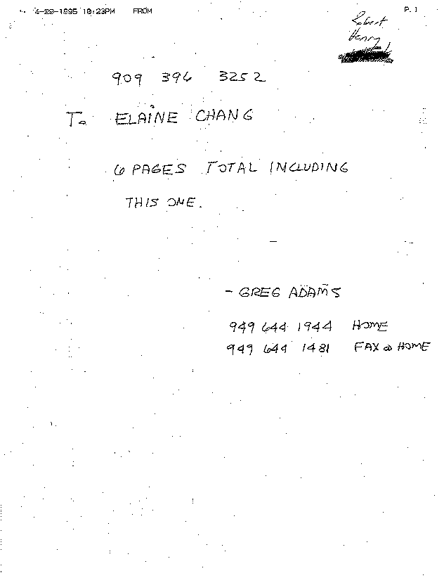

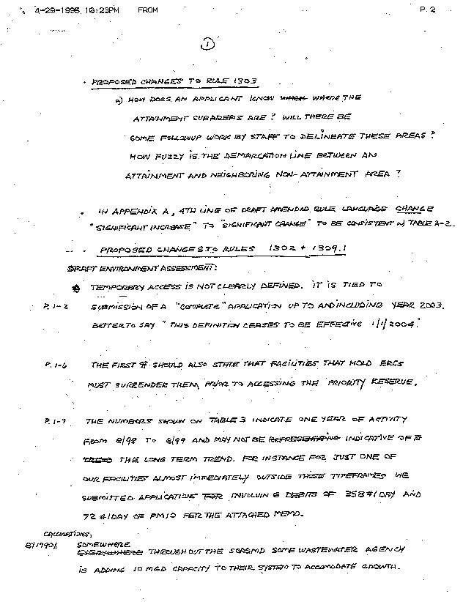
1-1
1-2
1-3
1-4
1-5
1-6

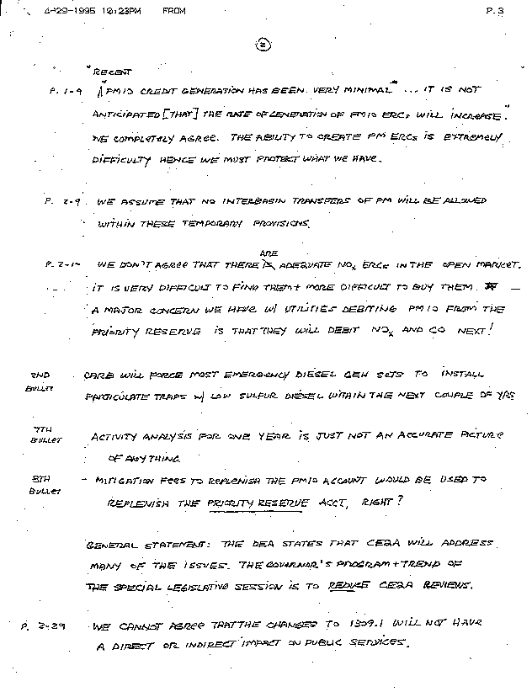
1-7
1-8
1-9
1-10
1-11
1-12
1-14
1-13

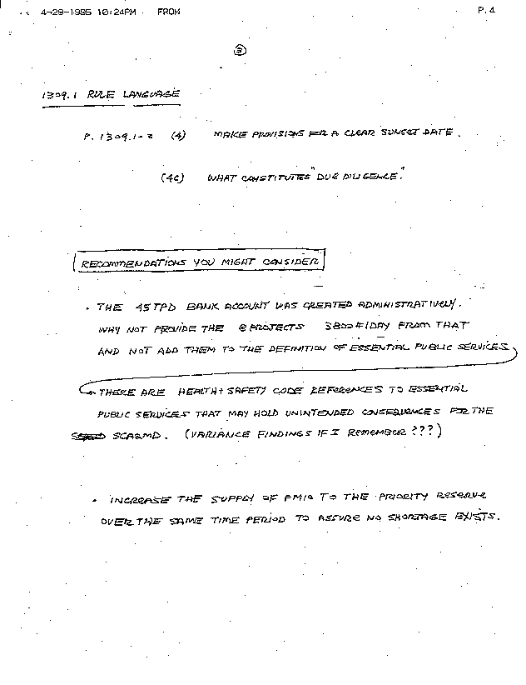
1-15
1-16
1-17

COMMENT LETTER #1 FROM
County Sanitation Districts of Los Angeles County
(March 7, 2001)

Response 1-1

The AQMD compiles and published monthly air quality data obtained from its monitoring station network that one can refer to in identifying the attainment status of a particular subregion. Air quality maps, including ones that define subareas of attainment and monitoring stations, are also published periodically and are available to the public. The staff report to proposed amended Rule 1303 provides: these maps, the procedure a facility would follow to determine eligibility for the appropriate modeling criteria and an example to illustrate the eligibility analysis.

The procedure requires that the new emissions plus the measured background could not create a violation of any state or national ambient air quality standard. In sub-regions that do not meet the ambient standards, the modeling criteria will not change from the current procedure; the new emissions may not cause a measurable increase in air quality concentration for the pollutant modeled.

Under the proposed amendments, modeled increases from the new or modified source will be compared to the background air quality data and the applicable federal and state air quality standards. Background air quality is based on the location that of concern, which would typically be the point of maximum ground level impact. It is the ambient pollutant concentration at that location and not the location of the source, which will be used to determine the location of concern.

Once the location of concern has been identified, the monitoring zone that includes that location is determined. The District is divided into 37 monitoring zones. Ambient air quality data are obtained within that monitoring zone or in an adjacent zone that is representative of that zone. Background air quality is the highest reading for the pollutant of concern for the previous three years.

Response 1-2

"Significant increase" and "significant change" are synonymous and possess the same meaning. Because there is no intention for these words to possess different meanings, "increase" has been modified to "change" on the 4th line of Appendix A in order to reduce any further confusion.

Response 1-3

The temporary access to the AQMD's priority reserve PM10 (particulate matter less than 10 microns) account is for permit to construct applications submitted during the calendar years 2000, 2001, 2002, or 2003. This temporary access is defined in proposed amended Rule 1309.1(a)(4). Because the calendar year for 2003 ends on December 31st, permit to construct applications may still be processed under this provision in 2004. Therefore, it would be inappropriate to include "this definition ceases to be effective 1/1/2004."

Response 1-4

Under the current Rule 1309.1(a)(4)(E), a facility is already subject to the requirement that "if a subject facility holds an Emission Reduction Credit (ERC), then that ERC must be used before access to the priority reserve is allowed." Compliance with this requirement remains unchanged as a result of the proposed amendments. As requested, this language will be added to the "Project Background" section of the Final EA.

Response 1-5

Table 3 lists two published data bases: the New Source Review (NSR) creditable emission reductions and the total emission increases. While the latter reflects the total emission increases from one year (August 1, 1998 to July 31, 1999) of NSR activity, the balance of creditable emission reductions accounts for all activity up to July 1999, including the carry-over balance from previous years. Any withdraws from the priority reserve before August 1998 would be reflected in the total balance of creditable emission reductions.

During the period between August 1, 1997 to July 31, 1998, no PM10 offsets (for both Federal and State NSR Compliance) were requested from the priority reserve (please refer to the April 9, 1999 AQMD Governing Board Agenda Item No. 22). Then, according to the "Report on Effectiveness of Regulation XIII - New Source Review" to the Governing Board (please refer to the March 13, 1998 AQMD Governing Board Agenda Item No. 25), no PM10 priority reserve activity was recorded between August 1, 1996 to July 31, 1997 (Federal NSR Compliance). In the same report, no emission increases from the priority reserve were reported for State NSR compliance for the previous seven years (October 1990 to July 31, 1997).

Table 3 presents the total emission increases for which the AQMD is accountable to comply with Federal NSR requirements. The AQMD-funded offsets for the State NSR requirements reported 20 pounds (0.01 tons) per day of PM10 withdrawn from the priority reserve offsets for the same period. These data are the latest presented to the AQMD Governing Board at their August 2000 meeting. Staff does acknowledge that withdrawals from the priority reserve after July 31, 1999 are not displayed in Table 3. These withdrawals have not yet been released to the public or to the AQMD Governing Board in their annual update of NSR activity.

Response 1-6

It is assumed that this comment illustrates potential demand for PM10 ERCs from wastewater agencies since 1990. However, sufficient ERCs have been available to accommodate this demand without going to the priority reserve as indicated in response to comment 1-5. Further, staff can't speculate that these projects "somewhere" will occur in the three years this provision would be in effect. Also, 400 pounds per day for PM-10 shall be exclusively reserved for use by essential public services for the affected years.

Response 1-7

On page 1-9 of the Draft EA, AQMD staff is referring to PM10 ERCs generated in the open market by existing permitted sources and not PM10 ERCs supplied to the priority reserve from an existing account of credits generated from previous shutdowns, etc. Further, as indicated on page 1-9, PM10 credit generation is expected to be minimal, so it would be prudent for PM10 ERC holders to protect their current reserves, as indicated by the commentator. Given the limited opportunities of generating PM10 ERCs in the near term, it would be prudent for facilities to engage in and promote novel or unique opportunities to generate PM10 ERCs in the future to accommodate increased demand for wastewater agency services, for example.

Response 1-8

Under the current Rule 1309.1(a)(4)(F), allocations from the priority reserve shall not be transferred. This requirement is not proposed to be changed.

Response 1-9

It is correct that the amount of nitrogen oxides (NO_{x}) in the open market is typically in relatively short supply. The first paragraph on page 2-10 will be modified to reflect more appropriate wording. There is no proposal at this time to amend Rule 1309.1 to allow access to the priority reserve to offset the increase of NO_{x} or CO emissions from the power plant projects. Similarly, there is ample potential for CO reductions from mobile sources.

With regard to NO_{x} credits for power generating facilities, all of these facilities in the district are in the RECLAIM Program (Regulation XX). The SCAQMD is currently in the process of promulgating amendments to RECLAIM that would isolate power generating facilities from the RECLAIM trading market. Further, consistent with Governor Davis' Executive Order #D-24-01, if existing power generating facilities exceed their annual allocations, they could pay a Mitigation Fee. The SCAQMD would use the money obtained from the Mitigation Fees to fund NO_{x} emission reduction projects to generate RECLAIM trading credits (RTCs). The RTCs generated would then be returned to the power generating facilities to apply to any exceedances of their annual NO_{x} allocation. In addition, the proposed amendments require power generating facilities to install best available retrofit technology, which will further increase the supplies of RTCs available to these facilities. New power plants are expected to offset their emissions through an Air Quality Investment Program (AQIP) which will require the power plant to pay per pound of pollutant. The money will be invested in programs designed to generate credits from RECLAIM, mobile and area sources which represent real surplus reductions. Consequently, power generating facilities will have no affect on the availability of NO_{x} ERCs in the priority reserve.

Response 1-10

The California Air Resources Board (CARB) is developing state-wide fleet vehicle rules which would require the retrofitting diesel engines with particulate traps. Low-sulfur diesel requirements were adopted by the SCAQMD last year, i.e. PAR 431.2. The proposed amendments are being promulgated to facilitate compliance with RECLAIM requirements, which will reduce the need for construction of new emergency diesel generators.

Response 1-11

The "activity analysis" is an accurate picture of the most current NSR activity for one whole year (August 1, 1998 - July 31, 1999). Upon further research, this recent lack of activity with the priority reserve's PM10 account has been a similar trend over the last decade. Please refer to response 1-5. Reporting NSR activity to the AQMD Governing Board began in February 1997 in accordance to the requirements of Rule 1310(b).

Response 1-12

The intent of the mitigation fee is to fund future clean air projects and PM10 emission reduction programs. Any PM10 ERCs generated from these activities will be added to the priority reserve to replenish what was removed to offset the increase in PM10 emissions from the operation of the new power plant projects.

Response 1-13

Governor's program and trend is not to reduce CEQA reviews for all projects. Currently, the only reduced CEQA review is for peaker turbines installed before 1/1/01 (7 days). Otherwise, CEQA reviews are for power generating projects are only shortened by the amount allowed currently under CEQA.

Response 1-14

Since the commentator does not specifically indicate how public services will be adversely affected by the proposed amendments, it is difficult to respond to this assertion. However, as indicated in the EA for the proposed project, fire protection, police protection, schools and parks will not be adversely affected by the proposed amendments because they not change the number of employees, or require new or physically altered public service facilities. Given the historical activity of essential public services accessing the priority reserve (refer to response to comment 1-5), it is not foreseen that essential public services will be significantly adversely affected by the temporary decrease in number of PM10 ERCs available in the priority reserve to offset PM10 emissions from future projects. There is no evidence of large future projects at essential public services over the next three years that will warrant large withdrawals from the priority reserve and no evidence that there will not be sufficient PM10 ERCs available to offset those projects. Furthermore, to alleviate concerns expressed by the commentator, the proposed amendments will set aside 400 pounds of PM10 credits in the priority reserve over the next three years (2001-2003) for the exclusive use by essential public services. In addition, staff will be closely monitoring the priority reserve account activity and report back to the AQMD Governing Board with recommendations in the event the PM10 ERC balance drops substantially.

Response 1-15

The sunset date is the calendar year of 2003, which ends December 31, 2003. The "due diligence" is constituted by providing documentation, including phone logs, that demonstrates an effort has been made to obtain PM10 ERCs from the open market or state accounts. If the cost to procure or generate ERCs is higher than the proposed mitigation fee of $25,000 per pound of PM10, then the facility would be allowed to withdraw PM10 ERCs from the priority reserve.

Response 1-16

The NSR creditable emissions reductions (currently balanced at 44.69 tons of PM10 per day) are allocated to different accounts, such as the priority reserve, Rule 1304 offset sources, to be relinquished to qualified sources. A majority of these ERCs are allocated to accommodate growth among smaller emitters and specifically to offset emissions from new and modified equipment at facilities emitting less than amounts listed in Table A of Rule 1304. The PM10 offsets are limited to facilities emitting less than four tons per year (8,000 pounds per year). The new power plant facilities need much higher PM10 offsets (from 71 to 1,145 pounds PM10 per day, according to the "Credit Policy Issues for the NSR Program from the NSR Subcommittee to the AQMD Home Rule Advisory Group", February 5, 2001). Futhermore, since these credits have not been factored into the AQMD baseline, new PM10 control measures will have to be developed to offset these emissions and make up for any PM10 reduction shortfalls. However, because of the scarcity of stationary source categories with significant PM10 reduction potential and the looming deadline for the Basin to demonstrate attainment with the ambient air quality standard for PM10, such an undertaking would be ill-advised at this time.

Response 1-17

The priority reserve account will be monitored over the next three years to ensure both the power plant projects and essential public services to ensure the adequate availability of PM10 credits. The priority reserve is allocated 125 pounds per day each quarter of the year (500 pounds per day of PM10 each year). It is estimated that the power plant projects will need approximately 4,744 pounds per day of PM10 credits, which would allow all identified power plant projects with permit applications with the SCAQMD to be approved (please refer to Agenda Item 5B of the "Credit Policy Issues for the NSR Program from the NSR Subcommittee to the AQMD Home Rule Advisory Group", February 5, 2001). The new power plants currently hold approximately 1,000 pounds per day of PM10 credits. According to Rule 1309.1(a)(4)(e), facilities holding ERCs must use them before accessing the priority reserve. Then, according to the proposed amendments, facilities would be required to conduct a due diligence effort to secure publicly available PM10 ERCs. It is believed that approximately 1,000 pounds per day of PM10 credits are currently available in the open market. If they are obtained by the power plants, the remaining offsets, 2,744 pounds per day of PM10, could be retrieved from the priority reserve immediately, and leave a remaining balance of 341 pounds per day of PM10. However, if no PM10 ERCs are attainable from the open market, approximately 3,744 pounds per day of PM10 will likely be requested from the priority reserve by power generating facilities. By June 30, 2002, the priority reserve will have a PM10 ERC balance of 3,835 pounds per day, which will satisfy the PM10 offset requirement to permit all of the new power plants.

The following factors have been taken into account when considering the adequacy of the availability PM10 ERCs in the priority reserve to satisfy offsets needed for both new power plant projects and future essential public service projects: 1) 400 pounds per day of PM10 has been exclusively reserved for use by essential public services during the years that EGFs can access the priority reserve; 2) not all applications are expected to be submitted to the AQMD at the same time but rather over the three-year period; 3) the amount of PM10 offsets needed for the power plant projects have been overestimated; 4) under the current Rule 1309.1, there are mechanisms in place, at the discretion of the Executive Officer, to reserve priority reserve offsets for up to three years to allow multiyear essential public service projects to be planned; 5) pursuant to Rule 1309.1, specific projects shall be given priority for access to the priority reserve based on public health or safety regardless of the date of application submitted, and 6) a mitigation fee will be paid for each pound of PM10 withdrawn which will be used to generate additional PM10 offsets to replenish the priority reserve.

The AQMD could increase the amount of PM10 ERCs allocated into the priority reserve. However, if the total allocation over the three-year life of the project is greater than the currently allotted 150 pounds per day of PM10, the change would result in a significant adverse impact to air quality. The proposed amendments do not propose to increase the PM10 allocations.

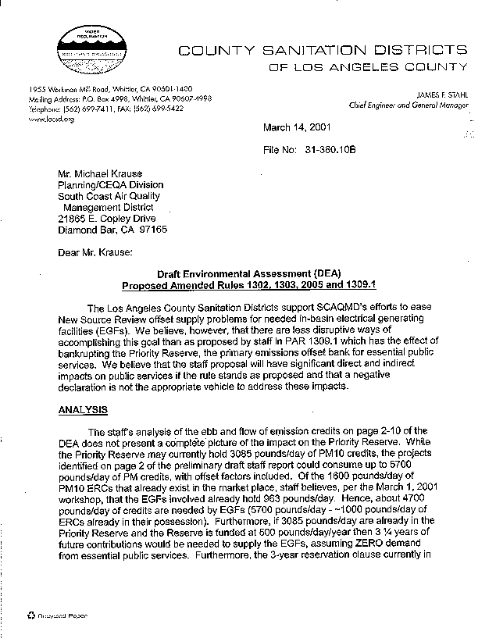
2-1
2-2
2-3

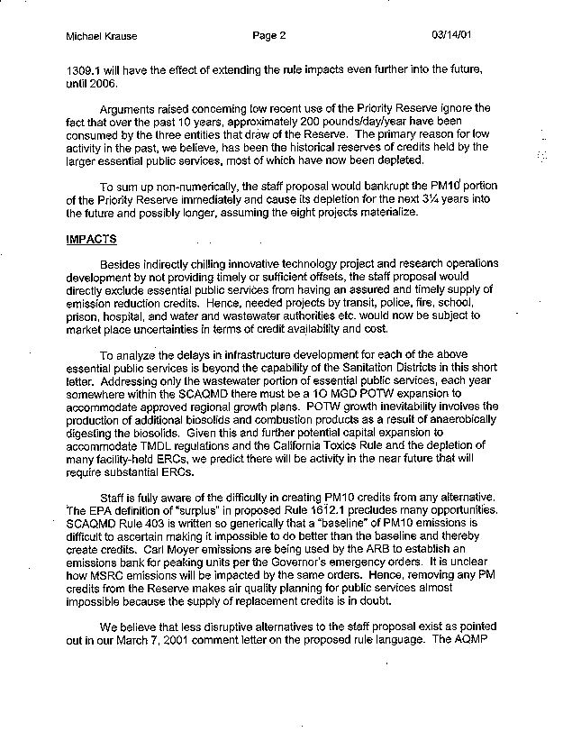
2-3
cont.
2-4
2-5
2-6
2-7
2-8
2-9

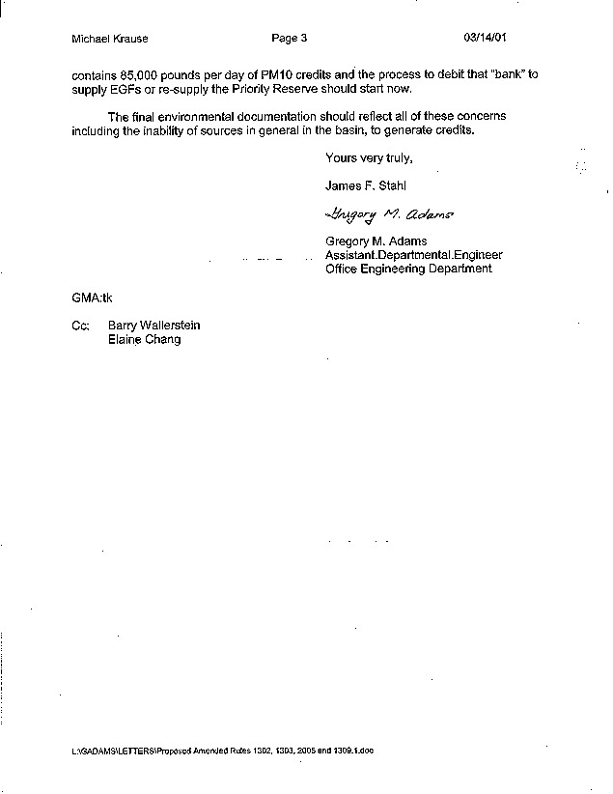
2-9
cont.
2-10

COMMENT LETTER #2 FROM
County Sanitation Districts of Los Angeles County
(March 14, 2001)

Response 2-1

The AQMD disagrees with the commentator's opinion that the proposed amendments to Rule 1309.1 will bankrupt the priority reserve. First, the amendments allow only a temporary access to the priority reserve until the end of the year 2003. Second, the EGFs will only be allowed access to the priority reserve's PM10 emissions account and will not have acces to other criteria pollutant account. Third, depending on how many PM10 emission reduction credits (ERCs) are attainable from the open market, the power plants will be requesting between 2,744 to 3,744 pounds per day of PM10 from the priority reserve. If the EGFs obtain all the PM10 credits in the open market, they can retrieve the remaining PM10 offsets from the priority reserve immediately and leave a balance of 341 pounds per day of PM10. If no PM10 ERCs are obtained from the open market, the priority reserve will satisfy the total request as of June 30, 2002, when the priority reserve will be supplied with additional PM10 ERCs up to 3,835 pounds per day. Fourth, it is unlikely the applications will be submitted at the same time which would "bankrupt" the priority reserve. Fifth, the California Air Resources Board (CARB) is in the process of establishing a PM10 credit bank that will be accessible by the peaker units thus ease the demand of the priority reserve account. Sixth, even if the power plant projects drain the available PM10 offsets, the priority reserve is allocated 125 pounds of PM10 each quarter of the year (500 pounds per year). Finally, the proposed amendments will set aside 400 pounds of PM10 credits over the next three years (2001-2003) for the exclusive use by essential public services. The AQMD could also increase the amount of PM10 ERCs allocated into the priority reserve. If that need arises, the AQMD will take the appropriate action.

With regard to potential significant adverse impacts to public services, the commentator is referred to the response to comment 2-6. It should be noted that, under the SCAQMD's certified regulatory program, a negative declaration was not prepared. The SCAQMD's CEQA document, an environmental assessment, did conclude, however, that the proposed project would not generate any significant adverse environmental impacts, including potential impacts to public services.

Response 2-2

As indicated by the commentator, the Draft EA accurately characterizes the demand and supply of PM1- ERCs relative to EGFs. According to the New Source Review (NSR) Subcommittee to the AQMD Home Rule Advisory Group, the power plant projects will need approximately 4,744 pounds per day of PM10 credits (please refer to Agenda Item 5B of the "Credit Policy Issues for the NSR Program from the NSR Subcommittee to the AQMD Home Rule Advisory Group," February 5, 2001). The power plants currently hold 1,000 pounds per day of PM10 credits and pursuant to Rule 1309.1(a)(4)(e), facilities holding ERCs must use them before accessing the priority reserve. Also, eligible facilities are required to provide a due diligence effort to obtain PM10 ERCs from the open market. There is an estimated 1,000 pounds per day of PM10 credits in the open market. Therefore, depending on how many PM10 ERCs are obtained from the open market, the power plants will be requesting between 2,744 - 3,744 pound per day of PM10 from the priority reserve.

Response 2-3

It is not expected to take three and a quarter years to establish an adequate supply of PM10 ERCs for future ERG projects. How much and when the power plants request the PM10 ERCs will dictate the availability of the credits in the priority reserve. If the power plants request approximately 2,744 pounds per day of PM10 (see response 2-2), then the priority reserve can immediately satisfy that request and maintain an excess balance of 341 pounds per day of PM10 ERCs. However, if no PM10 credits are obtained from the open market, the power plants will request approximately 3,744 pounds per day of PM10. The priority reserve can fulfill that request by June 30, 2002 assuming a normal schedule of replenishing PM10 allocations, which would leave a balance of 91 pounds per day of PM10. The priority reserve is allocated 125 pounds per day of PM10 per quarter (500 pounds per year). Furthermore, the proposed amendments will set aside 400 pounds of PM10 credits over the next three years (2001-2003) for their exclusive use by the essential public services.

Subsequent to the release of the Draft EA, the proposed amended Rule 1309.1 was modified to exclude EGFs from the definition of essential public service. Therefore, EGFs will not be eligible for the provision of subparagraph (5)(c) which allows only essential public services to reserve priority reserve offsets for up to three years for multiyear projects.

Response 2-4

Staff is unclear whether the 200 pounds per day (per year over the last 10 years) noted in the comment: 1) is strictly for PM10 offsets; 2) includes activity after July 1999 when the last NSR balance was published; and 3) includes offsets requested from the priority reserve or offsets from ERCs held by eligible facilities. According to the annual reports on "Effectiveness of Regulation XIII - New Source Review" to the Governing Board, from October 1990 to July 1999, the only recorded PM10 withdrawal from the priority reserve was 20 pounds per day (0.01 tons/day), calculated for state NSR compliance, during August 1, 1998 to July 31, 1999.

Pursuant to Rule 1309.1 (4)(E), a subject facility, such as an essential public service, is required to use any ERCs the facility holds before accessing the priority reserve. Therefore, low priority reserve activity in the past may be because larger essential public services held a reserve of credits which were used to offset their past projects. According to the AQMD records, since the inception of the priority reserve program in 1990, the Los Angeles Sanitation District has never held any PM10 ERC.

Response 2-5

Please refer to Responses 2-1, 2-2 and 2-3.

Response 2-6

The SCAQMD disagrees with the commentator's opinion that the proposed amendments will directly exclude essential public services or chill innovative technology projects and research operations. As indicated in the EA for the proposed project, fire protection, police protection, schools and parks will not be adversely affected by the proposed amendments because they not change the number of employees, or require new or physically altered public service facilities. Given the historical activity of essential public services accessing the priority reserve (refer to response to comment 1-5), it is not foreseen that essential public services will be significantly adversely affected by the temporary decrease in number of PM10 ERCs available in the priority reserve to offset PM10 emissions from future projects. There is no evidence of large future projects at essential public services over the next three years that will warrant large withdrawals from the priority reserve and no evidence that there will not be sufficient PM10 ERCs available to offset those projects. Furthermore, to alleviate concerns expressed by the commentator, the proposed amendments will set aside 400 pounds of PM10 credits in the priority reserve over the next three years (2001-2003) for the exclusive use by essential public services. In addition, staff will be closely monitoring the priority reserve account activity and report back to the AQMD Governing Board with recommendations in the event the PM10 ERC balance drops substantially.

Response 2-7

Sufficient ERCs have been available to accommodate this demand without going to the priority reserve. Further, staff can't speculate that these future projects will occur in the three years this provision would be in effect. Also, 400 pounds per day for PM-10 shall be exclusively reserved for use by essential public services for the affected years.

Response 2-8

The mitigation fees will contribute to the following programs and projects designed to reduce PM10 emissions such as the usage of particulate traps and low sulfur diesel, and research, development and implementation of new PM10 reducing technology. While the planning and quantification of replacing the PM10 credits is not an easy task, it is not one that is "impossible." As reflected in responses 2-2, 2-3 and 2-4, the supply of replacement PM10 credits is not "in doubt." Also, the priority reserve will not have a zero balance while waiting to be replenished with replacement credits from PM10 emission reducing programs because the priority reserve is allocated 125 pounds per day of PM10 every 3 months (500 pounds per year) regardless of how much is being withdrawn or replenished.

Response 2-9

It is subjective to assume there is an alternative to the project that would be less "disruptive" for everyone. As responded in your March 7, 2001 comment letter, the NSR creditable emissions reductions (currently balanced at 44.69 tons of PM10 per day) are allocated to different accounts, such as the priority reserve and Rule 1304 offset sources to be relinquished to qualified sources. A majority of these ERCs are allocated to offset new and modified facilities emitting less than amounts listed in Table A of Rule 1304. The PM10 offsets are limited to facilities emitting less than four tons per year (8,000 pounds per year). The new power plant facilities need much higher PM10 offsets (from 71 to 1,145 pounds PM10 per day, according to the "Credit Policy Issues for the NSR Program from the NSR Subcommittee to the AQMD Home Rule Advisory Group", February 5, 2001). Futhermore, since these credits have not been factored in the AQMD baseline, new PM10 control measures will have to be developed to offset these emissions and make the environment whole. However, because of the scarcity of stationary source categories with significant PM10 reduction potential and the looming deadline for the Basin to demonstrate attainment with the ambient air quality standard for PM10, such an undertaking would be ill-advised at this time.

Response 2-10

As indicated in the previous responses to the commentator's comments, the EA prepared for the proposed amendments concluded that no significant adverse environmental are expected. The commentator has not provided any evidence to refute this conclusion. The general difficulty in generating credits is an existing situation and not a result of the proposed amendments. Concerns raised in this comment letter and SCAQMD's responses to these concerns have been prepared and are included in an appendix of the Final EA and are thus part of the final environmental documentation.

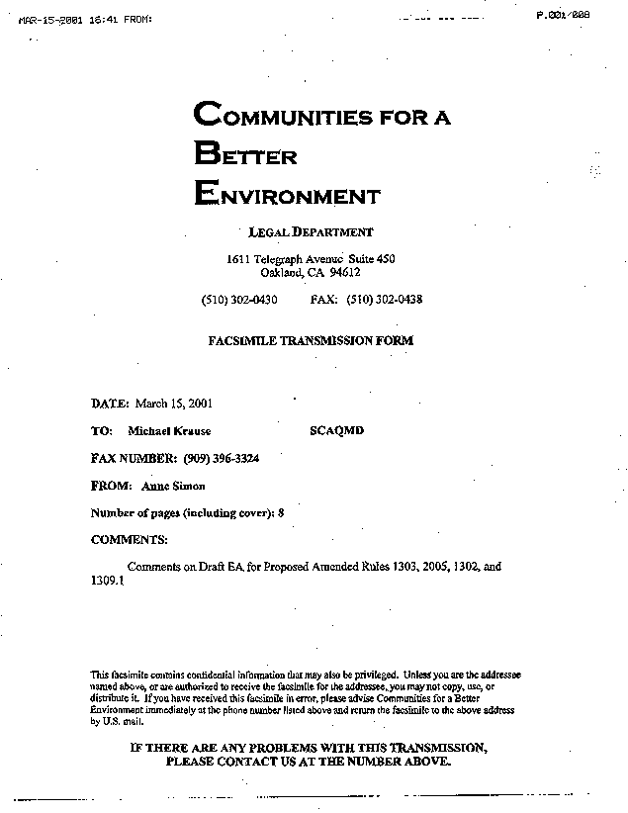

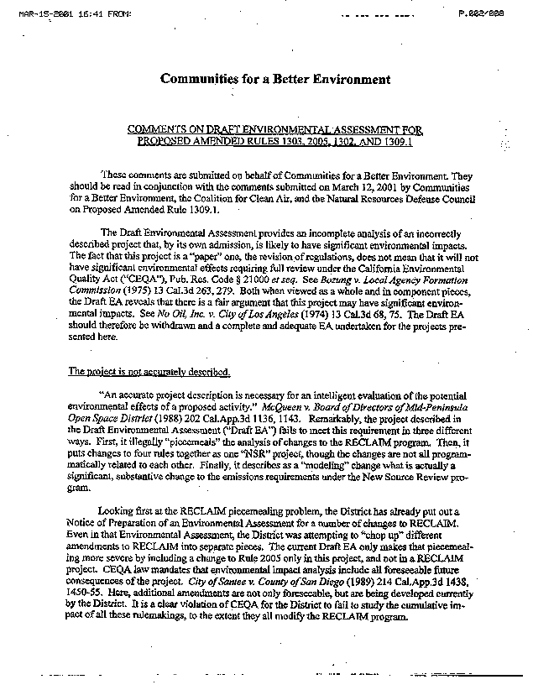
3-1
3-2
3-3
3-4

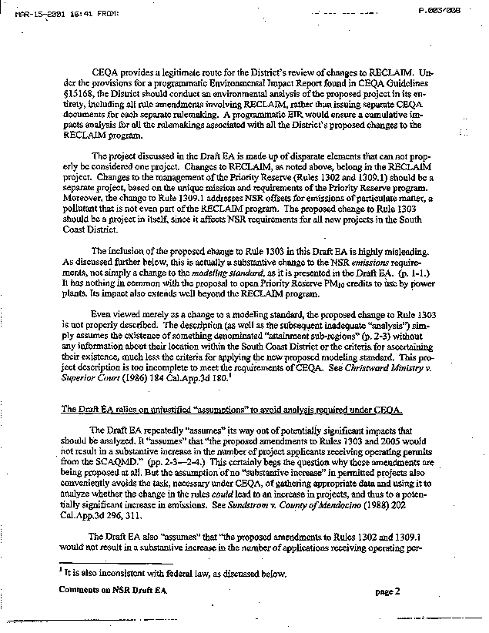
3-5
3-6
3-7
3-8
3-9
3-10

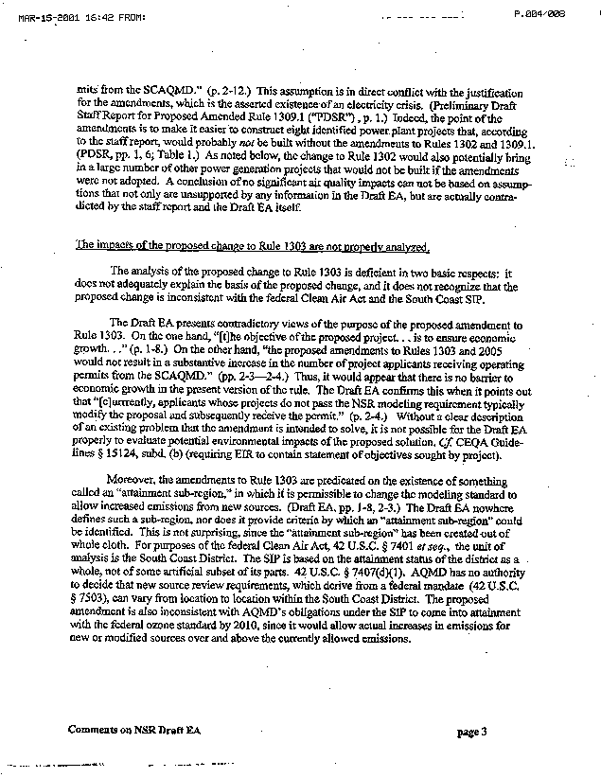
3-10
cont.
3-11
3-12

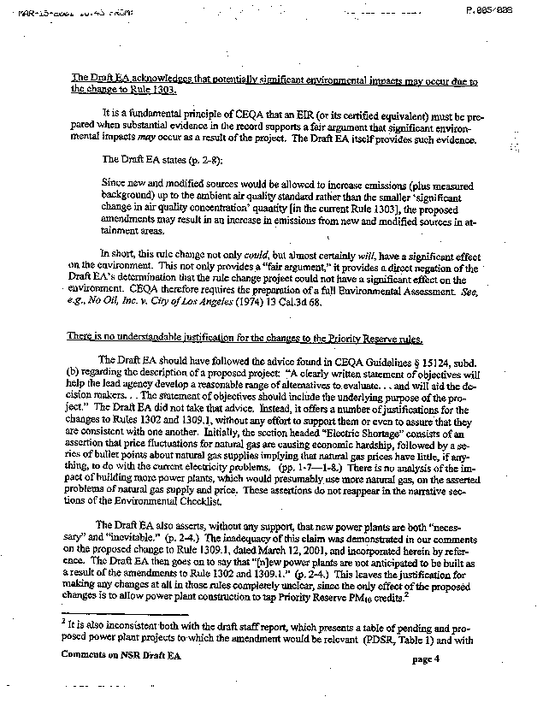
3-13
3-14
3-15

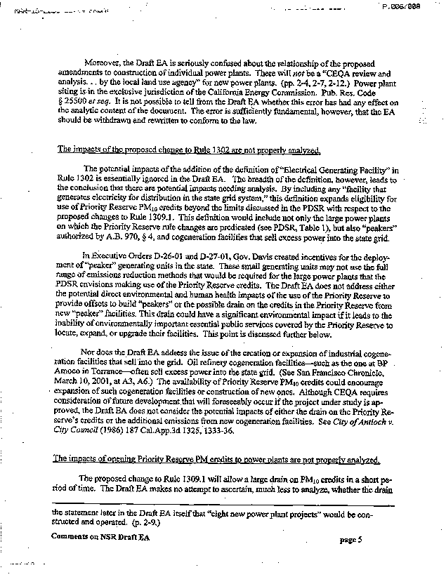
3-16
3-17
3-18
3-19
3-20

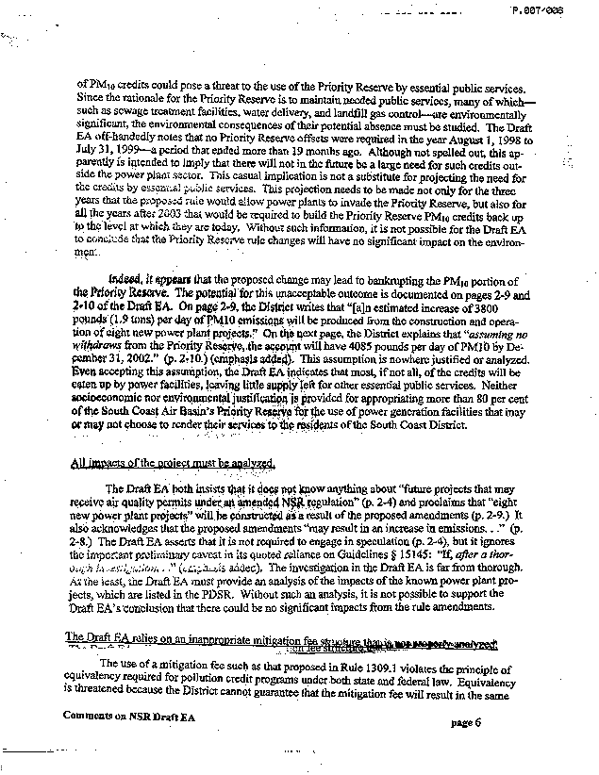
3-20
cont.
3-21
3-22
3-23

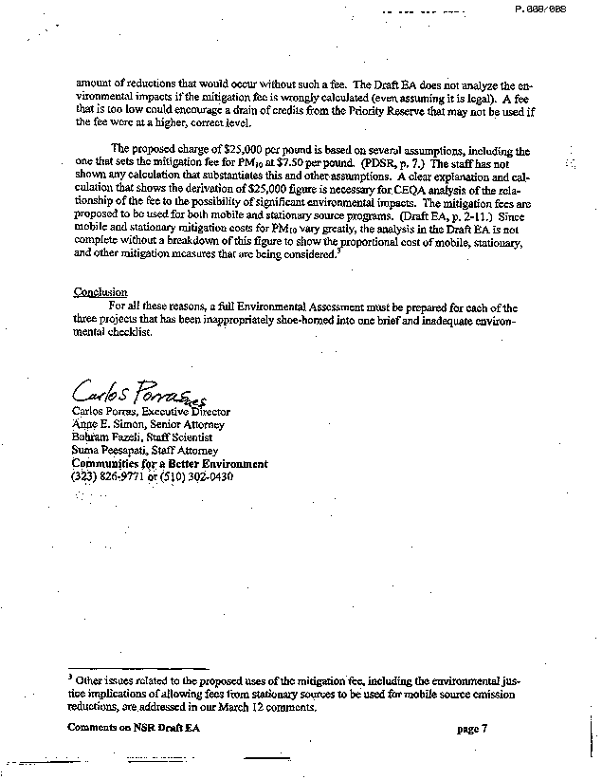
3-23
cont.
3-24
3-25

COMMENT LETTER #3 FROM
Communities for a better environment, the coalition for clean air and the natural resources defense council
(March 15, 2001)

Response 3-1

Thank you for your comments.

Response 3-2

It is unclear what the purpose is of the commentator’s statement that the proposed project is a “paper” project. The Draft EA does not refer to the proposed amendments as a paper project. Further the Draft EA acknowledges on page 1-2 that the proposed amendments are a project as defined by CEQA Guidelines §15378 and, therefore, is subject to an appropriate environmental analysis. Therefore, the reference to Bozung v. Local Agency Formation Commission (1975) 13 Cal.3d 263, 277-79 that actions that might be disparaged as mere "government paper-shuffling" can constitute a project, is not relevant to the proposed project.

The commentator provides no evidence that there is a fair argument that the proposed project will generate significant adverse environmental impacts, as indicated in the following responses. The commentator merely provides unsubstantiated opinions regarding potential environmental impacts that could be generated by the proposed project. Pursuant to CEQA Guidelines §15064(f)(5) opinion does not constitute substantial evidence.

Response 3-3

The SCAQMD disagrees with the commentator’s opinion that the Draft EA for the proposed project fails to include an accurate project description. A comprehensive project description is included in Chapter 1 of the Draft EA and the actual proposed amended rules are included in Appendix A. The commentator then states incorrectly that the project description is deficient in three ways. First, the project piecemeals changes to the RECLAIM program (refer to response to comment #3-4). Second, it analyzes four modifications that are not programmatically related (refer to response to comment #3-6). Third, the commentator believes the change in the modeling provision should be considered a significant adverse air quality impact (refer to responses to comments #3-7 and #3-8).

Response 3-4

In general, rules and regulations promulgated by the SCAQMD are crafted with many elements including applicability, definitions, emission limits, compliance dates, modeling, test methods, exemptions, etc. Rules are amended over time for a number of reasons including changes to federal or state law; changes in control technologies; requests for changes from state, federal, or regulated parties; etc. The actual analysis of potential adverse environmental impacts are often dictated by timing, that is, when the amendments are proposed to be amended to address specific issues. The currently proposed amendments are in response to issues raised late in the year 2000 and are an effort to amend new source review requirements. It is appropriate to amend Rule 2005 as part of the current project to maintain consistency between New Source Review provisions that apply only to RECLAIM facilities (Rule 2005) and similar provisions in Rule 1303 (non-RECLAIM facilities) regarding the change in the modeling criteria for a new source.

The proposed amendments to Regulation XX - RECLAIM and Proposed Rules (PR) 1631, 1632, 1633 and 2507 that are currently being developed are in response to an entirely different issue, i.e., current efforts to stabilize the RECLAIM trading credits (RTCs) trading market by increasing supply, through the creation of mobile and area source credit generation rules, reducing demand and increasing the RTC trading information availability and accuracy. The Governing Board did not direct staff to begin work on this project until the January 19, 2001 public Board Hearing, well after initiation of the currently proposed amendments. The Draft EA for proposed amendments to RECLAIM and PR1631, 1632, 1633 and 2507 will include an evaluation of potential adverse cumulative impacts from Rule 2005 so the assertion of piecemealing of the impacts from changes to the RECLAIM program is not correct.

The reference made by the commentator to City of Santee v. County of San Diego, 4th District (1989) 214 Cal.App.3d 1438, 1451-55 refers to an EIR where future phases of a jail facility project were not evaluated. In this case, the court found that the EIR should have evaluated future phases of the same project. This case is not relevant to the proposed project because there are no plans currently to make future modifications to Rule 2005. Modifications to other Regulation XX rules, however, are currently being promulgated. Even though this is not the same project, the Draft EA for the proposed amendments to Regulation XX does include a cumulative impacts analysis that includes Rule 2005, which is consistent with CEQA Guidelines §15130.

Response 3-5

Preparation of a program CEQA document is useful under a number of circumstances. Indeed the SCAQMD typically prepares a program CEQA document for projects with broad policy programs, e.g., the AQMP, fleet vehicle rules, etc. This approach allows the SCAQMD greater flexibility to deal with basic problems. In the case of the proposed project, a program CEQA document is unnecessary because the project focuses on very specific components of the SCAQMD’s New Source Review program (Regulation XIII and Rule 2005). The Draft EA focuses its analysis on the proposed project in its entirety. The CEQA document for other amendments to the RECLAIM program will include as part of the environmental impact analysis, an analysis of cumulative impacts.

Response 3-6

The proposed amendments to Rules 1303, 2005 and 1309.1 are related to the general requirements of the New Source Review (NSR) program. Rule 1303 contains NSR requirements for any new or modified sources, Rule 2005 NSR provisions for RECLAIM facilities and Rule 1309.1 regulates the usage of the priority reserve which provides emission offsets necessary under the NSR program. Therefore, the rules' amendments could be considered an "NSR" project. As noted in response to comment #3-4, it is appropriate to amend Rule 2005 as part of the current project to maintain consistency with amendments to Rule 1303 regarding similar New Source Review provisions that apply only to RECLAIM facilities (Rule 2005) and similar provisions in Rule 1303 (non-RECLAIM facilities) regarding the change in the modeling criteria for a new source.

The current proposed amendments to Rule 2005 will, however, be analyzed in the Draft EA for the Regulation XX - RECLAIM amendments under the cumulative impacts analysis. A separate environmental document could have been prepared for proposed amendments to Rule 1309.1, but the conclusions regarding potential adverse environmental impacts would not have changed. As a matter of fact, separating the project in this way would lessen the environmental impacts from each project analyzed separately.

The proposed amendments to Rule 1303 were evaluated for the impacts on all new projects in the district eligible for the new modeling criteria.

Response 3-7

The phrase from the Draft EA cited by the commentator that the change to the NSR emissions requirements is a change to the modeling standards is simply part of the summary of the project description and is not intended either implicitly or explicitly as an analysis. The analysis of potential adverse impacts from the change to the modeling standard is contained in Chapter 2. For example, on page 2-8, the draft EA states "the proposed amendments may result in an increase in emissions from new and modified sources in attainment areas." The analysis, however, concluded that these potential adverse impacts would not exceed any significance criteria.

Please see Response 3-6 with regards to the why the rules were analyzed as one project. The amendments to Rule 1303 do affect facilities outside of the RECLAIM program and the draft EA takes that into account.

Proposed amended Rules 1303 and 2005 were developed to recognize that much of the district is in attainment for some ambient air quality standards. The amendments to Rule 1309.1 have been proposed in order to ease the New Source Review offset supply problems facing electrical generating facilities (EGFs) who are constructing new power plants needed to resolve the state's power crisis. Again, the time these amendments are introduced to the public dictated when an environmental document is created, and the relationship of the amendments determined what modifications are analyzed as one project.

The change to the modeling requirement can be viewed as a substantial change to the NSR program, however the adverse air quality impacts have been determined to be not significant. Facilities qualify for the new amendments if they are located in a sub-region of attainment and if the new emissions plus the measured background does not create a violation of the standard. In sub-regions that do not meet the ambient standards, the modeling criteria will remain the same and new emissions may not cause a significant increase in air quality concentration (as set forth in Rule 1303, Table A-2).

Response 3-8

The staff report for proposed amendments to Rules 1303 and 2005 provides locations in the district currently eligible for the modeling criteria and the parameters necessary to determine that eligibility. The draft EA acknowledges a potential increase in emissions (page 2-8) but concludes that air quality standards would not be violated (page 2-9) and sensitive receptor would not result in impaired health (page 2-11) because localized emissions will be required to be at or below the health based ambient air quality standards. In sub-regions that do not meet the ambient air standards, the modeling criteria will remain the same, and the new emissions will be prevented from causing a measurable increase in ambient concentrations. The proposed amendments do not affect Best Available Control Technology (BACT) requirements, Lowest Achievable Emission Rate (LAER) standards or the emission offset requirements.

Response 3-9

CEQA recognizes that preparing an environmental analysis necessarily involves some degree of forecasting (CEQA Guidelines §15144). In an effort to forecast potential adverse environmental impacts, it is necessary to make working assumptions. To forecast future activity compiled data of past permit applications received by the SCAQMD that would have been affected by the proposed amendments, as well as business trends, economic changes and growth presumptions. The Draft EA assumes that new or modified sources will not be developed strictly because of a new modeling criteria and therefore "would not result in a substantive increase in the number of applications receiving operating permits." However, if a new or modified source does apply for a permit in the future, the size and capacity of the projects may or may not be larger than would otherwise occur without the proposed amendments. As discussed on page 2-9, any increase in emissions will not be significant. The reason why these amendments are being proposed is to recognize that much of the district is in attainment for some ambient air quality standards. Thus, additional economic growth could be allowed without creating localized air quality impacts.

Response 3-10

The commentator suggests that past permit history is not representative of future activity because of the construction of eight power plants in the future. It should be noted that the SCAQMD has, in the recent past, received and completed, or is in the processing of completing, permit processing for projects at nine power generating facilities in the district, which are expected to be online by June 1, 2001. Consequently, review of past permitting activity is considered to be representative of future permitting activity.

The amendments to Rule 1309.1 do not require the construction of new power plants and are not expected to be the sole incentive to construct a new power plant. Thus, the proposed project "would not result in a substantive increase in the number of applications receiving operating permits." Power plant projects are very expensive and technically complex, so there are a number of factors controlling why a power producing business would be constructed besides an allowance to tap into the priority reserve to comply with a PM10 offset requirement. Some of these factors include planning commission approval, CEQA compliance, air quality regulation compliance and approval from other public agencies.

The environmental impacts from creating the priority reserve was previously analyzed in a Draft EA (SCAQMD No. 900502SS, May 1990) and this proposed amendment does not expand its use, although it does expand the number of types of facilities that can access it. Further, the proposed amendments do not pose a significant adverse impact to air quality primarily because the offsets removed from the priority reserve have already been earned through shutdowns, etc. in the past, and additionally, a mitigation fee will be required for each pound of PM10 withdrawn from the priority reserve. This fee will be used to generate future PM10 credits that will replenish the priority reserve. Rule 1302 will not be amended at this time. Electric generating facilities (EGFs) will not be classified as essential public services.

However, there are eight new power plants planned for development in the near future and this allowance for additional growth, and the flexibility to comply with current air quality regulations, will assist them. The proposed power plants are in direct response to the electricity crisis in California and would reduce or eliminate the possibility of rolling blackouts, which disrupt business and residences and create associated safety issues such as loss of electricity to operate traffic lights, air conditioners, and increased toxic, NO_{x}, and PM10 emissions if businesses run dirty diesel generators to a greater extent than otherwise would occur. As explained on page 2-10, emissions from new power plants are likely to be smaller than emissions from backup generators that would otherwise occur. Thus, even if one assumes power plant emissions are "caused" by this amendment, there would not be a significant increase.

Response 3-11

The SCAQMD disagrees with the commentator’s opinion that the analysis of impacts of the proposed changes to Rule 1303 are deficient. First, the commentator states that the Draft EA does not contain an adequate explanation of the basis of the change. The commentator appears to be referring to the project objectives in using the term "basis of the proposed change" and indicates that the Draft EA does not clearly articulate the project objectives as required by CEQA Guidelines §15124(b). This provision is relevant to the preparation of EIRs only. The EA for the proposed project was prepared under the SCAQMD’s certified regulatory program (Public Resources Code §21080.5 and SCAQMD Rule 110). Further, the Draft EA is considered a substitute document prepared pursuant to CEQA Guidelines §15252. This section contains no requirement for a statement of project objectives. In spite of these requirements, however, as noted by the commentator there is a statement of objectives on page 1-8.

The purposes of the project are not contradictory. There would not likely be an increase in the number of permits issued. Currently, project applicants typically modify their projects to obtain permits. Under the amendments, the hourly emissions from an individual project may increase but are not allowed to increase enough to cause a violation of air quality standards.

Response 3-12

Both the definitions of sub-region and the criteria by which an "attainment sub-region" could be identified can be found in the staff report for the proposed amendments to Rule 1303 and 2005. Again, these definitions were not necessary to determine environmental impacts and even if included in the environmental document, would not change the conclusions made in the Draft EA regarding the environmental impacts.

The SCAQMD's NSR program demonstrates consistency with both the state and federal requirements. The existing modeling requirement in NSR is not required by the Clean Air Act. Therefore, the Clean Air Act does not prohibit the district from establishing different requirement in different parts of the Basin. The modeling criteria under the SCAQMD's NSR program is more stringent than federal requirements because minor sources are regulated as well as major sources. In addition, facilities in the non-attainment subregions would continue to comply with the existing modeling requirement which prohibits them from exceeding the change in ambient air quality concentration as listed in Table A-2 of Rule 1303.

The proposed amendment is not inconsistent with SCAQMD's obligations under the SIP to come into attainment with the federal ozone standard by 2010 because the facilities located in non-attainment subregions will not be eligible for the modified modeling requirement. Only facilities located in subregions of attainment will qualify for the modified modeling criteria as long as they do not exceed the air quality standards. Also, eligible facilities will still be subject to BACT and offset requirements. Therefore, the AQMD's goal to achieve the federal ozone standard by 2010 will not backslide as a result from the proposed amendment. While emissions from an individual facility may be greater per hour than under the existing rule, the total emissions in any area may not exceed the state and federal standards. Therefore, total emissions in any one area cannot be predicted to be greater than under the existing rule.

Response 3-13

The proposed amendments may allow facilities in attainment sub-regions to emit more than would otherwise occur existing Rule 1303, but these increases will not create significant adverse air quality impacts for the following reasons. For localized impacts, facilities in the attainment sub-regions must still demonstrate that they will not cause or contribute to an exceedance of any ambient air quality standard. The ambient air quality standard is a health-based standard. Consequently, a facility that does not cause or contribute to a violation of any ambient air quality standard will not create adverse localized human health impacts.

The proposed amendments will not create significant regionalized air quality impacts because Rule 1303(b)(2) requires that a facility offset any emission increases at a 1.2-to-1.0 ratio. This means that a facility will have to provide and additional 20 percent of offset emissions (ERCs) for every one pound increase at the facility. This provision of Rule 1303 remains in effect and is not being modified as part of the proposed amendments.

The SCAQMD's CEQA thresholds for significance, according to the CEQA Handbook adopted by the SCAQMD Governing Board, are based on major source emission thresholds. The SCAQMD does not consider the "significant" increase specified in Regulation XIII modeling criteria to be significant for the purposes of CEQA. Rather these thresholds were originally established to capture any measurable impact. Actual increases from individual facilities are too speculative to predict or analyze.

Response 3-14

The objective and purpose of proposed amended Rule 1309.1 is provided in different locations in the Draft EA including the introduction section (page 1-1 and 1-2), the project description section (page 1-9) and the environmental discussion section (page 2-4). Originally, in order to allow the power plants to tap into the priority reserve, Rule 1302 had to be modified to classify the EGFs as an essential public service, who have access to the priority reserve under Rule 1309.1. However, since the release of the Draft EA, EGFs are no longer classified as an essential public service and thus, no amendments are proposed to Rule 1302 at this time.

The proposed project does not require the construction of new power plants. The amendments to Rule 1309.1 will assist in the permitting of new power plants but do not ensure that a power plant will be built. There are other factors, such as CEQA compliance, air quality regulation compliance and approval from other public agencies, are required before the power plant can be developed. Each new power plant would be considered a "project" and subject to the requirements of CEQA. The increased demand for natural gas, used as the primary combustion fuel to produce steam in boilers, would need to be evaluated under the project specific CEQA analysis. The SCAQMD has recently analyzed power plant impact on natural gas supplies, and concluded there was not a significant impact, as part of the RECLAIM proposed amendments. It was estimated that the potential incremental increase in consumption of natural gas and electricity would be less than one-tenth of one percent and thus, the impact was concluded to be not significant. The proven natural gas reserves and potential resources that can be economically developed can provide affordable supplies to serve the U.S. at current demand levels for the next 50 years.

Response 3-15

It is readily apparent that new power generating facilities are necessary given dire forecasts of electricity shortages over the next few years. Further, because of society's infrastructure dependency on electric power from street lights to elevators to computers to home security systems, and because of the current shortage of electricity to power these systems, power plants are "necessary" to reduce or eliminate the possibility of rolling blackouts during peak power demand periods. Without major increases in energy suppliers, along with consumer conservation, construction of new power plants is "inevitable" as indicated by the fact that up to eight new power plant projects are currently under consideration.

As previously noted, the proposed project does not require the construction of new power plants. The amendments to Rule 1309.1 will merely assist in the permitting of new power plants but do not ensure that a power plant will be built. There are other factors, such as CEQA compliance, air quality regulation compliance and approval from other public agencies, are required before the power plant can be built and operated. The draft EA was stating that the proposed amendments to Rule 1309.1 are not anticipated to be the sole incentive or reason to construct a new power plant. Please refer to Response 3-10 for further discussion. The wording on page 2-4 will be modified to be more clear.

Response 3-16

The commentator's opinion that the responsibility for CEQA review and analysis is "in the exclusive jurisdiction of the California Energy Commission" is not correct, but the CEC does play a role in approving many projects. In general, if the power plant is installing equipment that increases generation capacity by greater than or equal to 50 megawatts (MW) of electricity, then the CEQA obligations are the responsibility of the CEC. However, if the increase in generating capacity is less than 50 MW, the initial CEQA obligations are the responsibility of the local land use agency. These responsibilities have been modified slightly by the recent Governor's Executive Orders. If there is a public agency with greater discretionary approval authority over the project, then the local land use agency may surrender lead CEQA authority to that responsible public agency. For example, the SCAQMD has assumed the role of lead agency for a number of projects at LADWP power generating facilities. This does not change any of the analysis in the Draft EA.

Response 3-17

Since the release of the Draft EA, the AQMD will not be recommending amendments to Rule 1302 at this time so there will be no definition for Electrical Generating Facility in Rule 1302. However, the effects of allowing power generating facilities to have access to the priority reserve have been comprehensively analyzed in Chapter 2 of the EA.

Response 3-18

The Draft EA references the potential offsets from power plant projects prepared by the NSR Subcommittee to the AQMD Home Rule Advisory Group (please refer to Agenda Item 5B of the "Credit Policy Issues for the NSR Program from the NSR Subcommittee to the AQMD Home Rule Advisory Group", February 5, 2001). Some of those facilities, including LADWP, include "peaker" generating units.

The priority reserve account will be monitored over the next three years as required by the proposed amendments to ensure that both power plant projects and essential public services projects have sufficient access to an adequate supply of PM10 credits. The priority reserve is allocated 125 pounds per day each quarter of the year (500 pounds per day of PM10 each year). It is estimated that the power plant projects will need approximately 4,744 pounds per day of PM10 credits and that the power plants currently hold approximately 1,000 pounds per day of PM10 credits. According to Rule 1309.1(a)(4)(e), facilities holding ERCs must use them before accessing the priority reserve. Then, according to the proposed amendments, facilities need to conduct a due diligence effort to secure publicly available PM10 ERCs. It is believed approximately 1,000 pounds per day of PM10 are available in the open market. If they are obtained by the power plants, the remaining offsets, 2,744 pounds per day of PM10, could be retrieved from the priority reserve today, and leave a balance of 341 pounds per day of PM10. However, if no PM10 ERCs are attainable from the open market, approximately 3,744 pounds per day of PM10 will be requested from the priority reserve. By June 30, 2002, the priority reserve will have a PM10 ERC balance of 3,835 pounds per day, which will satisfy the PM10 offset requirement to permit all of the new power plants. The California Air Resources Board (CARB) is in the process of establishing a PM10 credit bank that will be accessible by the peaker units thus ease the demand of the priority reserve account. With regards to potential public services impacts, the commentator is referred to the response #3-20.

Response 3-19

If a facility qualifies as an EGF and satisfies the requirements of proposed amended Rule 1309.1(4), then they are eligible to draw from the pool of PM10 credits in the priority reserve. Staff does not believe, however, that the priority reserve will be drained and that hardship will be imposed on essential public services for the following reasons: 1) 400 pounds per day of PM10 has been exclusively reserved for use by essential public services during the years EGFs can access the priority reserve; 2)not all applications are expected to be submitted to the AQMD at the same time but rather over the three year period; 3) the amount of PM10 offsets needed for the power plant projects have been overestimated; 4) under the current Rule 1309.1, there are mechanisms in place, at the discretion of the Executive Officer, to reserve priority reserve offsets for up to three years to allow multiyear essential public service projects to be planned; 5) pursuant to Rule 1309.1, specific projects shall be given priority for access to the priority reserve based on public health or safety regardless of the date of application submitted, and 6) a mitigation fee will be paid for each pound of PM10 withdrawn which will be used to generate additional PM10 offsets to replenish the priority reserve.

The analysis of the effects that power generating facilities are expected to have relative to their access to the priority reserve is based on the eight facilities identified by the NSR Subcommittee to the AQMD Home Rule Advisory Group (Agenda Item 5B, February 5, 2001). It would be speculation at this time to assume that existing cogeneration facilities like the Watson Cogeneration Facility at the BP Amoco facility in Carson (not Torrance) will expand generating capacity. Engaging in speculation is not consistent with CEQA Guidelines §15145.

Response 3-20

Please refer to Response 3-19 regarding the commentor's concern that the amendments are a "drain" on the priority reserve and it's effect on essential public services.

The Draft EA highlights the NSR activity of the priority reserve over the last recorded and publicly released year (August 1, 1998 - July 31, 1999). This data year, ending 19 months ago, was just released at the August 2000 Governing Board meeting. Nothing written in the Draft EA is "off-handed" and there is no "casual implication" that there will not be any activity in the future. There is no evidence to support that there will be a large need for credits outside the power plant sector. The Draft EA was merely providing an idea of how much PM10 credits would be in the priority reserve if there were no withdraws, which is also not unlikely. This recent lack of activity with the priority reserve's PM10 account has been a similar trend over the last decade. During the period between August 1, 1997 to July 31, 1998, no PM10 offsets (for both Federal and State NSR Compliance) were requested from the priority reserve (please refer to the April 9, 1999 AQMD Governing Board Agenda Item No. 22). Then, according to the "Report on Effectiveness of Regulation XIII - New Source Review" to the Governing Board (please refer to the March 13, 1998 AQMD Governing Board Agenda Item No. 25), no PM10 priority reserve activity was recorded between August 1, 1996 to July 31, 1997 (Federal NSR Compliance). In the same report, no emission increases from the priority reserve were reported for State NSR compliance for the previous seven years (October 1990 to July 31, 1997). The only recorded PM10 withdraw from the priority reserve is 20 pounds per day (0.01 tons/day), calculated for state NSR compliance, during August 1, 1998 to July 31, 1999 (according to the annual reports on "Effectiveness of Regulation XIII - New Source Review" to the Governing Board, from October 1990 to July 1999).

As indicated in the EA for the proposed project, fire protection, police protection, schools and parks will not be adversely affected by the proposed amendments because they not change the number of employees, or require new or physically altered public service facilities. Given the historical activity of essential public services accessing the priority reserve, it is not foreseen that essential public services will be significantly adversely affected by the temporary decrease in number of PM10 ERCs available in the priority reserve to offset PM10 emissions from future projects. There is no evidence of large future projects at essential public services over the next three years that will warrant large withdrawals from the priority reserve and no evidence that there will not be sufficient PM10 ERCs available to offset those projects. Furthermore, to alleviate concerns expressed by the commentator, the proposed amendments will set aside 400 pounds of PM10 credits in the priority reserve over the next three years (2001-2003) for the exclusive use by essential public services. In addition, staff will be closely monitoring the priority reserve account activity and report back to the AQMD Governing Board with recommendations in the event the PM10 ERC balance drops substantially.

Response 3-21

The AQMD disagrees that the proposed amendments to Rule 1309.1 will bankrupt the priority reserve. First, the amendments allow only a temporary access to the priority reserve until the end of year 2003. Second, the EGFs will only be allowed access to the priority reserve's PM10 emissions account and no other criteria pollutant. Third, depending on how many PM10 emission reduction credits (ERCs) are attainable from the open market, the power plants will be requesting between 2,744 - 3,744 pound per day of PM10 from the priority reserve, assuming all identified power plants are constructed. If the EGFs obtain all the PM10 credits in the open market, they can retrieve the remaining PM10 offsets from the priority reserve immediately and leave a balance of 341 pounds per day of PM10. If no PM10 ERC are obtained from the open market, the priority reserve will satisfy the total request as of June 30, 2002 when the priority reserve will have approximately 3,835 pounds per day of PM10. Finally, even if the power plant projects drain the available PM10 offsets, the priority reserve is allocated 125 pounds of PM10 each quarter of the year (500 pounds per year). The AQMD could increase the amount of PM10 ERCs allocated into the priority reserve. The proposed rule has been modified to ensure availability of PM10 offsets for essential public services. If that need arises, the AQMD will take the appropriate action. Again, the Draft EA was merely providing an estimate of how much PM10 credits would be in the priority reserve if there were no withdraws. If there is a withdraw, the pool of credits would be lower and it would take longer for the power plants to access the needed PM10 credits.

The justification for allowing power plants the access is to assist them in their creation and operation, while maintaining existing air quality regulations and environmental protection. The offsets in the priority reserve have already been earned through shutdowns, etc., and in addition, facilities will be required to pay a mitigation fee for each pound of PM10 withdrawn which will be used to generate additional PM10 offsets to replenish the priority reserve.

Response 3-22

The commentator appears to misinterpret the information in the Draft EA. Under Rule 1309.1, the analysis assumes that the proposed amendments will affect a specific group of EGFs which have been studied by the NSR Subcommittee to the AQMD Home Rule Advisory Group who have determined the eight power plants and their potential emissions from operation. Refer to response #3-19. These emission values were provided in the Draft EA's analysis of potential impacts from amendments to Rule 1309.1. Please refer to responses #3-18 to #3-21 and page 2-10 of the EA as to why the amendments to Rule 1309.1 were determined to be not significant. The statement in the EA relative to future projects does not include the eight facilities identified by the NSR subcommittee, which are analyzed, but to potential future projects beyond these eight for which there is currently no information.

If located in an area of attainment, the proposed amendments will allow facilities to increase their emissions without the modeling requirement. However, these emissions above the allowed are required to be offset, so the impact is considered not significant.

Response 3-23

The proposed mitigation fee was derived from the proposed mitigation fee for RECLAIM NO_{x}, the current price of PM10 ERCs and the cost effectiveness for PM10 reductions through the Carl Moyer program. Staff believes this is an appropriate amount to generate credits to replenish the priority reserve. If the value is determined to be too low, then the mitigation fee can be changed at a later date. The fee is not considered to be low enough to encourage a drain of the priority reserve since the current price for PM10 ERCs is approximately $10,000 per pound. The mitigation fee is not illegal. To the contrary, the emissions offsets available in the priority reserve are based on valid reductions and could lawfully be used in the NSR program even if no payment were made.

Response 3-24

Please refer to Response 3-23 with regards to the relationship of the fee to the possibility of significant environmental impacts. There is a discussion in the staff report for proposed amended Rule 1309.1 regarding how the mitigation fee was derived.

Response 3-25

These three rule amendments affect NSR requirements and they allow flexibility to comply with current air quality requirements without sacrificing environmental protection. Proposed amendments to Rules 1303 and 2005 were developed to recognize that much of the district is in attainment for some ambient air quality standards, provide compliance flexibility for eligible facilities, and harmonize the modeling criteria under the federal law with the local NSR requirements. The amendments to Rule 1309.1 have been proposed in order to ease the NSR offset supply problems facing EGFs who are constructing new power plants needed to resolve the state's power crisis.

Aside from expressing an opinion, the commentator has not provided any substantial evidence that the analysis of potential adverse environmental impact is deficient in any way. Because the environmental impacts were determined to be not significant, an EA with no significant impacts was prepared. There was no intention of "shoe-horning" the projects and the analysis "adequately" addresses all the required topic areas and discloses all the facts known at the time of the analysis.

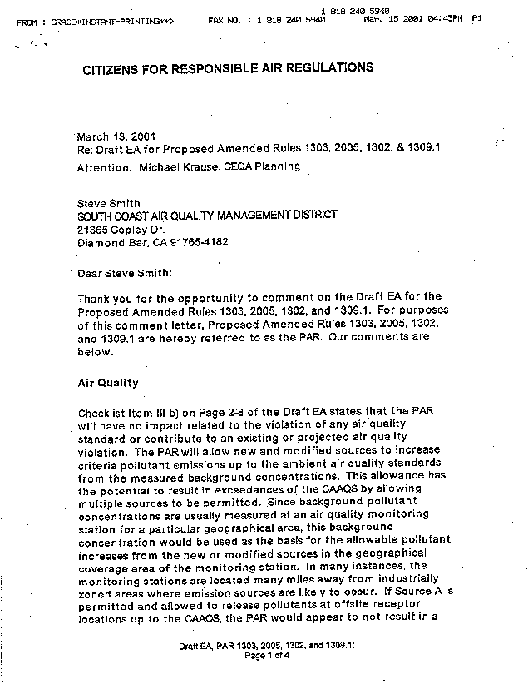
4-1

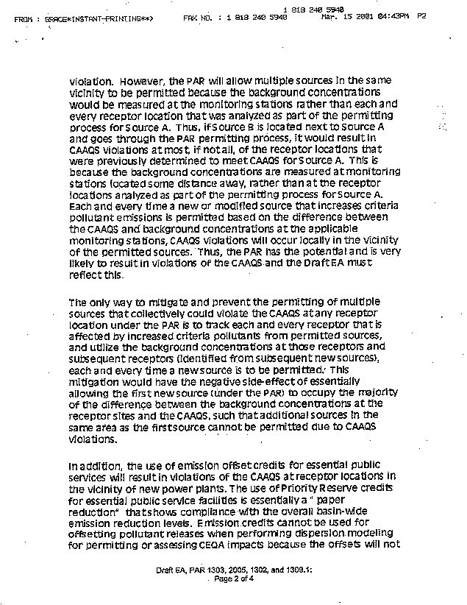
4-1
cont.
4-2
4-3

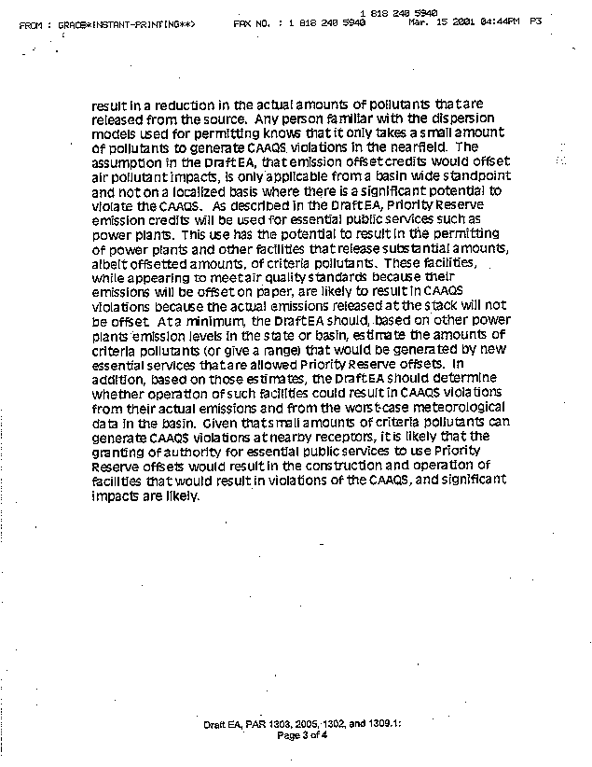
4-3
cont.
4-4

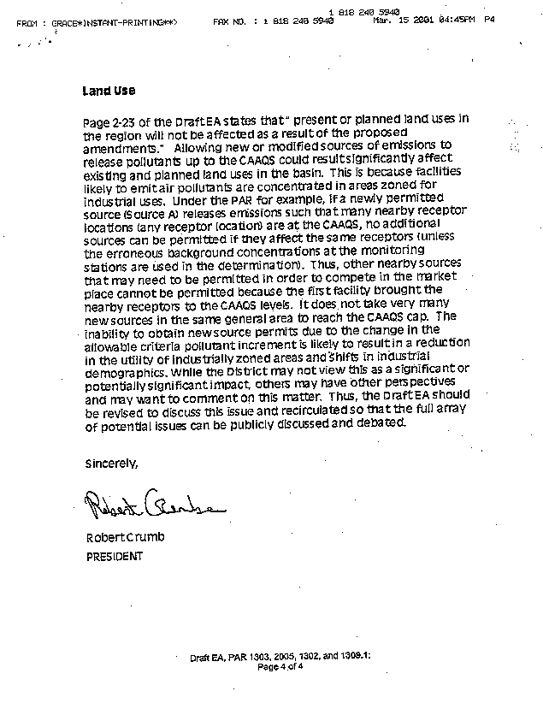
4-5

COMMENT LETTER #4 FROM
Citizens for Responsible Air Regulations
(March 13, 2001)

Response 4-1

The SCAQMD possesses the most extensive air quality monitoring system in the country. There are 37 monitoring zones in the district and ambient air quality data is obtained within that monitoring zone. Under the proposed amendments, modeled increases from new or modified sources will be compared to the background air quality data and the applicable federal or state air quality standards. The background air quality is based on the location of concern, which would typically be the point of maximum ground level impact. The location of concern is identified with one of the monitoring zones and the background air quality is the highest reading for the pollutant of concern for the previous three years. If multiple sources are increasing their pollutant emissions up to the standards, then the recordings at the local monitoring station will begin to reflect those changes. In this situation, the subregion would become non-attainment and future new or modified facilities would revert to subjectivity to the detectable change in concentration thresholds.

Additionally, localized air quality impacts from the project are avoided because new or modified sources would still be required to comply with Lowest Achievable Emission Rate (LAER) requirements through installation of Best Available Control Technology (BACT). LAER is a continuously evolving rate that gets lower over time through improvements or breakthroughs in air pollution control technologies.

In addition to the BACT requirements, all new or modified facilities would still be required to comply with offset requirements for any facilities that increase emissions by one pound or more per day. The offset ratio is 1:2 to 1.0, which means that each pound of emission increase must be offset by 1.2 pounds.

Existing rules and regulations continue to control emissions from existing sources (Regulation XI) and new sources (Regulation XIII and Rule 1401). Further, the SCAQMD continues implementing and promulgating AQMP control measures as air pollution control rules and regulations, which will continue to improve air quality in the future. Although a large portion of the pollution is generated by mobile sources, CARB regulations to lower mobile source emissions and SCAQMD fleet vehicle rules requiring replacement fleet vehicles to be low emitting or operate on alternative clean fuels also contribute to improving air quality region wide.

Facilities are currently subject to the air quality concentration standards in Rule 1303, Appendix A. If it is assumed that air quality does not improve over time, affected facilities would continue to be subject to the concentration thresholds and there is no change to the existing setting.

Response 4-2

In this comment, the commentator assumes that air quality remains static. This is not the case. Please refer to Response 4-1 with regards to the commentor's concern that multiple sources could collectively violate the ambient air quality standards. Further, the AQMP and SCAQMD rules and regulations are growth accommodating. This means that as the number of emission sources increases, the SCAQMD must continually identify control measures to further reduce emissions in the district. This typically occurs during each AQMP revision cycle (every three years). Therefore, it is anticipated that background concentrations will continue to drop so that one facility will not consume the entire amount of allowable emissions.

Response 4-3

The conclusion that air quality impacts would not be significant is based on the same rationale provided in this comment. The proposed project will not create significant adverse localized impacts because the facilities must still demonstrate through modeling that they do not cause or contribute to localized impacts. ERCs are not part of the modeling analysis and the Draft EA does not assume that localized impacts will not be significant because of offsets. The proposed project will not create significant adverse regional impacts because project proponents would still be required to provide offsets, which do influence regional air quality, at a 1.2-to-1.0 ratio.

Response 4-4

According to the NSR Subcommittee to the AQMD Home Rule Advisory Group (please refer to Agenda Item 5B of the "Credit Policy Issues for the NSR Program from the NSR Subcommittee to the AQMD Home Rule Advisory Group", February 5, 2001), it is estimated that the power plant projects will need approximately 4,744 pounds per day of PM10 credits and that the power plants currently hold approximately 1,000 pounds per day of PM10 credits. According to Rule 1309.1(a)(4)(e), facilities holding emission reduction credits (ERCs) must use them before accessing the priority reserve. Then, according to the proposed amendments, facilities need to conduct a due diligence effort to secure publicly available PM10 ERCs. It is believed approximately 1,000 pounds per day of PM10 are available in the open market. Depending on how many PM10 ERCs are attainable from the open market, the power plants will be requesting between 2,744 - 3,744 pound per day of PM10 from the priority reserve. The rule is designed to continue to prevent violations of air quality standards as a result of issuing any permit.

Response 4-5

Whether a facility is subject to the modeling requirements pursuant to Rule 1303 should not affect land use and planning considerations by local governments. If a newly permitted source releases emissions such that many nearby receptor locations are brought to their standards, then the additional sources would be subject to the modeling requirements and not necessarily prohibited from being permitted. The objective of the proposed amendments was to allow for economic growth while not sacrificing localized impacts or environmental protection of attainment areas. What facilities, how many facilities and where the facilities will be located cannot be dictated by the proposed amendments. Also, see responses #4-1 and #4-2 with regard to potential impacts from multiple sources.

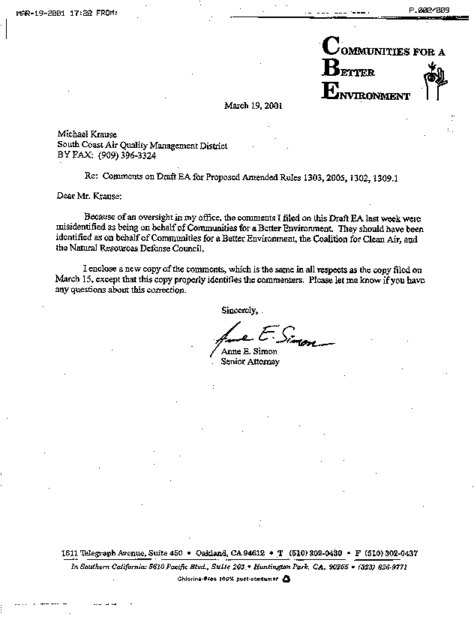
5-1

COMMENT LETTER #5 FROM
Communities for a better environment, the coalition for
clean air and the natural resources defense council
(March 19, 2001)

Response 5-1

We acknowledge that your comment letter sent March 15, 2001 was on behalf of Communities for a Better Environment, the Coalition for Clean Air and the Natural Resources Defense Council. Because the comments submitted in this letter have not changed from the comments sent on March 15, 2001 (see Comment Letter #3), the responses are not repeated here.

The Lewis-Presley Air Quality Management Act, 1976 Cal. Stats., ch 324 (codified at Health & Safety Code, §§40400-40540).
Health & Safety Code, §40460 (a).
Health & Safety Code, §40440 (a).
Orphan shutdowns are emission decreases from stationary sources that go out of business, permanently cease emitting activities, and do not apply for ERC's.
Emission reductions from shutdowns for which ERCs are issued are discounted to BACT levels and credited to the NSR account.
Several offset exemptions are provided in Rule 1304 and are either beneficial to the environment or driven by severe economic needs.
Proposed new language is shown as underlined text. Proposed deletions are shown by strikethrough text.
The SCAQMD’s permit processing procedures include the requirement that an applicant complete and submit a 400-CEQA form. This form is used to determine CEQA applicability for the proposed project.

