south coast air quality management district

Final Environmental Assessment:

Proposed Amended Rule 1151 – Motor Vehicle and Mobile Equipment Non-Assembly Line Coating Operations

November 2005

SCAQMD No. 092705JK

Executive Officer
Barry R. Wallerstein, D. Env.

Deputy Executive Officer
Planning, Rule Development and Area Sources
Elaine Chang, DrPH

Assistant Deputy Executive Officer
Planning, Rules, and Area Sources
Laki Tisopulos, Ph.D., P.E.

Planning and Rules Manager
Planning, Rule Development and Area Sources
Susan Nakamura

Author: James Koizumi Air Quality Specialist

Technical
Assistance: Ricardo Rivera Air Quality Specialist

Reviewed By: Steve Smith, Ph.D. Program Supervisor, CEQA
Larry Bowen Manager, Planning, Rules, and Area Sources
Ed Muehlbacher, P.E. Program Supervisor, Planning, Rules, and Area Sources
Frances Keeler Senior Deputy District Counsel
Jean Ospital Health Effects Officer, Planning, Rules, and Area Sources

South coast air quality management district

governing board

CHAIRMAN: WILLIAM A. BURKE, Ed.D.
Speaker of the Assembly Appointee

VICE CHAIRMAN: S. ROY WILSON, Ed.D.
Supervisor, Fourth District
Riverside County Representative

MEMBERS:
MICHAEL D. ANTONOVICH
Supervisor, Fifth District
Los Angeles County Representative

JANE CARNEY
Senate Rules Committee Appointee

BEATRICE J.S. LAPISTO-KIRTLEY
Mayor, City of Bradbury
Cities Representative, Los Angeles County, Eastern Region

RONALD O. LOVERIDGE
Mayor, City of Riverside
Cities Representative, Riverside County

GARY OVITT
Supervisor, Fourth District
San Bernardino County Representative

JAN PERRY
Councilmember, Ninth District
Cities Representative, Los Angeles County, Western Region

MIGUEL A. PULIDO
Mayor, City of Santa Ana
Cities Representative, Orange County

JAMES SILVA
Supervisor, Second District
Orange County Representative

CYNTHIA VERDUGO-PERALTA
Governor's Appointee

DENNIS YATES
Mayor, City of Chino
Cities Representative, San Bernardino County

EXECUTIVE OFFICER:
BARRY R. WALLERSTEIN, D.Env.
PREFACE
This document constitutes the Final Environmental Assessment (EA) for Proposed amended Rule 1151 – Motor Vehicle and Mobile Equipment Non-Assembly Line Coating Operations. The Draft EA was released for a 30-day public review and comment period from October 20, 2005 to November 18, 2005. Five comment letters were received from the public. The comment letters and responses to the comments can be found in Appendix D. To ease in identification, modifications to the document are included as underlined text and text removed from the document is indicated by strikethrough.
Subsequent to the release of the Draft EA, the ARB Suggested Control Measure (SCM) for Automotive Coatings was adopted by the ARB Board on October 20, 2005. The SCM was modified during the ARB Board Meeting to delay the VOC content limit for adhesion promoters, primer, and single stage coatings from January 1, 2009 to January 1, 2010. To be consistent with the SCM, PAR 1151 was modified to delay the VOC content limit compliance date for adhesion promoters, primer, and single stage coatings to January 1, 2010. Modifications have been made to the proposed Draft EA in accordance with changes to PAR 1151 and its Staff Report. The VOC emission reductions from adhesion promoters, primer, and single stage coatings is estimated to be 0.19 ton per day of the total four tons of VOC reductions expected from PAR 1151. The entire four tons of VOC emission reductions would still occur, but the 0.19 tons per day would be delayed from January 1, 2009 to January 1, 2010. The delay in the VOC content limit compliance date for adhesion promoters, primer, and single stage coatings is not considered significant new information, because no formal commitment to the emission reductions or effective dates had previously been made by the Governing Board, so this modification is not considered to be a relaxation of an adopted rule.
Other minor modifications have been made to the Final EA for clarity and continuity. None of the modifications alter any conclusions reached in the Draft EA, nor provide new information of substantial importance relative to environmental impacts in the draft document that would require recirculation of the Draft EA pursuant to California Environmental Quality Act (CEQA) Guidelines §15088.5. This conclusion is supported by substantial evidence in the administrative record. Therefore, this document is now a Final EA.

Table of contents

CHAPTER 1 - PROJECT DESCRIPTION

Introduction 1-1
California Environmental Quality Act 1-2
Areas of Controversy 1-3
Project Location 1-4
Project Objective 1-5
Project Background 1-5
Project Description 1-11

CHAPTER 2 - ENVIRONMENTAL CHECKLIST

Introduction 2-1
General Information 2-1
Environmental Factors Potentially Affected 2-2
Determination 2-3
Environmental Checklist and Discussion 2-4

Figures
Figure 1-1 - Boundaries of the South Coast Air Quality Management District 1-4

Tables
Table 1-1 - Compliant Coatings Summary 1-7
Table 1-2 - Emissions Inventory Percent Distribution - Undercoats 1-8
Table 1-3 - Emissions Inventory Percent Distribution – Top Coats 1-8
Table 1-4 - Emissions Inventory Percent Distribution – Specialty Coatings 1-8
Table 1-5 - Current and Proposed Coating Categories 1-13
Table 1-6 - Current and Proposed Coating Categories – Specialty Coatings 1-13
Table 2-1 - Air Quality Significance Thresholds 2-9
Table 2-2 –Criteria Emissions from Construction 2-10
Table 2-3 - VOC Emission Reductions from PAR 1151 2-12
Table 2-4 - Secondary Criteria Emissions from Additional Auto body Heaters 2-12
Table 2-5 - Health Risk from TBAc Substitution for Non-Topcoat Categories 2-15
Table 2-6 - Odor from TBAc Substitution for Non-Topcoat Categories 2-16
Table 2-7 - Chemical Characteristics of Solvents 2-30

APPENDIX A - PROPOSED AMENDED RULE 1151

APPENDIX B – assumptions and calculations

APPENDIX C – dispersion modeling input files

APPENDIX D – COMMENTS AND RESPONSE TO COMMENTS

C H A P T E R 1 - P R O J E C T D E S C R I P T I O N

Introduction
California Environmental Quality Act
Areas of Controversy
Project Location
Project Objective
Project Background
Project Description

INTRODUCTION
The California Legislature created the South Coast Air Quality Management District (SCAQMD) in 1977 as the agency responsible for developing and enforcing air pollution control rules and regulations in the South Coast Air Basin (Basin) and portions of the Salton Sea Air Basin and Mojave Desert Air Basin (collectively known as the “district”). By statute, the SCAQMD is required to adopt an air quality management plan (AQMP) demonstrating attainment of all federal and state ambient air quality standards for the district. Furthermore, the SCAQMD must adopt rules and regulations that carry out the AQMP. The 2003 AQMP concluded that major reductions in criteria pollutant emissions of volatile organic compounds (VOCs) and oxides of nitrogen (NOx) are necessary to attain the air quality standards for ozone and particulate matter (PM10). Ozone, a criteria pollutant, is formed when VOCs react with NOx in the atmosphere and has been shown to adversely affect human health. VOC emissions also contribute to the formation of PM10.

Although health-based standards have not been established for VOCs, health effects can occur from exposures to high concentrations of VOCs because of interference with oxygen uptake. In general, ambient VOC concentrations in the atmosphere are suspected to cause coughing, sneezing, headaches, weakness, laryngitis, and bronchitis, even at low concentrations. Some hydrocarbon components classified as VOC emissions are thought or known to be toxic air contaminants (TACs). With stationary and mobile sources being the major producers of VOCs, which contribute to ozone formation, reducing the quantity of VOCs in the Basin has been an on-going priority effort by the SCAQMD.

Because coatings used for motor vehicles and mobile equipment have been considered by SCAQMD as one potential source where VOC emission reductions can be achieved, in May 1989, Rule 1151 – Motor Vehicle and Mobile Equipment Non-Assembly Line Coating Operations, was adopted. Since its adoption, Rule 1151 has been amended eleven times, with the most recent amendments occurring in 1998. Rule 1151 was developed to reduce VOC emissions from motor vehicle and mobile equipment non-assembly line coating operations. Rule 1151 applies to both commercial and noncommercial refinishing coating operations that include, but are not limited to, auto body repair shops, production auto body paint shops, new car dealer repair/paint shops, fleet operators repair/paint shops, custom-made car fabrication facilities, truck body builders, and any other motor vehicle or mobile equipment non-assembly line coating operations. Motor vehicle assembly line coating operations are subject to SCAQMD Rule 1151. Rule 1151 establishes VOC limits by coating category and vehicle type (Group I and Group II vehicles). Group I vehicles include large-sized trucks, buses and mobile equipment. Group II vehicles include passenger cars, small and medium-sized trucks and vans, motor homes, and motorcycles. Historically it was believed that 3,500 businesses that use automotive coatings were subject to Rule 1151. Current estimates based on SCAQMD records indicate that there are approximately 1,730 commercial refinishing facilities with permits to construct and operate 2,500 spray paint booths.

The primary objective of the proposed amendments to Rule 1151 (PAR 1151) is to implement in part 2003 AQMP control measure CTS-10 - Miscellaneous Industrial Coatings and Solvent Operations. Specifically, reductions in VOC contents for automobile and mobile equipment refinishing coatings are proposed in PAR 1151 and are estimated to achieve a reduction of four tons per day of VOC emissions by January 1, 20092010. The anticipated VOC emission reductions from PAR 1151 would help achieve a portion of the overall emission reduction commitments in CTS-10. Amendments to other SCAQMD rules are expected to achieve the remainder of the emission reduction commitments in the control measures. For example, Rule 1145 – Plastic, Rubber, Leather, and Glass Coatings, as amended on December 3, 2004, is expected to achieve a VOC reduction of 1.27 tons per day by 2010.

The proposed amendments modify Rule 1151 coating categories and VOC limits in accordance with California Air Resources Board (ARB)’s 2005 Proposed Draft Automotive Refinishing Coating Suggested Control Measure (SCM). Specifically, the proposed amendments: (1) Combine Group I and Group II vehicle categories and establish VOC limits by coating category only; (2) Eliminate the composite VOC limit for multistage systems and establish independent VOC limits for both the color and clear parts of the multistage coating system; (3) Combine the primer, primer surfacer, and primer sealer categories and establish a single VOC limit for primers; and (4) Eliminate the general specialty coating category and replace it with specific categories. Other changes are proposed throughout PAR 1151 for consistency, to enhance compliance and enforceability, and to improve clarity.

The new VOC limits proposed in Rule 1151 are essentially identical to the VOC limits being proposed under adopted in the ARB 2005 Proposed Draft Automotive Refinishing Coating SCM. According to information generated by ARB, with the exception of the VOC limits proposed for adhesion promoters and pretreatment coatings, the VOC limits proposed for new coating categories are based upon products that are currently available in the marketplace in the United States and/or other parts of the world. ARB expects that products that are compliant with PAR 1151 requirements should be available by the final effective date of January 1, 20092010. It is likely that existing VOC projects would be reformulated with VOC exempt solvents or as water-based products.

california environmental quality act
PAR 1151 applies to coating operations of motor vehicle and mobile equipment non-assembly line coating operations and, therefore, is a “project” as defined by the California Environmental Quality Act (CEQA). SCAQMD is the lead agency for the project and has prepared this draft Environmental Assessment (EA) with no significant adverse impacts pursuant to its Certified Regulatory Program. California Public Resources Code §21080.5 allows public agencies with regulatory programs to prepare a plan or other written document in lieu of an environmental impact report once the Secretary of the Resources Agency has certified the regulatory program. SCAQMD's regulatory program was certified by the Secretary of the Resources Agency on March 1, 1989, and is codified as SCAQMD Rule 110. Pursuant to Rule 110, SCAQMD has prepared this draft EA.

CEQA and Rule 110 require that potential adverse environmental impacts of proposed projects be evaluated and that feasible methods to reduce or avoid significant adverse environmental impacts of these projects be identified. To fulfill the purpose and intent of CEQA, the SCAQMD has prepared this draft EA to address the potential adverse environmental impacts associated with the proposed project. The draft EA is a public disclosure document intended to: (a) provide the lead agency, responsible agencies, decision makers and the general public with information on the environmental effects of the proposed project; and, (b) be used as a tool by decision makers to facilitate decision making on the proposed project.

SCAQMD’s review of the proposed project shows that the project would not have a significant adverse effect on the environment. Therefore, pursuant to CEQA Guidelines §15252, no alternatives or mitigation measures are required to be included in this draft EA. The analysis in Chapter 2 supports the conclusion of no significant adverse environmental impacts.

AREAS of Controversy
The proposed project includes a limited VOC exemption for tertiary butyl acetate (TBAc). TBAc has been delisted as a VOC by the Environmental Protection Agency (EPA); it has not been delisted as a VOC by the California Air Resources Board (ARB) or the SCAQMD. ARB is considering a total included an exclusion of TBAc from the definition of VOC in the suggested control measure (SCM) for automotive coatings which will be presented to was adopted by the ARB Governing Board in October 2005. Since SCAQMD staff is using the ARB Draft SCM for automotive refinishing coatings as guidance for developing PAR 1151ARB’s SCM allows local air districts discretion regarding how they handle TBAc. As result, a limited VOC exemption for TBAc has been included. Exempting The exemption of TBAc from the definition of VOC is expected to increase its use, specifically as a replacement for conventional VOC solvents in automotive refinishing coatings. SCAQMD staff has completed a risk analysis for the limited VOC exemption following methodology similar to that used by ARB staff in the ARB Draft Staff Report for the aAutomotive refinishing coating Coating SCM and ARB Draft Environmental Impact Assessment of TBAc.

Staff has received comments from the public objecting to some of the assumptions and parameters used in both the ARB and SCAQMD risk analyses. Five comment letters have been received from the public. The comment letters and response to comments can be found in Appendix D. The following is a summary of the Oobjections that have been raised regarding the following assumptions and parameters:

- TBAc and its metabolite tert-butyl alcohol (TBA) are not listed by any regulatory agencies as carcinogens. A final cancer potency factor/unit risk factor has not been issued approved by any regulatory agency for either TBAc or TBA, although OEHHA has developed a cancer potency and acute toxic factor for TBA. Therefore, the manufacturer has requested that TBAc should be fully delisted as a VOC, preferably in Rule 102.
- Sufficient health risk information is not available for TBAc or TBA. TBAc should not be delisted as a VOC until chronic toxicity testing is completed and approved toxicity values are established by a regulatory agency and it has been demonstrated that TBAc will not significantly adversely impact public health.
- The assumption of 100 percent conversion of TBAc to TBA is too conservative. Lyondell has suggested 46 percent.

Other comments have been received stating that TBAc should not be delisted in full or in part as a VOC because limited toxicity data are available and it has not been tested for chronic toxicity. Further, waterborne coatings are available for use by industry based on the ARB SCM for automobile refinishing coatings and public testimony during the Public Workshop for PAR 1151. Finally, comments have been received that if TBAc is delisted, manufacturers will formulate compliant coatings with TBAc in preference over some water-based formulations.

Public comments are addressed in the text of the Final EA and Appendix D. SCAQMD staff relies on EPA, ARB and the Office of Environmental Health Hazard Assessment (OEHHA) to establish toxic risk values and risk assessment methodology. SCAQMD staff evaluated the risk associated with the limited VOC exemption for TBAc using the available toxic risk values and methodologies provided developed by ARB and OEHHA. The results are included in Chapter 2.

project location
PAR 1151 would affect facilities located throughout the SCAQMD’s jurisdiction. The SCAQMD has jurisdiction over an area of 10,473 square miles, consisting of the four-county South Coast Air Basin (Basin) and the Riverside County portions of the Salton Sea Air Basin (SSAB) and the Mojave Desert Air Basin (MDAB). The Basin, which is a subarea of the district, is bounded by the Pacific Ocean to the west and the San Gabriel, San Bernardino, and San Jacinto Mountains to the north and east. The 6,745 square-mile Basin includes all of Orange County and the non-desert portions of Los Angeles, Riverside, and San Bernardino counties. The Riverside County portion of the SSAB and MDAB is bounded by the San Jacinto Mountains in the west and spans eastward up to the Palo Verde Valley. The federal non-attainment area (known as the Coachella Valley Planning Area) is a subregion of both Riverside County and the SSAB and is bounded by the San Jacinto Mountains to the west and the eastern boundary of the Coachella Valley to the east (Figure 1-1).
Figure 1-1
Boundaries of the South Coast Air Quality Management District

project OBJECTIVE
The objective of PAR 1151 is to partially implement the 2003 AQMP control measures CTS-10 - Miscellaneous Industrial Coatings, to further reduce VOC emissions from all affected source categories by 2010. PAR 1151 is expected to achieve a portion of the overall emission reduction commitments in CTS-10 for the motor vehicle and mobile source equipment non-assembly line coating operation source category by reducing the VOC content limits for coatings and is anticipated to achieve a VOC reduction of four tons per day. PAR 1151 was developed to be consistent with the ARB 2005 Proposed Draft Automotive Refinishing Coating SCM. In addition, other changes are proposed throughout PAR 1151 for consistency, to enhance compliance and enforceability, and to improve clarity.

project BACKGROUND
There are two main classes of automotive coatings: undercoats and topcoats. Undercoats include primers, primer surfacers, and primer sealers. Undercoats prepare the exterior surfaces by providing corrosion resistance, adhesion and a smooth foundation for subsequent topcoats. Topcoats are applied to provide color, gloss, and a protective finish. Topcoats can be classified into three main categories: (1) single-stage solid color or mono-coats, (2) single-stage metallic finish, and (3) multistage systems.

Single-stage topcoats consist of only one final coating, which is applied over undercoats to provide color, gloss, and protection. The difference in the single-stage solid color and the single stage-metallic finish is that the single-stage solid colors do not contain any metal flakes.

Multistage coatings, unlike the conventional single-stage coatings, consist of two or more layers, each contributing separately to the final finishes’ characteristics. The initial layer, or basecoat layer, contains the pigmentations and metallic flakes that provide the final color and color effects. Multistage coatings include two-stage systems as well as three-stage systems. Three-stage coatings differ from the two stage-systems in that they include a midcoat layer that provides additional color effects, such as a pearlized light effect resulting from mica flakes. The final coatings in multistage systems are non-pigmented clear coats that provide hardness and durability to the final finish. The nature of the coating systems requires that all coating components be used to refinish the vehicle in order to provide the required appearance and performance.

The main difference in the application of coatings in a manufacturing setting to that of a refinishing environment are the curing characteristics of coatings. Automotive original equipment manufacturing (OEM) coatings are typically cured by the use of baking ovens that operate at high temperatures. The types of coatings used in refinishing operations are typically air-dry cured with the aid of infrared lamps or by forced-air spray booths. Refinishing shops cannot use high temperature ovens due to the potential damage to other automobile components made of plastic or other materials that may be damaged at high temperatures. Therefore, automotive refinishing coatings are formulated for faster drying times.

Coatings Available to Meet the Proposed VOC Limits
The proposed coating categories and the corresponding VOC limits are identical to the categories and VOC limits proposed under the 2005 ARB Proposed Draft Automotive Coating SCM. In developing the revised coating categories and VOC limits for the Proposed Draft Automotive Coating SCM, ARB staff considered the results of the 2002 Automotive Refinishing Coatings survey; information from automotive refinishing coating manufacturers, solvent suppliers, and other industry groups; the existing VOC limits for automotive refinishing coatings; and the results of ARB’s technical analysis that included review of trade journals and other literature related to coating product information.

Based on their review, ARB staff has concluded that the proposed VOC content limits are technologically and commercially feasible by the effective date of January 1, 20092010. With the exception of two coating categories, adhesion promoter and pretreatment coatings, ARB has concluded that there are compliant products available in the market place to meet the proposed VOC limits. However, ARB also believes based on information received from coating manufacturers, that compliant coatings will be available in the market place prior to the 20092010 implementation date for both adhesion promoters and pretreatment coatings. SCAQMD staff has received similar information as it relates to pretreatment coatings and expects that compliant pretreatment coatings will be available in the district within a year after the adoption of the proposed amendment (scheduled for December 2005).

Approximately 90 percent of the emission reductions associated with the proposed amendments is due to lowering the VOC content limit for basecoat or the color portion of the multistage coating systems. The proposed amendments to Rule 1151 are technology neutral because they don not specifically promote one compliant technology over other technology. However, the coating manufacturers have stated that the most likely technology that would be use to comply with the VOC limit for color coat is waterborne technology. Although used on a very limited basis in California, waterborne technology is available that meets the proposed limits. Waterborne basecoats have been used in Europe for many years and are being mandated there as of January 1, 2007 (ARB 2005).

Coating manufacturers for the California market have stated that development of a wider range of colors is required before the waterborne technology currently used in the European Union will be accepted in California. For this reason, the proposed final compliance date is January 1, 20092010.

Table 1-1 provides a summary of coatings that comply with the proposed VOC content limits for the affected coating categories. The information presented in Table 1-1 was generated based on information received from ARB. ARB generated this information based on data submitted by major automotive refinishing coating manufacturers as part of the 2002 automotive refinishing survey. The coating manufacturers that submitted information included, Akzo-Nobel, Bondo, BASF, Cumberland, DuPont, Earl Scheib, Ellis Paint, Fibre Glass – Evercoat, Hentzen, Jones-Blair, Magni, Montana Products, PPG, Sherman Williams, Spies Hecker, Standox, and Valspar. The information presented in the Table 1-1 is limited to only the coating categories that are affected by the proposed amendments to Rule 1151.

Affected Sources/Emissions Inventory
There are approximately 3,500 facilities in the district that use or handle automotive refinishing coatings. Approximately 1,700 facilities are fully dedicated to refinishing operations that currently operate approximately 2,500 spray booths under SCAQMD permit. These facilities include: auto body repair/paint shops, production auto body paint shops, new car dealer repair/paint shops, fleet operators repair/paint shops, custom-made car fabrication facilities, and truck body builders.

The emissions inventory for the automotive refinishing coating source category is estimated at 11.2 tons of VOC per day. The emissions inventory is based on the 2001 Survey of Automotive Refinish Coatings conducted by ARB. The emissions estimate for the district was derived by adjusting the VOC emissions estimate for the State of California using regional population factors and AQMP emission growth factors. The VOC emissions inventory for refinishing operations in the district is comprised of three main components: emissions from undercoats, topcoats, and specialty coatings. Tables 1-2, 1-3 and 1-4, provide the emissions percent distribution for each of the affected coating components. The emissions distributions presented in these tables are used to calculate emission reductions for the proposed amendments to Rule 1151.

Table 1-1 – Compliant Coatings Summary
(ARB Data, 2005)

Coating  Category | Number of Companies that: |  | Companies With Compliant Coatings | Regulatory VOC  (g/l)
Coating  Category | Sold Type of Coating in CA | Reported Compliant Mixtures⁽¹⁾
Adhesion Promoter | 5 | 0 | ⁽³⁾ | ⁽³⁾
Color Coat⁽²⁾ | 12 | 5 | Akzo-Nobel | < 420
Color Coat⁽²⁾ | 12 | 5 | PPG | < 420
Color Coat⁽²⁾ | 12 | 5 | Spies Hecker | < 420
Color Coat⁽²⁾ | 12 | 5 | Standox North America | < 420
Color Coat⁽²⁾ | 12 | 5 | Valspar | < 400
Pretreatment Coatings | 13 | 0 | ⁽³⁾ | ⁽³⁾
Primer (Primer Sealer) | 15 | 12 | Ellis Paint⁾ | 250
Single-Stage Coating⁽²⁾ | 13 | 1 | Spies Hecker | 331
Single-Stage Coating⁽²⁾ | 13 | 1 | Ellis Paint | 336
Temporary Protective Coating | 2 | 1 | Ellis Paint | 34
Truck Bed Liner Coating | 1 | 1 | Fibre Glass Evercoat | 278
Underbody Coating | 3 | 1 | Akzo-Nobel | 46
 |  |  | Fibre Glass Evercoat | 404
Uniform Finish Coating | 5 | 2 | PPG | 524
- Valid mixtures (coatings) that meet the proposed VOC limits.
- The mixtures (coating) for the color coat and single stage categories where reported as systems and not individual mixtures.
- At this time there are no compliant coatings available for these categories.

Table 1-2
Emissions Inventory Percent Distribution - Undercoats

Coating Category | Percent Contribution for Group I Vehicles | Percent Contribution for Group II Vehicles
Primer | 0.2 | 1.5
Primer Surfacer | 0.4 | 3.4
Primer Sealer | 0.2 | 2.3
Pretreatment | 0.2 | 1.8
Subtotal | 1.0 | 9.0
Total |  | 10.0

Table 1-3
Emissions Inventory Percent Distribution – Top Coats

Coating Category | Percent Contribution for Group I Vehicles | Percent Contribution for Group II Vehicles
Multistage Coating | 8.0 | 72.1
Single Stage Coating | 0.8 | 7.2
Multi-Colored Coating | 0.1 | 0.8
Subtotal | 8.9 | 80.1
 | Total | 89.0

Table 1-4
Emissions Inventory Percent Distribution – Specialty Coatings

Coating Category | Percent Contribution for Group I Vehicles | Percent Contribution for Group II Vehicles
Adhesion Promoters | 0.03 | 0.22
Underbody Coating | 0.01 | 0.07
Uniform Finishing Coating | 0.07 | 0.60
Subtotal | 0.11 | 0.89
 | Total | 1.0

Overview of Current Regulatory Requirements
There are three levels of regulatory control requirements that apply to VOCs from the automotive and mobile equipment refinishing coating industry, including the requirements proposed in PAR 1151: 1) local (i.e., SCAQMD); 2) state (i.e., California Air Resources Board or ARB); and 3) federal requirements (i.e., Environmental Protection Agency or EPA). The SCAQMD’s local efforts to specifically regulate sources of VOCs from this industry have been based partly on implementing measures already adopted by EPA and ARB. The following is an overview of the SCAQMD rules that have been adopted to implement federal, state, or SCAQMD VOC emission reduction programs.

SCAQMD Requirements
For motor vehicle and mobile equipment non-assembly line coating operations that are subject to Rule 1151, three related local rules for reducing VOC emissions from specific activities may also apply: Rule 442 – Usage of Solvents; Rule 1122 – Solvent Degreasers; and Rule 1171 – Solvent Cleaning Operations. Rule 442 applies to the use of VOC-containing materials or equipment that emit VOCs, but are not subject to the VOC content limits in Rule 1151. Rule 1122 applies to any operations, including motor vehicle and mobile equipment non-assembly line coating operations operations, in which components or machinery are cleaned with a solvent in a degreasing unit before being coated. The requirements of Rule 1171 would apply when using solvents to hand clean coating application equipment (i.e., spray guns) and storing and disposing of VOC-containing materials used in solvent cleaning operations at any affected facility, including motor vehicle and mobile equipment non-assembly line coating operation facilities.

There are several coatings used by the motor vehicle and mobile equipment non-assembly line coating industry formulated with toxic air contaminants (TACs) including but not limited to the following: carbon black, cobalt compounds, ethylbenzene, formaldehyde, methyl ethyl ketone (MEK), methyl isobutyl ketone (MIBK), toluene, xylene, zinc oxide, and isocyanates. The use of materials that contain toxic compounds is of particular concern to the SCAQMD and other agencies such as EPA, ARB, and the Occupational Safety and Health Administration (OSHA) because some of the TACs used in the motor vehicle and mobile equipment non-assembly line coating industry are considered carcinogens (cancer-causing) such as formaldehyde while others may have other non-cancer health effects. For these reasons, there are two other local rules regulating TAC emissions that may apply to motor vehicle and mobile equipment non-assembly line coating facilities: Rule 1401 – New Source Review of Toxic Air Contaminants, and Rule 1402 – Control of Toxic Air Contaminants from Existing Sources. Rule 1401 applies to new and modified facilities, including motor vehicle and mobile equipment non-assembly line coating operations, and Rule 1402 applies to facility-wide risk at existing facilities. Since the majority of motor vehicle and mobile equipment non-assembly line coatings facilities located within SCAQMD’s jurisdiction are existing sources, the requirements in Rule 1402 are the main drivers for reducing overall risk and, therefore, TAC emissions from this industry.

State Requirements
On March 2, 2001 ARB adopted “Performance Standards for Existing Stationary Sources – A Resource Document.” This document contains updated performance standards for various industries and applications that reflect both reasonably available control technology (RACT) and best available control technology (BACT) standards. One chapter is specifically dedicated to the category of “Auto Refinishing” which contains performance standards that are mostly aligned with the current requirements in Rule 1151 such as VOC content limits for various categories of mobile vehicle and mobile equipment non-assembly line coatings and transfer efficiency and control efficiency requirements. While, the “camouflage coatings” category in the performance standards document has a VOC content limit under Rule 1151, the SCM does not have a limit for that category. Similarly, the pretreatment wash primer and specialty coatings categories have usage limits under the SCM that are not included in Rule 1151. PAR 1151 contains a proposal to lower the VOC content limits to be consistent with ARB’s standards for these coating categories.

ARB has developed a draft SCM for automotive refinishing coatings. ARB is proposing has adopted the SCM to promote consistency and uniformity among non-assembly line automotive refinishing coating rules throughout California, while further reducing VOC emission reductions statewide. Uniformity of regulations throughout California would provide relief to automotive coating manufacturers and automotive refinishers who currently must meet differing VOC content limits for automotive refinishing coatings in different jurisdictions, and provide consistent guidance for operating techniques, control technology, house keeping practices and recordkeeping in different regions through the state. The emission reductions proposed adopted in the draft SCM would was designed to help districts attain and maintain state and national ambient air quality standards.

In addition to ARB’s industry-specific requirements, the Air Toxics "Hot Spots" Information and Assessment Act was enacted in September 1987 by the California State Assembly as Assembly Bill 2588 (hereafter referred to as the AB2588 program). Under this act, certain stationary sources are required to report the types and quantities of emissions for specified substances, including: carbon black, cobalt compounds, ethylbenzene, formaldehyde, MEK, MIBK, toluene, xylene, zinc oxide, and isocyanates they release into the air. Emissions of interest are those that result from the routine operation of a facility or that are predictable, including but not limited to continuous and intermittent releases and process upsets or leaks. The goals of AB2588 are to collect emissions data, to identify facilities having localized impacts, to ascertain health risks, and to notify nearby residents of significant risks. Most auto body facilities are not required to report under AB2588, since auto body shops are grouped as industry-wide facilities, which do not need to report individually under AB2588. Only one of the 1,700 automotive and mobile equipment refinishing coating facilities subject to Rule 1151 is currently in the AB2588 program.

Federal Requirements
The federal Clean Air Act (CAA) establishes requirements to regulate emissions of air pollutants to protect human health and the environment. In addition to regulating criteria pollutants, the CAA requires the EPA to regulate hazardous air pollutants (HAPs) that have been found to adversely affect human health. The following HAPs that are regulated by EPA are found in typical automotive refinishing coating formulations: carbon black, cobalt compounds, ethylbenzene, formaldehyde, MEK, MIBK, toluene, xylene, zinc oxide, and isocyanates... Federal regulations in the CAA include the New Source Performance Standards (NSPS) under §111 and the National Emissions Standards for Hazardous Air Pollutants (NESHAPs) under §112. The EPA periodically promulgates NSPS standards in the Code of Federal Regulations (CFR), Chapter 40, Part 60 (40 CFR Part 60) and NESHAPs in 40 CFR Parts 61 and 63. The SCAQMD has been delegated authority by EPA to implement and enforce both NSPS and NESHAP requirements. The requirements in 40 CFR Parts 60 and 61 are adopted by reference into SCAQMD Regulations IX and X, respectively, whenever these federal regulations are modified.

For the automotive refinishing industry, there is currently no applicable NSPS or NSHAP standard. However, there are National Volatile Organic Compound Emission Standards for Automotive Refinish Coatings, 40 CFR 59 Subpart B, which have established VOC content limits for automotive refinishing coatings. For all listed automotive refinishing coatings except for multi-colored topcoats (685 grams of VOC per liter – Rule 1151 versus 680 grams of VOC per liter – 40 CFR 59 Subpart B; the 5.7 pound of VOC per gallon limit is the same for both SCAQMD and EPA), these VOC content limits are already established by the existing Rule 1151. PAR 1151 would adopt the 680 grams of VOC per liter VOC content limit from National VOC Emission Standards for Automotive Refinish Coatings for multi-colored topcoats.

The VOCs and HAPs used in the automotive finish coatings industry may also be addressed in other federal legislation including but not limited to:
- Occupational Safety and Health Act (OSHA);
- Toxic Substances Control Act (TSCA);
- Comprehensive Environmental Response, Compensation and Liability Act (CERCLA);
- Title III of the Superfund Amendments and Reauthorization Act (SARA); and,
- Resource Conservation and Recovery Act (RCRA).

project description
Rule 1151 applies to any person who supplies, sells, offers for sale, manufacturers, or distributes or uses, applies, or solicits the use or application of any automotive coating or associated solvent for used within the district. The main purpose of PAR 1151 is to reduce emissions of VOCs by reducing the VOC content limits and assigning a future effective date for specified automotive refinishing coating materials. The following summarizes these and other changes to the proposed amended rule. A copy of PAR 1151 is included in Appendix A.

Purpose and Applicability
The purpose and applicability section would be separated into two separate subdivisions beginning on January 1, 2009July 1, 2008. The exemption for motor vehicles or mobile equipment or associated parts and components, during manufacture on an assembly line would be moved to the exemption section. On January 1, 2009 July 1, 2006, the applicability language would be expanded to include any person who supplies, sells, offers for sale, manufactures, or distributes any automotive coating or associated solvent for use within the district, as well as, any person who uses, applies, or solicits, the use or application of any automotive coating or associated solvent within the district.

Definitions of Terms (Effective on Date of Adoption)
Definitions applicable to automotive and mobile equipment refinishing coatings operations have been altered for clarification and consistency with the ARB 2005 Proposed Draft Automotive Coating SCM. The definition of VOC has been changed from “any volatile compound containing the element carbon, excluding methane, carbon dioxide, carbonic acid, metallic carbides or carbonates, ammonium carbonate, and exempt compounds” to “as defined in Rule 102 – Definition of Terms and for the purpose of this rule, tertiary butyl acetate (TBAc) is not a VOC except in coatings classified under the color coating and clear coat categories.”

TBAc was exempted from the definition of VOC in November 2004. Since that time, neither ARB nor most of the air quality agencies in California have taken action to delist TBAc. Because of its physical and chemical properties, if exempted from the definition of VOC, TBAc would be a desirable substitute solvent for several coating categories.

PAR 1151 states that the Executive Officer shall conduct a technical assessment on the use of TBAc as a non-VOC by July 1, 2007. In conducting the technical assessment, the Executive Officer shall consider all information on TBAc including, toxicity, carcinogenic and health risk assessment studies. The Executive Office shall report to the Governing Board as to the appropriateness of maintaining TBAc as a non-VOC.

Requirements (Effective dates July 1, 2008, January 1, 2009, January 1, 2010)
- Group I and Group II vehicle categories would be combined.
- The composite VOC limit for multistage systems would be eliminated and independent VOC limits would be established for the color and clear parts of the multistage coating system.
- Primer, primer surfacer, and primer sealer categories would be combined and a single VOC limit for primers would be established.
- The specialty coating category would be eliminated and replaced with specific categories.

The modified coating categories and VOC limits for color and clear coatings are proposed to be effective on July 1, 2008, with a sell-through provision in effect until January 1, 2009. This transitional period will allow users to become familiar with use of the new coating technologies with less impact to their ongoing operations. Consistent with the adopted SCM, the VOC limits for adhesion promoters, primers, and single-stage coatings are proposed to become effective January 1, 2010. The VOC limits for all other categories are proposed to become effective January 1, 2009. These changes are summarized in Table 1-5.

Prohibition of Possession, Specifications and Sales (Effective July 1, 2006)
PAR 1151 would include a prohibition to possess any automotive coating that is not in compliance with the requirements of VOC content limits presented in the rule unless the following conditions apply:

Table 1-5
Current and Proposed Coating Categories

Existing Coating Category | Existing VOC Limit (lb/gal) |  | Proposed Coating Category | Proposed VOC Limit (lb/gal) | Effective Date
Existing Coating Category | Group I | Group II | Proposed Coating Category | Proposed VOC Limit (lb/gal) | Effective Date
Pretreatment
Pretreatment | 6.5 | 6.5 | Pretreatment | 5.5 | Jan 1, 2009
Primers
Primer | 2.1 | 2.1 | Primer | 2.1 | Jan 1, 2010
Primer Surfacer | 2.1 | 2.1 | Primer | 2.1 | Jan 1, 2010
Primer Sealer | 2.1 | 2.8 | Primer | 2.1 | Jan 1, 2010
Topcoats |  |  | Primer | 2.1 | Jan 1, 2010
General | 2.8 | 3.5 | Single Stage Coating | 2.8 | Jan 1, 2010
Metallic/Iridescent | 2.8 | 3.5 | Single Stage Coating | 2.8 | Jan 1, 2010
Multi-Colored | 5.7 | 5.7 | Multi-Colored | 5.7 | Jan 1, 2009
Multistage | 2.8⁸ | 3.5 | Color Coat | 3.5 | Jul 1, 2008

Table 1-6
Current and Proposed Categories – Specialty Coatings

Existing Coating Category | Existing VOC Limit (lb/gal) |  | Proposed Coating Category | Proposed VOC Limit (lb/gal) | Effective Date
Existing Coating Category | Group I | Group II | Proposed Coating Category | Proposed VOC Limit (lb/gal) | Effective Date
Specialty Coatings
Adhesion Promoters | 7.0 | 7.0 | Adhesion Promoter | 4.5 | Jan 1, 2010
Uniform Finish Blenders | 7.0 | 7.0 | Uniform Finishing Coating | 4.5 | Jan 1, 2010
Elastomeric Materials | 7.0 | 7.0 | Primer (Plastic/Flexible Primers) | 2.1 | Jul 1, 2008
Elastomeric Materials | 7.0 | 7.0 | Clear Coat (Elastomeric Clears) | 2.1 | Jul 1, 2008
Anti-Glare Safety Coating | 7.0 | 7.0 | Any Other Coating | 2.1 | Jan 1, 2009
Impact Resistant Coating | 7.0 | 7.0 | Any Other Coating | 2.1 | Jan 1, 2009
Rubberized Asphaltic underbody Coating | 7.0 | 7.0 | Underbody Coating | 3.6 | Jan 1, 2009
Water Holdout Coating | 7.0 | 7.0 | Any Other Coating | 2.1 | Jan 1, 2009
Weld Thru Coatings | 7.0 | 7.0 | Any Other Coating | 2.1 | Jan 1, 2009
Bright Metal Trim Repair Coating | 7.0 | 7.0 | Any Other Coating | 2.1 | Jan 1, 2009
Other
Not in Existing Rule 1151 |  |  | Truck Bed Liner Coating | 2.6 | Jan 1, 2009

- The coating is located at a facility that uses an approved emission control device and the automotive and mobile equipment refinishing coatings meet the limits specified in the permit conditions.
- The coating is located at a facility that complies with the VOC coating limits via an approved Alternative Emissions Control Plan and the coating is specified in the plan.
- The coating is located at a training center, and used for educational purposes, and does not exceed 12 pounds per day. The coating is located at a prototype motor vehicle manufacturing facility and the coating is supplied by an assembly-line motor vehicle manufacture for used in the refinishing of a prototype motor vehicle provided that the VOC emissions from affected coating do not exceed 21 pounds per day and 930 pounds in any one calendar year.

PAR 1151 would include the following exceptions to the prohibition to solicit from any other person to use in the district any automotive coating, when applied as supplied or thinned or reduced according to the manufacture’s recommendation for application, does not meet:
- The applicable VOC limits for specified applications unless the coating is located at a facility that utilizes an approved emission control device and the coating meets the limits specified in the permit conditions; the coating is used at a facility that complies with the VOC coating limits via an approved Alternative Emissions Control Plan and the coating is specified in the plan; or the coating is exempt from this provision.
- The coating is specifically exempt by PAR 1151; and
- The coating meets the requirements for exempt compounds and carcinogenic materials;

PAR 1151 would also include the following exceptions to the prohibition for sale, sell, or distribute for use in the District, any automotive coating, which when applied as supplied or thinned or reduced according to the manufacturer’s recommendation for application does not meet the:
- The applicable VOC limits for specified applications unless the coating is located at a facility that utilizes an approved emission control device and the coating meets the limits specified in the permit conditions;
- Requirements of VOC content limits unless, the person that sells or distributes the coatings keeps specific records specified in PAR 1151 for this exemption for five years and makes them available to the executive officer;
- The coating is used at a facility that complies with the VOC coating limits via an approved Alternative Emissions Control Plan and the coating is specified in the plan;
- The coating is specifically exempt by PAR 1151; and
- The coating meets the requirements for exempt compounds and carcinogenic materials.

Exemptions
Effective upon Adoption Date
The exemption for prohibition from persons offering for sale to, selling to, distributing to persons who are operating an approved emissions control system under PAR 1151 was removed because this exemption was placed into the prohibition of possession, specification and sale which is summarized above.

Effective January 1, 2009
- The exemption for touch-up and stencil coatings would be removed since these categories will no longer exist.
- The prohibition for coatings or spray equipment which will be used solely outside of the district was removed since the exemption would be placed directly in the prohibition of possession, specification and sale section which is summarized above.
- The exemption for clearcoat that is formulated and recommend for use in conjunction with only waterborne-basecoats to the requirement for coating manufacturers that sell or offers for sale for use in the District clearcoat to offer for sale at least one clearcoat product line with a VOC content of 2.1 pounds per gallon or less at all locations where their clearcoat is sold or offered for sell to end users by February 1, 1999 would be removed.
- The exemption for clearcoat that is formulated and recommend for use in conjunction with only waterborne-basecoats to the requirement for any person that sells or offers for sale to the end user a coating manufacturer’s clearcoat for use in the District shall offer for sale at least one clearcoat product line with a VOC content of 2.1 pounds per gallon or less would be removed.
- An exemption for motor vehicles for mobile equipment or associated parts and components, during manufacture on an assembly line would be added since it would be removed from the purpose/applicability section.
- An exemption for automotive coatings that is are sold, supplied, or offered for sale in 0.05 fluid ounces or smaller containers would be added since the touch-up category would be removed.
- Color and clear coatings that are manufactured prior to the effective date of July ,1, 2008, that have a VOC content above the VOC limit specified for July 1, 2008, but not above the applicable limit on the date of manufacture may be possessed, sold, supplied, offered for sale, or applied up to December 31, 2008.

C H A P T E R 2 - E N V I R O N M E N T A L C H E C K L I S T

Introduction
General Information
Environmental Factors Potentially Affected
Determination
Environmental Checklist and Discussion

INTRODUCTION
The environmental checklist provides a standard evaluation tool to identify a project's potential adverse environmental impacts. This checklist identifies and evaluates potential adverse environmental impacts that may be created by the proposed project.

GENERAL INFORMATION
Project Title: | Proposed Amended Rule 1151 – Motor Vehicle and Mobile Equipment Non-Assembly Line Coating Operations
Lead Agency Name: | South Coast Air Quality Management District
Lead Agency Address: | 21865 Copley Drive  Diamond Bar, CA 91765
CEQA Contact Person: | Mr. James Koizumi (909) 396-3234
Rule 1151 Contact Person | Mr. Ricardo Rivera (909) 396-3069
Project Sponsor's Name: | South Coast Air Quality Management District
Project Sponsor's Address: | 21865 Copley Drive  Diamond Bar, CA 91765
General Plan Designation: | Not applicable
Zoning: | Not applicable
Description of Project: | PAR 1151 would implement in part AQMP Control Measure CTS-10 – Miscellaneous Industrial Coatings and Solvent Operations and was modified in accordance with ARB’s 2005 Draft Automotive Refinishing Coating SCM. PAR 1151 includes a prohibition of possession of affected non-compliant coatings effective July 1, 2006. PAR 1151 would reduce VOC content limits effective January 1, 2009 of specified coatings for motor vehicle and mobile equipment non-assembly line coating operations. The implementation of PAR 1151 is expected to reduce VOC emissions by four tons per day.
Surrounding Land Uses and Setting: | Not applicable
Other Public Agencies Whose Approval is Required: | Not applicable

Environmental Factors Potentially Affected
The following environmental impact areas have been assessed to determine their potential to be affected by the proposed project. As indicated by the checklist on the following pages, environmental topics marked with an "✓" may be adversely affected by the proposed project. An explanation relative to the determination of impacts can be found following the checklist for each area.

◻ | Aesthetics | ◻ | Agriculture Resources | ☑ | Air Quality
◻ | Biological Resources | ◻ | Cultural Resources | ☑ | Energy
◻ | Geology/Soils | ☑ | Hazards & Hazardous Materials | ☑ | Hydrology/  Water Quality
◻ | Land Use/Planning | ◻ | Mineral Resources | ◻ | Noise
◻ | Population/Housing | ◻ | Public Services | ◻ | Recreation
◻ | Solid/Hazardous Waste | ◻ | Transportation/  Traffic | ☑ | Mandatory Findings of Significance

DETERMINATION
On the basis of this initial evaluation:
☑ | I find the proposed project, in accordance with those findings made pursuant to CEQA Guideline §15252, COULD NOT have a significant effect on the environment, and that an ENVIRONMENTAL ASSESSMENT with no significant impacts will be prepared.
◻ | I find that although the proposed project could have a significant effect on the environment, there will NOT be significant effects in this case because revisions in the project have been made by or agreed to by the project proponent. An ENVIRONMENTAL ASSESSMENT with no significant impacts will be prepared.
◻ | I find that the proposed project MAY have a significant effect(s) on the environment, and an ENVIRONMENTAL ASSESSMENT will be prepared.
◻ | I find that the proposed project MAY have a "potentially significant impact" on the environment, but at least one effect 1) has been adequately analyzed in an earlier document pursuant to applicable legal standards, and 2) has been addressed by mitigation measures based on the earlier analysis as described on attached sheets. An ENVIRONMENTAL ASSESSMENT is required, but it must analyze only the effects that remain to be addressed.
◻ | I find that although the proposed project could have a significant effect on the environment, because all potentially significant effects (a) have been analyzed adequately in an earlier ENVIRONMENTAL ASSESSMENT pursuant to applicable standards, and (b) have been avoided or mitigated pursuant to that earlier ENVIRONMENTAL ASSESSMENT, including revisions or mitigation measures that are imposed upon the proposed project, nothing further is required.

Date: October 19, 2005 Signature:
Steve Smith, Ph.D.
Program Supervisor
ENVIRONMENTAL CHECKLIST AND DISCUSSION
As discussed in Chapter 1, the main focus of the proposed amended rule is to reduce VOC emissions from the automotive and mobile equipment refinishing industry by lowering the VOC content limits, effective January 1, 2009for various coating categories between July 1, 2008 and January 1, 2010, and modifying the category descriptions for specified coating categories to correspond to ARB’s 2005 Proposed Draft Automotive Refinish Coatings SCM. The proposed amendments would also add a prohibition of possession effective July 1, 2006, that would make it illegal to be in possession of non-compliant coatings unless specific conditions are met.

The proposed amendments modify the rule’s coating categories and VOC limits in accordance with ARB’s 2005 Proposed Draft Automotive Refinishing SCM. Specifically, the proposed amendments: (1) combine Group I and Group II vehicle categories and establish VOC limits by coating category only; (2) eliminate the composite VOC limit for multistage systems and establish independent VOC limits for both the color and clear parts of the multistage coating system; (3) combine the primer, primer surfacer, and primer sealer categories and establish a single VOC limit for primers; and, (4) eliminate the specialty coating category and replace it with specific categories, as needed.

PAR 1151 does not contain any direct requirements for new or replacement equipment. Affected facilities are expected to use water-based or VOC exempt solvents to comply with the proposed VOC content limits. Facilities that switch from solvent based paint to water soluble paint may need to retrofit or replace existing spray booths and add heaters to assist with drying. Staff has estimated that of the 1,700 facilities in the district, 82 facilities may need to retrofit or replace spray booths and add heaters. Staff expects that both the spray booths and the heaters would be prefabricated units that would not require the use of heavy construction equipment to install.

Staff estimates that the proposed amendments would reduce VOC emissions by four tons per day by January 1, 20092010. No new emissions are directly expected from PAR 1151. Secondary emissions, either criteria pollutant or air toxic, could be generated from heaters or solvent substitutes. The potentially significant adverse environmental impacts associated from secondary emissions are evaluated in the following environmental checklist.

The proposed prohibition of possession requirement would not have any direct effect on emissions estimates. The prohibition would aide verifying compliance; therefore, no further evaluation of the prohibition of possession will be done.

 | Potentially Significant Impact | Less Than Significant Impact | No Impact
I. AESTHETICS. Would the project:

- Have a substantial adverse effect on a scenic vista? | ◻ | ◻ | ☑
- Substantially damage scenic resources, including, but not limited to, trees, rock outcroppings, and historic buildings within a state scenic highway? | ◻ | ◻ | ☑
- Substantially degrade the existing visual character or quality of the site and its surroundings? | ◻ | ◻ | ☑
- Create a new source of substantial light or glare which would adversely affect day or nighttime views in the area? | ◻ | ◻ | ☑

Significance Criteria
The proposed project impacts on aesthetics will be considered significant if:
- The project will block views from a scenic highway or corridor.
- The project will adversely affect the visual continuity of the surrounding area.
- The impacts on light and glare will be considered significant if the project adds lighting which would add glare to residential areas or sensitive receptors.

Discussion

I.a), b), c) & d) PAR 1151 would reduce VOC emissions from the non-assembly line mobile refinishing coating industry by lowering the VOC content limits and modifying the category descriptions for specified coating categories. The expected options for compliance with the VOC content limits are the use of new formulations of certain coating materials by starting on July 1, 20092008.
The primary method of compliance will be to reformulate coatings with water-based or VOC exempt solvent formulations. PAR 1151 does not require the construction of any new buildings or other structures. While not directly required by PAR 1151, operators may replace or retrofit existing spray booths and add heaters at facilities that convert from solvent to water-based coatings to assist in production. Staff estimates that 82 facilities may retrofit or replace spray booths and add heaters. Since the retrofitted or replaced spray booths would be located within the boundaries of existing facilities and would not be substantially different in physical appearance, it is not expected that spray booths would obstruct scenic resources or degrade the existing visual character of a site, including but not limited to: trees, rock outcroppings, or historic buildings. Operators may use reformulated compliant coatings in place of currently used coatings, but this is not expected to change operating practices at affected facilities.
Additional light or glare would not be created which would adversely affect day or nighttime views in the area since no light generating equipment would be required to comply with proposed amended rule.

Based upon these considerations, significant adverse aesthetics impacts are not anticipated and will not be further analyzed in this Draft EA. Since no significant aesthetics impacts were identified, no mitigation measures are necessary or required.

 | Potentially Significant Impact | Less Than Significant Impact | No Impact
II. AGRICULTURE RESOURCES. Would the project:

a) Convert Prime Farmland, Unique Farmland, or Farmland of Statewide Importance (Farmland), as shown on the maps prepared pursuant to the Farmland mapping and Monitoring Program of the California Resources Agency, to non- agricultural use? | ◻ | ◻ | ☑
b) Conflict with existing zoning for agricultural use, or a Williamson Act contract? | ◻ | ◻ | ☑
c) Involve other changes in the existing environment which, due to their location or nature, could result in conversion of Farmland, to non-agricultural use? | ◻ | ◻ | ☑

Significance Criteria

Project-related impacts on agricultural resources will be considered significant if any of the following conditions are met:
- The proposed project conflicts with existing zoning or agricultural use or Williamson Act contracts.
- The proposed project will convert prime farmland, unique farmland or farmland of statewide importance as shown on the maps prepared pursuant to the farmland mapping and monitoring program of the California Resources Agency, to non-agricultural use.
- The proposed project would involve changes in the existing environment, which due to their location or nature, could result in conversion of farmland to non-agricultural uses.

II.a), b), & c) PAR 1151 would reduce VOC emissions from the automotive and mobile equipment refinishing coating industry by lowering the VOC content limits and modifying the category descriptions for specified coating categories. The expected options for compliance with the VOC content limits are the use of new formulations of certain automotive and mobile equipment refinishing coating materials bystarting on January 1, 2009July 1, 2008.
The primary method of compliance will be to reformulate affected coatings with water-based or exempt solvent formulations. PAR 1151 does not require the construction of any new buildings or other structures. While not directly required by PAR 1151, operators may replace or retrofit existing spray booths and add heaters at facilities that convert from solvent to water-based coatings to assist in production. Staff does not expect that heavy construction equipment would be required. Any new or retrofit construction would occur at existing industrial or commercial facilities, so new use designations, including agricultural designations, would not be altered by the proposed project. Therefore, PAR 1151 is not expected to convert any classification of farmland to non-agricultural use or conflict with zoning for agricultural use or a Williamson Act contract.

Based upon these considerations, significant agricultural resource impacts are not anticipated and will not be further analyzed in this Draft EA. Since no significant agriculture resources impacts were identified, no mitigation measures are necessary or required.

 | Potentially Significant Impact | Less Than Significant Impact | No Impact
III. AIR QUALITY. Would the project:

a) Conflict with or obstruct implementation of the applicable air quality plan? | ◻ | ◻ | ☑
b) Violate any air quality standard or contribute to an existing or projected air quality violation? | ◻ | ☑ | ◻
c) Result in a cumulatively considerable net increase of any criteria pollutant for which the project region is non-attainment under an applicable federal or state ambient air quality standard (including releasing emissions that exceed quantitative thresholds for ozone precursors)? | ◻ | ☑ | ◻
d) Expose sensitive receptors to substantial pollutant concentrations? | ◻ | ☑ | ◻
e) Create objectionable odors affecting a substantial number of people? | ◻ | ☑ | ◻
f) Diminish an existing air quality rule or future compliance requirement resulting in a significant increase in air pollutant(s)? | ◻ | ◻ | ☑

III.a) Attainment of the state and federal ambient air quality standards protects sensitive receptors and the public in general from the adverse effects of criteria pollutants which are known to have adverse human health effects. PAR 1151 contributes directly to carrying out the goals of the AQMP by implementing control measure CTS-10. Constant Consistent with control measure CTS-10, PAR 1151 is expected to reduce VOC emissions from all affected source categories, which in turn, contribute to attaining the state and federal ambient air quality standards. Thus, because PAR 1151 implements a portion of the control measure CTS-10 from the 2003 AQMP, it is not expected to conflict or obstruct implementation of the applicable AQMP.

III.b), c), d) & f) For a discussion of these items, refer to the following analysis.

Air Quality Significance Criteria
To determine whether or not air quality impacts from adopting and implementing the proposed amendments are significant, impacts will be evaluated and compared to the following criteria. The project will be considered to have significant adverse air quality impacts if any one of the thresholds in Table 2-1 are equaled or exceeded.

Construction Air Quality Impacts
It is expected that operators at affected facilities will comply with PAR 1151 using reformulated coating products. PAR 1151 does not require any construction directly. Operators at affected facilities who decide to use water-based automobile and mobile equipment refinishing coatings may need to install, replace or retrofit spray booths and add heaters. The Preliminary Staff Report for PAR 1151 estimates that operators at 82 medium-sized facilities may need to install, replace or retrofit their existing spray booths and add heaters. It is assumed for the analysis that spray booths at all 82 facilities would be replaced using prefabricated spray booths requiring minor assembly (hand tools, no welding) and heaters, and that no heavy equipment would be required for their installation. It was assumed that diesel-fueled mini-cranes would be used to install, replace or retrofit spray booths and add heaters and that replacement would occur in one day. Forklifts could also be used in place of cranes; however, cranes were used because the emission factors for cranes were greater than those of forklifts. It was assumed that a maximum of ten facilities would install spray booths and add heaters on the same day. This assumption is considered to be conservative for the following reasons. All 82 operators are not expected to replace spray booths. Some operators may choose compliant coatings formulated with exempt solvents and some operators may simply retrofit existing spray booths. Since, installation would occur over a three-year period and installation is expected to be accomplished in one day, it is unlikely that more than a few operators would replace booths on the same day. Finally, booth vendors typically use their own work crews to install their spray booths. As a result it is expected that each vendor would have a limited number of crews that could install booths on any one day.

Criteria emissions from construction are presented in Table 2-2. None of the emissions exceed the significance thresholds in Table 2-1. Therefore, PAR 1151 is not significant for construction air quality adverse impacts.

Operational Air Quality Impacts

Summary
The overall objective of the proposed project is to lower certain VOC content limits of non-assembly line refinishing coatings by January 1, 2009starting on July 1, 2008. By this effective date, it is estimated that PAR 1151 will permanently reduce VOC emissions from this affected source category by approximately four tons per day.

Table 2-1
Air Quality Significance Thresholds

Mass Daily Thresholds
Pollutant | Construction | Operation
NOx | 100 lbs/day | 55 lbs/day
VOC | 75 lbs/day | 55 lbs/day
PM10 | 150 lbs/day | 150 lbs/day
SOx | 150 lbs/day | 150 lbs/day
CO | 550 lbs/day | 550 lbs/day
Lead | 3 lbs/day | 3 lbs/day
Toxic Air Contaminants (TACs) and Odor Thresholds
TACs  (including carcinogens  and non-carcinogens) | Maximum Incremental Cancer Risk ≥ 10 in 1 million  Hazard Index ≥ 1.0 (project increment)  Hazard Index ≥ 3.0 (facility-wide)
Odor | Project creates an odor nuisance pursuant to SCAQMD Rule 402
Ambient Air Quality for Criteria Pollutants ª
NO2  1-hour average  annual average | SCAQMD is in attainment; project is significant if it causes or contributes to an exceedance of the following attainment standards:  0.25 ppm (state)  0.053 ppm (federal)
PM10  24-hour average  annual geometric average  annual arithmetic mean | 10.4 μg/m³ (recommended for construction) ^{b} & 2.5 μg/m³ (operation)  1.0 μg/m³  20 μg/m³
Sulfate  24-hour average | 1 ug/m³
CO  1-hour average  8-hour average | SCAQMD is in attainment; project is significant if it causes or contributes to an exceedance of the following attainment standards:  20 ppm (state)  9.0 ppm (state/federal)
ª Ambient air quality thresholds for criteria pollutants based on SCAQMD Rule 1303, Table A-2 unless otherwise stated.
^{b} Ambient air quality threshold based on SCAQMD Rule 403.
KEY: | lbs/day = pounds per day | ppm = parts per million | ug/m³ = microgram per cubic meter | ≥ greater than or equal to

Table 2-2
Criteria Emissions from Construction

Description | CO  (lb/day) | NOx  (lb/day) | PM10  (lb/day) | SOx  (lb/day) | VOC  (lb/day)
Cranes | 22.1 | 69.4 | 3.5 | 11.8 | 6.1
Worker and Delivery Trucks | 17.7 | 24.4 | 0.6 | 0.3 | 1.6
Total | 39.8 | 93.8 | 4.2 | 12.1 | 7.7
Significance Thresholds | 550 | 100 | 150 | 150 | 75
Significant? | No | No | No | No | No

Although there are a number of coatings that currently comply with the VOC content limits contained in PAR 1151, for some coating categories the precise formulations are unknown. As a result, the environmental analysis focuses on potential replacements such as PCBTF, TBAc and acetone as the most likely compounds to be used in future compliant formulations based on currently available information. Formulation using other exempt solvent products would be speculative at this time and are not considered in the analysis. Any toxic compounds used in new coating formulations may have limited usefulness as they would also be subject to Rules 1401 or 1402. However, any use of the future formulations, with or without VOCs, toxics, ozone depleting compounds and global warming compounds, would be evaluated to determine if they would be subject to permitting and regulatory requirements as appropriate.

Reductions from PAR 1151
PAR 1151 contains several amendments; some would reduce VOC emissions while others will not. The proposed changes to PAR 1151 that reduce VOC emissions from affected facilities are reductions to VOC content limits for various automotive and mobile equipment refinishing coating categories. The proposed amendments would reduce the allowable VOC content limits for specified automotive and mobile equipment refinishing coatings effective January 1, 2009beginning on July 1, 2008.

The VOC content limits of for clear coats and color PAR 1151 would become effective on July 1, 2008. However, the sell though exemption would allow for clear coats and color products manufactured before July 1, 2008 to be used until January 1, 2009. While there may be VOC reductions that occur early because the VOC content limits would become effective on July 1, 2008, no credit will be taken for these early reductions. Since clear coats and color products manufactured before July 1, 2008 can be used until January 1, 2009, it was assumed that all anticipated VOC reductions from clear coats and color would occur no later than January 1, 2009.

Subsequent to the release of the Draft EA, the VOC content limits for adhesion promoters, primers and single stage coatings were delayed from January 1, 2009 to January 1, 2010. Based on Table 3-2, this would delay VOC emission reductions from adhesion promoters, primers and single stage coatings (0.01 tons of VOC emission reductions from adhesion promoters + 0.03 ton of VOC emission reductions per day from primers + 0.15 ton of VOC emission reductions per day from single stage coatings = 0.19 ton of VOC emission reductions per day) for one year. VOC content limits for all other affected coatings would be become effective on January 1, 2009. Therefore, all four tons of VOC reductions from PAR 1151 are expected to occur by January 1, 2010.

Changes to VOC Emissions
The emission reductions for the proposed amendments are presented in Table 2-3. The VOC emission reductions were calculated using a comparison of the current and proposed VOC emissions limits. Typically this type of analysis is done on a solids basis. However, it is assumed for this analysis that future reformulated compliant coatings would, in general, have similar solids content by weight and specific gravity compared to current formulations. The following provides the information and steps used to obtain the data in Table 2-3.

- The total estimated 2010 annual average VOC emissions inventory of 8,176,000 pounds per year was estimated from the 11.2 tons of VOC per day reported in the ARB 2001 Survey of Automotive Refinishing Coatings. The annual average VOC emissions inventory was corrected using population factors and regional growth factors from the AQMP for automotive refinishing source categories. The annual average VOC emissions inventory was distributed by categories using the information in Tables 1-2, 1-3, and 1-4. Table 2-23 only includes categories that would be affected by PAR 1151 (i.e., have proposed VOC content limits).
- The baseline usage (gallons per year), based on the 2010 annual average inventory, was obtained by dividing the emissions from each category by the current applicable VOC emission limit. This calculation yields the number of gallons currently used by each of the affected categories, assuming all coatings sold are at the current applicable limit. Although this estimate is a calculated number, the results generated correspond well to the data reported under the ARB 2002 Survey of Automotive Coatings.
- The projected or future usage (gallons per year) in 2010 is assumed to be equal to the estimated 2010 baseline usage since the solid content by weight, and specific gravity of both current and future coatings are assumed to be constant. This assumption is based on information provided by coating manufacturers.
- The ending emissions are then calculated by multiplying the proposed coating usage by the proposed VOC content limit.
- The emission reductions are estimated by calculating the difference between current emissions and the ending emissions.

If the risk from TBAc is found to be significant based on the technical assessment required by PAR 1151 by effective date of July 1, 2007, and the Governing Board elects to rescind the VOC exemption for TBAc;, the anticipated VOC emission foregone are estimated to be 0.4 tons per day. The VOC reductions would then be 3.6 tons per day. See Appendix B for detailed calculations on emission reductions foregone. Thus, this EA assesses emission reductions for this project to be between 3.6 and 4.0 tons per day.

Based on the above analysis, it can be shown that PAR 1151 would not diminish an existing or future air quality rule or compliance requirement.

Secondary Criteria Pollutant Emissions
Secondary criteria pollutant emissions would be generated if new heaters are installed at all 82 affected medium-sized facilities where operators may choose to replace solvent-borne coatings with water-based coatings to comply with the proposed VOC content limits. Secondary emissions from the auto body heaters are presented in Table 2-4. Detailed emission calculations can be found in Appendix B. Criteria pollutant emissions estimated for the auto body heaters do not exceed the significance thresholds for criteria pollutants in Table 2-1. Therefore, PAR 1151 is not expected to be significant for operational criteria pollutants.

Table 2-3
VOC Emission Reductions from PAR 1151

Current |  |  |  | Proposed |  |  | Emission  Reductions
Coating Category | Usage  (gal/yr) | VOC Limit  (lb/gal) | Emissions  (lb/yr) | Usage  (gal/yr) | VOC Limit  (lb/gal) | Emissions  (lb/yr) | (lb/yr) | (ton/day)
Pretreatment | 25,157 | 6.5 | 163,520 | 25,157 | 5.5 | 138,363 | 25,157 | 0.03
Group II Primer Sealer | 67,160 | 2.8 | 188,048 | 67,160 | 2.1 | 141,036 | 47,012 | 0.06
Single Stage (Group II) | 168,192 | 3.5 | 588,672 | 168,192 | 2.8 | 470,938 | 117,734 | 0.16
Group I Multistage (Color Portion) | 155,733 | 4.2 | 654,080 | 155,733 | 3.5 | 545,067 | 109,013 | 0.15
Group II Multistage (Color Portion) | 935,698 | 6.3 | 5,894,896 | 935,698 | 3.5 | 3,274,942 | 2,619,954 | 3.59
Adhesion Promoter | 2,920 | 7.0 | 20,440 | 2,920 | 4.5 | 13,140 | 7,300 | 0.01
Underbody Coating | 934 | 7.0 | 6,541 | 934 | 3.6 | 3,362 | 3,177 | 0.004
Uniform Finishing Coating | 7,826 | 7.0 | 54,779 | 7,826 | 4.5 | 35,215 | 19,564 | 0.03
Total | 1,363,620 |  | 7,570,976 | 1,363,620 |  | 4,622,063 | 2,632,058 | 4
Emissions, lb/year = Usage, gal/year = VOC limit, lb/gal
Emissions Reduction = Current Emissions, lb/year – Proposed Emissions, lb/year

Table 2-4
Secondary Criteria Emissions from Additional Auto Body Heaters

Description | VOC  (lb/day) | NOx  (lb/day) | SOx  (lb/day) | CO  (lb/day) | PM  (lb/day)
Auto body Heater Emissions | 1.8 | 33.8 | 0.2 | 9.1 | 2.0
Significance Threshold | 55 | 55 | 150 | 550 | 150
Significant? | No | No | No | No | No

Overview of Potential Reformulated Compliant Products
The purpose of Rule 1151 is to control VOC emissions from refinishing coatings applied to automobile and mobile equipment primarily by limiting the VOC content of affected coatings. Rule 1151 does not directly regulate TAC emissions, but may indirectly control TAC emissions to the extent that TACs are also classified as VOCs. As a result, some existing compliant coating formulations contain TACs such as: carbon black, cobalt compounds, ethylbenzene, formaldehyde, MEK, MIBK, toluene, xylene, zinc oxide, and isocyanates. Although Rule 1151 does not limit TAC emissions from affected coatings, cancer and non-cancer health risks from TACs are regulated by either Rules 1401 or 1402. The general trend in reformulating coatings and solvents has been to move away from toxic formulations to less toxic or non-toxic water-based formulations.

The automobile and mobile equipment refinishing coatings industry has indicated that compliant coatings could be reformulated with tertiary butyl acetate (TBAc) for some coatings applications. Although TBAc has been delisted as a VOC by EPA, it has not been delisted as a VOC by ARB or the SCAQMD. At the state level, ARB suggests that when Districts are considering exempting TBAc from the definition as a VOC, they should also consider potential risks associated with exposures to TBAc. ARB is considering a total exclusion of TBAc from the definition of VOC in the suggested control measure for automotive coatings which will be presented to the ARB Governing Board in October 2005. The ARB Environmental Impact Assessment of TBAc quantified health benefits associated with the potential reduction of ground-level ozone concentrations. The report states that 33 to 54 tons of TBAc substitution per day would result in a statewide reduction of approximately 80 to 140 tons per day of ozone which is a reduction of one percent of the estimated statewide ozone formation. Based on this reduction “approximately 11 pre-mature deaths annually (five to 16 deaths as a possible range) or 770 premature deaths (350 to 1,120 as a probable range) for the 70-year duration would be avoided state-wide (using several simplifying assumptions) for one percent reduction of total ozone associated with TBAc usages.” The report states specifically that for the Basin, reductions in the maximum one-hour ozone exposure (at the 95 percent confidence level) would reduce result in five fewer premature deaths (two to seven as a probable range) avoided for all ages, 34 fewer hospitalizations (13 to 48 as probable range) avoided due to respiratory diseases for all ages, five fewer emergency room visits (three to seven as a probable range) avoided for children under 18 years of age, 34,000 fewer school absences (3,500 to 77,000 as a probable range) avoided among children five to 17 years of age, and 19,000 fewer minor restricted activity days (101,100 to 41,000 as probable range) avoided for adults above 18 years of age. These health effect benefits are associated with the reduction of ozone, and; therefore, would be realized independent of the VOC- exempt solvent used, as long as, the ozone reductions were achieved. SCAQMD staff believes that the VOC reductions resulting from PAR 1151 would occur through the use of water-based and/or VOC- exempt solvent substitution.

Health Risk Analysis for TBAc
When EPA delisted TBAc as a VOC, the Federal Register stated, “However, given the potential for increased use of TBAc, EPA does believe that further toxicity testing is warranted to resolve the uncertainty associated with the limited evidence that is currently available.” The reason for the uncertainty regarding the potential toxicity of TBAc is that, although TBAc has not undergone specific toxicity testing, it has demonstrated its ability to metabolize to tert-butyl alcohol (TBA), a substance that has been shown to produce tumors in rats. As a result, the Federal Register notice delisting TBAc as a VOC stated, “In response to these concerns Lyondell has agreed to work with EPA to perform the toxicity testing needed to resolve the current [toxicity] uncertainty.”

As stated above, PCBTF and acetone are exempt solvents that are currently commonly used to reduce the VOC content of automotive refinishing coatings. Neither PCBTF nor acetone has been listed as toxics by any regulatory agencies. While toxic risk values have not been issued by EPA, ARB or OEHHA, this does not mean that values may not be identified later after more studies have been completed and evaluated. However, at this time no health advisories have been published by EPA, ARB or OEHHA on PCBTF and acetone; therefore, no health risk analysis will be completed on PCBTF or acetone for PAR 1151.

SCAQMD staff has completed a health risk analysis for TBA as a surrogate of TBAc in Appendix B following methodology similar to that used in the ARB Staff Report for the 2005 Draft Automobile Coating SCM Staff Report. The SCAQMD health risk analysis was modified to use localized district-specific parameters. The largest amount of coating used in the district at Rule 1151 facilities for automobile refinishing according to the 2002-2003 annual emission inventory was used with “worst-case” meteorological data and SCAQMD default modeling parameters. The same weight fractions of xylene, toluene and MEK that were used in the ARB Staff Report for the 2005 Draft Automobile Coating SCM Staff Report were used for this analysis. The analysis assumed that TBAc would replace fifty percent of the xylene, toluene and MEK that is used in current compliant coating formulations. This assumption is constant consistent with the ARB Staff Report for the 2005 Draft Automobile Coating SCM Staff Report. Because PCBTF and acetone are currently exempt solvents that are used to lower VOC content, SCAQMD staff assumed that 100 percent of the existing PCBTF and acetone usage in currently compliant coatings would be replaced with TBAc to be conservative.

The original PAR 1151 that was circulated for the public workshop exempted TBAc from the definition of VOC for all non-assembly line automotive and mobile equipment refinishing coatings regulated by Rule 1151. A risk greater than 10 in one million was estimated if TBAc was completely delisted as a VOC and substituted for xylene, toluene, MEK, acetone and PCBTF (26 in one million or 26x10⁻⁶). The Staff Report states that water-based color coats are available for most colors and should be available for all colors by January 1, 2009. Clear coats that meet the proposed 2.1 pound per gallon VOC limit through the use of PCBTF already exist. Staff expects that January 1, 2009 would provide enough time for clear coat manufacturers to meet the proposed 2.1 pound per gallon VOC limit using other formulations. Together the color coat and clear coat comprise the topcoat category. The Staff Report estimates that top coats comprise 80 percent of the PR 1151 coating categories. Since topcoats that can meet the VOC limits proposed in PAR 1151 are available, the current version of PAR 1151 would only allow TBAc to be exempted from the VOC definition of a for non-topcoat categories (i.e., all categories except clear and color coats). PAR 1151 has been modified to include the limited VOC exemption for TBAc is part of the proposed project.

Based on the limited VOC exemption proposed for inclusion in PAR 1151, which excludes topcoats, the “worst-case” estimated carcinogenic risk to a residential receptor would be five in a million, which is below the significance threshold of 10 in a million. Acute and chronic hazard indices were estimated to be less than the significance threshold of 1.0. Therefore, PAR 1151 with the limited VOC exemption is considered not significant for both carcinogenic and noncarcinogenic risk. A summary of carcinogenic and noncarcinogenic risk is presented in Table 2-5. A detailed discussion of the health risk analysis and calculations can be found in Appendix B.

Table 2-5
Health Risk from TBAc Substitution for Non-Topcoat Categories

Description | Carcinogenic Risk | Noncarcinogenic Chronic Risk | Noncarcinogenic Acute Risk
Risk Value | 5 in a million | N/A | 0.02
Significance Threshold | 10 in a million | 1.0 | 1.0
Significant? | No | No | No

III.d) Affected facilities are not expected to expose sensitive receptors to substantial pollutant concentrations from the implementation of PAR 1151 for the following reasons: 1) the affected facilities are existing facilities located in industrial or commercial areas; 2) there are no significant construction or operational VOC emission increases associated with the proposed rule changes; 3) the use of future compliant materials must comply with all applicable SCAQMD rules and regulations, 4) the greatest estimated carcinogenic risk from TBAc substitution at a facility with the most reported annual automotive refinishing coating use would be five in a million, which is less than the significance threshold of 10 in one million, and 5) the acute noncarcinogenic risk would be less than the significance threshold of 1.0. Therefore, significant adverse air quality impacts to sensitive receptors are not expected from implementing PAR 1151.

III.e) Historically, the SCAQMD has enforced odor nuisance complaints through SCAQMD Rule 402 - Nuisance. Affected facilities are not expected to create objectionable odors affecting a substantial number of people for the following reasons: 1) the affected facilities are existing facilities located in industrial or commercial areas with appropriate controls in place; 2) the use of any new compliant materials are expected to replace existing automobile and mobile equipment refinishing coating materials such that there will no additional odors generated; 3) the use of future compliant materials must comply with all applicable SCAQMD rules and regulations; and, 4) some of the future compliant materials with lower VOC contents may actually result in lower odor impacts compared to the current materials in use.

Water-based coatings have less solvent than existing solvent-based coatings. Based on site visit comparison between a solvent-based coating manufacturing facility and a water-based coating manufacturing facility, facilities that convert to water-based coatings are assumed to have a beneficial effect on nuisance odor.

Odor Analysis
The one-hour air dispersion model concentrations were converted to one-minute concentrations. These concentrations were then compared to odor thresholds. The odor threshold TBAc is below the odor threshold, if it were substituted at 50 percent for xylene, toluene and MEK, and 100 percent for acetone and PCBTF. A summary of the odor analysis is presented in Table 2-6. Detailed calculations can be found in Appendix B.

Table 2-6
VOC Concentrations and Odor Thresholds

Component | VOC Conc.  (ug/m³) | Odor Thresholdª  (ppm) | Odor Threshold  (ug/m³) | Exceeds Odor Threshold
Solvents in Existing Coatings
Xylene | 1,194 | 0.08 | 346 | Yes
Toluene | 1,094 | 0.16 | 602 | Yes
MEK | 398 | 2 | 5,886 | No
PCBTF | 895 | 1^{b} | 7,370 | No
Acetone | 1,591 | 3.6 | 26,531 | No
Solvents in Existing Coatings
TBAc | 766 | 4 | 18,965 | No
a) Haz-Map National Institutes of Health, http://hazmap.nlm.nih.gov unless otherwise noted.
b) MANA, MSDS for OXSOL100 (PCBTF), June 16, 2005

Odor thresholds were compared to one-minute concentrations estimated by air dispersion model. The concentration of TBAc from replacing conventional solvents with TBAc was less than the TBAc odor threshold of four ppm. The concentrations for the existing conventional VOCs xylene and toluene were estimated to be above their odor thresholds; therefore, since TBAc concentrations were below the odor threshold, TBAc would be less likely to be detected (see Appendix B). Therefore, no significant additional odor impacts are expected to result from implementing the proposed amendments.

Conclusion
Based on the preceding discussion, PAR 1151 is expected to reduce VOC emissions by four tons per day which is an air quality benefit. Secondary criteria emissions that would be generated by heaters were found to be less than significant. The health risk analysis using “worst-case” TBAc emissions for limited usage of coating categories was concluded to be less than significant for both carcinogenic and noncarcinogenic risk.

Implementing PAR 1151 would not diminish an existing air quality rule or future compliance requirement, nor conflict with or obstruct implementation of the applicable air quality plan. The proposed requirements would be more stringent than the existing Rule 1151 and does not impede any future requirements. It would implement in part the 2003 AQMP control measure CTS-10.

The proposal has no provision that would cause a violation of any air quality standard or directly contribute to an existing or projected air quality violation. The lower coating VOC content requirements would assist in reducing VOC emissions, and; therefore, ozone concentrations.

Since VOC air quality impacts from implementing PAR 1151 are seen as benefits, and PAR 1151 would not cause an exceedance of any of the air quality significance thresholds in Table 2-1, air quality impacts are not considered to be cumulatively considerable as defined in CEQA Guidelines §15065(c). Therefore, the proposed project is not expected to result in a cumulatively considerable net increase of any criteria pollutant.

Thus, PAR 1151 is not expected to result in significant adverse air quality impacts and mitigation measures are not required.

 | Potentially Significant Impact | Less Than Significant Impact | No Impact
IV. BIOLOGICAL RESOURCES. Would the project:

a) Have a substantial adverse effect, either directly or through habitat modifications, on any species identified as a candidate, sensitive, or special status species in local or regional plans, policies, or regulations, or by the California Department of Fish and Game or U.S. Fish and Wildlife Service? | ◻ | ◻ | ☑
b) Have a substantial adverse effect on any riparian habitat or other sensitive natural community identified in local or regional plans, policies, or regulations, or by the California Department of Fish and Game or U.S. Fish and Wildlife Service? | ◻ | ◻ | ☑
c) Have a substantial adverse effect on federally protected wetlands as defined by §404 of the Clean Water Act (including, but not limited to, marsh, vernal pool, coastal, etc.) through direct removal, filling, hydrological interruption, or other means? | ◻ | ◻ | ☑
d) Interfere substantially with the movement of any native resident or migratory fish or wildlife species or with established native resident or migratory wildlife corridors, or impede the use of native wildlife nursery sites? | ◻ | ◻ | ☑
e) Conflicting with any local policies or ordinances protecting biological resources, such as a tree preservation policy or ordinance? | ◻ | ◻ | ☑
f) Conflict with the provisions of an adopted Habitat Conservation plan, Natural Community Conservation Plan, or other approved local, regional, or state habitat conservation plan? | ◻ | ◻ | ☑

Significance Criteria

Impacts on biological resources will be considered significant if any of the following criteria apply:
- The project results in a loss of plant communities or animal habitat considered to be rare, threatened or endangered by federal, state or local agencies.
- The project interferes substantially with the movement of any resident or migratory wildlife species.
- The project adversely affects aquatic communities through construction or operation of the project.

Discussion
PAR 1151 would reduce VOC emissions from the automotive and mobile equipment refinishing coating industry by adjusting the VOC content limits and category descriptions for several existing categories of coatings. The expected options for compliance with the VOC content limits are the use of water-based formulations of certain the automotive and mobile equipment refinishing coating materials by January 1, 20092010.

IV.a), b), c), & d) PAR 1151 would only affect equipment or processes related to the automotive and mobile equipment refinishing coating operations located at existing facilities in industrial or commercial areas, which have already been greatly disturbed. The primary method of compliance will be to reformulate affected coatings with water-based or exempt solvent formulations. PAR 1151 does not require the construction of any new buildings or other structures. While not directly required by PAR 1151, operators may replace or retrofit existing spray booths and add heaters at facilities that convert from solvent to water-based coatings to assist in production. It is expected that any new equipment or retrofit would occur on existing paved areas within existing facilities without the need for heavy construction equipment. In general, industrial or commercial areas do not typically support riparian habitat, federally protected wetlands, or migratory corridors. Additionally, special status plants, animals, or natural communities are not expected to be found on or in close proximity to the affected facilities.

IV.e) & f) PAR 1151 would not conflict with local policies or ordinances protecting biological resources nor local, regional, or state conservation plans because it will only affect operations at existing automotive and mobile equipment refinishing coating facilities located in industrial and commercial areas. Additionally, PAR 1151 will not conflict with any adopted Habitat Conservation Plan, Natural Community Conservation Plan, or any other relevant habitat conservation plan for the same reason.

The SCAQMD, as the Lead Agency for the proposed project, has found that, when considering the record as a whole, there is no evidence that the proposed project will have potential for any new adverse effects on wildlife resources or the habitat upon which wildlife depends. Accordingly, based upon the preceding information, the SCAQMD has, on the basis of substantial evidence, rebutted the presumption of adverse effect contained in §753.5 (d), Title 14 of the California Code of Regulations.

Based upon these considerations, significant adverse biological resources impacts are not anticipated and will not be further analyzed in this Draft EA. Since no significant adverse biological resources impacts were identified, no mitigation measures are necessary or required.

 | Potentially Significant Impact | Less Than Significant Impact | No Impact
V. CULTURAL RESOURCES. Would the project:

- Cause a substantial adverse change in the significance of a historical resource as defined in §15064.5? | ◻ | ◻ | ☑
- Cause a substantial adverse change in the significance of an archaeological resource as defined in §15064.5? | ◻ | ◻ | ☑
- Directly or indirectly destroy a unique paleontological resource or site or unique geologic feature? | ◻ | ◻ | ☑
d) Disturb any human remains, including those interred outside aof formal cemeteries? | ◻ | ◻ | ☑

Significance Criteria

Impacts to cultural resources will be considered significant if:
- The project results in the disturbance of a significant prehistoric or historic archaeological site or a property of historic or cultural significance to a community or ethnic or social group.
- Unique paleontological resources are present that could be disturbed by construction of the proposed project.
- The project would disturb human remains.

V.a), b), c), & d) The primary method of compliance with PAR 1151 would be to reformulate affected coatings with water-based or exempt solvent formulations. PAR 1151 does not require the construction of any new buildings or other structures. While not directly required by PAR 1151, operators may replace or retrofit existing spray booths and add heaters at facilities that convert from solvent to water-based coatings to assist in production. Spray booths and heaters are expected to be prefabricated and dropped into place at existing facilities without the use of heavy construction equipment. Therefore, no impacts to historical resources are anticipated to occur as a result of implementing the proposed project. PAR 1151 is not expected to require physical changes to the environment, which may disturb paleontological or archaeological resources. Furthermore, it is envisioned that the areas where the automotive and mobile equipment refinishing coating facilities exist are already either devoid of significant cultural resources or whose the existing cultural resources if any have been previously disturbed.

Based upon these considerations, significant adverse cultural resources impacts are not expected from the implementing PAR 1151 and will not be further assessed in this Draft EA. Since no significant cultural resources impacts were identified, no mitigation measures are necessary or required.

 | Potentially Significant Impact | Less Than Significant Impact | No Impact
VI. ENERGY. Would the project:

a) Conflict with adopted energy conservation plans? | ◻ | ◻ | ☑
b) Result in the need for new or substantially altered power or natural gas utility systems? | ◻ | ☑ | ◻
c) Create any significant effects on local or regional energy supplies and on requirements for additional energy? | ◻ | ☑ | ◻
d) Create any significant effects on peak and base period demands for electricity and other forms of energy? | ◻ | ☑ | ◻
e) Comply with existing energy standards? | ◻ | ◻ | ☑

Significance Criteria

Impacts to energy and mineral resources will be considered significant if any of the following criteria are met:
- The project conflicts with adopted energy conservation plans or standards.
- The project results in substantial depletion of existing energy resource supplies.
- An increase in demand for utilities impacts the current capacities of the electric and natural gas utilities.
- The project uses non-renewable resources in a wasteful and/or inefficient manner.

Discussion

VI.a) & e) The proposed project requires compliance with proposed VOC content limits to reduce VOC emissions associated with non-assembly line automotive and mobile equipment refinishing coatings. PAR 1151 does not require any action which would result in any conflict with an adopted energy conservation plan or violation of any energy conservation standard. Since PAR 1151 would affect existing facilities, it will not conflict with adopted energy conservation plans because existing facilities would be expected to continue implementing any existing energy conservation plans. Additionally, affected facilities are expected to comply with existing energy conservation plans and standards to minimize operating costs but still comply with the requirements of PAR 1151. Project construction and operation activities would not utilize non-renewable resources in a wasteful or inefficient manner.

Further, any new facilities would be required to comply with energy conservation plans and standards as part of the building permit process undertaken with the local jurisdiction. The siting of new non-assembly line automotive and mobile equipment refinishing coatings facilities is predominantly governed by the local jurisdiction, and not within the purview of the SCAQMD. The local jurisdiction sets standards (including energy conservation) and zoning guidelines regarding new development, and will approve or deny applications for building new facilities. During the local land use permit process, the project proponent may be required by the local jurisdiction to undertake a site-specific CEQA analysis to determine the impacts, if any, associated with the siting and construction of new development.

As a result, PAR 1151 would not conflict with energy conservation plans, use non-renewable resources in a wasteful manner, or result in the need for new or substantially altered power or natural gas systems. Accordingly these impact issues will not be further analyzed in the Draft EA.

VI.b), c) & d) The primary effect of implementing PAR 1151 is that specified categories of the automotive and mobile equipment refinishing coatings will be subject to lower VOC content requirements. This is typically accomplished by reformulating them with water-based or exempt solvents. Reformulating the automotive and mobile equipment refinishing coatings is expected to create little or no demand for energy at affected facilities. Staff estimates that 82 medium sized facilities may require heaters to accelerate the drying time associated with water-based coatings. The number of automobiles that can be painted in a day (five automobiles per day) was estimated from the average annual revenue and the average repair costs. Based on discussions with permit application engineers, heaters at medium-sized facilities are rated between 250,000 to 1,000,000 Btu per hour with a heating cycle of 20 minutes. Based upon theses assumptions an additional 1,700,000 Btu per day would be required, if operators at all 82 facilities installed heaters. Detailed calculations are presented in Appendix B.

Natural gas is supplied by private companies such as Southern California Gas Company (Gas Company) and San Diego Gas and Electric (SDG&E); and municipal utilities such as Long Beach Gas and Electric Department and Southwest Gas Corporation.

Natural gas is supplied to the majority of the district by the Gas Company. The Gas Company supplies between 1.2 to 3.4 billion cubic feet of natural gas per day. The amount of natural gas required if 82 medium-size facilities installed heaters was estimated to be 1,700,000 cubic feet per day. This is an increase of approximately 0.14 percent, which based on a telephone conversation with The Gas Company, is not considered significant increase in natural gas use; and significant amounts of fuel would not be needed when compared to existing supplies .

Since the natural gas use is not considered significant, no new or substantially altered power or natural gas utility systems are expected to be needed. Also, because natural gas use is not considered significant, PAR 1151 is not expected to create any significant effects on local or regional energy supplies and on requirements for additional energy.

Electrical energy impacts (estimated to be approximately 2,300 kW = 82 facilities x 28 kW at 10,000 cfm) associated with ancillary equipment (e.g., fans, motors, etc.) used in conjunction with the heaters will not constitute significant adverse energy impacts. Furthermore, the small amount of additional fuel that may be used to generate electricity would be negligible compared to existing supplies and, thus, would not substantially deplete existing energy resources.

Based upon the above considerations, the proposed project is not expected to use energy in a wasteful manner, would not substantially deplete energy resources. Furthermore, if additional fuel is needed to for heaters used to dry reformulated coatings, it would not be a wasteful use of energy nor substantially deplete existing energy resources.

Based upon the preceding analysis, it is not expected that PAR 1151 would create any significant effects on peak and base period demands for electricity and other forms of energy since only minor construction activities (replacement or retrofit of existing spray booths) are anticipated as a result of facilities complying the lowered VOC content limits for automotive and mobile equipment refinishing coatings.

Therefore, PAR 1151 is not expected to generate significant adverse energy resources impacts and will not be discussed further in this Draft EA. Since no significant energy impacts were identified, no mitigation measures are necessary or required.

 | Potentially Significant Impact | Less Than Significant Impact | No Impact
VII. GEOLOGY AND SOILS. Would the project:

a) Expose people or structures to potential substantial adverse effects, including the risk of loss, injury, or death involving: | ◻ | ◻ | ☑
- Rupture of a known earthquake fault, as delineated on the most recent Alquist-Priolo Earthquake Fault Zoning Map issued by the State Geologist for the area or based on other substantial evidence of a known fault? | ◻ | ◻ | ☑
- Strong seismic ground shaking? | ◻ | ◻ | ☑
- Seismic–related ground failure, including liquefaction? | ◻ | ◻ | ☑
- Landslides? | ◻ | ◻ | ☑

 | Potentially Significant Impact | Less Than Significant Impact | No Impact
b) Result in substantial soil erosion or the loss of topsoil? | ◻ | ◻ | ☑
c) Be located on a geologic unit or soil that is unstable or that would become unstable as a result of the project, and potentially result in on- or offsite landslide, lateral spreading, subsidence, liquefaction or collapse? | ◻ | ◻ | ☑
- Be located on expansive soil, as defined in Table 18-1-B of the Uniform Building Code (1994), creating substantial risks to life or property? | ◻ | ◻ | ☑
e) Have soils incapable of adequately supporting the use of septic tanks or alternative waste water disposal systems where sewers are not available for the disposal of waste water? | ◻ | ◻ | ☑

Significance Criteria

Impacts on the geological environment will be considered significant if any of the following criteria apply:
- Topographic alterations would result in significant changes, disruptions, displacement, excavation, compaction or over covering of large amounts of soil.
- Unique geological resources (paleontological resources or unique outcrops) are present that could be disturbed by the construction of the proposed project.
- Exposure of people or structures to major geologic hazards such as earthquake surface rupture, ground shaking, liquefaction or landslides.
- Secondary seismic effects could occur which could damage facility structures, e.g., liquefaction.
- Other geological hazards exist which could adversely affect the facility, e.g., landslides, mudslides.

Discussion

PAR 1151 would reduce VOC emissions from the automotive and mobile equipment refinishing coating industry by adjusting the VOC content limits and category descriptions for several existing categories of coatings. The options for compliance with the VOC content limits are primarily expected to be the use of new formulations of certain automotive and mobile equipment refinishing coating materials by January 1, 2009. .

VII.a) Southern California is an area of known seismic activity. Structures must be designed to comply with the Uniform Building Code Zone 4 requirements if they are located in a seismically active area. The local city or county is responsible for assuring that a proposed project complies with the Uniform Building Code as part of the issuance of the building permits and can conduct inspections to ensure compliance. The Uniform Building Code is considered to be a standard safeguard against major structural failures and loss of life. The goal of the code is to provide structures that will: (1) resist minor earthquakes without damage; (2) resist moderate earthquakes without structural damage but with some non-structural damage; and (3) resist major earthquakes without collapse but with some structural and non-structural damage.

The Uniform Building Code bases seismic design on minimum lateral seismic forces (“ground shaking”). The Uniform Building Code requirements operate on the principle that providing appropriate foundations, among other aspects, helps to protect buildings from failure during earthquakes. The basic formulas used for the Uniform Building Code seismic design require determination of the seismic zone and site coefficient, which represent the foundation conditions at the site.

Accordingly, buildings and equipment at existing affected facilities are likely to conform to the Uniform Building Code and all other applicable state and local codes in effect at the time they were constructed. The expected options for compliance with the VOC content limits are the use of new formulations of certain automotive and mobile equipment refinishing coating materials by January 1, 2009, new or retrofit control technology (spray booths, afterburners), and spray equipment (air flow devices, heaters, and spray guns) may be required to comply with PAR 1151. It is expected that control technology and spray equipment would be installed according to all applicable state and local codes. As a result, substantial exposure of people or structure to the risk of loss, injury, or death involving seismic-related activities is not anticipated and will not be further analyzed in this Draft EA.

VII.b) PAR 1151 will affect automotive and mobile equipment refinishing coating activities, which occur at existing industrial or commercial facilities. The primary effect of PAR 1151 is a change in formulation of automotive and mobile equipment refinishing coatings currently in use; however, water-based coatings may require new or retrofit control technology (spray booths, afterburners), and spray equipment (air flow devices, heaters, and spray guns). Operators at 82 medium-sized affected facilities may also install new spray booths and heaters. It is expected that control technology and spray equipment can be installed without heavy equipment within existing paved areas at the existing industrial or commercial facilities. Therefore, no soil disruption from excavation, grading, or filling activities; changes in topography or surface relief features; erosion of beach sand; or changes in existing siltation rates are anticipated from the implementation of PAR 1151.

VII.c) & d) Since PAR 1151 will affect operations of existing automotive and mobile equipment refinishing coating facilities, it is expected that the soil types present at the affected facilities will not be further susceptible to expansion or liquefaction. Furthermore, subsidence is not anticipated to be a problem since no excavation, grading, or filling activities will occur at affected facilities. Further, the proposed project does not involve drilling or removal of underground products (e.g., water, crude oil, et cetera) that could produce subsidence effects. Additionally, the affected areas are not envisioned to be prone to landslides or have unique geologic features since the affected facilities are located in industrial or commercial areas where such features have already been altered or removed.

In addition, since the proposed project will affect operations at existing facilities, it is expected that people or property will not be exposed to expansive soils or soils incapable of supporting water disposal. Further, the proposed project does not require installation of septic tanks or other alternative waste water systems. All waste streams are expected to be sent to local sewage systems or handled by a contractor, such as Safety Kleen. The main effect of the proposed project will be a change in the formulations of materials already in use at the affected facilities.

VII. e) The proposed project does not require or involve the installation of septic tanks or alternative wastewater disposal systems. Therefore, no impacts from failures of septic systems related to soils incapable of supporting such systems are anticipated.

Based on the above discussion, the proposed project is not expected to have an adverse impact on geology or soils. Since no significant adverse impacts are anticipated, this environmental topic will not be further analyzed in the draft EA.

 | Potentially Significant Impact | Less Than Significant Impact | No Impact
VIII. HAZARDS AND HAZARDOUS MATERIALS. Would the project:

a) Create a significant hazard to the public or the environment through the routine transport, use, disposal of hazardous materials? | ◻ | ☑ | ◻
- Create a significant hazard to the public or the environment through reasonably foreseeable upset and accident conditions involving the release of hazardous materials into the environment? | ◻ | ☑ | ◻
- Emit hazardous emissions, or handle hazardous or acutely hazardous materials, substances, or waste within one-quarter mile of an existing or proposed school? | ◻ | ☑ | ◻
- Be located on a site which is included on a list of hazardous materials sites compiled pursuant to Government Code §65962.5 and, as a result, would create a significant hazard to the public or the environment? | ◻ | ☑ | ◻

 | Potentially Significant Impact | Less Than Significant Impact |  | No Impact
- For a project located within an airport land use plan or, where such a plan has not been adopted, within two miles of a public airport or public use airport, would the project result in a safety hazard for people residing or working in the project area? | ◻ | ◻ |  | ☑
- For a project within the vicinity of a private airstrip, would the project result in a safety hazard for people residing or working in the project area? | ◻ | ◻ |  | ☑
- Impair implementation of or physically interfere with an adopted emergency response plan or emergency evacuation plan? | ◻ |  | ◻ | ☑
- Expose people or structures to a significant risk of loss, injury or death involving wildland fires, including where wildlands are adjacent to urbanized areas or where residences are intermixed with wildlands? | ◻ |  | ◻ | ☑
- Significantly increased fire hazard in areas with flammable materials? | ◻ |  | ◻ | ☑

Significance Criteria

Impacts associated with hazards will be considered significant if any of the following occur:
- Non-compliance with any applicable design code or regulation.
- Non-conformance to National Fire Protection Association standards.
- Non-conformance to regulations or generally accepted industry practices related to operating policy and procedures concerning the design, construction, security, leak detection, spill containment or fire protection.
- Exposure to hazardous chemicals in concentrations equal to or greater than the Emergency Response Planning Guideline (ERPG) 2 levels.

PAR 1151 would reduce VOC content for automobile and mobile equipment refinishing coatings by January 1, 2009. The primary method of compliance will be to reformulate affected coatings with water-based or exempt solvent formulations. PAR 1151 does not require the construction of any new buildings or other structures. While not directly required by PAR 1151, operators may replace or retrofit existing spray booths and added heaters at facilities that convert from solvent to water-based coatings to assist in production.

VIII.a, b) c) & i) Though there are no provisions in the proposed amended rule that would increase the total amount of automotive and mobile equipment refinishing coatings currently used by affected facilities, the use of new formulations of automotive and mobile equipment refinishing coating may alter the chemical constituents of the solvents used in these operations. Since these facilities already use automotive and mobile equipment refinishing coating materials that contain toxics, such as ethylbenzene, formaldehyde, MEK, MIBK, toluene, triethylamine, 1,2,4-trimethylbenzene, xylene, and isocyanates which all of which currently require product delivery and waste transport services, it is assumed that there will be no increase in potential material delivery or waste disposal truck trips in response to PAR 1151. PAR 1151 has no provisions that dictate the use of any specific material. Persons who apply automobile and mobile equipment refinishing coatings have the flexibility of choosing the coating best suited for their operation. It is likely that persons who apply automobile and mobile equipment refinishing coatings would choose a coating that does not pose a substantial safety hazard. According to the ARB’s Draft SCM for non-assembly line automotive refinishing coatings, water-based compliant formulations are available for most coatings categories affected by PAR 1151.

It is assumed that coatings would be reformulated as water based or with exempt solvents such as PCBTF, TBAc or acetone. Reformulation with water-based coatings would reduce the risk of flammability, since solvents are not typically included as part of the formulation of these coatings. As shown in Table 2-7, TBAc and Acetone have the same flammability rating as the conventional solvents that would be replaced (toluene, xylene, MEK). TBAc has characteristics that are in the range of the conventional solvents (boiling points, evaporation rates, flash points and explosive limits, auto-ignition temperatures and vapor pressures) for the solvent it would replace. PCBTF also has characteristics that are similar to the solvents likely to be replaced; however, its auto ignition temperature is lower. While the auto-ignition temperature for PCBTF is the lowest of the solvents presented it is still 194°F (97°C) and the flashpoint temperature of 109°F is higher than both the replacement solvents evaluated. PCBTF’s National Fire Protection Association (NFPA) Flammability Classification is the least of the solvents evaluated (1 = combustible if heated verses 3 = warning: flammable liquid flash point below 100ºF for TBAc and acetone). The autoignition temperature of a substance is the temperature at or above which a material will spontaneously ignite (catch fire) without an external source of ignition, such as a spark or flame. Flash point is the lowest temperature at which a liquid would have concentration in the air near the liquid surface which could be ignitable by an external source of ignition (spark or flame). The lower the flash point, the easier it is to ignite the material. Acetone has characteristics that are similar to the conventional solvents it would likely replace; however, the flash point temperature is the lowest compared to all solvents evaluated. Acetone vapors will not cause an explosion unless the vapor concentration exceeds 26,000 ppm. In contrast, toluene vapors can cause an explosion at 12,000 ppm; the concentration of MEK that could cause an explosion is 14,000 ppm; and the concentration of xylene vapors that could cause an explosion is even lower at 10,000 ppm. Under operating guidelines of working with flammable coatings under well-ventilated areas, as prescribed by the fire department codes, it would be difficult to achieve concentrated streams of such vapors.

The following safety practices and application techniques are recommended by the National Association of Corrosion Engineers (NACE) and the Society for Protective Coatings during the application of coatings including future compliant coatings. Thus, applicators are not expected to require additional training regarding the proper handling or application of compliant coatings containing hazardous materials which will further reduce the applicator’s exposure because these safety measures tend to be established in existing affected facilities.

Worker Isolation – Areas where coatings with hazardous materials are applied should be restricted to essential workers. If feasible, these workers should avoid direct contact with hazardous materials by using automated equipment or area with plenty of ventilation.

Protective Clothing and Equipment – When there is potential for hazardous material exposure, workers should be provided with and required to use appropriate personal protective clothing and equipment such as coveralls, footwear, chemical-resistant gloves and goggles, full faceshields, and suitable respiratory equipment.

Respiratory Protection – Only the most protective respirators should be used for situations involving exposures to hazardous materials because they have poor warning properties, are potent sensitizers, or may be carcinogenic. These respirators include:

Any respiratory protection program must, at a minimum, meet the requirements of the OSHA respiratory protection standard [29 CFR 1910.134]. Respirators must be certified by NIOSH and MSHA according to 30 CFR or by NIOSH (effective July 19, 1995) according to 42 CFR 84. A complete respiratory protection program should include: (1) regular training and medical evaluation of personnel, (2) fit testing, (3) periodic environmental monitoring, (4) periodic maintenance, inspection, and cleaning of equipment, (5) proper storage of equipment, and (6) written standard operating procedures governing the selection and use of respirators. The program should be evaluated regularly. The following publications contain additional information about selection, fit testing, use, storage, and cleaning of respiratory equipment: NIOSH Guide to Industrial Respiratory Protection [NIOSH 1987a] and NIOSH Respiratory Design Logic [NIOSH 1987b]. Examples of complying with these regulations include the following:

- Any self-contained breathing apparatus with a full facepiece operated in a pressure-demand or other positive-pressure mode, and
- Any supplied-air respirator with a full facepiece operated in a pressure-demand or other positive-pressure mode in combination with an auxiliary self-contained breathing apparatus operated in a pressure-demand or other positive-pressure mode.

Worker and Employer Education – Worker education is vital to a good occupational safety and health program. OSHA requires that workers be informed about:

- Materials that may contain or be contaminated with hazardous materials;
- The nature of the potential hazard [29 CFR 1910.1200]. Employers must transmit this information through container labeling, material safety data sheets (MSDSs), and worker training;
- The serious health effects that may result from hazardous material exposures; and
- Any materials that may contain or be contaminated with hazardous materials.

Additionally, workers should take the following steps to protect themselves from hazardous material exposure:

- Be aware that the highest hazardous material concentrations may occur inside containment structures.
- Wash hands and face before eating, drinking, or smoking outside the work area.
- Participate in medical monitoring and examination programs, air monitoring programs, or training programs, offered by your employer.

As a result of being delisted as a VOC by the USEPA, ARB, and many air districts, acetone and PCBTF usage have been increasing irrespective of the currently proposed amendments. In any event, it is likely that for automobile and mobile source categories acetone and PCBTF usage could increase further. If the limited exemption for the definition of VOC is approved by the SCAQMD’s Governing Board, the use of TBAc would also increase. An increase in acetone, PCBTF and TBAc usage may increase the number of trucks or rail cars that transport acetone within the state. The VOC exempt solvents would replace existing conventional solvents, and the replacement would be equivalent based on weight according to the Staff Report for the ARB Draft SCM for Automobile Refinishing Coatings SCM. As shown previously, the hazardous characteristics of the VOC exempt solvents are similar to those of the conventional VOC solvents; therefore, the overall risk is not expected to change. Additionally, the safety characteristics of individual trucks or rail cars that transport acetone, PCBTF and TBAc will not be affected by the proposed amendments. The consequences (exposure effects) of an accidental release of any of the solvents are directly proportional to the size of the individual transport trucks or rail cars and the release rate. Although the probability of an accidental release of acetone, PCBTF and or TBAc could increase, it would increase proportionally to the decrease in probability of the conventional solvents that would be replaced so that the overall probability of an accidental release is not expected to change appreciably. The severity or consequences of an incident involving exempt solvent and TBAc is expected to be similar to conventional solvents, because the hazard characteristics of the VOC exempt solvents and TBAc are similar to the conventional solvents. In other words, many conventional coating solvents are as flammable as acetone, PCBTF and TBAc, so there would generally be little or no net change in the hazard consequences from the reformulation of automobile and mobile equipment refinishing coatings formulated with acetone, PCBTF, or TBAc to comply with the proposed amendments. Increased usage of compliant water-based coatings would substantially reduce the hazard consequences in the event of an accidental release.

Similarly, the storage or use of acetone, PCBTF and TBAc based coatings at sites subject to Rule 1151 would not be expected to result in significant adverse hazard impacts. As shown in Table 2-7, the flammability classifications by the NFPA are the same for toluene, xylene, MEK, acetone and TBAc. PCBTF has a lower flammability classification of 1 = combustible if heated. Recognizing that acetone has the lowest flash point, it still has a high lower explosive limit. Acetone vapors will not cause an explosion unless the vapor concentration exceeds 26,000 ppm. In contrast, toluene vapors can cause an explosion at 12,000 ppm; the concentration of MEK that could cause an explosion is 14,000 ppm; and the concentration of xylene vapors that could cause an explosion is even lower at 10,000 ppm. Under operating guidelines of working with flammable coatings under well-ventilated areas, as prescribed by the fire department codes, it would be difficult to achieve concentrated streams of such vapors.

The Uniform Fire Code and Uniform Building Code set standards intended to minimize risks from flammable or otherwise hazardous materials. Local jurisdictions are required to adopt the uniform codes or comparable regulations. Local fire agencies require permits for the use or storage of hazardous materials and permit modifications for proposed increases in their use. Permit conditions depend on the type and quantity of the hazardous materials at the facility. Permit conditions may include, but are not limited to, specifications for sprinkler systems, electrical systems, ventilation, and containment. The fire departments make annual business inspections to ensure compliance with permit conditions and other appropriate regulations.

Table 2-7
Chemical Characteristics of Solvents

Conventional Solvents
Chemical  Compound | M.W. ª | Boiling Point  (@760 mmHg, ºF) |  | Evap.  Rate  (@25 ºC) | Flash point  (ºF) | LEL/UEL^{b}  (% by Vol.) | Auto-ignition  Temperature  (ºC) | Vapor Pressure  (mmHg @  20 ºC) | Flammability Classification ^{c}  (NFPA) ^{d}
Toluene | 92 | 232 |  | 2.0 | 41 | 1.2/7 | 538 | 22 | 3
Xylene | 106 | 282 |  | 0.8 | 81 | 1.0/6.6 | 499 | 6 | 3
MEK | 72 | 176 |  | 4.0 | 25 | 1.8/11.5 | 474 | 8.7 | 3
Replacement Solvents
Chemical  Compound | M.W. ª | Boiling Point  (@760 mmHg, ºF) |  | Evap.  Rate  (@25 ºC) | Flash point  (ºF) | LEL/UEL^{b}  (% by Vol.) | Auto-ignition  Temperature  (ºC) | Vapor Pressure  (mmHg @  20 ºC) | Flammability Classification ^{c}  (NFPA) ^{d}
Acetone | 58 | 133 | 6.1 |  | -4 | 2.6/12.8 | 538 | 180 | 3
Tert Butyl Acetate^{f} | 116 | 208 | 2.8 |  | 40 | 1.26/6.88 | 518 | 34 | 3
PCBTF | 181 | 282 | 0.9 |  | 109 | 0.9/10.5 | 97 | 5.3 | 1
Source: OxyChem Specialty Business Group
ª Molecular weight
^{b} Lower explosive limit/upper explosive limit
^{c} Flammability Rating: 0 = Not Combustible; 1 = Combustible if heated; 2 = Caution: Combustible liquid flash point of 100º to 200ºF; 3 = Warning: Flammable liquid flash point below 100ºF; 4 = Danger: Flammable gas or extremely flammable liquid
^{d} NFPA = National Fire Protection Association
^{e} NIOSH Pocket Guide to Chemical Hazards
^{f} Lyondell MSDS dated February 2, 2005

Further, all hazardous materials are expected to be used in compliance with established OSHA or Cal/OSHA regulations and procedures, including providing adequate ventilation, using recommended personal protective equipment and clothing, posting appropriate signs and warnings, and providing adequate worker health and safety training. When taken together, the above regulations provide comprehensive measures to reduce hazards of explosive or otherwise hazardous materials. Compliance with these and other federal, state and local regulations and proper operation and maintenance of equipment should ensure the potential for explosions or accidental releases of hazardous materials is not significant.

It is anticipated that the current regulatory requirements regarding flammable and otherwise hazardous materials will not need to be amended as a result of the proposed project since, in part, acetone is already widely used. Based on the preceding information and safeguards, it is also expected that implementing PAR 1151 is not expected to increase or create any new hazardous emissions which would adversely affect existing/proposed schools within one-quarter mile of the facility since it is most likely that water-based coatings would be the main compliance formulation.

VIII.d) Government Code §65962.5 typically refers to a list of facilities that may be subject to Resource Conservation and Recovery Act (RCRA) permits. It is possible that some facilities regulated by PAR 1151 may be on such a list. For any facilities affected by the proposed amended rule that are on the Government Code §65962.5 list, it is anticipated that they would continue to manage any and all hazardous materials and hazardous waste, in accordance with federal, state and local regulations

VIII.e), & f) In general, the purpose of PAR 1151 is to achieve VOC emission reductions through lowering VOC content limits for automobile and mobile equipment refinishing coatings, which will ultimately improve air quality and reduce adverse human health impacts related to poor air quality. Since automobile and mobile equipment refinishing coatings operations would be occurring at existing industrial or commercial facilities, implementation of PAR 1151 is not expected to increase or create any new hazardous emissions which could adversely affect public/private airports located in close proximity to the affected sites. Accordingly, these impact issues are not further evaluated in this Draft EA.

VIII.g) PAR 1151 has no provisions that dictate the use of any specific automobile and mobile equipment refinishing coatings formulation. For some applications, persons who apply automobile and mobile equipment refinishing coatings may have the flexibility of choosing the compliant coating best suited for their operations. If available, it is likely that operators would choose a compliant formulation that does not pose a substantial safety hazard, in particular,-water based formulations. As shown in the discussion under item VIII.a), b) & c) above, it is expected that replacement automobile and mobile equipment refinishing coatings will generally be less toxic than currently used solvents.

In addition, Health and Safety Code §25506 specifically requires all businesses handling hazardous materials to submit a business emergency response plan to assist local administering agencies in the emergency release or threatened release of a hazardous material. Business emergency response plans generally require the following:

1. Identification of individuals who are responsible for various actions, including reporting, assisting emergency response personnel and establishing an emergency response team;
2. Procedures to notify the administering agency, the appropriate local emergency rescue personnel, and the California Office of Emergency Services;
3. Procedures to mitigate a release, or threatened release to minimize any potential harm or damage to persons, property or the environment;
4. Procedures to notify the necessary persons who can respond to an emergency within the facility;
5. Details of evacuation plans and procedures;
6. Descriptions of the emergency equipment available in the facility;
7. Identification of local emergency medical assistance; and
8. Training (initial and refresher) programs for employees in:
a. The safe handling of hazardous materials used by the business;
b. Methods of working with the local public emergency response agencies;
c. The use of emergency response resources under control of the handler; and
d. Other procedures and resources that will increase public safety and prevent or mitigate a release of hazardous materials.

In general, every county or city and all facilities using a minimum amount of hazardous materials are required to formulate detailed contingency plans to eliminate, or at least minimize, the possibility and effect of fires, explosion, or spills. In conjunction with the California Office of Emergency Services, local jurisdictions have enacted ordinances that set standards for area and business emergency response plans. These requirements include immediate notification, mitigation of an actual or threatened release of a hazardous material, and evacuation of the emergency area. Based on the preceding information, it is not anticipated that PAR 1151 would impair implementation of or physically interfere with an adopted or modified emergency response plan or emergency evacuation plan.

VIII.h) Since the use of automobile and mobile equipment refinishing coatings would generally be expected to occur at industrial or commercial sites in urban areas where wildlands are typically not prevalent, risk of loss or injury associated with wildland fires is not expected as a result of implementing PAR 1151

In conclusion, potentially significant adverse hazard impacts resulting from adopting and implementing PAR 1151 are not expected and will not be considered further.

 | Potentially Significant Impact | Less Than Significant Impact | No Impact
IX. HYDROLOGY AND WATER QUALITY. Would the project:

a) Violate any water quality standards or waste discharge requirements? | ◻ | ◻ | ☑
- Substantially deplete groundwater supplies or interfere substantially with groundwater recharge such that there would be a net deficit in aquifer volume or a lowering of the local groundwater table level (e.g. the production rate of pre-existing nearby wells would drop to a level which would not support existing land uses or planned uses for which permits have been granted)? | ◻ | ◻ | ☑

 | Potentially Significant Impact |  | Less Than Significant Impact |  | No Impact
c) Substantially alter the existing drainage pattern of the site or area, including through alteration of the course of a stream or river, in a manner that would result in substantial erosion or siltation on- or offsite? |  | ◻ |  | ◻ |  | ☑
d) Substantially alter the existing drainage pattern of the site or area, including through alteration of the course of a stream or river, or substantially increase the rate or amount of surface runoff in a manner that would result in flooding on- or offsite? |  | ◻ |  | ◻ |  | ☑
e) Create or contribute runoff water which would exceed the capacity of existing or planned stormwater drainage systems or provide substantial additional sources of polluted runoff? |  | ◻ |  | ◻ |  | ☑
f) Otherwise substantially degrade water quality? |  | ◻ |  | ☑ |  | ◻
g) Place housing within a 100-year flood hazard area as mapped on a federal Flood Hazard Boundary or Flood Insurance Rate Map or other flood hazard delineation map? |  | ◻ |  | ◻ |  | ☑
h) Place within a 100-year flood hazard area structures which would impede or redirect flood flaws? |  | ◻ |  | ◻ |  | ☑
i) Expose people or structures to a significant risk of loss, injury or death involving flooding, including flooding as a result of the failure of a levee or dam? |  | ◻ |  | ◻ |  | ☑
j) Inundateion by seiche, tsunami, or mudflow? |  | ◻ |  | ◻ |  | ☑
k) Exceed wastewater treatment requirements of the applicable Regional Water Quality Control Board? |  | ◻ |  | ☑ |  | ◻

 |  |  | Potentially Significant Impact |  |  | Less Than Significant Impact |  |  | No Impact
l) Require or result in the construction of new water or wastewater treatment facilities or expansion of existing facilities, the construction of which could cause significant environmental effects? |  | ◻ |  |  | ☑ |  |  | ◻
- Require or result in the construction of new storm water drainage facilities or expansion of existing facilities, the construction of which could cause significant environmental effects? |  | ◻ |  |  | ◻ |  |  | ☑
n) Have sufficient water supplies available to serve the project from existing entitlements and resources, or are new or expanded entitlements needed? | ◻ |  |  | ☑ |  |  | ◻
o) Require in a determination by the wastewater treatment provider which serves or may serve the project that it has adequate capacity to serve the project's projected demand in addition to the provider's existing commitments? |  | ◻ |  |  | ☑ |  |  | ◻

Significance Criteria

Potential impacts on water resources will be considered significant if any of the following criteria apply:

Water Quality:
- The project will cause degradation or depletion of ground water resources substantially affecting current or future uses.
- The project will cause the degradation of surface water substantially affecting current or future uses.
- The project will result in a violation of National Pollutant Discharge Elimination System (NPDES) permit requirements.
- The capacities of existing or proposed wastewater treatment facilities and the sanitary sewer system are not sufficient to meet the needs of the project.
- The project results in substantial increases in the area of impervious surfaces, such that interference with groundwater recharge efforts occurs.
- The project results in alterations to the course or flow of floodwaters.

Water Demand:
- The existing water supply does not have the capacity to meet the increased demands of the project, or the project would use a substantial amount of potable water.
- The project increases demand for water by more than five million gallons per day.

Discussion
The expected options for compliance with the proposed VOC content limits in PAR 1151 are the use of new formulations of certain automotive and mobile equipment refinishing coatings by January 1, 2009. Although some coatings may be formulated using water-based materials (e.g., prefabricated one-component systems), most compliant coatings are expected to be formulated with water-based or exempt compound solvents. As a result, PAR 1151 may increase demand for water by approximately 5,396 gallons per day for both manufacture of water-based formulations and clean-up of compliant water-based coatings, which is less than the significance threshold of 5,000,000 gallons per day (see calculation in Appendix B). Further, disposal practices associated with existing organic solvent-based products are not expected to change.

There are no provisions in the proposed amended rule that would require an increase in the amount of materials used by the automotive and mobile equipment refinishing coating industry. The change in allowable VOC content limits for certain automotive and mobile equipment refinishing coatings used for specific applications has little or no potential to affect hydrology or water quality. The changes to PAR 1151 would merely establish VOC content limits at levels which would allow the continued use of most automotive and mobile equipment refinishing coatings.

PAR 1151 has no provision that would require the construction of additional water resource facilities, the need for new or expanded water entitlements, or an alteration of drainage patterns. Based on the analysis of increased water demand from implementing PAR 1151 (see Appendix B), total increased demand for water used to clean multistage coating equipment as a result of implementing PAR 1151 is estimated to be 311,400 gallons per year (1,198 gallons per day) or approximately 0.67 gallon per day per cleaning unit. If all of this water is collected and disposed of at an approved disposal site or properly treated and disposed of to the sewer system, PAR 1151 has the potential to generate 1,198 gallons per day of wastewater.
An increase in the amount of wastewater generated by all affected Rule 1151 facilities of 1,198 gallons per day is not considered significant for the following reasons. The anticipated increase in wastewater of 1,198 gallons per day is substantially less than the amount of wastewater estimated for the 1996 amendments to Rule 1171 (32,692 gallons per day). Although, water quality impacts for the 1996 amendments to Rule 1171 were concluded to be significant, monitoring performed by LACSD in 1998 and 1999 did not identify any detectable increase in the concentrations of aqueous based cleaners. It is not expected that a substantially smaller increase in wastewater, 1,198 gallons per day, would be detectable at publicly owned treatment works (POTWs).
The project would not substantially deplete groundwater supplies or interfere substantially with groundwater recharge. PAR 1151 would not create or contribute runoff water that would exceed the capacity of existing or planned stormwater drainage systems or provide substantial additional sources of polluted runoff.

In addition, the proposed amended rule is not expected to require additional wastewater disposal capacity, violate any water quality standard or wastewater discharge requirements, or otherwise substantially degrade water quality.

IX.a), f), k), l), & o) Complying with the proposed project may result in generation of increased volumes of wastewater. The increased wastewater generated as a result of implementing PAR 1151 is estimated to be 1,198 gallons per day (see Appendix B). PAR 1151 is not expected to have significant adverse water demand or water quality impacts, because it does not exceed any of the water quality significance criteria identified in this discussion.

IX.b) & n) Because some facility operators may choose to use compliant water-based coatings, the proposed changes to PAR 1151 may increase existing water demand by 5,396 gallons per day (see Appendix B). Since the usage is below the significance threshold of 5,000,000 gallons per day, PAR 1151 is not expected to substantially deplete groundwater supplies or interfere with groundwater recharge such that there would be a net deficit in aquifer volume or a lowering of the local groundwater table level. In addition, implementation of PAR 1151 will not substantially increase demand for water from existing entitlements and resources, and will not require new or expanded entitlements. Therefore, no water demand impacts are expected as the result of implementing the proposed amendments.

IX.c), d), & e) Implementation of PAR 1151 would affect operations at existing affected facilities, which are typically located in industrial or commercial areas that are paved and the drainage infrastructures are already in place. Since PAR 1151 may include only minor construction activities (replacement or retrofit of existing spray booths) within existing affected facilities, no changes to storm water runoff, drainage patterns, groundwater characteristics, or flow are expected. Therefore, these impact areas are not expected to be affected by PAR 1151.

IX.g), h), i), & j) The project will not require construction of new housing or contribute to the construction of new building structures other than replacement or retrofit of existing spray booths within existing affected facilities. PAR 1151 is not expected to require additional workers at affected facilities. Therefore, PAR 1151 is not expected to generate construction of any new structures in 100-year flood areas as mapped on a federal Flood Hazard Boundary or Flood Insurance Rate Map or other flood delineation map. As a result, PAR 1151 is not expected to expose people or structures to significant flooding risks. Finally, PAR 1151 will not affect in any way any potential flood hazards inundation by seiche, tsunami, or mud flow that may already exist relative to existing facilities.

IX.m) PAR 1151 will not increase storm water discharge, since only minor construction activities (replacement or retrofit of existing spray booths) are expected to occur within affected facilities. Therefore, no new storm water discharge treatment facilities or modifications to existing facilities will be required due to the implementation of PAR 1151. Accordingly, PAR 1151 is not expected to generate significant adverse impacts relative to construction of new storm water drainage facilities.

Based upon the above considerations, significant hydrology and water quality impacts are not expected from the implementation of PAR 1151 and will not be further analyzed in this Draft EA. Since no significant hydrology and water quality impacts were identified, no mitigation measures are necessary or required.

 | Potentially Significant Impact | Less Than Significant Impact | No Impact
X. LAND USE AND PLANNING. Would the project:

a) Physically divide an established community? | ◻ | ◻ | ☑
b) Conflict with any applicable land use plan, policy, or regulation of an agency with jurisdiction over the project (including, but not limited to the general plan, specific plan, local coastal program or zoning ordinance) adopted for the purpose of avoiding or mitigating an environmental effect? | ◻ | ◻ | ☑
c) Conflict with any applicable habitat conservation or natural community conservation plan? | ◻ | ◻ | ☑

Significance Criteria

Land use and planning impacts will be considered significant if the project conflicts with the land use and zoning designations established by local jurisdictions.

Discussion
X.a) The proposed project would regulate automotive and mobile equipment refinishing coating operations at existing industrial or commercial facilities. The expected option for compliance is expected to be the use of coatings formulated with water-based or exempt compound solvents. Since PAR 1151 affects operations at existing facilities, it does not include any components that would require physically dividing an established community.

X.b) & c) There are no provisions in PAR 1151 that would affect land use plans, policies, or regulations. Land use and other planning considerations are determined by local governments and no land use or planning requirements will be altered by regulating VOC emissions from automotive and mobile equipment refinishing coating operations. Since PAR 1151 would establish lower VOC content requirements for coatings used at affected facilities, PAR 1151 would not affect in any way habitat conservation or natural community conservation plans, agricultural resources or operations, and would not create divisions in any existing communities. Therefore, present or planned land uses in the region will not be significantly adversely affected as a result of the proposed amended rule.

Based upon these considerations, significant land use and planning impacts are not expected from the implementation of PAR 1151 and will not be further analyzed in this Draft EA. Since no significant land use and planning impacts were identified, no mitigation measures are necessary or required.

 | Potentially Significant Impact | Less Than Significant Impact | No Impact
XI. MINERAL RESOURCES. Would the project:
- Result in the loss of availability of a known mineral resource that would be of value to the region and the residents of the state? | ◻ | ◻ | ☑
- Result in the loss of availability of a locally-important mineral resource recovery site delineated on a local general plan, specific plan or other land use plan? | ◻ | ◻ | ☑

Significance Criteria

Project-related impacts on mineral resources will be considered significant if any of the following conditions are met:
- The project would result in the loss of availability of a known mineral resource that would be of value to the region and the residents of the state.
- The proposed project results in the loss of availability of a locally-important mineral resource recovery site delineated on a local general plan, specific plan or other land use plan.

Discussion

XI.a) & b) There are no provisions in PAR 1151 that would result in the loss of availability of a known mineral resource of value to the region and the residents of the state, or of a locally-important mineral resource recovery site delineated on a local general plan, specific plan or other land use plan.

Based upon the above considerations, significant mineral resources impacts are not expected from the implementation of PAR 1151 and will not be further analyzed in this Draft EA. Since no significant mineral resources impacts were identified, no mitigation measures are necessary or required.

 | Potentially Significant Impact | Less Than Significant Impact | No Impact
XII. NOISE. Would the project result in:

- Exposure of persons to or generation of noise levels in excess of standards established in the local general plan or noise ordinance, or applicable standards of other agencies? | ◻ | ◻ | ☑
- Exposure of persons to or generation of excessive groundborne vibration or groundborne noise levels? | ◻ | ◻ | ☑
c) A substantial permanent increase in ambient noise levels in the project vicinity above levels existing without the project? | ◻ | ◻ | ☑
d) A substantial temporary or periodic increase in ambient noise levels in the project vicinity above levels existing without the project? | ◻ | ◻ | ☑
e) For a project located within an airport land use plan or, where such a plan has not been adopted, within two miles of a public airport or public use airport, would the project expose people residing or working in the project area to excessive noise levels? | ◻ | ◻ | ☑
f) For a project within the vicinity of a private airship, would the project expose people residing or working in the project area to excessive noise levels? | ◻ | ◻ | ☑

Significance Criteria

Impacts on noise will be considered significant if:
- Construction noise levels exceed the local noise ordinances or, if the noise threshold is currently exceeded, project noise sources increase ambient noise levels by more than three decibels (dBA) at the site boundary. Construction noise levels will be considered significant if they exceed federal Occupational Safety and Health Administration (OSHA) noise standards for workers.
- The proposed project operational noise levels exceed any of the local noise ordinances at the site boundary or, if the noise threshold is currently exceeded, project noise sources increase ambient noise levels by more than three dBA at the site boundary.

Discussion

XII.a) PAR 1151 would affect automotive and mobile equipment refinishing coating facilities that are located in existing industrial or commercial settings. The expected options for compliance with the VOC content limits are the use of new formulations of certain automotive and mobile equipment refinishing coating materials by January 1, 2009. Operators that choose to use water-based automotive refinishing coatings to comply with the VOC limits may need to replace or retrofit existing spray booths. Since installation is expected to be comprised of pre-fabricated equipment that would not require heavy duty construction equipment, noise impacts would be minimal. Thus, the proposed project is not expected to expose persons to the generation of excessive noise levels above current facility levels because the proposed project primarily involves using different formulations of automotive and mobile equipment refinishing coatings while generally using the same coating application techniques. It is expected that any facility affected by PAR 1151 will comply with all existing noise control laws or ordinances. Further, Occupational Safety and Health Administration (OSHA) and California-OSHA have established noise standards to protect worker health. It is expected that all workers at affected facilities will continue complying with applicable noise standards.

XII.b) PAR 1151 is not anticipated to expose people to or generate excessive groundborne vibration or groundborne noise levels since only minor construction activities (replacement or retrofit of existing spray booths) are expected to occur at the existing facilities and switching to reformulated products is not expected to involve, in any way, equipment that generates vibrations.

XII.c) A permanent increase in ambient noise levels at the affected facilities above existing levels as a result of implementing the proposed project is unlikely to occur because for most affected facilities no new equipment would be installed as part of implementing PAR 1151. The existing noise levels are unlikely to change and raise ambient noise levels in the vicinities of the existing facilities to above a level of significance because the proposed project primarily involves using different formulations of automotive and mobile equipment refinishing coatings while generally using the same coating application techniques. No new noise impacts are expected at facilities where spray booths are retrofitted or replaced and heaters are installed, because this type of equipment would be similar to the equipment replaced and would not be expected to generate higher noise levels than existing equipment.

XII.d) No increase in periodic or temporary ambient noise levels in the vicinity of affected facilities above levels existing prior to PAR 1151 is anticipated because the proposed project would require only minor construction (replacement or retrofit of existing spray booths) activities at affected facilities using equipment already located at the affected facility. As indicated earlier, operational noise levels are expected to be equivalent to existing noise levels.

XII.e) & f) Implementation of PAR 1151 would not generally consist of improvements within the existing facilities requiring heavy-duty construction equipment or construction activities directly. Minor construction may be required to replace or retrofit existing spray booths. Even if an affected facility is located near a public/private airport, there are no new noise impacts expected from any of the existing facilities as a result of complying with the proposed project. Thus, PAR 1151 is not expected to expose people residing or working in the vicinities of public airports to excessive noise levels.

Based upon these considerations, significant noise impacts are not expected from the implementation of PAR 1151 and are not further evaluated in this Draft EA. Since no significant noise impacts were identified, no mitigation measures are necessary or required.

 | Potentially Significant Impact | Less Than Significant Impact | No Impact
XIII. POPULATION AND HOUSING. Would the project:

a) Induce substantial growth in an area either directly (for example, by proposing new homes and businesses) or indirectly (e.g. through extension of roads or other infrastructure)? | ◻ | ◻ | ☑
b) Displace substantial numbers of existing housing, necessitating the construction of replacement housing elsewhere? | ◻ | ◻ | ☑
c) Displace substantial numbers of people, necessitating the construction of replacement housing elsewhere? | ◻ | ◻ | ☑

Significance Criteria

Impacts of the proposed project on population and housing will be considered significant if the following criteria are exceeded:
- The demand for temporary or permanent housing exceeds the existing supply.
- The proposed project produces additional population, housing or employment inconsistent with adopted plans either in terms of overall amount or location.

Discussion

XIII.a) The proposed project is not anticipated to generate any significant effects, either direct or indirect, on the district's population or population distribution as no additional workers are anticipated to be required to comply with the proposed amendments. Human population within the jurisdiction of the SCAQMD is anticipated to grow regardless of implementing PAR 1151. As such, PAR 1151 will not result in changes in population densities or induce significant growth in population. It is expected that any construction activities at affected facilities would use construction workers from the local labor pool.

XIII.b) & c) Because the proposed project affects existing industrial and commercial facilities, PAR 1151 is not expected to result in the creation of any industry that would affect population growth, directly or indirectly induce the construction of single- or multiple-family units, or require the displacement of people elsewhere.

Based upon these considerations, significant population and housing impacts are not expected from the implementation of PAR 1151 and are not further evaluated in this Draft EA. Since no significant population and housing impacts were identified, no mitigation measures are necessary or required.

 | Potentially Significant Impact | Less Than Significant Impact | No Impact
XIV. PUBLIC SERVICES. Would the proposal result in substantial adverse physical impacts associated with the provision of new or physically altered governmental facilities, need for new or physically altered government facilities, the construction of which could cause significant environmental impacts, in order to maintain acceptable service ratios, response times or other performance objectives for any of the following public services:

a) Fire protection? | ◻ | ◻ | ☑
b) Police protection? | ◻ | ◻ | ☑
c) Schools? | ◻ | ◻ | ☑
d) Parks? | ◻ | ◻ | ☑
e) Other public facilities? | ◻ | ◻ | ☑

Significance Criteria

Impacts on public services will be considered significant if the project results in substantial adverse physical impacts associated with the provision of new or physically altered governmental facilities, or the need for new or physically altered government facilities, the construction of which could cause significant environmental impacts, in order to maintain acceptable service ratios, response time or other performance objectives.

Discussion

XIV.a) & b) Although facilities will likely switch to using new formulations of automotive and mobile equipment refinishing coatings, the overall amount of usage at any one facility over current levels is not expected to change to the extent that would increase the chances for fires or explosions requiring a response from local fire departments. As shown in the Section VIII - Hazards and Hazardous Material section of this Draft EA, the hazard characteristics of the VOC exempt solvents and TBAc are similar to the hazardous characteristics of the conventional VOC solvents. Furthermore, additional inspections at affected facilities associated with the use of the new formulations by city building departments or local fire departments are not expected to be necessary because it is expected that most compliant coatings will be formulated using water-based technologies. Compliant solvents will have similar hazard attributes to existing conventional coatings. Finally, PAR 1151 is not expected to have any adverse effects on local police departments because police would be required to respond to accidental releases of hazardous materials during transport. Since hazard impacts from implementing PAR 11517 were concluded to be less than significant, potential impacts to local police departments are also expected to be less than significant.

XIV.c) & d) As indicated in discussion under item XIII. Population and Housing, implementing PAR 1151 would not induce population growth or dispersion during either construction or operation. Therefore, with no increase in local population anticipated, additional demand for new or expanded schools or parks is not anticipated. As a result, no significant adverse impacts are expected to local schools or parks.

XIV.e) The proposed project will result in the use of new formulations of automotive and mobile equipment refinishing coatings. Besides permitting the equipment or altering permit conditions, there is no other need for government services. The proposal would not result in the need for new or physically altered government facilities in order to maintain acceptable service ratios, response times, or other performance objectives. There will be no increase in population and, therefore, no need for physically altered government facilities.

Based upon these considerations, significant public services impacts are not expected from the implementation of PAR 1151 and are not further evaluated in this Draft EA. Since no significant public services impacts were identified, no mitigation measures are necessary or required.

 | Potentially Significant Impact | Less Than Significant Impact | No Impact
XV. RECREATION. Would the project:

a) Would the project iIncrease the use of existing neighborhood and regional parks or other recreational facilities such that substantial physical deterioration of the facility would occur or be accelerated? | ◻ | ◻ | ☑
b) Does the project iInclude recreational facilities or require the construction or expansion of recreational facilities that might have an adverse physical effect on the environment? | ◻ | ◻ | ☑

Significance Criteria

Impacts to recreation will be considered significant if:
- The project results in an increased demand for neighborhood or regional parks or other recreational facilities.
- The project adversely effects existing recreational opportunities.

Discussion
XV.a) & b) As discussed under “Land Use and Planning” above, there are no provisions in the PAR 1151 that would affect land use plans, policies, or regulations. Land use and other planning considerations are determined by local governments and no land use or planning requirements will be altered by the changes proposed in PAR 1151. The proposed project would not increase the demand for or use of existing neighborhood and regional parks or other recreational facilities or require the construction of new or expansion of existing recreational facilities that might have an adverse physical effect on the environment because it will not directly or indirectly increase or redistribute population.

Based upon these considerations, significant recreation impacts are not expected from the implementation of PAR 1151 and are not further evaluated in this Draft EA. Since no significant recreation impacts were identified, no mitigation measures are necessary or required.

 | Potentially Significant Impact | Less Than Significant Impact | No Impact
XVI. SOLID/HAZARDOUS WASTE. Would the project:

a) Be served by a landfill with sufficient permitted capacity to accommodate the project’s solid waste disposal needs? | ◻ | ◻ | ☑
b) Comply with federal, state, and local statutes and regulations related to solid and hazardous waste? | ◻ | ◻ | ☑

Significance Criteria

The proposed project impacts on solid/hazardous waste will be considered significant if the following occurs:
- The generation and disposal of hazardous and non-hazardous waste exceeds the capacity of designated landfills.

Discussion
XVI.a) & b) Because of the high cost of many automotive refinishing coatings, they are used generally in small quantities with little waste. For this same reason, there are no solid or hazardous waste impacts associated with the proposed amendments to Rule 1151. The primary focus of the proposed amendments would merely lower the VOC content limits for certain automotive and mobile equipment refinishing coatings effective January 1, 2009. As a result, no change in the amount or character of solid or hazardous waste streams is expected to occur. PAR 1151 is not expected to increase the volume of solid or hazardous wastes from automotive and mobile equipment refinishing coating operations, require additional waste disposal capacity, or generate waste that does not meet applicable local, state, or federal regulations.

Based on these considerations, PAR 1151 is not expected to increase the volume of solid or hazardous wastes from automotive and mobile equipment refinishing coating operations that would require disposal at existing municipal or hazardous waste disposal facilities or require additional waste disposal capacity. Further, implementing PAR 1151 is not expected to interfere with any affected facility’s ability to comply with applicable local, state, or federal waste disposal regulations. Since no solid/hazardous waste impacts were identified, no mitigation measures are necessary or required.

 | Potentially Significant Impact | Less Than Significant Impact | No Impact
XVII. TRANSPORTATION/TRAFFIC. Would the project:

a) Cause an increase in traffic which is substantial in relation to the existing traffic load and capacity of the street system (i.e., result in a substantial increase in either the number of vehicle trips, the volume to capacity ratio on roads, or congestion at intersections)? | ◻ | ◻ | ☑
- Exceed, either individually or cumulatively, a level of service standard established by the county congestion management agency for designated roads or highways? | ◻ | ◻ | ☑
- Result in a change in air traffic patterns, including either an increase in traffic levels or a change in location that results in substantial safety risks? | ◻ | ◻ | ☑
- Substantially increase hazards due to a design feature (e.g. sharp curves or dangerous intersections) or incompatible uses (e.g. farm equipment)? | ◻ | ◻ | ☑
e) Result in inadequate emergency access or? | ◻ | ◻ | ☑

 | Potentially Significant Impact | Less Than Significant Impact | No Impact
f) Result in inadequate parking capacity? | ◻ | ◻ | ☑
g) Conflict with adopted policies, plans, or programs supporting alternative transportation (e.g. bus turnouts, bicycle racks)? | ◻ | ◻ | ☑

Significance Criteria

Impacts on transportation/traffic will be considered significant if any of the following criteria apply:
- Peak period levels on major arterials are disrupted to a point where level of service (LOS) is reduced to D, E or F for more than one month.
- An intersection’s volume to capacity ratio increase by 0.02 (two percent) or more when the LOS is already D, E or F.
- A major roadway is closed to all through traffic, and no alternate route is available.
- There is an increase in traffic that is substantial in relation to the existing traffic load and capacity of the street system.
- The demand for parking facilities is substantially increased.
- Water borne, rail car or air traffic is substantially altered.
- Traffic hazards to motor vehicles, bicyclists or pedestrians are substantially increased.
- The need for more than 350 employees.
- An increase in heavy-duty transport truck traffic to and/or from the facility by more than 350 truck round trips per day.
- Increase customer traffic by more than 700 visits per day.

Level-of-Service (LOS) measures the operating conditions in the intersection related to traffic flow and delay. The Highway Capacity Manual (HCM) (TRB, 1985) defines LOS as: “...a measure of driver discomfort, frustration, fuel consumption, and lost travel time. Specifically, level-of-service criteria are stated in terms of the average stopped delay ...” The LOS of an intersection is described by a rating system of A through F. HCM describes the LOS ratings as follows.

Level-of-Service A - describes operations with very low delay, i.e., less than 5.0 seconds per vehicle.

Level-of-Service B - describes operations with delays in the range of 5.1 to 15.0 seconds per vehicle. More vehicles stop at LOS B than at LOS A, which results in higher levels of average delay.

Level-of-Service C - describes operations with delays in the range of 15.1 to 25.0 seconds per vehicle. A significant number of vehicles stop at this level; however, many still pass through the intersection without stopping.

Level-of-Service D - describes operations with delays in the range of 25.1 to 40.0 seconds per vehicle. At LOS D, the influence of congestion becomes more noticeable. Many vehicles stop, and the proportion of vehicles not stopping declines.

Level-of-Service E - describes operations with delays in the range of 40.1 to 60.0 seconds per vehicle. This is considered to be the highest limit of acceptable delay.

Level-of-Service F - describes operations with delays in excess of 60.0 seconds per vehicle. This is considered to be unacceptable to most drivers. This condition often occurs with oversaturation, i.e., when arrival flow rates exceed the capacity of the intersection.

Discussion
XVII.a) & b) Proposed amended Rule 1151 affects VOC content limits of coatings used in automotive and mobile equipment refinishing coatings operations and has no potential to adversely affect transportation. There could be at least one delivery trip to 82 medium-sized facilities to deliver booths/heaters. This number of trips should not add to traffic congestion, because the trips would be dispersed over time (would not occur at the same date or time) and area. The proposed amendments would have no affect on existing automotive and mobile equipment refinishing coating operations that would change or cause additional transportation demands or services. Therefore, since few construction-related trips and no additional operational-related trips are anticipated, the implementation of PAR 1151 is not expected to significantly adversely affect circulation patterns on local roadways or the level of service at intersections near affected facilities. Therefore, this impact issue is not further evaluated in this Draft EA.

XVII.c) PAR 1151 will affect existing automotive and mobile equipment refinishing coating facilities. The height and appearance of the existing structures are not expected to change and therefore, implementation of PAR 1151 is not expected to adversely affect air traffic patterns. Further, PAR 1151 will not affect in any way air traffic in the region because compliant coating products are not expected to be transported by plane to any appreciable extent. Therefore, this impact issue is not further evaluated in this Draft EA.

XVII.d) PAR 1151 will involve existing automotive and mobile equipment refinishing coating facilities such that no offsite modifications to roadways are anticipated for the proposed project that would result in an additional design hazard or incompatible uses. Therefore, this impact issue is not further evaluated in this Draft EA.

XVII.e) PAR 1151 will involve existing automotive and mobile equipment refinishing coating facilities with no changes expected to emergency access at or in the vicinity of the affected facilities. The proposed project is not expected to adversely impact emergency access. Therefore, this impact issue is not further evaluated in this Draft EA.

XVII.f) PAR 1151 will involve existing automotive and mobile equipment refinishing coating facilities with no changes expected to the parking capacity at or in the vicinity of the affected facilities. PAR 1151 is not expected to require additional workers, so additional parking capacity will not be required. Therefore, the project is not expected to adversely impact on- or off-site parking capacity. Therefore, this impact issue is not further evaluated in this Draft EA.

XVII.g) PAR 1151 will involve existing automotive and mobile equipment refinishing coating facilities with no facility modifications or changes expected. The implementation of PAR 1151 will not result in conflicts with alternative transportation, such as bus turnouts, bicycle racks, et cetera. Therefore, this impact issue is not further evaluated in this Draft EA.

Based upon these considerations, PAR 1151 is not expected to generate significant adverse transportation/traffic impacts and, therefore, this topic will not be considered further. Since no significant transportation/traffic impacts were identified, no mitigation measures are necessary or required.

 | Potentially Significant Impact | Less Than Significant Impact | No Impact
XVIII. MANDATORY FINDINGS OF SIGNIFICANCE. Would the project have:

a) Does the project have the pPotential to degrade the quality of the environment, substantially reduce the habitat of a fish or wildlife species, cause a fish or wildlife population to drop below self-sustaining levels, threaten to eliminate a plant or animal community, reduce the number or restrict the range of a rare or endangered plant or animal or eliminate important examples of the major periods of California history or prehistory? | ◻ | ◻ | ☑
- Does the project have iImpacts that are individually limited, but cumulatively considerable? ("Cumulatively considerable" means that the incremental effects of a project are considerable when viewed in connection with the effects of past projects, the effects of other current projects, and the effects of probable future projects) | ◻ | ◻ | ☑
c) Does the project have eEnvironmental effects that will cause substantial adverse effects on human beings, either directly or indirectly? | ◻ | ☑ | ◻

XVIII.a) As discussed in the “Biological Resources” section, PAR 1151 is not expected to significantly adversely affect plant or animal species or the habitat on which they rely because PAR 1151 is expected to affect equipment or processes located at existing facilities, which are typically located in industrial or commercial areas that have already been greatly disturbed and that currently do not support such habitats. Additionally, special status plants, animals, or natural communities are not expected to be found within close proximity to the facilities affected by PAR 1151.

XVIII.b) Based on the foregoing analyses, since PAR 1151 will not generate any project-specific significant environmental impacts, PAR 1151 is not expected to cause cumulative impacts in conjunction with other projects that may occur concurrently with or subsequent to the proposed project. Related projects to the currently proposed project include existing and proposed rules and regulations, as well as AQMP control measures. Furthermore, because PAR 1151 does not generate project-specific impacts, cumulative impacts are not consider to be "cumulatively considerable” as defined by CEQA guidelines §15065(a)(3). For example, the environmental topics checked ‘No Impact’ (e.g., aesthetics, agriculture resources, biological resources, cultural resources, energy, geology and soils, hazards and hazardous materials, hydrology and water quality, land use and planning, mineral resources, noise, population and housing, public services, recreation, solid/hazardous waste and transportation and traffic) would not be expected to make any contribution to potential cumulative impacts whatsoever. For the environmental topic checked ‘Less than Significant Impact’ (e.g., air quality), the analysis indicated that project impacts would not exceed any project-specific significance thresholds. This conclusion is based on the fact that the analyses for each of these environmental areas concluded that the incremental effects of the proposed project would be minor and, therefore, not considered to be cumulatively considerable. Also, in the case of air quality impacts, the net effect of implementing the proposed project with other proposed rules and regulations, and AQMP control measures is an overall reduction in district-wide emissions leading to the attainment of state and national ambient air quality standards. Therefore, it is concluded that PAR 1151 as no potential for significant cumulative or cumulatively considerable impacts in any environmental areas.

XVIII.c) Based on the foregoing analyses, PAR 1151 is not expected to cause significant adverse effects on human beings. Significant adverse air quality impacts are not expected from the implementation of PAR 1151. The direct impact from the proposed project, however, is a VOC reduction of four tons per day or approximately 8,000 pounds of VOC per day beginning January 1, 2009. Based on the health risk analysis in Appendix B, no significant toxic adverse effects are expected from the limited TBAc exemption from the definition of VOC, which may be for used for non-topcoat coatings. Based on the preceding analyses, no significant adverse impacts to aesthetics, agriculture resources, biological resources, cultural resources, energy, geology and soils, hazards and hazardous materials, hydrology and water quality, land use and planning, mineral resources, noise, population and housing, public services, recreation, solid/hazardous waste and transportation and traffic are expected as a result of the implementation of PAR 1151.

As discussed in items I through XVIII above, the proposed project has no potential to cause significant adverse environmental effects.

A P P E N D I X A

P R O P O S E D A M E N D E D R U L E 1 1 5 1

In order to save space and avoid repetition, please refer to the latest version of the proposed amended Rule 1151 located elsewhere in the rule package.
The version “PAR 1151 October 19, 2005” of the proposed rule was circulated with the Draft Environmental Assessment that was released on October 20, 2005 for a 30-day public review and comment period ending November 18, 2005.
Original hard copies of the Draft Environmental Assessment, which include the version “PAR 1151 October 19, 2005 of the proposed amended rule, can be obtained through the SCAQMD Public Information Center at the Diamond Bar headquarters or by calling (909) 396-2039.

A P P E N D I X B

A S S U M P T I O N S A N D C A L C U L A T I O N S
Energy Consumption and Emission Estimates From Heater Operations

The primary effect of implementing PAR 1151 is that specified categories of the automotive and mobile equipment refinishing coatings will be subject to lower VOC content requirements. Approximately 90 percent of the emission reductions associated with the proposed amendments are due to the lowering of the VOC limit for basecoat or the color portion of the multistage coating systems. The proposed amendments to Rule 1151 are technology neutral. However, the coating manufacturers have stated that the most likely technology that would be use to comply with the VOC limit for color coat is waterborne technology. Although used in a very limited basis in California, waterborne technology is available that meets the proposed limits. Waterborne basecoats have been used in Europe for many years and is being mandated there as of January 1, 2007 (ARB 2005).

Staff estimates that 82 medium sized facilities may require heaters to assist with drying time associated with water-based coatings. This estimate was based on the following:

- There are 1,726 refinishing facilities operating 2,448 spray booths.
- The facility distribution based on revenue, verified through Dunn and Bradstreet, is 78, 9, and 13 percent for small, medium and large facilities, respectively.
- The total number of medium and large facilities is 388 facilities.
- Medium and large facilities are assumed to need heaters based on production needs, which was determined by revenue.
- Twenty-five percent of the spray booths currently operated (612 spray booths) are assumed to be heated, down-draft booths, which can be used for water-based coatings.
- It was assumed that each of the medium and large spray booths operate at least two heated, down-draft spray booths, based on a review of permitting data. Therefore, the total number of facilities requiring heaters is estimated by subtracting the facilities that are currently assumed to operate heated, down-draft spray booths (612/2 = 306) from total number of medium and large facilities (388 – 3006 = 82 facilities).
- Facilities that need heaters would install 1,000,000 Btu/hr heaters (250,000 Btu/hour to 1,000,000 Btu/hour range) based on permitting data.

The number of automobiles that can be painted in a day was estimated from the average annual revenue and the average repair costs. The annual revenue and the average cost of repair are not limited only to coatings. For example, the ARB Staff Report for the 2005 Draft Automobile Coating SCM Staff Report states that some facilities may be completing body repair work without painting the vehicle and others may subcontract vehicle painting. The number of vehicles estimated that could be painted per day (five vehicles) is assumed to be conservative, because based on discussions with SCAQMD inspectors, it is estimated that only two cars per day can be painted at a medium-size facility. Based on discussions with permit application engineers, heaters at medium-sized facilities are rated between 250,000 to 1,000,000 Btu per hour with a heating cycle of 20 minutes.

Total Number of Facilities: 1,726
Total Number of Spray Booths: 2,500
Total Number of New Heaters: 82

Assumptions:

- Natural gas is used to operate the heaters.
- New heaters would be installed in medium sized
- Medium facility annual revenue $2,500,000
- Average repair cost is $2,200 (ARB SCM, 2005)
- Heaters at medium-sized facilities are rated at 1,000,000 Btu/hr (250,000 Btu/hour to 1,000,000 Btu/hour range).
- The heating cycle is 20 minutes.
- Natural gas in the district has a heating value of 1,050 btu/cf.
- SCAQMD default emission factors from the Annual Emissions Reporting Program are valid. The Rule 1146.2 NOx emission factor for process heaters between 0.4 MMBtu/hr and 2 MMBtu/hr is more appropriate, but the Annual Emissions Reporting Program emission factors was used because it is more conservative and included emission factors for other criteria pollutants besides NOx.
- Abbreviations Key:
MM | = mega or million
k | = kilo
lb | = pound
scf | =standard cubic foot

Emission Estimates
An estimated five cars can be repaired per day ($9,470/$2,200 ~5 cars). If five cars are painted per day 1,700,000 Btu per day of natural gas is needed (1,000,000 Btu/hour x 5 cars x 20 minutes/cycle x 1 hour/60 minutes). SCAQMD default emission factors from the Annual Emissions Reporting Program are presented in Table B-1. Criteria emissions are estimated according to the following equation:

Daily Emissions, lb/day = Number of Facilities x Heaters per Facility x Usage per Facility, scf/day x Emission Factor lb/scf. For example, total VOC emissions from heater usage at 82 facilities would be calculated as follows:

VOC, lb/day = 82 facilities x 2 heaters per facility x 1,587 scf/day x 5.7 lb VOC/day =.0.9 lb/day

Table B-2 shows that based on the assumptions made no criteria emissions generated by the heaters would exceed the criteria significance thresholds. NOx emissions from the process heaters using the Rule 1146.2 emission factor of 0.037 pounds per million Btu are presented in Table B-3.

Table B-1
Default Annual Emissions Reporting Emission Factors for Automotive Refinishing Heaters/Ovens

Description | VOC Emissions Factor  (lb/MMscf) | NOx*  Emissions Factor  (lb/MMscf) | SOx Emissions Factor  (lb/MMscf) | CO Emissions Factor  (lb/MMscf) | PM Emissions Factor  (lb/MMscf)
Auto body Heaters | 7.00 | 130.00 | 0.83 | 35.00 | 7.50
* The new process heater emission factor from Rule 1146.1 for process heaters between 0.4 MMBtu/hr and 2 MMBtu/hr is 0.037 lb/MMBtu.

Table B-2
Criteria Emission Estimates

Description | Number  of Facilities | Heaters per Facility | Single Facility Usage  (scf/day) | VOC  (lb/day) | NOx  (lb/day) | SOx  (lb/day) | CO  (lb/day) | PM  (lb/day)
Auto body Heater Emissions | 82 | 2 | 1,587 | 1.8 | 33.8 | 0.2 | 9.1 | 2.0
Significance Threshold |  |  |  | 55 | 55 | 150 | 550 | 150
Significant? |  |  |  | No | No | No | No | No
Emissions, lb/day = number of facilities x heaters per facility x single facility usage, scf/day x EF, lb/MMcf x MMcf/1,000 scf

Table B-3
Alternative NOx Emission Estimate

Description | Number  of Facilities | Heaters per Facility | Single Facility Usage  (scf/day) | NOx  (lb/MMBtu) | Heating Value  (Btu/cft) | NOx  (lb/day)
Auto body Heaters | 82 | 2 | 1,587 | 0.037 | 1,050 | 10.1
NOx emissions factor, lb/MMBtu from Rule 1146.2.
Emissions, lb/day = number of facilities x heaters per facility x single facility usage, scf/day x EF, lb/MMBtu x heating value, Btu/cft x MMBtu/1,000,000 Btu

Emission Estimates From Spray Booth Replacement and Heater INSTallation

The Preliminary Staff Report for PAR 1151 estimates that operators at 82 medium-sized facilities may need to install, replace or retrofit their spray booths and add heaters. It is assumed for this analysis that the spray booths requiring minor assembly (hand tools, no welding) at all 82 facilities would be replaced using prefabricated spray booths and heaters; therefore, no heavy equipment would be required for their installation. It was assumed that diesel-fueled mini-crane would be used to install, replace or retrofit spray booths and add heaters and that replacement could occur in one day. Forklifts could also be used in place of cranes; however, cranes were used because the emission factors for cranes were greater than those of forklifts. Since emission factors are not available, emission factors for an average crane from ARB’s OffRoad Model were used. It was assumed that a maximum of ten facilities would install or replace spray booths and add heaters on the same day. This assumption is considered to be conservative for the following reasons. All 82 operators are not expected to replace spray booths. Some operators may choose compliant coatings formulated with exempt solvents and some operators may simply retrofit existing spray booths. Since installation would occur over a three-year period and installation is to be accomplished in one day, it is unlikely that more than a few operators would install replace booths on the same day. Finally spray booth vendors typically use their own work crews to install their spray booths. As a result, it is expected that each vendor would have a limited under of crews that could install booths on any one day. ARB emission factors for diesel fueled cranes are presented in Table B-4.

It was assumed that one heavy-duty truck would be required to deliver the spray booth and heater and that a construction crew of three would also be needed. ARB EMFAC2002 emission factors were used to estimate emissions. These emission factors are presented on Table B-6. Emissions from delivery truck and worker commutes are presented in Table B-7.

Criteria emissions from construction are presented in Table B-8. None of the emissions exceed the significance thresholds in Table 2-1. Therefore, PAR 1151 is not significant for construction air quality adverse impacts.

Table B-4
ARB OffRoad Model Emission Factors for Diesel Fueled Cranes

CO Emission Factor  (lb/hr) | NOx Emission Factor  (lb/hr) | PM10 Emission Factor  (lb/hr) | SOx Emission Factor  (lb/hr) | VOC Emission Factor  (lb/hr)
0.368 | 1.157 | 0.059 | 0.196 | 0.102
SCAB values provided by the ARB, Aug 2004. Equipment is diesel fueled.

Table B-5
Criteria Emission from Diesel Fueled Cranes

Description | No of Cranes | Hours of Operation | CO  (lb/day) | NOx  (lb/day) | PM10  (lb/day) | SOx  (lb/day) | VOC  (lb/day)
Emissions | 10 | 6 | 22.1 | 69.4 | 3.5 | 11.8 | 6.1
Significance Thresholds |  |  | 550 | 100 | 150 | 150 | 75
Significant? |  |  | No | No | No | No | No
Emissions, lb/day = number of cranes x hours of operation x emission factor, lb/hr

Table B-6
EMFAC2002 Fleet Emission Factors for the 2005 Calendar Year

Vehicle Travel | CO  (lb/mile) | NOx  (lb/mile) | PM10  (lb/mile) | SOx  (lb/mile) | VOC  (lb/mile)
Heavy-Heavy Duty Truck | 0.0056 | 0.029 | 0.00073 | 0.00039 | 0.0015
Construction Worker Vehicle | 0.011 | 0.001 | 0.00004 | 0.00001 | 0.0003
Source: ARB's EMFAC2002 V2.2, 2004 (Winter, 75ºF, 40% RH, 35 mph, HHD diesel and LDT2 catalytic categories)
Table B-7
EMFAC2002 Fleet Emission Factors for the 2005 Calendar Year

Vehicle | Number of Facilities | No. of One-Way Trips/Day | Trip Length (miles) | CO  (lb/day) | NOx  (lb/day) | PM10  (lb/day) | SOx  (lb/day) | VOC  (lb/day)
Heavy-Heavy Duty Truck | 10 | 1 | 40 | 4.48 | 23.2 | 0.584 | 0.312 | 1.2
Construction Worker Vehicle | 10 | 3 | 20 | 13.2 | 1.2 | 0.048 | 0.012 | 0.36
Total |  |  |  | 17.68 | 24.4 | 0.632 | 0.324 | 1.56

Table B-8
Summary of Construction Emissions and Significance Evaluation

Description | CO  (lb/day) | NOx  (lb/day) | PM10  (lb/day) | SOx  (lb/day) | VOC  (lb/day)
Cranes | 22.1 | 69.4 | 3.5 | 11.8 | 6.1
Worker and Delivery Trucks | 17.7 | 24.4 | 0.6 | 0.3 | 1.6
Total | 39.8 | 93.8 | 4.2 | 12.1 | 7.7
Significance Thresholds | 550 | 100 | 150 | 150 | 75
Significant? | No | No | No | No | No

TOXIC EMISSIONS AND RISK ANALYSIS
Risk from air toxics is evaluated on a localized level. That is, risk is evaluated from air toxics emitted from a source or set of sources upon sensitive receptors in the surrounding community. For CEQA purposes a “worst-case” scenario is evaluated and the results are compared to established significance thresholds. The underlying assumption is that if the worst-case scenario is less than significant, then all other scenarios are less than significant.

A worst-case scenario is developed by using the most conservative assumptions at a facility that would emit the highest amount of the worst TACs with the worst-case release parameters upon near receptors under the worst meteorology.

SCAQMD staff believes that coating manufacturers would reformulate automobile or mobile equipment refinishing coatings with either water-based or exempt compound solvents. Based upon a review of the possible water-based or exempt compound solvents staff has identified tert-butyl acetate (TBAc) as a possible replacement solvent. TBAc metabolizes into tert-butanol (TBA). Replacement of conventional solvents with TBAc to comply with PAR 1151 may expose nearby sensitive receptors to relatively large does of TBAc. Neither TBAc nor TBA has been listed as a carcinogenic compound by a regulatory agency. The ARB Environmental Impact Assessment of Tertiary-Butyl Acetates states:

“TBAc has low acute inhalation, oral, dermal, and ocular toxicity, and no impacts in several short-term genotoxicity assays. No chronic, developmental, or reproductive toxicity data are available for TBAc. Additionally, no carcinogencity data are available for TBAc. However, based on the absence of information regarding long-term exposure, birth defects, and cancer, it is not possible to assess the potential for non-cancer adverse health effects from long-term exposure to TBAc.

TBAC has been demonstrated to be substantially metabolized to tertiary-butyl alcohol (TBA) in rats. Genetic toxicity data for TBA are mixed, but information from a positive genotoxicity study for TBA suggests that TBA may cause oxidative DNA damage. Further, the assays employed in the negative studies are generally insensitive to oxidative DNA damage. TBA has been shown to induce tumors in both rats and mice. This raises a concern that exposure to TBAC may result in a cancer risk to humans because of its metabolic conversion to TBA. Therefore, an inhalation unit risk factor for TBAC of 4 × 10⁻7 (µg/m³)⁻¹ was derived by the OEHHA from the cancer potency factor for TBAC. The unit risk factor for TBAC assumes 100 percent metabolic conversion to TBA. The calculation assumed a human breathing rate of 20 m³/day, 70 percent fractional absorption, and an average human body weight of 70 kg.

It has been proposed that the TBA carcinogenicity data may not be relevant to human cancer risk assessment. However, the data are insufficient to allow the determination that the TBA carcinogenicity data are not relevant to human cancer risk assessment. Therefore, TBAC should be considered to pose a potential cancer risk to humans.”

A health risk assessment using TBA as a surrogate for TBAc was also examined in the ARB Staff Report for the Draft Automotive Coating SCM Staff Report; therefore, SCAQMD staff has also examined the potential health risk of TBA as a surrogate for TBAc based on local parameters.

SCAQMD staff used methodology similar to that used by ARB staff in the ARB Staff Report for the Draft Automotive Coatings SCM Staff Report for to evaluate risk. SCAQMD staff altered the methodology to account for differences between an overall California evaluation completed by ARB and the local characteristics and parameters of the district. ARB staff only examined substitution of TBAc for existing VOC solvents. Parachlorobenzotrifluoride (PCBTF) and acetone are VOC exempt compounds that are currently used to lower the VOC content of coatings. SCAQMD staff included substitution of TBAc with PCBTF and acetone, since TBAc could be used in place of PCBTF and acetone if it were defined as a VOC exempt compound for automotive refinishing coatings in PR 1151. SCAQMD staff used the “worst-case” meteorology data for the District instead of the northern California meteorology data used by ARB. ARB uses the regulatory default dispersion options and allows the use of the rural dispersion coefficient for air dispersion modeling. SCAQMD staff require that the calms processing routine be bypassed (a non-regulatory default), and that only the urban dispersion coefficient is used for air dispersion modeling. These differences are explained in further detail later in this document.

PCBTF and acetone are exempt solvents that are currently used to reduce the VOC content of coatings. Neither PCBTF nor acetone has been listed as toxics by any regulatory agencies. No advisories have been published by ARB or OEHHA on PCBTF and acetone; therefore, no health risk evaluation will be completed on PCBTF or acetone for PAR 1151.

Coating Usage
SCAQMD staff based coating usage on the largest amount of coating used at a single applicable automotive/mobile equipment refinishing facility in the district in the 2002-2003 annual emissions inventory database. The largest amount of coating at a single facility occurred at a truck refinishing facility. However, since the VOC content limits for truck coatings would not be altered by PAR 1151, the largest amount of automobile refinishing coatings at a single facility was used. The largest amount of coating reported at an automobile refinishing coating facility was 3,000 gallons per day or 10,528 pounds of VOC per day according to the 2003-2004 annual emissions inventory database.

Based on a review of total VOCs reported from facilities subject to Rule 1151 in the 2002-2003 annual emissions inventory database, four percent of the total number of facilities that report their emissions would be greater than 3,000 gallons per day. Table B-9 shows the number of facilities by amount of total VOC material used daily at Rule 1151 facilities in the 2002-2003 annual emissions inventory database. The total VOC material usage includes non-Rule 1151 VOC material, but is presented to show that the maximum usage of coating used in the health risk analysis is much larger than the normal Rule 1151 facility. Over 88 percent of the Rule 1151 facilities use less than 2,000 gallons of VOC material per day; over half of the PAR 1151 facilities use less than 500 gallons per day.

Table B-9
Percentage of Facilities That Submitted Annual Emission Reporting (AER) Programª
by VOC Material Usage

Total VOC Material Usage^{b}  (gallons/day) | No of AER  Facilities | Percentage of AER Facilities | Percentage of Total Rule 1151 Facilitiesª
4,000 or greater | 3 | 1% | 0.18%
3,000 to 4,000 | 7 | 3% | 0.41%
2,000 to 3,000 | 15 | 7% | 0.88%
2,000 to 1,000 | 31 | 14% | 1.82%
500 to 1,000 | 44 | 20% | 2.59%
less than 500 | 118 | 54% | 94.12%
Totals | 218ª | 100% | 100%
a) This table includes the facilities that submitted Annual Emission Reporting Program (AERs) Reports. AER reports are only required from sources that
- Four tons or more per year of sulfur oxides (SOx), volatile organic compounds (VOCs), nitrogen oxides (NOx), specific organics, or particulate matter;
- More than 100 tons per year of carbon monoxide (CO);
- In excess of the thresholds for specific toxic air contaminants and ozone-depleting compounds listed in Table IV of Rule 301.
The remainder of the approximately 1,700 automotive refinishing facilities is assumed to have a total VOC materials usage less tan 500 gallons per day, since it is assumed that the operators do not have to report under the annual emissions inventory program.
b) The usages are total VOC material usage (coatings, cleaners, etc.) from Rule 1151 facilities as reported in the 2002-2003 annual emissions inventory database; therefore, the usages reported in this Table include VOC materials not covered by Rule 1151.

TAC Content of Coatings

TBAc
SCAQMD staff developed the amount of TBAc to be substituted into the coatings in a similar fashion to ARB. ARB staff estimated that TBAc would replace the VOC solvents toluene, xylene and methyl ethyl ketone (MEK) in the automobile refinishing coatings. The weight percentage of the coating was estimated from the ARB 2002 Automotive Coatings Survey. ARB staff assumed that 50 percent substitution of toluene, xylene and MEK.

In addition to the assumptions made by ARB staff, SCAQMD staff assumes that parachlorobenzotrifluoride (PCBTF) could also be replaced by TBAc. PCBTF is a VOC exempt solvent that is currently used to reduce the VOC content of coatings. PCBTF has a slower drying time than TBAc and is more expensive. PCBTF costs $2.00 per pound, while TBAc costs $0.80 per pound. Since PCBTF is already a VOC substitute, to be conservative SCAQMD staff assumed that 100 percent of PCBTF would be substituted with TBAc. Conventional solvents that could be replaced by TBAc are presented in Table B-10. Existing VOC and exempt solvent usage is presented in Tables B-11 and B-12.

Table B-10
Toxic Air Contaminate Parameters

Compound | Weight Percentage | Evaporation Rate | Percent Substitution with TBAc | Cost  $/lb
Toluene | 11% of VOC | 2.24 | 50% | $0.66
Xylene | 12% of VOC | 0.75 | 50% | $0.60
Methyl ethyl ketone | 4% of VOC | 4.78 | 50% | $1.23
Parachlorobenzotrifluoride | 35% of Exempt Solvent | 0.9 | 100% | $2.00
Acetone | 65% of Exempt Solvent | 2.8 | 100% | $1.13
Tert-butyl acetate | N/A | 2.8 | N/A | $0.80

Table B-11
VOC Emission Rates from Conventional Solvents

VOC to Be Replaced | VOC Usage  (1b/yr) | Weight Fraction of Compound in VOC | Fraction Substitution with TBAc | TBAc Emissions (tons/yr) | TBAc Emissions (lb/yr) | Emission Rate 8h/d, 5 d/w  (g/s) | Emission Rate 24 h/d, 7 d/w  (g/s)
Xylene | 10,528 | 0.12 | 0.5 | 0.32 | 632 | 0.038 | 0.009
Toluene | 10,528 | 0.11 | 0.5 | 0.29 | 579 | 0.035 | 0.008
MEK | 10,528 | 0.04 | 0.5 | 0.11 | 211 | 0.013 | 0.003
VOC usage, lb/yr from SCAQMD Annual Emissions Reporting Inventory. The VOC usage was estimated from automobile refinishing coatings only (i.e., solvents, cleaners and other non-Rule 1151 VOC containing products were not included in the VOC usage).
Weight fraction of compound in VOC and fraction substitution with TBAc from ARB Staff Report for the Proposed Draft Automotive Coatings SCM Staff Report, SeptemberOctober 2005.
Emission rate, ton/yr = VOC usage, lb/yr x weight fraction of compound in VOC x fraction TBAc substitution x 1 ton/2,000 lb
Emission rate, lb/yr = VOC usage, lb/yr x weight fraction of compound in VOC x fraction TBAc substitution
Emission rate 8 h/d, 5 d/w, g/s = emission rate, lb/yr x 453.59 g/lb x year/52 weeks x week/5 days x day/8 hours x hour/3,600 seconds
Emission rate 24 h/d, 7 d/w, g/s = emission rate, lb/yr x 453.59 g/lb x year/52 weeks x week/7 days x day/24 hours x hour/3,600 seconds

Table B-12
Currently Exempt Compound Emission Rates

Exempt Compound to Be Replaced | Exempt Compound Usage  (1b/yr) | Weight Fraction of Compound in Exempt Solvent | Fraction Substitution with TBAc | TBAc Emissions (tons/yr) | TBAc Emissions (lb/yr) | Emission Rate 8h/d, 5 d/w  (g/s) | Emission Rate 24 h/d, 7 d/w  (g/s)
PCBTF | 3,402 | 0.35 | 1.0 | 0.60 | 1,204 | 0.073 | 0.017
Acetone | 3,402 | 0.65 | 1.0 | 1.10 | 2,196 | 0.133 | 0.032
Exempt compound usage, lb/yr estimated from SCAQMD Annual Emissions Inventory using ratio of VOC solvents to exempt solvents in the ARB Draft 2002 Survey of Automotive Refinish Coatings Weight fraction of exempt compound and fraction substitution with TBAc from ARB Staff Report for the Draft Automotive Coatings SCM Staff Report, SeptemberOctober 2005.
Emission rate, ton/yr = exempt compound usage, lb/yr x weight fraction of exempt compound x fraction TBAc substitution x 1 ton/2,000 lb
Emission rate, lb/yr = exempt compound usage, lb/yr x weight fraction of exempt compound x fraction TBAc substitution
Emission rate 8 h/d, 5 d/w, g/s = emission rate, lb/yr x 453.59 g/lb x year/52 weeks x week/5 days x day/8 hours x hour/3,600 seconds
Emission rate 24 h/d, 7 d/w, g/s = emission rate, lb/yr x 453.59 g/lb x year/52 weeks x week/7 days x day/24 hours x hour/3,600 seconds

Release Parameters
SCAQMD staff used release parameters that ARB staff used to estimate TBAc concentrations for their risk assessment in the Staff Report for the 2005 Draft Automotive Coating SCM Staff Report risk assessment. ARB estimated TBAc at four specific automotive body repair facilities shown in Table B-13. Building downwash was assumed with a nominal building of 20 foot long by 20 foot wide by 20 foot high.

Table B-13
Facility Source Parameters

Facility | Stack Height  (m) | Stack Diameter  (m) | Stack Gas Temp  (K) | Stack Gas Velocity  (m/s) | Operation Schedule
F1 | 8.53 | 0.61 | 294 | 22.64 | M-F  8-12 pm  1-5pm
F2 | 6.25 | 0.61 | 293 | 15.09 | M-F  8-12 pm  1-5pm
F3 | 1.83 | 0.76 | 295 | 10.34 | M-F  8-12 pm  1-5pm
F4* | 3.96 | 0.69 | 293 | 17.9 | M-Sun  24 hr/day

The USEPA ISCST3 (Version 02035) air dispersion model was utilized in this analysis to estimate above ambient downwind concentrations form emissions directly emitted from a point source. ISCST3 is a regulatory Gaussian plume model. For this analysis, it was assumed that TBAc emissions are inert.

SCAQMD staff used SCAQMD dispersion modeling parameters and West Los Angeles meteorological data which is assumed to be the worst-case meteorological data for the district. Table B-14 presents changes made by SCAQMD staff to the ARB dispersion modeling parameters.

SCAQMD staff used a unitized emission rate of one gram per second in the dispersion model. The largest concentration estimated for any of the four facilities was then used as the worst-case. The worst-case concentration was then multiplied by the emission rate of each pollutant to estimate the concentration of each pollutant. Table B-15 presents the unitized emission rate concentrations estimated using ISCST3.

Receptor Grid
SCAQMD staff used the same 10 meter by 10 meter very fine receptor grid used by ARB staff to estimate the maximum impacted receptor.

Table B-14
Dispersion Modeling Parameters

Parameter Assumption | ARB | SCAQMD
Model Control Options
Use regulatory default? | Yes | No
Urban or Rural? | Urban and Rural (F2) | Urban
Gradual plume rise? | No | No
Stack tip downwash? | Yes | Yes
Buoyancy induced dispersion? | Yes | Yes
Calms processing? | Yes | No
Missing data processing? | No | No
Source Options
Include building downwash? | Yes | Yes
Lowbound option? | No | No
Meteorology Options
Meteorological data | Stockton and Fresno (F2) | West Los Angeles

Table B-15
ISCST3 Estimated Unit Emission Rate Annual Concentrations

Facility | Receptor Location | Distance to Receptor with Highest Conc.  (m) | Operation Schedule | Unit Emission Rate Annual Conc.  (ug/m³)/(g/s)
F1 | 70, 60 | 92 | M-F, 8-12 pm and 1-5 pm | 11
F2 | 20, 20 | 28 | M-F, 8-12 pm and 1-5 pm | 49
F3 | 20, 10 | 22 | M-F, 8-12 pm and 1-5 pm | 219
F4 | 20, 20 | 28 | M-Sun, 24 hr | 83
Maximum unit emission rate concentration modeled |  |  |  | 219

Carcinogenic Risk
The ARB Staff Report for the 2005 Draft Automotive Coating SCM assumed 100 percent of TBAc would be metabolized to TBA (ARB SCM, 2005). A Lyondell representative has stated that 46 percent of TBAc inhaled by lab rats was found to metabolize to TBA based on a metabolism and pharmacokinetic study of TBAc prepared by Huntington Life Science (Pourreau, 2005). SCAQMD staff also assumed 100 percent of TBAc would be metabolized to TBA, since the SCAQMD defers to EPA, OEHHA and ARB to establish parameters to be used in health risk analyses. TBA has carcinogenic and acute non carcinogenic risk values that have been developed by Budroe, et al. (Budroe, 2005) and used by OEHHA and ARB.

Carcinogenic risk was estimated by SCAQMD staff using the following equations:

Carcinogenic risk = maximum unit emission rate conc.(ug/m³)/(g/s) x emission rate (g/s) x cancer potency factor, (mg/kg-day)⁻¹ x exposure factor x conversion factor, (mg-m³)/(ug^{-l}) x mp x fractional absorption

Exposure factor = (exposure frequency, day/year x exposure duration, yr)/exposure averaging time, day
= (350 days/year x 70 years)/25,550 days
= 0.96 for residential receptors

Cancer Potency Factor
A cancer potency factor of 2.0x10⁻³ (ug/m³)⁻¹ for TBA present by Budroe, et al. was used. The cancer potency factor is equivalent to the unit risk factor of 4.0x10⁻⁷ (mg/kg-day)⁻¹ used in the ARB Draft Staff Report for the Automotive Coatings SCM Staff Report when a 70 present fractional absorption rate is used with a breathing rate of 20 cubic meters per day and an average human body weight of 70 kilograms.

Carcinogenic Risk
Carcinogenic risk was estimate for two scenarios. The first scenario would be the complete delisting of TBAc for automotive and mobile equipment refinishing coatings. This scenario is consistent with the version of PAR 1151 that was presented at the Public Workshop on September 30, 2005. The second scenario would be the partial delisting of TBAc for only non-topcoat .automotive and mobile equipment refinishing coatings. Under each scenario, three sub-scenarios were completed. The first examined the risk from substituting only 50 percent of the xylene, toluene and MEK in existing coatings as was done in the ARB Staff Report for the Draft Automotive Coating SCM Staff Report. The second was to add complete PCBTF replacement to the 50 percent of the xylene, toluene and MEK in existing coatings. The third was to add complete substitution of PCBTF and acetone, as well as, 50 percent of the xylene, toluene and MEK in existing coatings.

As detailed above, the risk estimated in each scenario is based on “worst-case” parameters: the largest automobile refinishing coating usage at a single facility in the district, “worst-case” meteorology, complete metabolization of TBAc to TBA, and a fine grid of 10 meters by 10 meters of residential receptors.

Table B-16 presents the risk from the complete delisting of TBAc for automotive and mobile equipment refinishing coatings. If only 50 percent of the xylene, toluene and MEK in existing coatings is substituted as was done in the ARB Staff Report for the Draft 2005 Automotive Coating SCM Staff Report, then the risk would be eight in one million (8x10⁻⁶). If PBCTF is completely replaced in addition to the 50 percent substitution of the xylene, toluene and MEK then the risk would be 14 in one million (14x10⁻⁶). If acetone and PCBTF are completely replaced in addition to the 50 percent substitution of the xylene, toluene and MEK then the risk would be 26 in one million (26x10⁻⁶). These risks would be significant. However, the proposed project does not completely delist TBAc from all automotive refinishing coatings.

Table B-17 presents the risk from partially delisting of TBAc for only non-topcoat automotive and mobile equipment refinishing coatings. If only 50 percent of the xylene, toluene and MEK in existing coatings are substituted as was done in the ARB Staff Report for the 2005 Draft Automotive Coating SCM Staff Report, then the risk would be two in a million. If PBCTF is completely replaced in addition to the 50 percent substitution of the xylene, toluene and MEK then the risk would be three in a million. If acetone and PCBTF are completely replaced in addition to the 50 percent substitution of the xylene, toluene and MEK then the risk would be five in a million. The SCAQMD carcinogenic significance threshold is 10 in a million, so the risk of five in a million is not significant.

The risk of five in a million is based on “worst-case” automotive refinishing coating usage, meteorology, release and dispersion modeling parameters. The “worst-case” automobile refinishing coating usage reported used at an automobile refinishing coating facility was 3,000 gallons per day. Table B-9 presents and correlates the number of facilities to the total solvent usage rate. The usages reported in Table B-9 include all VOC usage including non-Rule 1151 material such as solvent cleaners. Even though the usages in Table B-9 cannot be used to directly to estimate risk (since non-Rule 1151 materials are include), what can be seen qualitatively is that the “worst-case” refinishing coating usage is not typical of automobile refinishing coating usage. Based on Table B-9,which only includes facilities that submit AER reports; and that a majority of the automobile refinishing coating facilities do not report under the AER program, presumably because automobile refinishing coating use is under the reporting requirements; it appears that most of the facilities (94 percent) would use less than 500 gallons.

Table B-16
Carcinogenic Risk from Completely Delisting TBAc

Replacements | Maximum Unit Emission Rate Annual Conc.  (ug/m³)/(g/s) | TBAc to TBA Metabolization Rate | Emission Rate 8h/d, 5 d/w  (g/s) | TBA  URF  (ug/m³)⁻¹ | TBA Cancer Potency  (mg/  kg-day)-1 | Daily Breathing Rate  (L/kg body weight-day) | Exposure Factor | Conversion  (mg-m3)/  (ug-l) | MP | Fractional Absorption | TBA  MICR | TBA  Risk in a Million
Xylene, Toluene, and MEK | 219 | 1 | 0.086 | 4.00E-07 | 2.00E-03 | 302 | 0.96 | 1.00E-06 | 1.00 | 0.70 | 7.63E-06 | 8
Xylene, Toluene, MEK, and PCBTF | 219 | 1 | 0.159 | 4.00E-07 | 2.00E-03 | 302 | 0.96 | 1.00E-06 | 1.00 | 0.70 | 1.41E-05 | 14
Xylene, Toluene, MEK, PCBTF and Acetone | 219 | 1 | 0.292 | 4.00E-07 | 2.00E-03 | 302 | 0.96 | 1.00E-06 | 1.00 | 0.70 | 2.59E-05 | 26
Maximum unit emission rate annual conc., (ug/m³)/(g/s) was estimated modeling a unit emission rate of one gram per sec at four facilities using ISCST3
TBAc to TBA metabolization rate from ARB Staff Report for the 2005 Draft Automotive Coatings SCM Staff Report, SeptemberOctober 2005.
Compound emission rate, g/s estimated in tables above.
Xylene, toluene and MEK Emission rate, g/s = 0.038 + 0.035 + 0.013 = 0.086
Xylene, toluene, MEK, and PCBTF Emission rate, = g/s 0.038 + 0.035 + 0.013 + 0.057 = 0.143
Xylene, toluene, MEK, PCBTF and acetone Emission rate, = g/s 0.038 + 0.035 + 0.013 + 0.057 + 0.102 = 0.246
TBA cancer potency with fractional absorption of 70 percent is equivalent to the unit risk factor of 4.00E-07 used by ARB Staff Report for the 2005 Draft Automotive Coatings SCM Staff Report, SeptemberOctober 2005.
Daily breathing rate, exposure factor are standard SCAQMD parameters for risk assessment
Exposure factor = (exposure frequency, day/year x exposure duration, year)/exposure averaging time, day = (350 days/year x 70 years)/25,550 days = 0.96 for residential receptors
Carcinogenic risk = maximum unit emission rate conc.(ug/m3)/(g/s) x emission rate (g/s) x cancer potency factor, (mg/kg-day)⁻¹ x exposure factor x conversion factor, (mg-m³)/(ug-l) x mp x fractional absorption

Table B-17
Carcinogenic Risk from Partial Delisting of TBAc for non-Topcoat Coatings

Replacements | TBA  Risk in a Million | Weight Percent Topcoat | TBA  Risk in a Million w/o Topcoat
Xylene, Toluene, and MEK | 8 | 0.8 | 2
Xylene, Toluene, MEK, and PCBTF | 14 | 0.8 | 3
Xylene, Toluene, MEK, PCBTF and Acetone | 26 | 0.8 | 5
TBA Risk in a Million w/o Top Coat = TBA Risk in a Million x (1 - Weight Percent Topcoat)

Non Carcinogenic Risk

Non-carcinogenic risk is estimated by dividing the concentration of a compound by its reference exposure level (REL) as follows:

Chronic HI = (maximum unit emission rate annual conc., (ug/m3)/(g/s) x emission rate, g/s)/(chronic REL, ug/m3)

Acute HI = (maximum unit emission rate 1-hour conc., (ug/m3)/(g/s) x emission rate, g/s)/(acute REL, ug/m3)

If the chronic or acute HI for a given target organ exceeds 1.0, then the proposed project is considered significant for non-carcinogenic risk.

Reference Exposure Levels
Chronic RELs for xylene and toluene were taken from the SCAQMD Risk Assessment Procedures for Rules 1401 and 212, Version 7.0.

The acute REL of 1 mg/m³ presented by Budroe, et al. was used to estimate acute noncarcinogenic risk from TBA.

Chronic Hazard Indices
Tables B-18 through B-19 present calculations for chronic hazard indices. The maximum unit emission rate concentration is based on the unit emission rate concentration derived for the carcinogenic risk estimates in Tables B-10 through B-15. Xylene and toluene are the only compounds in the existing coatings that have chronic hazard indices. Chronic hazard indices were not estimated for non-exempt solvents since no chronic RELs were identified. No hazard index for any target organ exceed 1.0, therefore, it is expected that PR 1151 would be less than significant for chronic noncarcinogenic risk.

Acute Hazard Indices
Acute hazard indices are developed from one-hour concentrations. Table B-20 presents the estimated one-hour concentrations that were predicted using ISCST3. The maximum unit emission rate one-hour concentration was estimated to be 6,877 (ug/m³)(1 g/s). The actual emission rates are estimated in Tables B-21 and B-22. Acute hazard indices are estimated in Tables B-23 through B-28. While, the acute hazard index for TBAc was slightly higher than the conventional solvents, no acute hazard indices for either the existing solvents or the substitution solvent TBAc were estimated to be above 1.0 for any target organ. Therefore, it is expected that PR 1151 would be less than significant for acute noncarcinogenic risk.

Table B-18
Existing Individual Chronic Hazard Indices from Conventional Coating Solvents

Component | Maximum Unit Emission Rate Annual Conc.  (ug/m³)/(g/s) | Emission Rate 8h/d,  5 d/w  (g/s) | Chronic REL | Chronic HI
Xylene | 219 | 0.08 | 7.00E+02 | 2.39E-02
Toluene | 219 | 0.07 | 3.00E+02 | 5.11E-02
Maximum unit emission rate annual conc., (ug/m3)/(g/s) was estimated modeling a unit emission rate of one gram per sec at four facilities using ISCST3
Chronic HI = (maximum unit emission rate annual conc., (ug/m3)/(g/s) x emission rate, g/s)/(acute REL, ug/m3)

Table B-19
Existing Chronic Hazard Indices from Conventional Coating Solvents

Component | Developmental | Nervous System | Respiratory System
Xylene |  | 2.39E-02 | 2.39E-02
Toluene | 5.11E-02 | 5.11E-02 | 5.11E-02
 | 5.11E-02 | 7.50E-02 | 7.50E-02

Table B-20
ISCST3 Estimated Unit Emission Rate One-Hour Concentrations

Facility | Unit Emission Rate 1-Hour Conc.  (ug/m³)/(g/s) | Receptor Location | Distance to Receptor with Highest Conc.  (m) | Operation Schedule
F1 | 383 | 40, 0 | 40 | M-F, 8-12 pm and 1-5 pm
F2 | 992 | -10 20 | 22 | M-F, 8-12 pm and 1-5 pm
F3 | 6,877 | -20, 0 | 20 | M-F, 8-12 pm and 1-5 pm
F4 | 1,920 | 0, -20 | 20 | M-Sun, 24 hr
Maximum | 6,877

Table B-21
VOC Emission Rates for Conventional Solvents

VOC to Be Replaced | VOC Usage  (1b/yr) | Possible VOC to Be Substituted | Percentage Substitution with TBAc | VOC Emissions (tons/yr) | VOC Emissions (lb/yr) | VOC Emission Rate 8h/d, 5 d/w  (g/s) | VOC Emission Rate 24 h/d, 7 d/w  (g/s) | TBAc Emission Rate 8h/d, 5 d/w  (g/s) | TBAc Emission Rate 24 h/d, 7 d/w  (g/s)
Xylene | 10,528 | 0.12 | 0.50 | 0.63 | 1,263 | 0.077 | 0.018 | 0.038 | 0.009
Toluene | 10,528 | 0.11 | 0.50 | 0.58 | 1,158 | 0.070 | 0.017 | 0.035 | 0.008
MEK | 10,528 | 0.04 | 0.50 | 0.21 | 421 | 0.026 | 0.006 | 0.013 | 0.003
VOC usage, lb/yr from SCAQMD Annual Emissions Inventory
Weight fraction of compound in VOC and fraction substitution with TBAc from ARB Staff Report for the Draft Automotive Coatings SCM Staff Report, SeptemberOctober 2005.
Emission rate, ton/yr = VOC usage, lb/yr x weight fraction of compound in VOC x fraction TBAc substitution x 1 ton/2,000 lb
Emission rate, lb/yr = VOC usage, lb/yr x weight fraction of compound in VOC x fraction TBAc substitution
Emission rate 8 h/d, 5 d/w, g/s = emission rate, lb/yr x 453.59 g/lb x year/52 weeks x week/5 days x day/8 hours x hour/3,600 seconds
Emission rate 24 h/d, 7 d/w, g/s = emission rate, lb/yr x 453.59 g/lb x year/52 weeks x week/7 days x day/24 hours x hour/3,600 seconds

Table B-22
Currently Exempt Compound Emission Rates

Exempt Compound to Be Substituted | Exempt Compound Usage  (1b/yr) | Possible Exempt Compound to Be Substituted | Percentage Substitution with TBAc | VOC Emissions (tons/yr) | VOC Emissions (lb/yr) | Exempt Compound Emission Rate 8h/d,  5 d/w  (g/s) | Exempt Compound Emission Rate 24 h/d,  7 d/w  (g/s) | TBAc Emission Rate 8h/d,  5 d/w  (g/s) | TBAc Emission Rate 24 h/d,  7 d/w  (g/s)
PCBTF | 10,528 | 0.09 | 1.00 | 0.47 | 948 | 0.057 | 0.014 | 0.057 | 0.014
Acetone | 10,528 | 0.16 | 1.00 | 0.84 | 1,684 | 0.102 | 0.024 | 0.102 | 0.024
Exempt compound usage, lb/yr estimated from SCAQMD Annual Emissions Inventory using ratio of VOC solvents to exempt solvents in the ARB Draft 2002 Survey of Automotive Refinish Coatings Weight fraction of exempt compound and fraction substitution with TBAc from ARB Staff Report for the Draft Automotive Coatings SCM Staff Report, SeptemberOctober 2005.
Emission rate, ton/yr = exempt compound usage, lb/yr x weight fraction of exempt compound x fraction TBAc substitution x 1 ton/2,000 lb
Emission rate, lb/yr = exempt compound usage, lb/yr x weight fraction of exempt compound x fraction TBAc substitution
Emission rate 8 h/d, 5 d/w, g/s = emission rate, lb/yr x 453.59 g/lb x year/52 weeks x week/5 days x day/8 hours x hour/3,600 seconds
Emission rate 24 h/d, 7 d/w, g/s = emission rate, lb/yr x 453.59 g/lb x year/52 weeks x week/7 days x day/24 hours x hour/3,600 seconds
Table B-23
Existing Individual Acute Hazard Indices from Conventional Coating Solvents

Component | Maximum Unit Emission Rate 1-Hour Conc.  (ug/m³)/(g/s) | Emission Rate 8h/d,  5 d/w  (g/s) | Acute REL | Acute HI
Xylene | 6,877 | 0.08 | 2.20E+04 | 2.39E-02
Toluene | 6,877 | 0.07 | 3.70E+04 | 1.30E-02
MEK | 6,877 | 0.03 | 1.30E+04 | 1.35E-02
Maximum unit emission rate 1-hour conc., (ug/m³)/(g/s) was estimated modeling a unit emission rate of one gram per sec at four facilities using ISCST3
Acute HI = (maximum unit emission rate 1-hour conc., (ug/m³)/(g/s) x emission rate, g/s)/(acute REL, ug/m³)

Table B-24
Existing Acute Hazard Index from Conventional Coating Solvents

Component | Developmental | Eye | Nervous System | Reproductive System | Respiratory System
Xylene |  | 2.39E-02 |  |  | 2.39E-02
Toluene | 1.30E-02 | 1.30E-02 | 1.30E-02 | 1.30E-02 | 1.30E-02
MEK |  | 1.35E-02 |  | 1.35E-02
 | 1.30E-02 | 5.05E-02 | 1.30E-02 | 2.65E-02 | 3.70E-02

Table B-25
Individual Acute Hazard Index from TBAc Substitution

Component | Maximum Unit Emission Rate Conc.  (ug/m³) | TBAc to TBA Metabolization Rate | Emission Rate 8h/d,  5 d/w  (g/s) | Acute REL | Acute HI
TBAc | 6876.93945 | 1 | 0.25 | 2.20E+04 | 7.67E-02

Table B-26
Total Acute Hazard Index from TBAc Substitution

Component | Respiratory System
TBA | 7.67E-02

Table B-27
Individual Acute Hazard Index from TBAc Substitution without the Topcoat Category

Component | Acute HI | Weight Percent Topcoat | Acute HI w/o Topcoat
TBAc | 7.67E-02 | 0.8 | 1.53E-02
Acute HI w/o Top Coat Category = Acute HI x (1 - Weight Percent Topcoat)
Table B-28
Total Acute Hazard Index from TBAc Substitution without the Topcoat Category

Component | Respiratory System
TBA | 1.53E-02

ODOR ANALYSIS
Since most odor complaints are associated with solvents used in coatings, based on staff observation at a water-based coating manufacturer, conversion from solvent to water-base automobile and mobile equipment refinishing coatings would reduce odor. PAR 1151 could increase the amount of exempt solvents used for some coating categories that are not reformulated using water-based formulations.

An odor analysis was completed using the same assumptions that were used to estimate the one-hour concentrations for the acute noncarcinogenic risk analysis. The one-hour concentrations were converted to one minute concentrations using the empirical equation presented in the Workbook of Atmospheric Dispersion Estimates (Turner, 1994). The equation is as follows:

Xs = Xk (tk/ts)^{p}

Where,
Xs is the desired concentration estimate for the sampling time, ts
Xk is the concentraction estimated for the shorter sampling time, tk
p is between 0.17 and 0.2

Table B-29 presents odor threshold concentrations and descriptions. The odor threshold concentration is the minimal concentration that a person can detect. If the estimated one-minute concentration is below the odor threshold, odors are expected to be less than significant.

Table B-29
Odor Thresholdsª

Component | Odor Threshold  (ppm) | Description
Xylene | 0.08 | Colorless liquid with an aromatic odor
Toluene | 0.16 | Colorless liquid with a sweet, pungent, benzene-like odor
MEK | 2.00 | Colorless liquid with a moderately sharp, fragrant, mint- or acetone-like odor.
PCBTF | < 1^{b} | Clear colorless liquid with naphthalenic odor^{b}
Acetone | 3.60 | Colorless liquid with a fragrant mint-like odor
TBAc | 4.00 | Colorless liquid with a fruity odor
a) Haz-Map National Institutes of Health, http://hazmap.nlm.nih.gov unless otherwise noted.
b) MANA, MSDS for OXSOL100 (PCBTF), June 16, 2005

Tables B-30 and B-31 present predicted odor concentrations from existing solvent based coatings and the odor concentration from the largest amount of TBAc assumed to be substituted for the existing solvents. Table B-32 presents the odor concentration from TBAc, if TBAc was not exempted as a VOC for the topcoat category. When compared to odor thresholds, only xylene and toluene concentrations from existing automobile and mobile equipment refinishing coatings would exceed the odor thresholds.

Table B-30
Existing Odor Concentrations for Conventional Solvents

Component | Maximum Unit Emission Rate Conc.  (ug/m3) | Emission Rate 8h/d,  5 d/w  (g/s) | Adjustment from 1 Hr to 1 Min Avg Time | VOC Conc.  (ug/m³) | MW  (g/mol) | Odor Threshold  (ppm) | Odor Threshold  (ug/m³) | Exceeds Odor Threshold
Xylene | 6,877 | 0.08 | 2.27 | 1,194 | 106 | 0.08 | 346 | Yes
Toluene | 6,877 | 0.07 | 2.27 | 1,094 | 92 | 0.16 | 602 | Yes
MEK | 6,877 | 0.03 | 2.27 | 398 | 72 | 2 | 5,886 | No
PCBTF | 6,877 | 0.06 | 2.27 | 895 | 181 | 1 | 7,370 | No
Acetone | 6,877 | 0.10 | 2.27 | 1,591 |  | 3.6 | 26,531 | No
Adjustment from 1-hr to 1-min averaging time from Turner, Workbook of Atmospheric Dispersion Estimates an Introduction to Dispersion Modeling, 2nd Ed., 1994, (60 min/1 min)^0.2 = 2.27
VOC conc., ug/m³ = maximum unit emission rate 1-hr conc., ug/m3 x emission rate 8 h/d, 5d/w, g/s x adjustment from 1-hr to 1-min averaging time

Table B-31
Odor Concentrations TBAc Substitution for Existing Solvents

Component | Maximum Unit Emission Rate Conc.  (ug/m³) | Emission Rate 8h/d,  5 d/w  (g/s) | TBAc to TBA Metabolization Rate | Adjustment from 1 Hr to 1 Min Avg Time | VOC Conc.  (ug/m³) | Odor Threshold  (ppm) | Odor Threshold  (ug/m3) | Exceeds Odor Threshold
TBAc | 6,877 | 0.25 | 1 | 2.27 | 3,829 | 4 | 18,965 | No
Adjustment from 1-hr to 1-min averaging time from Turner, Workbook of Atmospheric Dispersion Estimates an Introduction to Dispersion
Modeling, 2nd Ed., 1994, (60 min/1 min)^0.2 = 2.27
VOC conc., ug/m3 = maximum unit emission rate 1-hr conc., ug/m³ x emission rate 8 h/d, 5d/w, g/s x adjustment from 1-hr to 1-min averaging time

Table B-32
Odor Concentrations TBAc Substitution for Existing Solvents without the Topcoat Category

Component | VOC Conc.  (ug/m³) | Weight Percent Topcoat | VOC Conc. w/o Topcoat Category  (ug/m³) | Odor Threshold  (ppm) | Odor Threshold  (ug/m³) | Exceeds Odor Threshold
TBAc | 3,829 | 0.8 | 766 | 4 | 18,965 | No
VOC conc., ug/m³ = VOC conc. without topcoat category, ug/m³ x (1 - Weight Percent Topcoat)

Emissions Reduction Foregone
Assuming a worst case scenario analysis that TBAc is the only viable exempt solvent to reduce the VOC limit for all categories other than color coating (multistage color portion) the emission reductions forgone for the project are estimated to be approximately 0.3 tons per day (see Table B-33). It is important to note however, that there may be other exempt solvents that may be used such as PCBTF to achieve the proposed limits. The 0.3 ton of VOC per day is estimated by subtracting the emission reductions from the multistage color portion approximately 3.74 tons of VOC per day from the total 4.0 tons of VOC per day = 0.3 ton of VOC per day.

Table B-33
PAR 1151 – Emission Reductions Foregone

Current |  |  |  | Proposed |  |  | Emission  Reductions
Coating Category | Usage  (gals/year) | VOC Limit  (lbs/gal) | Emissions  (lbs/year) | Usage  (gals/year) | VOC Limit  (lbs/gal) | Emissions  (lbs/year) | (lbs/year) | (tons/day)
Pretreatment | 25,157 | 6.5 | 163,520 | 25,157 | 5.5 | 138,363 | 25,157 | 0.03
Group II Primer Sealer | 67,160 | 2.8 | 188,048 | 67,160 | 2.1 | 141,036 | 47,012 | 0.06
Single Stage (Group II) | 168,192 | 3.5 | 588,672 | 168,192 | 2.8 | 470,938 | 117,734 | 0.16
Adhesion Promoter | 2,920 | 7.0 | 20,440 | 2,920 | 4.5 | 13,140 | 7,300 | 0.01
Underbody Coating | 934 | 7.0 | 6,541 | 934 | 3.6 | 3,362 | 3,177 | 0.004
Uniform Finishing Coating | 7,826 | 7.0 | 54,779 | 7,826 | 4.5 | 35,215 | 19,564 | 0.03
Totals | 272,189 |  | 1,022,000 | 272,189 |  | 802,054 | 219,944 | 0.29

Water Quality Impacts
At the scoping meeting for PAR 1151 (held 9/30/05), the SCAQMD received a comment that reducing the VOC content of clear coat and primer coat coatings to 2.1 pounds per gallon could result in water quality impacts resulting from cleanup of coatings reformulated using water based formulations. Cleanup operations at facilities subject to Rule 1151 and all other facilities that involve hand wipe cleanup operations except those using solvent degreasers are subject to the requirements of Rule 1171 – Solvent Cleaning Operations. Previous environmental analyses of amendments to Rule 1171, in particular the 1996 amendments to Rule 1171, that have resulted in a transition to water based cleaning formulations for all hand wipe applications, including those at facilities regulated by Rule 1151, have been prepared in the past and are summarized in the following paragraphs.
Background
In September 1996, Rule 1171 was amended to require the use of low VOC solvents in most cleanup operations. At that time, it was assumed that hand wipe cleaners were primarily solvent based and that the transition to low VOC hand wipe cleaners would result in reformulating solvent-based hand wipe cleaners primarily with water-based formulations. The environmental analysis of the 1996 amendments to Rule 1171 assumed that hand wipe solvent cleaners in general use at that time were provided as complete turn-key systems in which a solvent cleaner was provided by a service, who also removed any accumulated spent cleaning solvent.
Part of the concern that was identified as part of the 1996 environmental analysis of Rule 1171 was that some vendors were advertising their aqueous cleaners as being sewer safe. That is, they told customers and potential customers that the cleaning solution could be safely disposed of in the sewer system because the cleaning solution is non-hazardous and biodegradable. However, because the solution often becomes contaminated with hazardous materials during the cleaning process, proper disposal would then be required, including disposal at an approved disposal facility or treatment prior to release to the sewer system.
The environmental analysis for the 1996 amendments to Rule 1171 found that some aqueous solvent formulations contain chemicals that cannot legally be discharged under most current publicly owned treatment works (POTW) standards, and sewer discharge was not recommended for at least three aqueous solvent formulations, although one vendor stated that he had permission from Orange County Sanitation District to discharge his particular solvent formulation. For all formulations, the ability of the POTW to accept the discharge depended on the application and on the method for discharge. Bulk discharge of untreated solvent would not likely be allowed due to the presence of oil and grease which accumulates in the solvent bath. The analysis found, however, that pretreatment of the bath by filtration, gravity separation, or carbon filtration may allow disposal to the sanitary sewer.
The 1996 environmental analysis for the amendments to Rule 1171 concluded that the total amount of wastewater generated by the proposed project was estimated to be 8,500,000 gallons per year (approximately 32,692 gallons per day), or 213 gallons per unit. The 1996 environmental analysis took a cautious approach to potential adverse water quality impacts by stating, “As with current solvent-borne cleaning operations, illegal disposal of spent cleaning materials could result in significant adverse impacts.” Further, that this potential impact could be exacerbated since some vendors of aqueous cleaning solvents advertise their products as being sewer safe. Accordingly, the proposed amendments may result in significant adverse water quality impacts even though 1) proper treatment or disposal would preclude this effect, and 2) some solvent cleaning operators may currently be illegally disposing of spent cleaning materials.
Because potential water quality impacts from illegal disposal of aqueous hand wipe cleaning solvents were concluded to be significant, the SCAQMD identified mitigation measures to reduce impacts, but not to less than significant levels. Mitigation measure WTR-1 required the SCAQMD to establish an outreach program and coordinate the program with POTWs, the Department of Toxic Substances Control (DTSC), and other appropriate agencies. Mitigation measure WTR-2 required the SCAQMD to request water quality monitoring and other relevant data from the POTWs on a not less than annual basis, beginning six months after the effective date of the VOC limits for the general repair and maintenance cleaning operations category.
In response to mitigation measure WTR-2 and a similar mitigation measure for the 1997 amendments to Rule 1122 – Solvent Degreasers, four categories of pollutants – metals, conventional pollutants, toxic volatile organics, and surfactants – were monitored in four sampling episodes from August 1998 to June 1999 and the results were compared to baseline monitored concentrations dating back to 1995. The monitoring showed that although concentrations of perchloroethylene and surfactants were increasing, aqueous based cleaners did not constitute a major constituent of effluent Further, LACSD has not experienced water quality issues related to aqueous based cleaners nor has it seen any increasing trends in measured concentrations due to the increased use of aqueous based cleaners. Based on the results of the effluent monitoring performed in 1998 and 1999, the Final Environmental Impact Report for the 2003 AQMP concluded that implementing AQMP control measures, including control measure CTS-10, that lower the VOC content of coatings and solvents would not generate significant adverse water quality impacts.
Water Quality Impacts from PAR 1151
The analysis of water quality impacts from implementing PAR 1151 assumes that all water quality impacts are generated from the conversion of multistage coatings from solvent based formulations to water based formulations. In particular, water quality impacts are expected to occur as a result of increased use of water based cleaners to clean multistage coating equipment. Further, it is expected that other coating categories, e.g., primers, single stage coatings, etc., that are currently formulated with organic solvents will be reformulated using exempt solvents such as acetone and/or PCBTF. As a result, clean-up procedures and clean-up solvents used to clean coating equipment for compliant solvent based coatings are not expected to change and will not be considered further.
Based on the analysis of increased water demand from implementing PAR 1151 (see following analysis), total increased demand for water used to clean multistage coating equipment as a result of implementing PAR 1151 is estimated to be 311,400 gallons per year (1,198 gallons per day) or approximately 0.67 gallon per day per cleaning unit. If all of this water is collected and disposed of at an approved disposal site or properly treated and disposed of to the sewer system, PAR 1151 has the potential to generate 1,198 gallons per day of wastewater.
An increase in the amount of wastewater generated by all affected Rule 1151 of 1,198 gallons per day is not considered significant for the following reasons. The anticipated increase in wastewater of 1,198 gallons per day is substantially less than the amount of wastewater estimated for the 1996 amendments to Rule 1171 (32,692 gallons per day). Although, water quality impacts for the 1996 amendments to Rule 1171 were concluded to be significant, monitoring performed by LACSD in 1998 and 1999 did not identify any detectable increase in the concentrations of aqueous based cleaners. It is not expected that a substantially smaller increase in wastewater, 1,198 gallons per day, would be detectable at POTWs.
Another indicator of whether or not water quality impacts are significant is whether local POTWs have the capacity to treat the additional wastewater generated by a project. According to the Final Environmental Impact Report for the 2003 Air Quality Management Plan, total sewage treatment capacity in the district is approximately 1,687 million gallons per day. It is expected that existing sewage treatment capacity in the district can accommodate an increase in wastewater generated by PAR 1151 of 1,198 gallons per day. Therefore, water quality impacts from implementing PAR 1151 are concluded to be less than significant.
Water Demand Impacts
Background
The 1996 environmental analysis for Rule 1171 also evaluated potential water demand impacts as a result a replacing solvent based cleaners with water based formulations. Based on the assumption for standard hand wipe cleaner usage at an average facility, including facilities regulated by Rule 1151, the total water demand from converting to water based hand wipe cleaners was estimated to be 8,500,000 gallons per year, or 213 gallons per cleaning unit. Assuming 260 work days per year, total increased daily water demand was estimated to be a little less than 32,700 gallons per day. This estimate was considered to be overly conservative because it did not account for the fact that many existing units were already using water based cleaners prior to the 1996 amendments to Rule 1171.
Increased water demand resulting from the 1996 amendments were concluded to be less than significant for the following reasons. Compared to baseline demand and supply (4.2 million acre-feet or 1.4 trillion gallons), the potential water demand for implementation of the proposed amendments is not considered significant. Further, increased water demand of approximately 32,700 gallons per day does not exceed the SCAQMD’s water demand significance threshold of five million gallons per day.
Water Demand Impacts from PAR 1151

Water demand impacts are generated primarily from water based cleaners used to clean multistage coating equipment and water used to reformulate existing multistage coatings to compliant water based coatings. To evaluate water demand impacts from PAR 1151, the following assumptions, which are consistent with the assumptions used in the analysis of the 1996 amendments to Rule 1171, will be used.
- To create the aqueous solvents, water is added to a concentrate usually delivered in five-gallon containers. Vendors report concentrate to water dilution ratios ranging from 1:2 to 1:50.
- The majority of the units which would be affected by the proposed amendments are 20-gallon units. Since there are some larger size units which would also be affected, this analysis assumes that cleaning units can hold 25 gallons. A single fill for a 25-gallon unit would require approximately 18 gallons of water.
- Additional water use may be necessary due to evaporation. While large uncovered heated units may have high evaporation rates, these systems usually include recycling, where rinse water is used to make up evaporation from the solvent tank. Additionally, most of the affected units are closed systems and would evaporate little, if any. As a conservative assumption, it is estimated that heated solvent baths may result in water evaporation of one quart per unit per day.
- Cleaning units are changed-out completely every two months.
Assumptions specific to facilities regulated by Rule 1151 include the following.
- Approximately 1,700 facilities are fully dedicated to automotive refinishing operations that operate 2,500 spray booths (Preliminary Draft Staff Report for PAR 1151, September 2005). A conservative assumption is that there is one cleaning unit per spray booth.
- It is assumed that all multistage coatings will be reformulated with water-based formulations. Multistage coatings comprise approximately 72 percent of the total automotive coating categories (Preliminary Draft Staff Report for PAR 1151, September 2005).
- It is assumed that 72 percent of the total number of spray booths will use water-based cleaners or 1,800 units (2,500 spray booths x 0.72).
- One gallon of solvent based multistage coating will be replaced by one gallon of compliant water based coating (Preliminary Draft Staff Report for PAR 1151, September 2005).
Based on the above assumptions, assuming the 1,800 units are changed-out completely every two months, total annual water use would be 194,400 gallons (1,800 units x 18 gal/unit x 6/year = 194,400 gal/year. Assuming all 1,800 units lose one quart of water per operating day, evaporation would amount to approximately 117,000 gallons per year (1qt. /unit x 1,800 units/day x 260 days/year x 1gal/4qt. = 117,000 gal/year). Total increased demand for water used to clean multistage coating equipment as a result of implementing PAR 1151 is estimated to be 311,400 gallons per year (1,198 gallons per day) or approximately 0.67 gallon per day per cleaning unit.
According the Preliminary Draft Staff Report for PAR 1151 (September 2005), the total annual usage of multistage coatings is 1,091,431 gallons. If all multistage coatings are replaced by water based formulations, water demand to formulate compliant multistage coatings would increase by 1,091,431 gallons per year. Therefore, total increased water demand as a result of implementing PAR 1151 is estimated to be 1,402,831 gallons per year (1,091,431 + 311,400) or 5,396 gallons per day. Increased demand for water of 5,396 is substantially less than the SCAQMD’s water demand significance threshold of five million gallons per day. As a result, water demand impacts are concluded to be less than significant.
References

Air Resources Board, Draft Report: 2002 Survey of Automotive Coatings. June,
2005. (ARB, 2005).

Air Resources Board, Staff Report for the Proposed Suggested Control Measure for Automotive Coatings, Stationary Source Division, Measures Assessment Branch, October 2005 (ARB SCM, 2005)

Air Resources Board, Staff Report. Draft Environmental Impact Assessment of Tertiary-
Butyl Acetate. June, 2005 (ARB EIA, 2005)

Budroe, John D., et. al., “Acute Toxicity and Cancer Risk Assessment Values for Tert-Butyl Acetate,” Regulatory Toxicology and Pharmacology, Volume 40, Issue 2, 2004 (Budroe, 2005)

MANA, MSDS for OXSOL (parachlorobenzotrifluoride), June 16, 2005

National Institute for Occupational Safety and Health, NIOSH Pocket Guide to Chemical Hazards, Publication No. 91-116, Washington D.C.: U.S. Government Printing Office, June 1994.

Occupational Safety and Health Administration, “OSHA Guideline for Tert-Butyl Acetate”, http:/www.osha.gov/SLTC/healthguidelines/tertbutylacetate/recognition.html.

SCAQMD Staff discussions with Jose Gomez, California Air Resources Board, September 2002 (Gomez, 2005)

Turner, Bruce D., Workbook of Atmospheric Dispersion Estimates an Introduction to Dispersion Modeling, 2nd Edition, Lewis Publishers, Boca Raton, 1994 (Turner, 1994)

A P P E N D I X C

D I S P E R S I O N M O D E L I N G I N P U T F I L E S
**
****************************************
**
** ISCST3 Input Produced by:
** ISC-AERMOD View Ver. 4.8.6
** Lakes Environmental Software Inc.
** Date: 9/30/2005
** File: C:\ISCView4\Projects\ARB TBAc all LA\F1\F1.INP
**
****************************************
**
**
****************************************
** ISCST3 Control Pathway
****************************************
**
**
CO STARTING
TITLEONE Source F1, LA
TITLETWO one point source (URBAN)
MODELOPT CONC URBAN NOCALM
AVERTIME 1 PERIOD
POLLUTID OTHER
TERRHGTS FLAT
RUNORNOT RUN
ERRORFIL ERRORS.OUT
CO FINISHED
**
****************************************
** ISCST3 Source Pathway
****************************************
**
**
SO STARTING
** Source Location **
** Source ID - Type - X Coord. - Y Coord. **
LOCATION STACK1 POINT 0.000 0.000
** Source Parameters **
SRCPARAM STACK1 1 8.534 294.100 22.64000 0.610
** Building Downwash **
BUILDHGT STACK1 6.10 6.10 6.10 6.10 6.10 6.10
BUILDHGT STACK1 6.10 6.10 6.10 6.10 6.10 6.10
BUILDHGT STACK1 6.10 6.10 6.10 6.10 6.10 6.10
BUILDHGT STACK1 6.10 6.10 6.10 6.10 6.10 6.10
BUILDHGT STACK1 6.10 6.10 6.10 6.10 6.10 6.10
BUILDHGT STACK1 6.10 6.10 6.10 6.10 6.10 6.10
BUILDWID STACK1 7.07 7.82 8.33 8.59 8.59 8.33
BUILDWID STACK1 7.82 7.07 6.10 7.07 7.82 8.33
BUILDWID STACK1 8.59 8.59 8.33 7.82 7.07 6.10
BUILDWID STACK1 7.07 7.82 8.33 8.59 8.59 8.33
BUILDWID STACK1 7.82 7.07 6.10 7.07 7.82 8.33
BUILDWID STACK1 8.59 8.59 8.33 7.82 7.07 6.10
LOWBOUND STACK1 0.00 0.00 0.00 0.00 0.00 0.00
LOWBOUND STACK1 0.00 0.00 0.00 0.00 0.00 0.00
LOWBOUND STACK1 0.00 0.00 0.00 0.00 0.00 0.00
LOWBOUND STACK1 0.00 0.00 0.00 0.00 0.00 0.00
LOWBOUND STACK1 0.00 0.00 0.00 0.00 0.00 0.00
LOWBOUND STACK1 0.00 0.00 0.00 0.00 0.00 0.00
** WeekDays:
** Winter
EMISFACT STACK1 SHRDOW 0.00 0.00 0.00 0.00 0.00 0.00
EMISFACT STACK1 SHRDOW 0.00 1.00 1.00 1.00 1.00 0.00
EMISFACT STACK1 SHRDOW 1.00 1.00 1.00 1.00 0.00 0.00
EMISFACT STACK1 SHRDOW 0.00 0.00 0.00 0.00 0.00 0.00
** Spring
EMISFACT STACK1 SHRDOW 0.00 0.00 0.00 0.00 0.00 0.00
EMISFACT STACK1 SHRDOW 0.00 1.00 1.00 1.00 1.00 0.00
EMISFACT STACK1 SHRDOW 1.00 1.00 1.00 1.00 0.00 0.00
EMISFACT STACK1 SHRDOW 0.00 0.00 0.00 0.00 0.00 0.00
** Summer
EMISFACT STACK1 SHRDOW 0.00 0.00 0.00 0.00 0.00 0.00
EMISFACT STACK1 SHRDOW 0.00 1.00 1.00 1.00 1.00 0.00
EMISFACT STACK1 SHRDOW 1.00 1.00 1.00 1.00 0.00 0.00
EMISFACT STACK1 SHRDOW 0.00 0.00 0.00 0.00 0.00 0.00
** Fall
EMISFACT STACK1 SHRDOW 0.00 0.00 0.00 0.00 0.00 0.00
EMISFACT STACK1 SHRDOW 0.00 1.00 1.00 1.00 1.00 0.00
EMISFACT STACK1 SHRDOW 1.00 1.00 1.00 1.00 0.00 0.00
EMISFACT STACK1 SHRDOW 0.00 0.00 0.00 0.00 0.00 0.00
** Saturday:
** Winter
EMISFACT STACK1 SHRDOW 0.00 0.00 0.00 0.00 0.00 0.00
EMISFACT STACK1 SHRDOW 0.00 0.00 0.00 0.00 0.00 0.00
EMISFACT STACK1 SHRDOW 0.00 0.00 0.00 0.00 0.00 0.00
EMISFACT STACK1 SHRDOW 0.00 0.00 0.00 0.00 0.00 0.00
** Spring
EMISFACT STACK1 SHRDOW 0.00 0.00 0.00 0.00 0.00 0.00
EMISFACT STACK1 SHRDOW 0.00 0.00 0.00 0.00 0.00 0.00
EMISFACT STACK1 SHRDOW 0.00 0.00 0.00 0.00 0.00 0.00
EMISFACT STACK1 SHRDOW 0.00 0.00 0.00 0.00 0.00 0.00
** Summer
EMISFACT STACK1 SHRDOW 0.00 0.00 0.00 0.00 0.00 0.00
EMISFACT STACK1 SHRDOW 0.00 0.00 0.00 0.00 0.00 0.00
EMISFACT STACK1 SHRDOW 0.00 0.00 0.00 0.00 0.00 0.00
EMISFACT STACK1 SHRDOW 0.00 0.00 0.00 0.00 0.00 0.00
** Fall
EMISFACT STACK1 SHRDOW 0.00 0.00 0.00 0.00 0.00 0.00
EMISFACT STACK1 SHRDOW 0.00 0.00 0.00 0.00 0.00 0.00
EMISFACT STACK1 SHRDOW 0.00 0.00 0.00 0.00 0.00 0.00
EMISFACT STACK1 SHRDOW 0.00 0.00 0.00 0.00 0.00 0.00
** Sunday:
** Winter
EMISFACT STACK1 SHRDOW 0.00 0.00 0.00 0.00 0.00 0.00
EMISFACT STACK1 SHRDOW 0.00 0.00 0.00 0.00 0.00 0.00
EMISFACT STACK1 SHRDOW 0.00 0.00 0.00 0.00 0.00 0.00
EMISFACT STACK1 SHRDOW 0.00 0.00 0.00 0.00 0.00 0.00
** Spring
EMISFACT STACK1 SHRDOW 0.00 0.00 0.00 0.00 0.00 0.00
EMISFACT STACK1 SHRDOW 0.00 0.00 0.00 0.00 0.00 0.00
EMISFACT STACK1 SHRDOW 0.00 0.00 0.00 0.00 0.00 0.00
EMISFACT STACK1 SHRDOW 0.00 0.00 0.00 0.00 0.00 0.00
** Summer
EMISFACT STACK1 SHRDOW 0.00 0.00 0.00 0.00 0.00 0.00
EMISFACT STACK1 SHRDOW 0.00 0.00 0.00 0.00 0.00 0.00
EMISFACT STACK1 SHRDOW 0.00 0.00 0.00 0.00 0.00 0.00
EMISFACT STACK1 SHRDOW 0.00 0.00 0.00 0.00 0.00 0.00
** Fall
EMISFACT STACK1 SHRDOW 0.00 0.00 0.00 0.00 0.00 0.00
EMISFACT STACK1 SHRDOW 0.00 0.00 0.00 0.00 0.00 0.00
EMISFACT STACK1 SHRDOW 0.00 0.00 0.00 0.00 0.00 0.00
EMISFACT STACK1 SHRDOW 0.00 0.00 0.00 0.00 0.00 0.00
SRCGROUP 1 STACK1
SO FINISHED
**
****************************************
** ISCST3 Receptor Pathway
****************************************
**
**
RE STARTING
GRIDCART GRIDEZ STA
XYINC -150.00 31 10.00 -150.00 31 10.00
GRIDCART GRIDEZ END
RE FINISHED
**
****************************************
** ISCST3 Meteorology Pathway
****************************************
**
**
ME STARTING
INPUTFIL C:\metdata\WESTLA.ASC
ANEMHGHT 10 METERS
SURFDATA 52158 1981
UAIRDATA 91919 1981
STARTEND 1981 1 1 1 1981 12 31 24
ME FINISHED
**
****************************************
** ISCST3 Output Pathway
****************************************
**
**
OU STARTING
RECTABLE ALLAVE 1ST
RECTABLE 1 1ST
POSTFILE PERIOD 1 PLOT F1.IS\F1_1000M.ISC 31
** Auto-Generated Plotfiles
PLOTFILE 1 1 1ST F1.IS\01H1G001.PLT
PLOTFILE PERIOD 1 F1.IS\PE00G001.PLT
OU FINISHED
**
**
****************************************
** Percentile/Rolling Average
****************************************
** PERCOPTN OFF
** ROLLOPTN OFF
** SKIPCALM OFF
** ROLLPATH C:\ISCView4\Projects\ARB TBAc all LA\F1\F1.IS\Percentile\
**
**
****************************************
**
** ISCST3 Input Produced by:
** ISC-AERMOD View Ver. 4.8.6
** Lakes Environmental Software Inc.
** Date: 9/30/2005
** File: C:\ISCView4\Projects\ARB TBAc all LA\F2\F2.INP
**
****************************************
**
**
****************************************
** ISCST3 Control Pathway
****************************************
**
**
CO STARTING
TITLEONE Source F2, LA
TITLETWO one point source (URBAN)
MODELOPT CONC URBAN NOCALM
AVERTIME 1 PERIOD
POLLUTID OTHER
TERRHGTS FLAT
RUNORNOT RUN
ERRORFIL ERRORS.OUT
CO FINISHED
**
****************************************
** ISCST3 Source Pathway
****************************************
**
**
SO STARTING
** Source Location **
** Source ID - Type - X Coord. - Y Coord. **
LOCATION STACK1 POINT 0.000 0.000
** Source Parameters **
SRCPARAM STACK1 1 6.250 293.000 15.09000 0.610
** Building Downwash **
BUILDHGT STACK1 6.10 6.10 6.10 6.10 6.10 6.10
BUILDHGT STACK1 6.10 6.10 6.10 6.10 6.10 6.10
BUILDHGT STACK1 6.10 6.10 6.10 6.10 6.10 6.10
BUILDHGT STACK1 6.10 6.10 6.10 6.10 6.10 6.10
BUILDHGT STACK1 6.10 6.10 6.10 6.10 6.10 6.10
BUILDHGT STACK1 6.10 6.10 6.10 6.10 6.10 6.10
BUILDWID STACK1 7.07 7.82 8.33 8.59 8.59 8.33
BUILDWID STACK1 7.82 7.07 6.10 7.07 7.82 8.33
BUILDWID STACK1 8.59 8.59 8.33 7.82 7.07 6.10
BUILDWID STACK1 7.07 7.82 8.33 8.59 8.59 8.33
BUILDWID STACK1 7.82 7.07 6.10 7.07 7.82 8.33
BUILDWID STACK1 8.59 8.59 8.33 7.82 7.07 6.10
LOWBOUND STACK1 0.00 0.00 0.00 0.00 0.00 0.00
LOWBOUND STACK1 0.00 0.00 0.00 0.00 0.00 0.00
LOWBOUND STACK1 0.00 0.00 0.00 0.00 0.00 0.00
LOWBOUND STACK1 0.00 0.00 0.00 0.00 0.00 0.00
LOWBOUND STACK1 0.00 0.00 0.00 0.00 0.00 0.00
LOWBOUND STACK1 0.00 0.00 0.00 0.00 0.00 0.00
** WeekDays:
** Winter
EMISFACT STACK1 SHRDOW 0.00 0.00 0.00 0.00 0.00 0.00
EMISFACT STACK1 SHRDOW 0.00 1.00 1.00 1.00 1.00 0.00
EMISFACT STACK1 SHRDOW 1.00 1.00 1.00 1.00 0.00 0.00
EMISFACT STACK1 SHRDOW 0.00 0.00 0.00 0.00 0.00 0.00
** Spring
EMISFACT STACK1 SHRDOW 0.00 0.00 0.00 0.00 0.00 0.00
EMISFACT STACK1 SHRDOW 0.00 1.00 1.00 1.00 1.00 0.00
EMISFACT STACK1 SHRDOW 1.00 1.00 1.00 1.00 0.00 0.00
EMISFACT STACK1 SHRDOW 0.00 0.00 0.00 0.00 0.00 0.00
** Summer
EMISFACT STACK1 SHRDOW 0.00 0.00 0.00 0.00 0.00 0.00
EMISFACT STACK1 SHRDOW 0.00 1.00 1.00 1.00 1.00 0.00
EMISFACT STACK1 SHRDOW 1.00 1.00 1.00 1.00 0.00 0.00
EMISFACT STACK1 SHRDOW 0.00 0.00 0.00 0.00 0.00 0.00
** Fall
EMISFACT STACK1 SHRDOW 0.00 0.00 0.00 0.00 0.00 0.00
EMISFACT STACK1 SHRDOW 0.00 1.00 1.00 1.00 1.00 0.00
EMISFACT STACK1 SHRDOW 1.00 1.00 1.00 1.00 0.00 0.00
EMISFACT STACK1 SHRDOW 0.00 0.00 0.00 0.00 0.00 0.00
** Saturday:
** Winter
EMISFACT STACK1 SHRDOW 0.00 0.00 0.00 0.00 0.00 0.00
EMISFACT STACK1 SHRDOW 0.00 0.00 0.00 0.00 0.00 0.00
EMISFACT STACK1 SHRDOW 0.00 0.00 0.00 0.00 0.00 0.00
EMISFACT STACK1 SHRDOW 0.00 0.00 0.00 0.00 0.00 0.00
** Spring
EMISFACT STACK1 SHRDOW 0.00 0.00 0.00 0.00 0.00 0.00
EMISFACT STACK1 SHRDOW 0.00 0.00 0.00 0.00 0.00 0.00
EMISFACT STACK1 SHRDOW 0.00 0.00 0.00 0.00 0.00 0.00
EMISFACT STACK1 SHRDOW 0.00 0.00 0.00 0.00 0.00 0.00
** Summer
EMISFACT STACK1 SHRDOW 0.00 0.00 0.00 0.00 0.00 0.00
EMISFACT STACK1 SHRDOW 0.00 0.00 0.00 0.00 0.00 0.00
EMISFACT STACK1 SHRDOW 0.00 0.00 0.00 0.00 0.00 0.00
EMISFACT STACK1 SHRDOW 0.00 0.00 0.00 0.00 0.00 0.00
** Fall
EMISFACT STACK1 SHRDOW 0.00 0.00 0.00 0.00 0.00 0.00
EMISFACT STACK1 SHRDOW 0.00 0.00 0.00 0.00 0.00 0.00
EMISFACT STACK1 SHRDOW 0.00 0.00 0.00 0.00 0.00 0.00
EMISFACT STACK1 SHRDOW 0.00 0.00 0.00 0.00 0.00 0.00
** Sunday:
** Winter
EMISFACT STACK1 SHRDOW 0.00 0.00 0.00 0.00 0.00 0.00
EMISFACT STACK1 SHRDOW 0.00 0.00 0.00 0.00 0.00 0.00
EMISFACT STACK1 SHRDOW 0.00 0.00 0.00 0.00 0.00 0.00
EMISFACT STACK1 SHRDOW 0.00 0.00 0.00 0.00 0.00 0.00
** Spring
EMISFACT STACK1 SHRDOW 0.00 0.00 0.00 0.00 0.00 0.00
EMISFACT STACK1 SHRDOW 0.00 0.00 0.00 0.00 0.00 0.00
EMISFACT STACK1 SHRDOW 0.00 0.00 0.00 0.00 0.00 0.00
EMISFACT STACK1 SHRDOW 0.00 0.00 0.00 0.00 0.00 0.00
** Summer
EMISFACT STACK1 SHRDOW 0.00 0.00 0.00 0.00 0.00 0.00
EMISFACT STACK1 SHRDOW 0.00 0.00 0.00 0.00 0.00 0.00
EMISFACT STACK1 SHRDOW 0.00 0.00 0.00 0.00 0.00 0.00
EMISFACT STACK1 SHRDOW 0.00 0.00 0.00 0.00 0.00 0.00
** Fall
EMISFACT STACK1 SHRDOW 0.00 0.00 0.00 0.00 0.00 0.00
EMISFACT STACK1 SHRDOW 0.00 0.00 0.00 0.00 0.00 0.00
EMISFACT STACK1 SHRDOW 0.00 0.00 0.00 0.00 0.00 0.00
EMISFACT STACK1 SHRDOW 0.00 0.00 0.00 0.00 0.00 0.00
SRCGROUP F2 STACK1
SO FINISHED
**
****************************************
** ISCST3 Receptor Pathway
****************************************
**
**
RE STARTING
GRIDCART GRIDEZ STA
XYINC -150.00 31 10.00 -150.00 31 10.00
GRIDCART GRIDEZ END
RE FINISHED
**
****************************************
** ISCST3 Meteorology Pathway
****************************************
**
**
ME STARTING
INPUTFIL C:\metdata\WESTLA.ASC
ANEMHGHT 10 METERS
SURFDATA 52158 1981
UAIRDATA 91919 1981
STARTEND 1981 1 1 1 1981 12 31 24
ME FINISHED
**
****************************************
** ISCST3 Output Pathway
****************************************
**
**
OU STARTING
RECTABLE ALLAVE 1ST
RECTABLE 1 1ST
POSTFILE PERIOD F2 PLOT F2.IS\F1_1000M.ISC 31
** Auto-Generated Plotfiles
PLOTFILE 1 F2 1ST F2.IS\01H1G001.PLT
PLOTFILE PERIOD F2 F2.IS\PE00G001.PLT
OU FINISHED
**
**
****************************************
** Percentile/Rolling Average
****************************************
** PERCOPTN OFF
** ROLLOPTN OFF
** SKIPCALM OFF
** ROLLPATH C:\ISCView4\Projects\ARB TBAc all LA\F2\
**
**
****************************************
**
** ISCST3 Input Produced by:
** ISC-AERMOD View Ver. 4.8.6
** Lakes Environmental Software Inc.
** Date: 9/30/2005
** File: C:\ISCView4\Projects\ARB TBAc all LA\F3\F3.INP
**
****************************************
**
**
****************************************
** ISCST3 Control Pathway
****************************************
**
**
CO STARTING
TITLEONE Source F3, LA
TITLETWO one point source (URBAN)
MODELOPT CONC URBAN NOCALM
AVERTIME 1 PERIOD
POLLUTID OTHER
TERRHGTS FLAT
RUNORNOT RUN
ERRORFIL ERRORS.OUT
CO FINISHED
**
****************************************
** ISCST3 Source Pathway
****************************************
**
**
SO STARTING
** Source Location **
** Source ID - Type - X Coord. - Y Coord. **
LOCATION STACK1 POINT 0.000 0.000
** Source Parameters **
SRCPARAM STACK1 1 1.828 295.220 10.34000 0.762
** Building Downwash **
BUILDHGT STACK1 6.10 6.10 6.10 6.10 6.10 6.10
BUILDHGT STACK1 6.10 6.10 6.10 6.10 6.10 6.10
BUILDHGT STACK1 6.10 6.10 6.10 6.10 6.10 6.10
BUILDHGT STACK1 6.10 6.10 6.10 6.10 6.10 6.10
BUILDHGT STACK1 6.10 6.10 6.10 6.10 6.10 6.10
BUILDHGT STACK1 6.10 6.10 6.10 6.10 6.10 6.10
BUILDWID STACK1 7.07 7.82 8.33 8.59 8.59 8.33
BUILDWID STACK1 7.82 7.07 6.10 7.07 7.82 8.33
BUILDWID STACK1 8.59 8.59 8.33 7.82 7.07 6.10
BUILDWID STACK1 7.07 7.82 8.33 8.59 8.59 8.33
BUILDWID STACK1 7.82 7.07 6.10 7.07 7.82 8.33
BUILDWID STACK1 8.59 8.59 8.33 7.82 7.07 6.10
LOWBOUND STACK1 0.00 0.00 0.00 0.00 0.00 0.00
LOWBOUND STACK1 0.00 0.00 0.00 0.00 0.00 0.00
LOWBOUND STACK1 0.00 0.00 0.00 0.00 0.00 0.00
LOWBOUND STACK1 0.00 0.00 0.00 0.00 0.00 0.00
LOWBOUND STACK1 0.00 0.00 0.00 0.00 0.00 0.00
LOWBOUND STACK1 0.00 0.00 0.00 0.00 0.00 0.00
** WeekDays:
** Winter
EMISFACT STACK1 SHRDOW 0.00 0.00 0.00 0.00 0.00 0.00
EMISFACT STACK1 SHRDOW 0.00 1.00 1.00 1.00 1.00 0.00
EMISFACT STACK1 SHRDOW 1.00 1.00 1.00 1.00 0.00 0.00
EMISFACT STACK1 SHRDOW 0.00 0.00 0.00 0.00 0.00 0.00
** Spring
EMISFACT STACK1 SHRDOW 0.00 0.00 0.00 0.00 0.00 0.00
EMISFACT STACK1 SHRDOW 0.00 1.00 1.00 1.00 1.00 0.00
EMISFACT STACK1 SHRDOW 1.00 1.00 1.00 1.00 0.00 0.00
EMISFACT STACK1 SHRDOW 0.00 0.00 0.00 0.00 0.00 0.00
** Summer
EMISFACT STACK1 SHRDOW 0.00 0.00 0.00 0.00 0.00 0.00
EMISFACT STACK1 SHRDOW 0.00 1.00 1.00 1.00 1.00 0.00
EMISFACT STACK1 SHRDOW 1.00 1.00 1.00 1.00 0.00 0.00
EMISFACT STACK1 SHRDOW 0.00 0.00 0.00 0.00 0.00 0.00
** Fall
EMISFACT STACK1 SHRDOW 0.00 0.00 0.00 0.00 0.00 0.00
EMISFACT STACK1 SHRDOW 0.00 1.00 1.00 1.00 1.00 0.00
EMISFACT STACK1 SHRDOW 1.00 1.00 1.00 1.00 0.00 0.00
EMISFACT STACK1 SHRDOW 0.00 0.00 0.00 0.00 0.00 0.00
** Saturday:
** Winter
EMISFACT STACK1 SHRDOW 0.00 0.00 0.00 0.00 0.00 0.00
EMISFACT STACK1 SHRDOW 0.00 0.00 0.00 0.00 0.00 0.00
EMISFACT STACK1 SHRDOW 0.00 0.00 0.00 0.00 0.00 0.00
EMISFACT STACK1 SHRDOW 0.00 0.00 0.00 0.00 0.00 0.00
** Spring
EMISFACT STACK1 SHRDOW 0.00 0.00 0.00 0.00 0.00 0.00
EMISFACT STACK1 SHRDOW 0.00 0.00 0.00 0.00 0.00 0.00
EMISFACT STACK1 SHRDOW 0.00 0.00 0.00 0.00 0.00 0.00
EMISFACT STACK1 SHRDOW 0.00 0.00 0.00 0.00 0.00 0.00
** Summer
EMISFACT STACK1 SHRDOW 0.00 0.00 0.00 0.00 0.00 0.00
EMISFACT STACK1 SHRDOW 0.00 0.00 0.00 0.00 0.00 0.00
EMISFACT STACK1 SHRDOW 0.00 0.00 0.00 0.00 0.00 0.00
EMISFACT STACK1 SHRDOW 0.00 0.00 0.00 0.00 0.00 0.00
** Fall
EMISFACT STACK1 SHRDOW 0.00 0.00 0.00 0.00 0.00 0.00
EMISFACT STACK1 SHRDOW 0.00 0.00 0.00 0.00 0.00 0.00
EMISFACT STACK1 SHRDOW 0.00 0.00 0.00 0.00 0.00 0.00
EMISFACT STACK1 SHRDOW 0.00 0.00 0.00 0.00 0.00 0.00
** Sunday:
** Winter
EMISFACT STACK1 SHRDOW 0.00 0.00 0.00 0.00 0.00 0.00
EMISFACT STACK1 SHRDOW 0.00 0.00 0.00 0.00 0.00 0.00
EMISFACT STACK1 SHRDOW 0.00 0.00 0.00 0.00 0.00 0.00
EMISFACT STACK1 SHRDOW 0.00 0.00 0.00 0.00 0.00 0.00
** Spring
EMISFACT STACK1 SHRDOW 0.00 0.00 0.00 0.00 0.00 0.00
EMISFACT STACK1 SHRDOW 0.00 0.00 0.00 0.00 0.00 0.00
EMISFACT STACK1 SHRDOW 0.00 0.00 0.00 0.00 0.00 0.00
EMISFACT STACK1 SHRDOW 0.00 0.00 0.00 0.00 0.00 0.00
** Summer
EMISFACT STACK1 SHRDOW 0.00 0.00 0.00 0.00 0.00 0.00
EMISFACT STACK1 SHRDOW 0.00 0.00 0.00 0.00 0.00 0.00
EMISFACT STACK1 SHRDOW 0.00 0.00 0.00 0.00 0.00 0.00
EMISFACT STACK1 SHRDOW 0.00 0.00 0.00 0.00 0.00 0.00
** Fall
EMISFACT STACK1 SHRDOW 0.00 0.00 0.00 0.00 0.00 0.00
EMISFACT STACK1 SHRDOW 0.00 0.00 0.00 0.00 0.00 0.00
EMISFACT STACK1 SHRDOW 0.00 0.00 0.00 0.00 0.00 0.00
EMISFACT STACK1 SHRDOW 0.00 0.00 0.00 0.00 0.00 0.00
SRCGROUP F3 STACK1
SO FINISHED
**
****************************************
** ISCST3 Receptor Pathway
****************************************
**
**
RE STARTING
GRIDCART GRIDEZ STA
XYINC -150.00 31 10.00 -150.00 31 10.00
GRIDCART GRIDEZ END
RE FINISHED
**
****************************************
** ISCST3 Meteorology Pathway
****************************************
**
**
ME STARTING
INPUTFIL C:\metdata\WESTLA.ASC
ANEMHGHT 10 METERS
SURFDATA 52158 1981
UAIRDATA 91919 1981
STARTEND 1981 1 1 1 1981 12 31 24
ME FINISHED
**
****************************************
** ISCST3 Output Pathway
****************************************
**
**
OU STARTING
RECTABLE ALLAVE 1ST
RECTABLE 1 1ST
POSTFILE PERIOD F3 PLOT C:\ISCView4\Projects\ARBTBA~2\F3\F1_1000M.ISC 31
** Auto-Generated Plotfiles
PLOTFILE 1 F3 1ST F3.IS\01H1G001.PLT
PLOTFILE PERIOD F3 F3.IS\PE00G001.PLT
OU FINISHED
**
**
****************************************
** Percentile/Rolling Average
****************************************
** PERCOPTN OFF
** ROLLOPTN OFF
** SKIPCALM OFF
** ROLLPATH C:\ISCView4\Projects\ARB TBAc all LA\F3\
**
**
****************************************
**
** ISCST3 Input Produced by:
** ISC-AERMOD View Ver. 4.8.6
** Lakes Environmental Software Inc.
** Date: 9/30/2005
** File: C:\ISCView4\Projects\ARB TBAc all LA\F4\F4.INP
**
****************************************
**
**
****************************************
** ISCST3 Control Pathway
****************************************
**
**
CO STARTING
TITLEONE Source F4, LA
TITLETWO one point source (URBAN)
MODELOPT CONC URBAN NOCALM
AVERTIME 1 PERIOD
POLLUTID OTHER
TERRHGTS FLAT
RUNORNOT RUN
ERRORFIL ERRORS.OUT
CO FINISHED
**
****************************************
** ISCST3 Source Pathway
****************************************
**
**
SO STARTING
** Source Location **
** Source ID - Type - X Coord. - Y Coord. **
LOCATION STACK1 POINT 0.000 0.000
** Source Parameters **
SRCPARAM STACK1 1 3.960 293.000 17.90000 0.686
** Building Downwash **
BUILDHGT STACK1 6.10 6.10 6.10 6.10 6.10 6.10
BUILDHGT STACK1 6.10 6.10 6.10 6.10 6.10 6.10
BUILDHGT STACK1 6.10 6.10 6.10 6.10 6.10 6.10
BUILDHGT STACK1 6.10 6.10 6.10 6.10 6.10 6.10
BUILDHGT STACK1 6.10 6.10 6.10 6.10 6.10 6.10
BUILDHGT STACK1 6.10 6.10 6.10 6.10 6.10 6.10
BUILDWID STACK1 7.07 7.82 8.33 8.59 8.59 8.33
BUILDWID STACK1 7.82 7.07 6.10 7.07 7.82 8.33
BUILDWID STACK1 8.59 8.59 8.33 7.82 7.07 6.10
BUILDWID STACK1 7.07 7.82 8.33 8.59 8.59 8.33
BUILDWID STACK1 7.82 7.07 6.10 7.07 7.82 8.33
BUILDWID STACK1 8.59 8.59 8.33 7.82 7.07 6.10
LOWBOUND STACK1 0.00 0.00 0.00 0.00 0.00 0.00
LOWBOUND STACK1 0.00 0.00 0.00 0.00 0.00 0.00
LOWBOUND STACK1 0.00 0.00 0.00 0.00 0.00 0.00
LOWBOUND STACK1 0.00 0.00 0.00 0.00 0.00 0.00
LOWBOUND STACK1 0.00 0.00 0.00 0.00 0.00 0.00
LOWBOUND STACK1 0.00 0.00 0.00 0.00 0.00 0.00
SRCGROUP 1 STACK1
SO FINISHED
**
****************************************
** ISCST3 Receptor Pathway
****************************************
**
**
RE STARTING
GRIDCART GRIDEZ STA
XYINC -150.00 31 10.00 -150.00 31 10.00
GRIDCART GRIDEZ END
RE FINISHED
**
****************************************
** ISCST3 Meteorology Pathway
****************************************
**
**
ME STARTING
INPUTFIL C:\metdata\WESTLA.ASC
ANEMHGHT 10 METERS
SURFDATA 52158 1981
UAIRDATA 91919 1981
STARTEND 1981 1 1 1 1981 12 31 24
ME FINISHED
**
****************************************
** ISCST3 Output Pathway
****************************************
**
**
OU STARTING
RECTABLE ALLAVE 1ST
RECTABLE 1 1ST
POSTFILE PERIOD 1 PLOT F4.IS\F1_1000M.ISC 31
** Auto-Generated Plotfiles
PLOTFILE 1 1 1ST F4.IS\01H1G001.PLT
PLOTFILE PERIOD 1 F4.IS\PE00G001.PLT
OU FINISHED
**
**
****************************************
** Percentile/Rolling Average
****************************************
** PERCOPTN OFF
** ROLLOPTN OFF
** SKIPCALM OFF
** ROLLPATH C:\ISCView4\Projects\ARB TBAc all LA\F4\
**

A P P E N D I X D

C O M M E N T S A N D R E S P O N S E T O C O M M E N T S

1-1
1-2
1-3
Responses to Comment Letter #1
Lyondell Chemical Company
October 3 2005

Response 1-1
A study titled “14C-[Tertiary-Butyl Acetate] Metabolism and Pharmachokinetic Study in the Rat after Inhalation” date May 12, 2000 was provided by Lyondell with the e-mailed comments. The study was used to support comments made by the commentator on the metabolic conversion of TBAc to TBA. The study constitutes information on development of metabolism and pharmacokinetic factors; but does not directly address the proposed project, PAR 1151; therefore, the study is not included with the Final EA.

The commentator states that SCAQMD staff should use a maximum metabolic conversion of TBAc to TBA of 46 percent instead of 100 percent. SCAQMD could not verify the 46 percent TBAc to TBA conversion value suggested by the commentator from the pharmacokinetic study. The 46 percent conversion value suggested by the commentator is not consistent with the cover letter on the pharmacokinetic study from Dr. George Cruzan to Ms. Gail Kelly of Lyondell, which states that “most of the inhaled TBAc is converted to TBA in rats.”

SCAQMD staff relies upon OEHHA to develop parameters to be used for health risk analysis. SCAQMD used 100 percent metabolic conversion recommended by OEHHA staff in a peer reviewed publication and used by ARB in their risk assessments for TBAc. The commentator should provide this comment to OEHHA for further review. Since SCAQMD staff follows the guidance of OEHHA with regard to toxicity of air toxics and procedures for health risk assessments, SCAQMD staff will continue to use TBA as a surrogate for TBAc and 100 percent conversion for the HRA prepared in the Draft EA for PAR 1151.

Response 1-2
The commentator suggests that the CEQA analysis should include the health benefits of TBAc resulting from a delay in the exemption of TBAc, because of the detrimental effects of toluene, xylene, and MEK in automotive coatings. The purpose of the CEQA document is to evaluate the impacts of the project on a worse-case scenario not promote one product over another. The benefits of the rule, i.e., VOC emission reductions are disclosed to provide the rational for the rule. Since VOC emissions are an ozone precursor, reducing VOC emissions generally results in reducing ozone formation.

SCAQMD staff is evaluating TBAc because of its potential to reduce ozone precursors. While TBAc may reduce PM10 and PM2.5 emissions, this rule seeks only VOC reductions.

Existing toluene and xylene usage is considered the baseline for CEQA purposes. Baseline health effects are not considered part of the impacts from proposed projects. If there is no change from the baseline or if impacts decline, then this is not considered to be an adverse impact. Since toluene and xylene are considered VOCs, it is not likely that their use would increase to comply with lower VOC content limits. Their use would likely decrease, because of the PAR 1151 VOC content limits. Further, their use is also regulated by Rule 1401 and 1402, since they are noncarcinogenic toxic air contaminates. Since OEHHA has developed carcinogenic and acute noncarcinogenic health risk values, it is important for SCAQMD staff to carefully evaluate the impacts of manufacturers substituting existing compounds with TBAc, so as not to have the effect of substituting one toxic compound with another.

Response 1-3
The commentator believes that the SCAQMD overestimated the health risk from TBAc and underestimates the benefits of TBAc. Until such time that chronic and acute toxicity are available, it is prudent for SCAQMD, as an agency responsible for protecting and improving public health, to take a more cautious approach. SCAQMD’s rationale for assumptions used to prepare the health risk analysis in the draft EA are presented in Response 1-2.

The draft EA includes a summary of the TBAc benefits presented in the ARB Draft Environmental Impact Assessment of Tertiary-Butyl Acetate (June, 2005). The reader is referred to the ARB’s Draft EIA for the complete analysis.
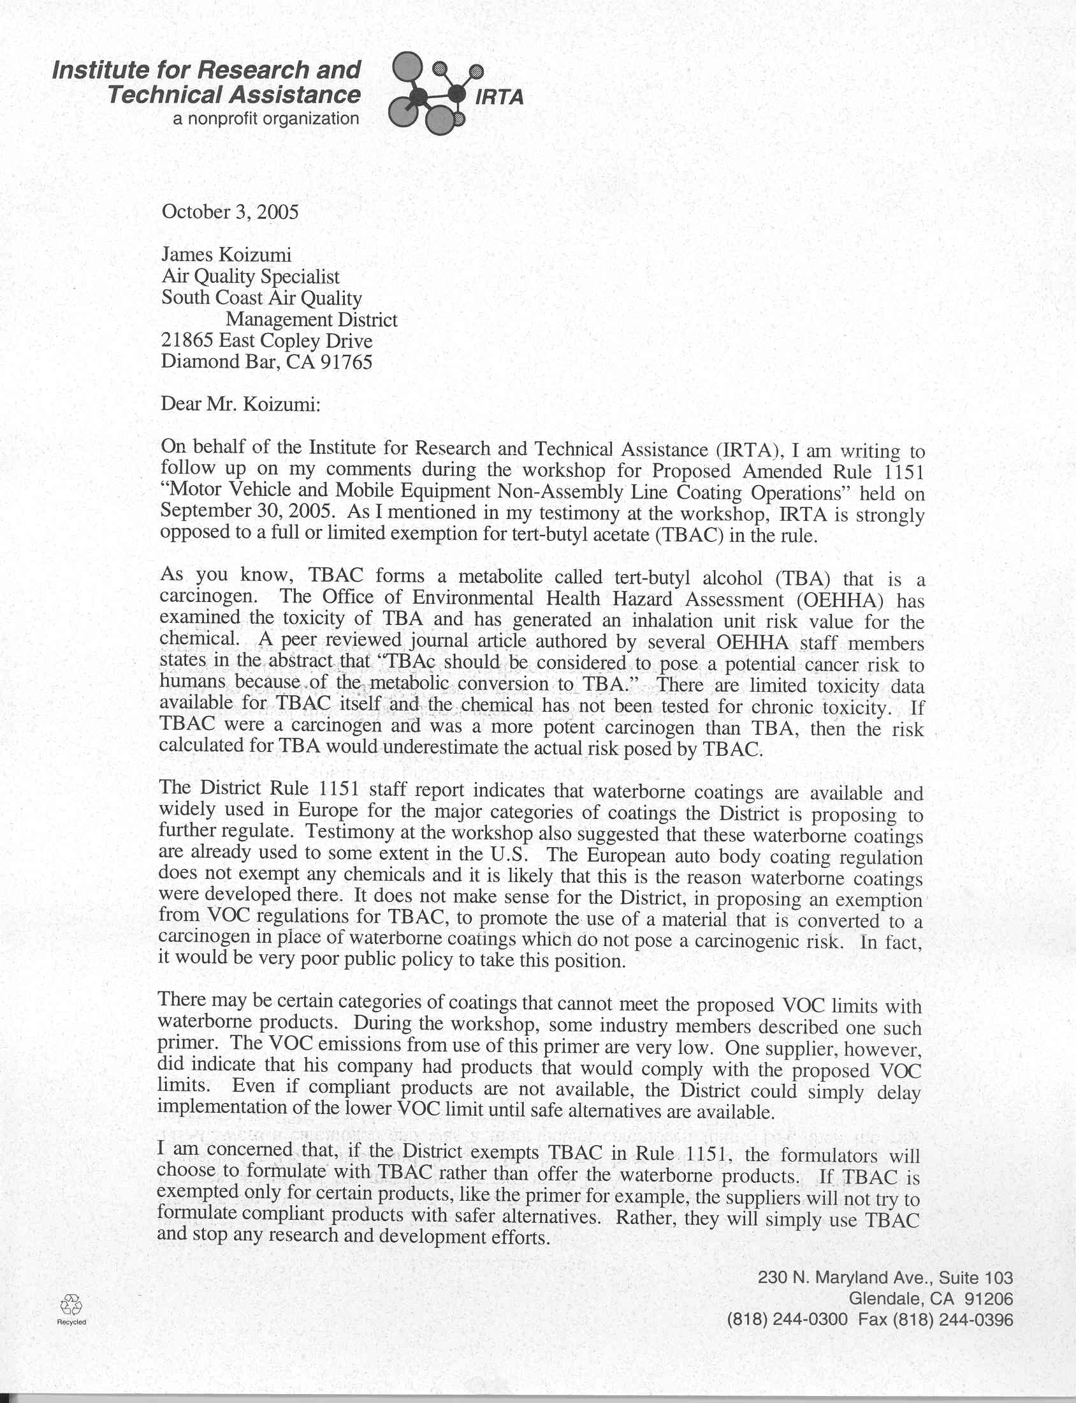
2-1
2-2

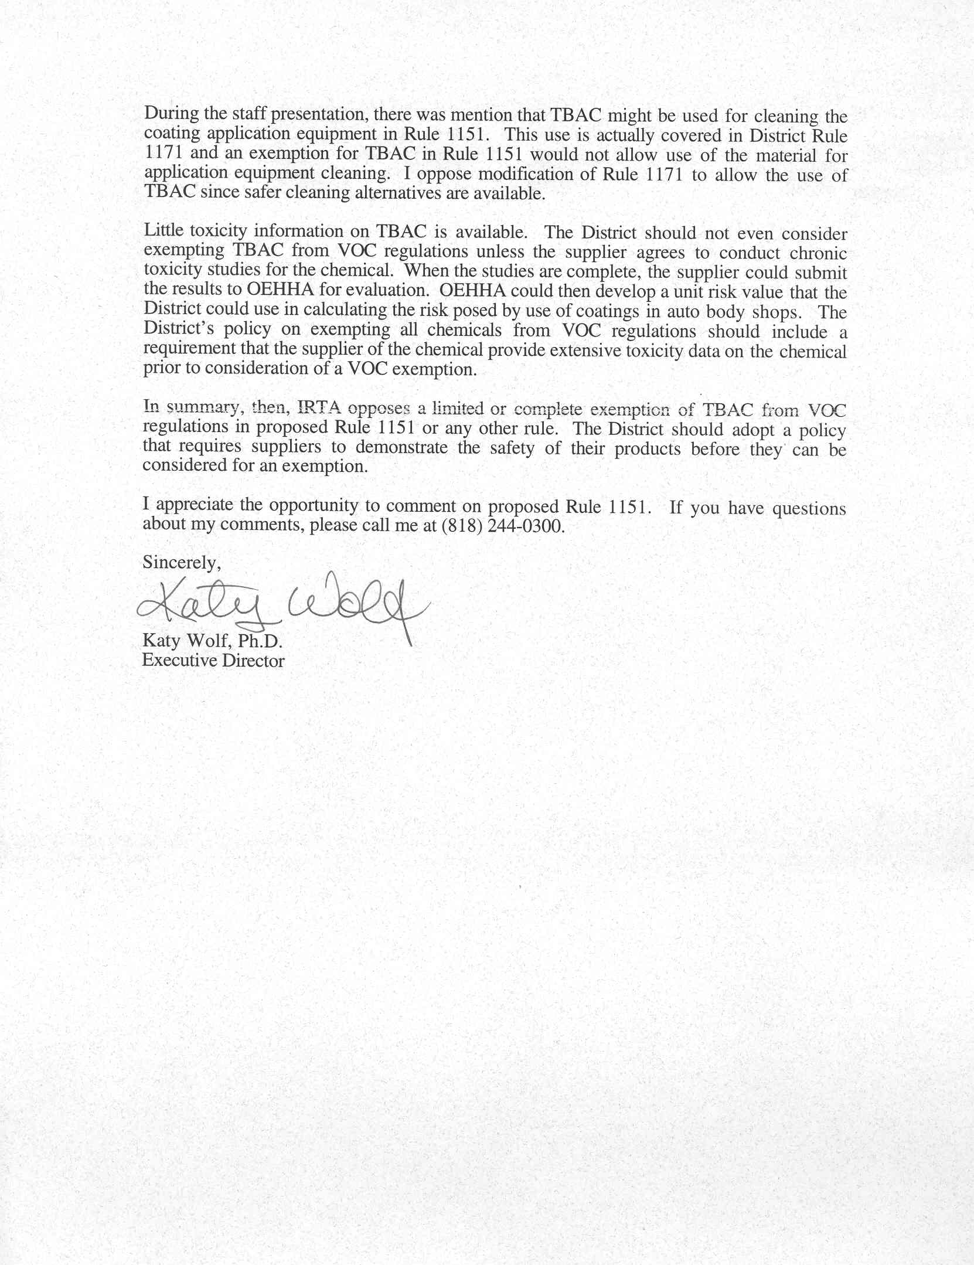
2-3
2-4
Responses to Comment Letter #2
Institute for Research and Technical Assistance
October 3, 2005

Response 2-1
SCAQMD staff understands that IRTA is against any exemption for TBAc from the VOC definition. In performing the background research for TBAc, SCAQMD staff also concluded that there is limited toxicity data available on TBAc. For this reason the health risk analysis prepared for PAR 1151 in the Draft EA used TBA as a surrogate for TBAc. The health risk analysis was prepared by SCAQMD staff using standard health risk protocol, health risk values provided in the peer-reviewed journal article authored by OEHHA staff, and parameters used by ARB to estimate risk from TBAc in the Staff Report for the SCM for Automotive Coatings. As with other projects evaluating the health impacts from air toxics, SCAQMD staff relied upon OEHHA/ARB to develop health risk values, associated parameters and procedures. The commentator should direct comments on the development of health risk values to OEHHA. SCAQMD staff believes that, based on available information, the cancer risk for TBAc included in the Draft EA is a conservative estimate that does not underestimate potential cancer risk from using TBAc at affected facilities. If the technical assessment on the use of TBAc required by PAR 1151 identifies additional information on the toxicity, either positive or negative, a revised and refined analysis will be prepared for the Governing Board’s consideration.

Response 2-2
It is correct that the staff report for PAR 1151 indicates that waterborne categories are available and used for the coatings affected by PAR 1151. Some users and manufacturers expressed concerns that, although compliant waterborne coatings may be available for some categories, they are not available for coatings within each category. For this reason, SCAQMD staff is considering the limited exemption for TBAc, because it is already delisted by EPA and by ARB specifically for automotive coatings. However, because EPA, OEHHA and ARB have expressed concerns regarding the potential toxicity of TBAc, to be health protective SCAQMD staff prepared a health risk analysis using TBA as a surrogate for TBAc used as a solvent for non-clear and non-color coat categories. The results of the health risk analysis indicate that the carcinogenic risk from TBAc usage for non-clear coat, non-color coat categories was estimated to be five in one million and less than 1.0 for noncarcinogenic chronic hazard index for the respiratory system. The carcinogenic risk is less than the significance threshold of 10 in one million and the chronic hazard index is less than the significance threshold of 1.0. PAR 1151 also requires a technology assessment by July 1, 2007, to evaluate any new information regarding toxicity, carcinogenic and health risk assessment (HRA) studies.

Response 2-3
SCAQMD staff understands that the commentator is opposed to amending Rule 1171 to exempt TBAc from the VOC definition. SCAQMD staff does not propose to allow the use of TBAc as an exempt solvent for cleaning operations either under PAR 1151 or Rule 1171.

Response 2-4
Although SCAQMD staff does not require chronic toxicity testing for compounds exempted from the definition of VOC by EPA and ARB, SCAQMD staff does attempt to compile as much toxicity, global warming, stratospheric ozone depleting potential, etc., information as is currently available in the CEQA document that is typically prepared when exempting a compound from the definition of VOC. In the case of TBAc, there is little available information on the toxicity of TBAc, but there is some toxicity information available on one of its metabolites, TBA. Estimated risk factors for TBA provided by OEHHA staff members in the peer reviewed publication mentioned by the commentator was used as a surrogate for determining potential cancer risk resulting from the limited exemption for TBAc. It should be noted that these surrogate risk factors developed by OEHHA staff have not been formally approved by the Scientific Review Panel yet. However, they reflect the best available information from OEHHA at this time, and these factors were used to conservatively estimate potential cancer risk from TBAc used under the proposed project. Weighing the conservatively estimated potential caner risk exposure due to the use of TBAc against the premature death estimated due to its low photochemical reactivity (as estimated by ARB), the proposed limited exemption of TBAc is more health protective compared to the complete exemption included in the SCM, while providing the coating manufacturers with the same flexibility in formulating compliant products with the future limits of PAR 1151 for certain coating categories.

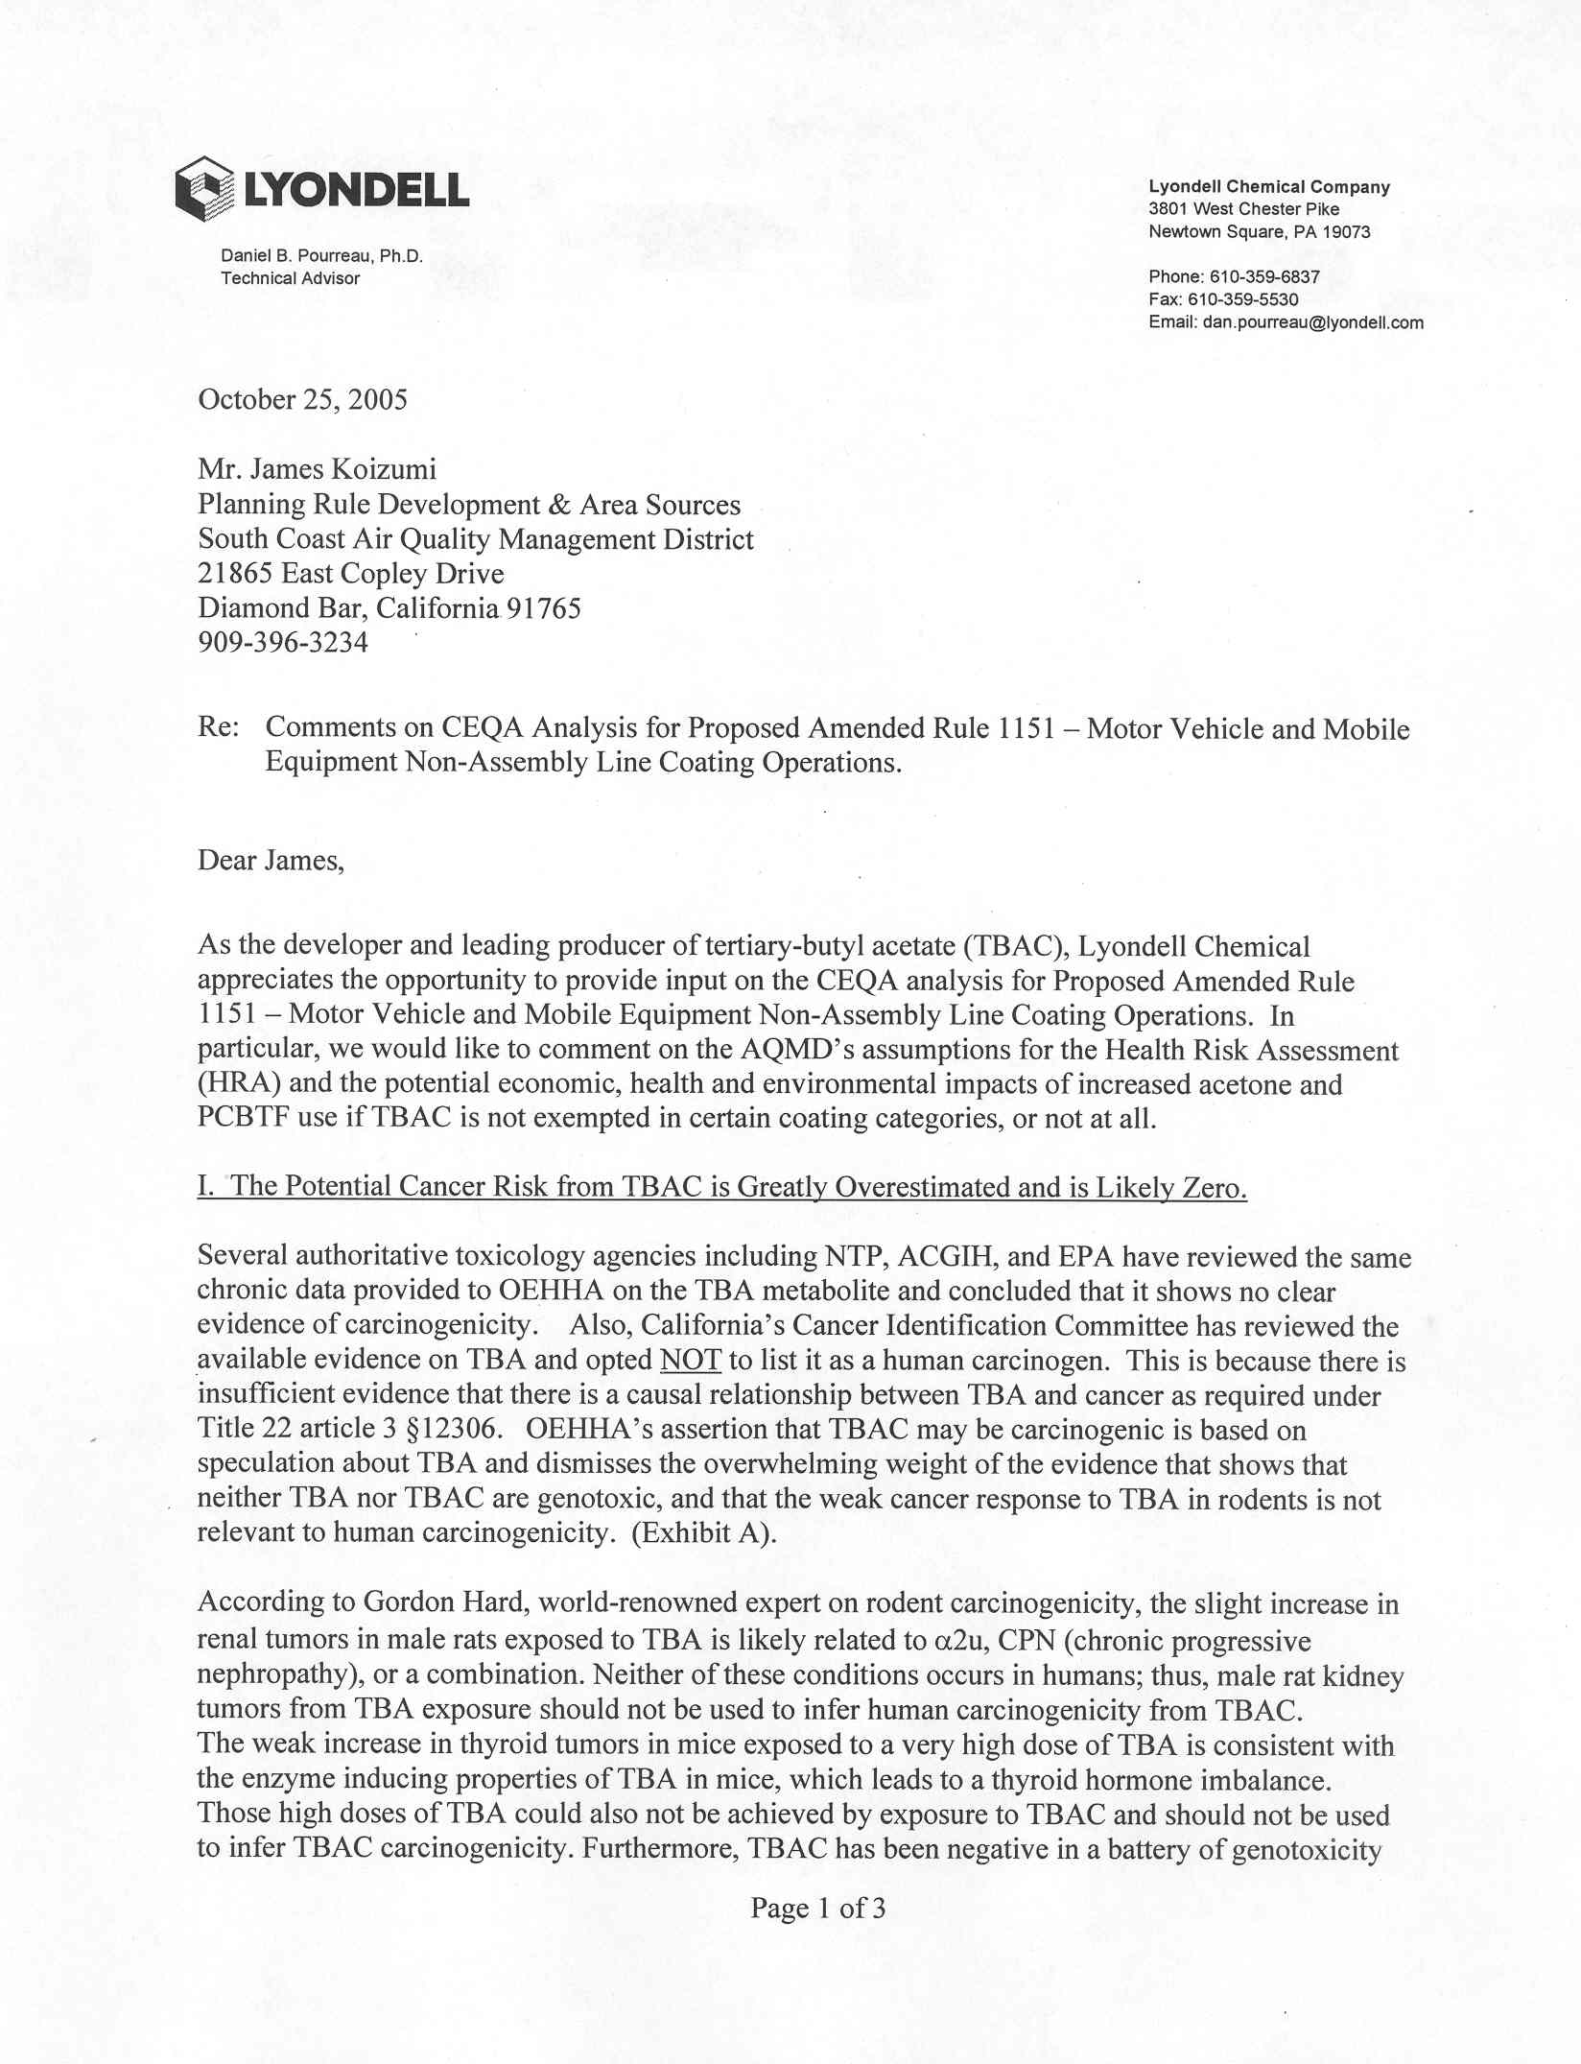
3-1
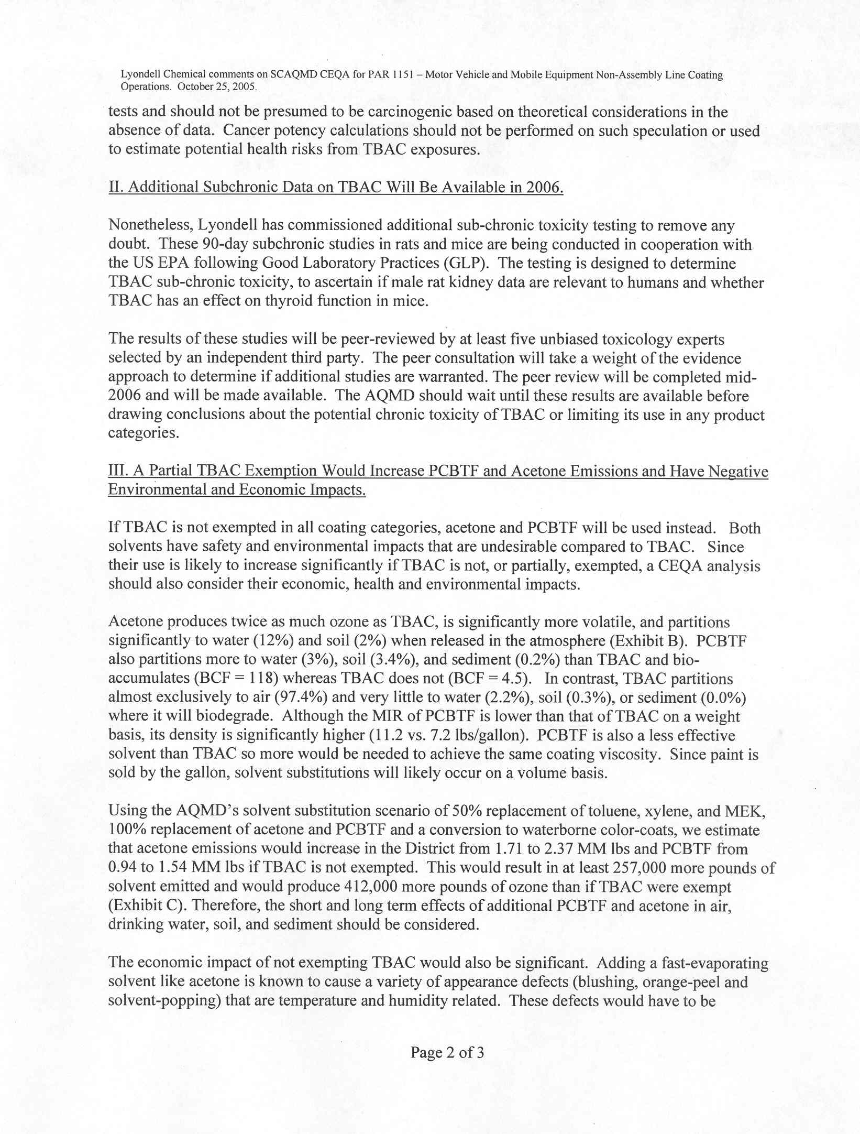
3-2
3-1
3-3
3-4
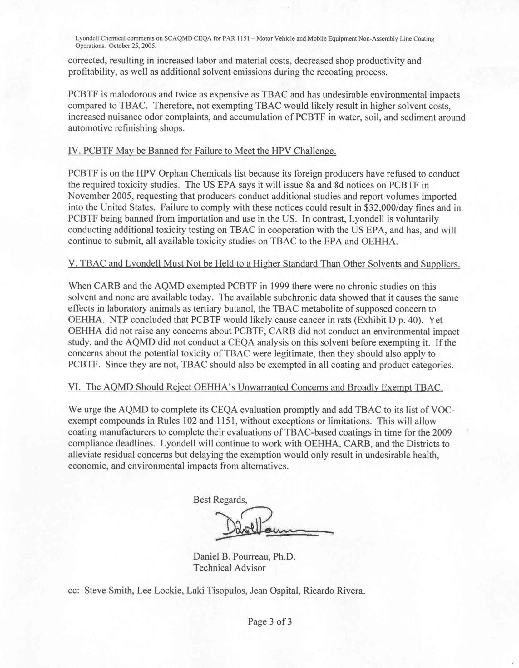
3-4
3-5
3-6
3-7
Responses to Comment Letter #3
Lyondell Chemical Company
October 25, 2005

Response 3-1
The commentator states that the carcinogenic risk should not be based on cancer potency value developed by OEHHA using what the commentator considers to be weak data. The commentator provides information from other references to support this opinion. The commentator should direct this information to OEHHA for consideration potentially revising its cancer potency value for TBA.

SCAQMD staff relies on and defers to OEHHA to provide cancer potency values for preparing a human health risk analysis (HRA). Since OEHHA staff has developed a cancer potency value for TBA and since TBAc is substantially metabolized into TBA, it is appropriate that the HRA prepared to evaluate health risks from TBAc in the Draft EA use TBA as a surrogate. The HRA in the Draft EA was based upon the most recent TBA cancer potency value provided by OEHHA. The TBAc carcinogenic HRA in the Draft EA is consistent with the methodology used by ARB in their TBAc health risk analysis.

Response 3-2
SCAQMD staff appreciates the additional data and will review any final studies the manufacturer or any other person provides. This is the purpose of the 2007 technical review included in the rule. SCAQMD staff encourages Lyondell to continue to work with OEHHA to provide more information for the subsequent technical review. SCAQMD staff requests that Lyondell complete long term toxicity test for carcinogenic effects.

SCAQMD staff believes that the partial exemption and technical review is prudent until further data is available. Since OEHHA has established a cancer potency value and ARB has used the value for human health risk analysis, SCAQMD staff has used this value for to prepare the HRA in the Draft EA.

Response 3-3
The commentator asserts that by not exempting TBAc, the PAR 1151 will generate increased air quality, water quality, and soil impacts. The commentator further asserts that PAR 1151 will generate economic cost impacts. Economic impacts are not required to be analyzed under CEQA. An analysis of potential economic impacts from implementing PAR 1151 can be found in the socioeconomic impact assessment.

As noted in the Draft EA, PAR 1151 will require the use of reformulate coatings in some automotive coating categories at existing affected facilities. As indicated in the Draft EA it is not expected that there will be an increase in accidental releases of future compliant coating products compared to existing coating products because safe handling and storage practices and procedures are already in place because some solvents such as xylene, toluene, acetone, etc., are considered flammable. TBAc has the same flammability rating, 3, as xylene, toluene, and acetone. In addition to the Uniform Building Code and Uniform Fire Code standards that affected facilities must comply with to prevent explosions and other types of accidental releases of hazardous or potentially hazardous materials, affected facilities may also be subject to the following state and federal regulations.

Under the Occupational Safety and Health Administration (OSHA) regulations [29 Code of Federal Regulations (CFR) Part 1910], facilities which use, store, manufacture, handle, process, or move highly hazardous materials must prepare a fire prevention plan. In addition, 29 CFR Part 1910.119, Process Safety Management (PSM) of Highly Hazardous Chemicals, and Title 8 of the California Code of Regulations, General Industry Safety Order §5189, specify required prevention program elements to protect workers at facilities that handle toxic, flammable, reactive or explosive materials. Prevention program elements are aimed at preventing or minimizing the consequences of catastrophic releases of the chemicals and include process hazard analyses, formal training programs for employees and contractors, investigation of equipment mechanical integrity, and an emergency response plan.

Section 112 (r) of the Clean Air Act Amendments of 1990 [42 U.S.C. 7401 et. seq.] and Article 2, Chapter 6.95 of the California Health and Safety Code require facilities that handle listed regulated substances to develop Risk Management Programs (RMPs) to prevent accidental releases of these substances, U.S. EPA regulations are set forth in 40 CFR Part 68. In California, the California Accidental Release Prevention (CalARP) Program regulation (CCR Title 19, Division 2, Chapter 4.5) was issued by the Governor’s Office of Emergency Services (OES). RMPs consist of three main elements: a hazard assessment that includes off-site consequences analyses and a five-year accident history, a prevention program, and an emergency response program. RMPs for existing facilities were required to be submitted by June 21, 1999. Affected facilities may also be required to comply with the U.S. EPA’s Emergency Planning and Community Right-to-Know Act (EPCRA), which requires annual reporting of releases from the facilities that are subject to this law and specific requirements in the event of an emergency release.

The Hazardous Materials Transportation (HMT) Act is the federal legislation that regulates transport of hazardous materials. The primary regulatory authorities are the U.S. Department of Transportation, the Federal Highway Administration, and the Federal Railroad Administration. The HMT Act requires that carriers report accidental releases of hazardous materials to the Department of Transportation at the earliest practical moment (49 CFR Subchapter C). Incidents which must be reported include deaths, injuries requiring hospitalization, and property damage exceeding $50,000. The California Department of Transportation (Caltrans) sets standards for trucks in California. The regulations are enforced by the California Highway Patrol.

California Assembly Bill 2185 requires local agencies to regulate the storage and handling of hazardous materials and requires development of a plan to mitigate the release of hazardous materials. Businesses that handle any of the specified hazardous materials must submit to government agencies (i.e., fire departments), an inventory of the hazardous materials, an emergency response plan, and an employee training program. The business plans must provide a description of the types of hazardous materials/waste on-site and the location of these materials. The information in the business plan can then be used in the event of an emergency to determine the appropriate response action, the need for public notification, and the need for evacuation.

Taken together, the above regulatory framework would be expected to minimize accidental releases of solvent materials, thus, minimizing the possibility of ground water or soil contamination impacts as indicated by the commentator.
With regard to the air quality impacts based on reactivity calculated by the commentator staff offers the following. The use of reactivity as a regulatory tool has been debated at the local, state, and national level for over 20 years. CARB is evaluating a strategy for consumer products and industrial emissions, and contracted with Dr. William Carter, University of California at Riverside, Center for Environmental Research and Technology, College of Engineering, for a study to assess the reactivities of VOC species found in the consumer products emissions inventory. According to Dr. Carter, reliable reactivity numbers do not currently exist from which accurate air quality policy can be derived based on reactivity and not total VOC emissions. Further, Dr. Carter asserts that ketones are the most important class of consumer emissions for which there are no environmental chamber reactivity data suitable for evaluating reactivity predictions. He also finds no experimental reactivity data for glycols or alcohols suitable for mechanism evaluation.

Another factor to be considered in the reactivity based approach, and probably the most important, is an accurate speciation profile of water-borne and solvent-borne coatings. Reactivity data for VOCs, especially those compounds used to formulate consumer and commercial products, are extremely limited. This is essentially the conclusion reached by EPA in a 1995 report to Congress which states, “...better data, which can be obtained only at great expense, is [sic] needed if the EPA is to consider relative photochemical reactivity in any VOC control strategy.”

Until the results of research and studies on reactivity are completed and peer reviewed, the SCAQMD believes that it would not be prudent to accept at face value ozone results such as those presented by the commentator. This is consistent with USEPA’s conclusion that regulation should be based on total mass VOC emissions and should not attempt to regulate based on reactivity

Response 3-4
An analysis of potential economic impacts from implementing PAR 1151 can be found in the socioeconomic impact assessment.

Based on the ARB Staff Report for the SCM for Automotive Coatings and discussion with automotive refinishing coating manufacturers, SCAQMD staff believes that most automotive refinishing coatings would be reformulated as water-based coatings. Few automotive refinishing coatings would be reformulated with acetone and PCBTF as these are generally available. The commentator states that if TBAc is not completely or partially exempted acetone and PCBTF will be used. First, these compounds are already being used in compliant formulations and it is expected that they could continue to be used to formulate compliant products under PAR 1151. Second, according to the staff report, water-based coatings in the categories affected by PAR 1151 are currently available and being used in Europe. As a result, neither PAR 1151 nor ARB’s SCM rely on formulations using TBAc to comply with the proposed VOC content limits. Finally, the appearance problems cited by the commentator can be eliminated by adding a solvent, such as PCBTF, to slow the drying time.
Response 3-5
SCAQMD staff contacted Mr. Mark Townsend of the High Production Volume (HPV) Chemical Branch of EPA. Mr. Townsend stated that 8a an 8d notices on the Orphan Chemical list are expected to be issued this month (November 2005). The 8a and 8d notices would request existing studies and reports that have not be provided by the companies to EPA. Mr. Townsend said that if sufficient health and safety data are not available EPA will require industry to complete a full battery of testing according to the “Screening Information Data Set Manual of the OECD Programme on the Co-operative Investigation of High Production Volume Chemicals” (SIDs Manual) which includes: acute toxicity, chronic toxicity, developmental and reproductive toxicity, mutagenicity, ecotoxicity, environmental fate, and physical-chemical properties. Mr. Townsend stated that it is highly unlikely that chemicals on the Orphan Chemical List would be banned, but EPA would force companies to complete a full battery of SIDs testing if sufficient baseline information does not exist.

At this time the commentator’s conclusions are speculative. SCAQMD staff will review any future EPA, OEHHA and ARB actions on all compliant and noncompliant chemicals and take appropriate action.

Response 3-6
PCBTF is currently exempt under Rule 102 so an exemption for PCBTF is not part of the proposed project. The commentator incorrectly states that the SCAQMD exempted PCBTF in 1999 without performing a CEQA analysis. The SCAQMD originally exempted PCBTF from the definition of VOC in November 1995, and classified it as a Group II compound. A Final EA was prepared to address potential impacts from the proposed action. Acetone, ethane, and volatile methyl siloxanes (VMS) were also exempted from the definition of VOC at that time. Acetone and ethane were classified as Group I compounds and VMS was classified as a Group II compound. PCBTF was exempted from the definition of VOC based on the information available at that time, which indicated, “PCBTF is not absorbed into the body to any appreciable extent. Most of the material is either exhaled back or excreted. The small quantities that are assimilated are converted to non-to non-toxic water soluble products and excreted.” (Final EA for Proposed Amended Rule 102 – Definition of Terms, October 1995). VMS, however, had undergone a 90-day sub chronic toxicity testing, which concluded that no gross or histopathological liver effects were noted in the subject animals. Based on these test results VMS was not considered to be carcinogenic. Later chronic toxicity testing, however, identified tumors in test animals.

PCBTF was moved from the Group II to the Group I list of exempt VOC compounds as part of amendments to Rule 102 adopted by the Governing Board on June 12, 1998. A Final Supplemental EA was prepared to address impacts from the proposed action. PCBTF was moved to the Group I list based on sub chronic toxicity data evaluated by OEHHA. After completing its review, OEHHA notified the SCAQMD in writing that there was an “absence of adverse health effects.” Based on this evaluation, the SCAQMD moved PCBTF from Group II to Group I.

Unlike TBAc, no cancer potency values had been developed at that time for either PCBTF or VMS or any of their metabolites. When OEHHA publishes toxicity values for chemicals, SCAQMD staff evaluates the health risk from these chemicals. Since cancer potency and acute chronic noncarcinogenic values have been provided by OEHHA for use in evaluating health risk impacts from TBAc’s metabolite, TBA, SCAQMD staff used these values to estimate the potential increase health risk from the limited VOC exemption for TBAc in PAR 1151.

Response 3-7
SCAQMD has completed its CEQA evaluation for TBAc for PAR 1151 in the Final EA. An evaluation of TBAc for Rule 102 is beyond the scope of the currently proposed project. Amending Rule 102 is not currently under consideration. Based on the evaluation of TBAc for PAR 1151, if TBAc were completely exempted from the VOC definition, potential adverse health risk impacts could exceed the SCAQMD’s cancer risk significance threshold of 10 in one million (10 x 10⁻⁶). Ultimately, the decision to include the limited exemption for TBAc rests with the SCAQMD’s Governing Board.

The commentator states that delaying the exemption of TBAc from the VOC definition would result in undesirable health, economic and environmental impacts. This statement is based on the assumption that TBAc itself does not currently have any health risk values identified for it at this time. The reason, however, that TBAc does not have any health risk values is that it has not undergone any toxicity testing. Further, an HRA included in the Draft EA demonstrates that there are potential health effects using TBA as a surrogate for TBAc, although not significant, from using TBAc under certain conditions. SCAQMD staff disagrees with the commentator’s opinion that not exempting TBAc will create other undesirable environmental impacts. See in particular, response #3-3.

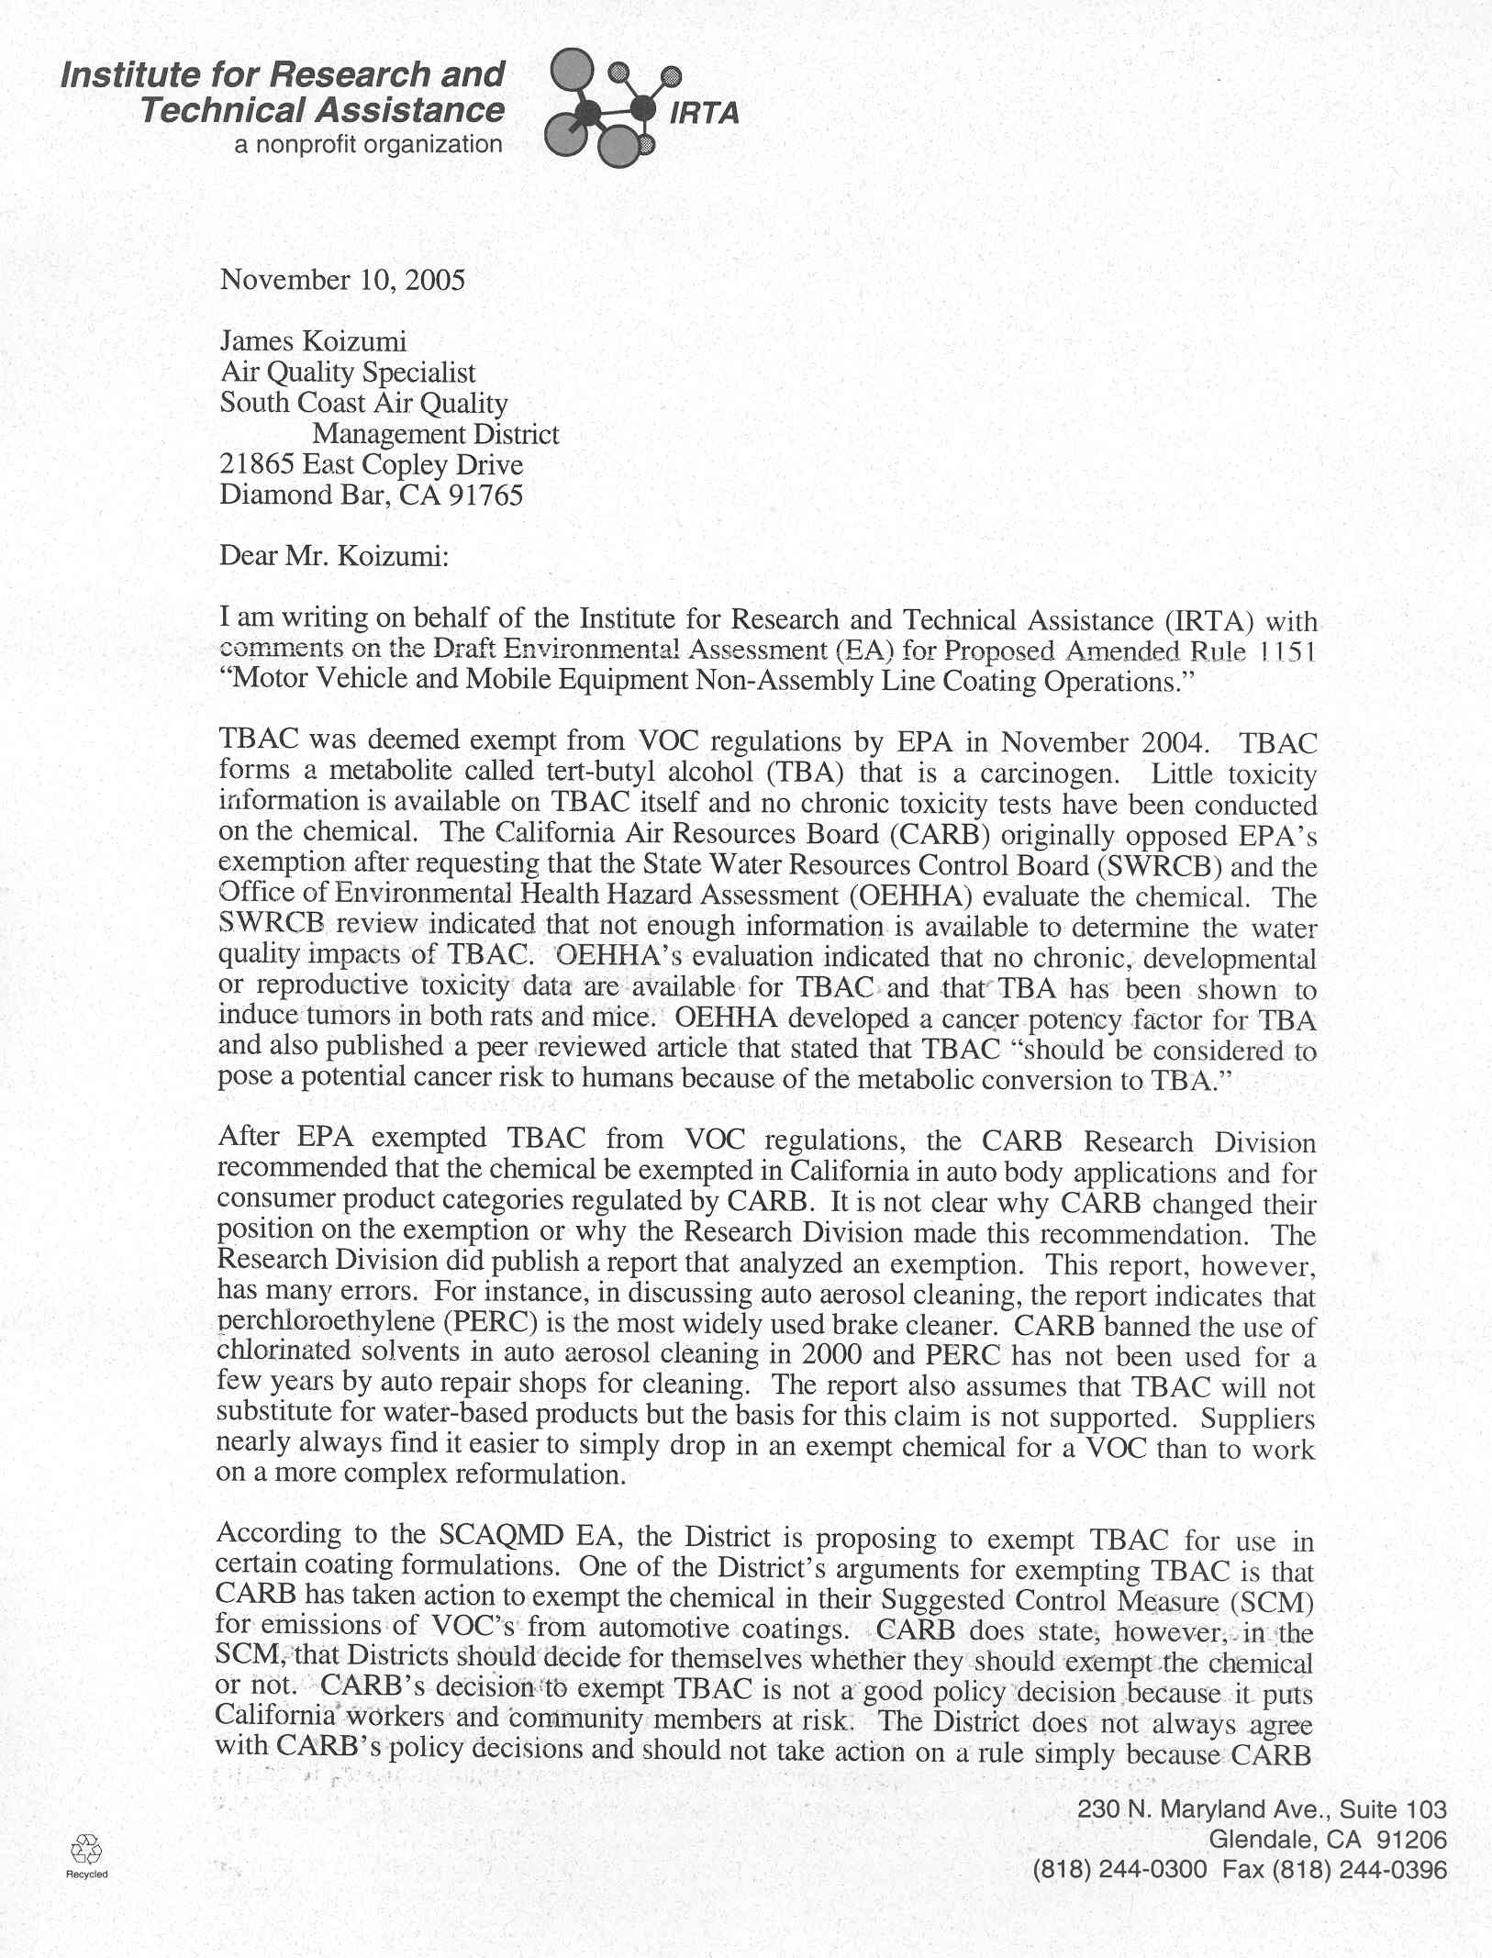
4-1
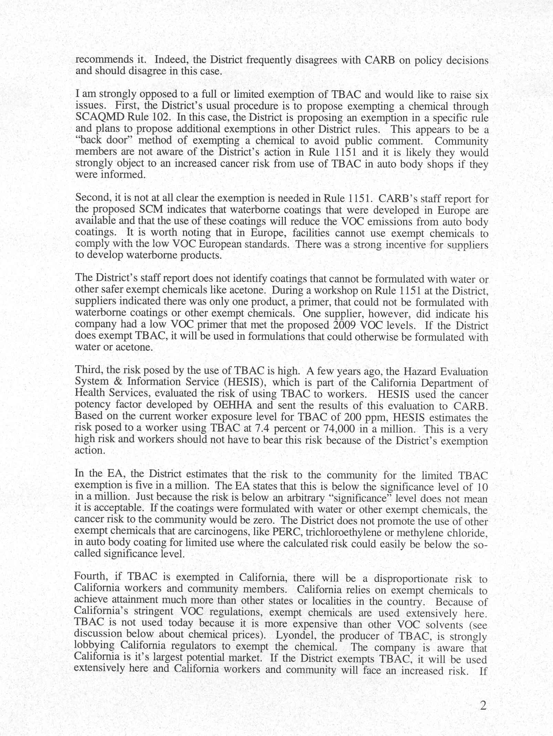
4-2
4-3
4-1
4-4
4-5
4-6
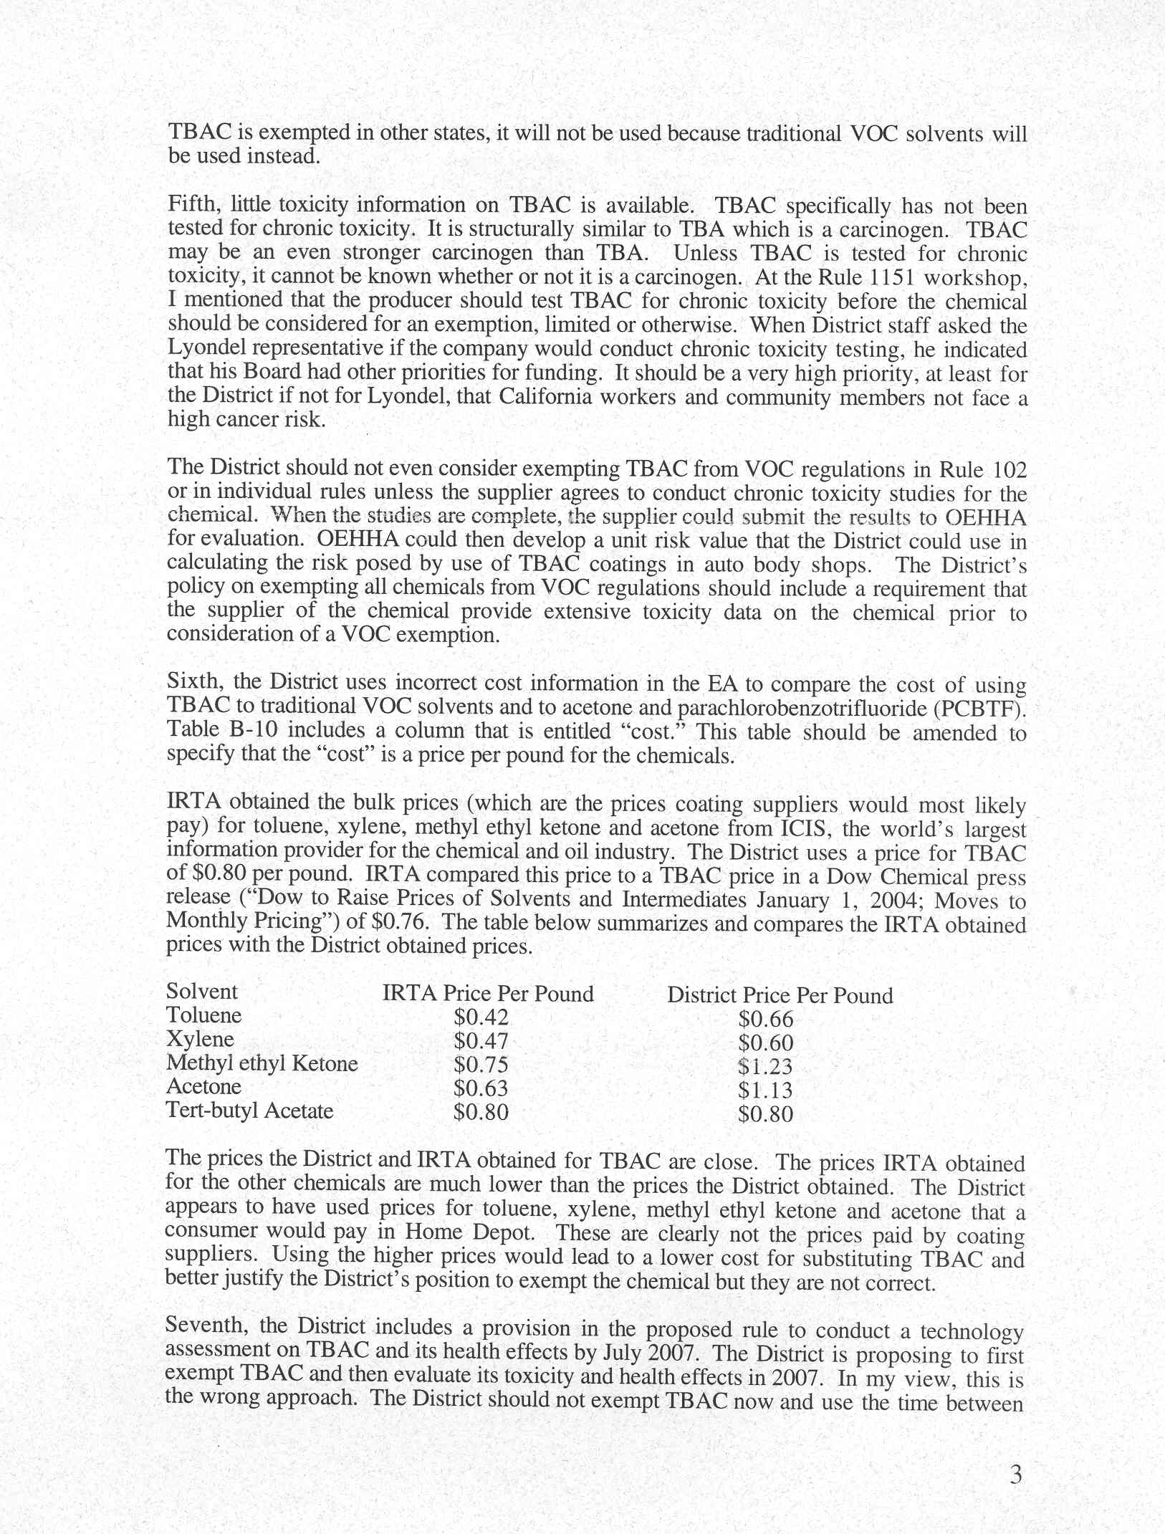
4-7
4-8
4-6
4-9
4-10
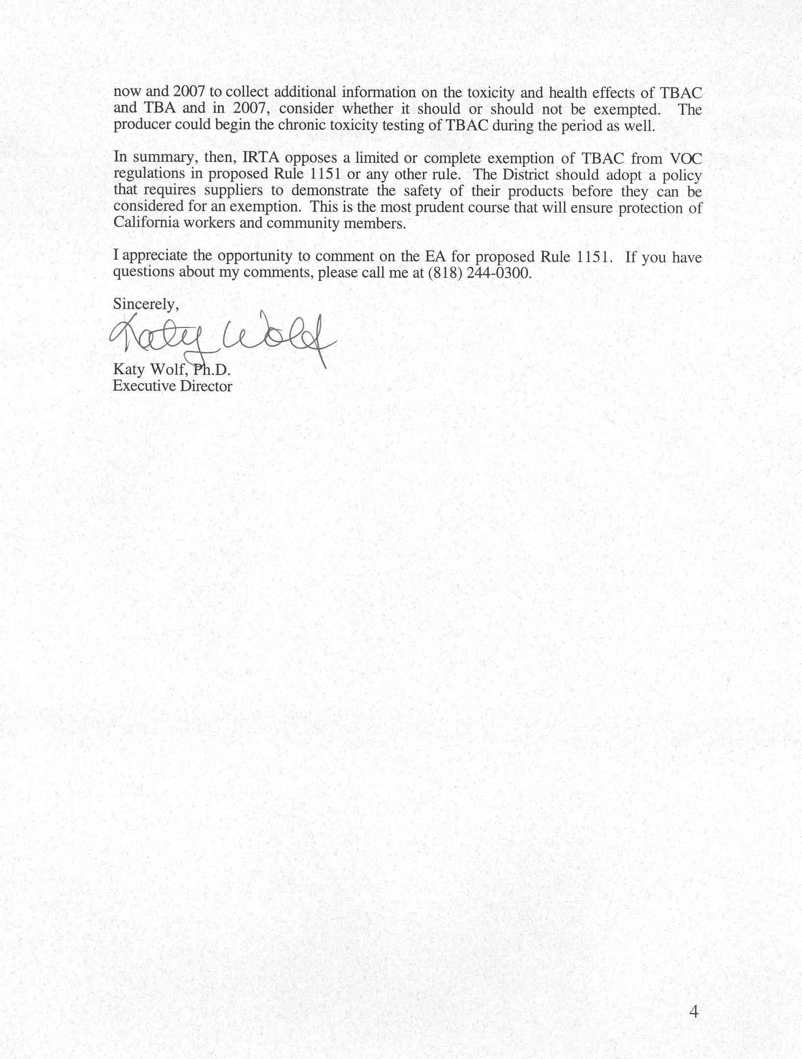
4-11
4-10
Responses to Comment Letter #4
Institute for Research and Technical Assistance
October 10, 2005

Response 4-1
This comment provides background information on TBAc, indicating that no toxicity testing has been conducted, and that one of TBAc’s metabolites, TBA, has been shown to induce tumors in rats and mice. SCAQMD staff is aware of this information and used the cancer potency information on TBA, used as a surrogate for TBAc, to prepare an HRA. The commentator states that SCAQMD staff is exempting TBAc for use in certain coating formulations because ARB has exempted TBAc in its Suggested Control Measure (SCM) for automotive coatings. It is correct that the Staff Report for the SCM states that ARB staff encourages districts to adopt the SCM without major changes, but recognizes that districts have the authority to include limited and specific exemptions to meet local needs.

At the September 30, 2005 public workshop for PAR 1151, SCAQMD staff solicited comments from the public regarding including an unlimited exemption for TBAC, consistent with ARB’s SCM, a limited exemption from the VOC definition for non-color and non-clear coat categories, and no exemption. Based on preliminary evaluations of the cancer risks from exempting TBAc conducted for the Draft EA, staff decided not to pursue a full exemption because potential cancer risks were shown to exceed by a substantial margin the SCAQMD’s cancer risk significance threshold of 10 in one million (10 x 10⁻⁶). Instead, SCAQMD staff is currently recommending the limited exemption for TBAc because the HRA showed cancer risks that did not exceed the cancer risk significance threshold. Using OEHHA health risk values and following a risk analysis procedure similar to the one used by ARB for their Automotive Refinishing Coating SCM, SCAQMD staff estimated that maximum risk to the surrounding receptors would be five in one million (5 x 10⁻⁶). The final decision on whether to provide a limited exemption for TBAc or no exemption will be made by the Governing Board based on information prepared by staff (e.g., Final EA and staff report for PAR 1151) and input from the public.

Response 4-2
The commentator states that by exempting TBAc from the VOC definition in PAR 1151 instead of through Rule 102, community members may not be as aware of the exemption as they would be if TBAc was exempted through Rule 102. While staff acknowledges the low photochemical reactivity of TBAc and its beneficial impacts on reducing ozone and particulate formation, staff is not recommending its complete exemption from the VOC definition at this time. This is because, there is limited information on its toxicity and one of its metabolites, TBA, has been shown to induce tumors in rats and mice. At the present time, neither TBAC nor TBA have been classified as TACs by OEHHA, and therefore are not listed in Rules 1401 or 1402, which provide SCAQMD with the necessary tools to limit usage of such compounds and limit potential risk and exposure. In the absence of such tools, a complete exemption under Rule 102 could potentially subject the public to higher risk and exposures, unnecessarily. The proposed limited exemption under PAR 1151 is more health protective compared to a complete delisting under Rule 102 or included in ARB’s SCM, while providing some level of compliant products with the future effective limits for certain coating categories.

Response 4-3
The commentator states that the exemption of TBAc from the VOC definition is not needed to achieve the VOC content limits in PAR 1151 because waterborne coatings are available for use. Further, the Staff Report for PAR 1151 does not identify coatings that cannot be formulated with water or other safer exempt chemicals. Color and clear coat categories have coatings that currently meet the proposed PAR 1151 VOC coating limits and it is expected that all coatings in this category would be able to achieve PAR 1151 VOC content limits by July 1, 2008 with water-based and existing exempt solvent formulations. The color and clear coat categories comprise 80 percent of the automotive refinishing coatings used. Although, neither PAR 1151 nor ARB’s SCM rely on formulations using TBAc to comply with the proposed VOC content limits, some coating manufacturers have indicated that for some of their coating systems (primer, color coat, and clear coat), water based coatings complying with PAR for all coatings in the system may not be achievable by the January 1, 2009 or January 1, 2010 compliance dates. This is one reason for considering the exemption for TBAc.

Response 4-4
The commentator states that risk to on-site workers is high. On-site worker exposure is under the jurisdiction of federal OSHA and the California Department of Industrial Relations Division of Occupational Safety and Health (DOSH). SCAQMD staff relies on OSHA and DOSH to establish and enforce health and safety regulations that will protect workers from chemical exposure and health risk impacts.

The HESIS worker risk value of 74,000 in one million was developed by multiplying the California PEL of 950,000 μg/m3 from CCR, Title 8, §5155, Table AC-1 by the OEHHA unit risk factor for TBAc of 4x10⁻⁷ (ug/m³)⁻¹, then adjusting exposure from residential parameters (24 hour/day, 365 day/week, 70 year lifetime) to worker parameters (8 hour/day, 250 day/week and 40 year lifetime).

SCAQMD staff contacted Dr. Julia Quint the chief of HESIS, who prepared the worker risk value of 74,000 in one million. The PEL for TBAc is based on acute exposure. Dr. Quint stated that the risk value was prepared to demonstrate that the PEL should be reduced to account for carcinogenic and chronic noncarcinogenic exposures. The estimate was developed under the assumption that employees would be exposed to TBAc concentrations equivalent to the PEL everyday. Dr. Quint said she was not certain if employees within spray booths would be exposed to the TBAc concentrations equivalent to the PEL every workday.

Based on the information provided by Dr. Quint, SCAQMD staff agrees that reducing the California PEL for TBAc will also reduce carcinogenic and chronic noncarcinogenic exposures. Reducing the PEL limiting the exemption for TBAc to the non-color and non-coating categories, and requiring workers to wear protective respirator equipment, would be expected to reduce worker exposure, but not eliminate it.

Response 4-5
The commentator states that because the risk identified in the Draft EA is less than the cancer risk significance threshold, an arbitrary value, does not mean it is an acceptable risk. First, the significance threshold is not an arbitrary number, it is based on the maximum allowable risk that new, modified, or relocated permitted units with best available control technology for toxics (T-BACT) in Rule 1401. This risk level was derived during the original rule promulgation process for Rule 1401, which evaluated, in part, risk levels established by other public agencies. The 10 in one million (10 x 10⁻⁶) level went through a public process as part of the original promulgation process for Rule 1401 and also went through a public process as a CEQA significance threshold as part of the Governing Board’s approval of the SCAQMD’s CEQA Air Quality Handbook in 1993. SCAQMD’s cancer risk significance threshold is consistent with Proposition 65 notification requirements and OEHHA incremental increase in carcinogenic risk significance threshold of ten in a million to determine significance.

SCAQMD Governing Board policy considers a project with a cancer risk less than 10 in one million (10 x 10⁻⁶) to be an acceptable risk. Through its adoption of Rules 1470 and 1401.1 the Board has acknowledged that certain sensitive receptors require additional protection from air toxics. In particular, Rule 1401.1 prohibits, for example, new permitted facilities with a facility-wide cancer risk greater than one in one million (1 x 10⁻⁶) from locating within 500 feet of a school. Ultimately, it is the SCAQMD Governing Board who will decide if a risk of five in one million (5 x 10⁻⁶) is an acceptable risk or not.

Response 4-6
The commentator states that TBAc is not used outside of California because of cost and air quality regulations are less stringent than in California. Further, exempting TBAc will result in substantially greater use of the chemical and greater exposure to residents and workers. It is likely that exempting TBAc from the definition of VOC will increase its usage in the district, while increasing exposure to residents. As already noted #4-1, SCAQMD staff has calculated that the cancer risk from the limited exemption for TBAc would be five in one million (5 x 10⁻⁶). Also as previously noted, it is the SCAQMD Governing Board who will decide if a risk of five in one million (5 x 10⁻⁶) is an acceptable risk or not.

Response 4-7
The commentator states that, because there are limited toxicity data for TBAc, toxicity testing should be a high priority. SCAQMD staff understands that there is little available information on the toxicity of TBAc, which is why the HRA in the Draft EA used TBA, which has a cancer potency value established by OEHHA, as a surrogate for TBAc. Limited exemption for TBAc would limit public exposure to TBAc compared to the complete exemption proposed by the SCM, while providing a solvent that will assist manufacturers with formulating coatings that would comply with the proposed VOC content limits in PAR 1151.

In particular, SCAQMD staff has proposed a limited exemption for TBAc for automotive refinishing coatings since non-TBAc coatings are available or are expected to be available for color and clear coats. The color and clear coats were estimated to comprise approximately 80 percent of the automotive refinishing coatings. TBAc would be exempted from the VOC definition for automotive refinishing coatings categories that industry has stated may not be able to meet PAR 1151 VOC content limits with water or existing exempt solvents. The maximum health risk estimated from the possible incremental increase in TBAc usage with the limited exemption would be five in one million. This health risk is below the significance threshold of 10 in one million. Therefore, off-site worker and residential health risk is expected to be less than significant.

Finally, in a letter submitted to the SCAQMD (see comment letter #3), a representative for the manufacturer of TBAc states that Lyondell has commissioned 90-subchronic studies that will be peer reviewed “by at least five unbiased toxicology experts selected by an independent third party. This study may provide useful sub chronic effects information that will be evaluated for use in further health risk analyses. SCAQMD staff has requested as a response to the comments made by the TBAc manufacturer representative that a long-term study be completed in addition to the sub chronic study.

Response 4-8
The commentator states that SCAQMD staff should adopt a policy that would require that suppliers of chemicals provide extensive toxicity data on those chemicals prior to consideration of a VOC exemption. Establishing a policy requiring toxicity data prior to delisting a chemical is not part of the currently proposed project. This suggestion will be forwarded to the Governing Board for consideration, however.

Response 4-9
The commentator states that units should be added to the cost column in Table B-10 and the costs presented do not reflect the cost paid by automobile suppliers. The units will be added to the cost column in Table B-10 in the Final EA.

The cost information presented in the CEQA document was provided by local coating manufacturers and is the best available cost for this region.

Response 4-10
The commentator states that SCAQMD staff should complete the technology assessment on TBAc first, and then decide whether to exempt TBAc from the VOC definition based on the results. SCAQMD staff believes that PAR 1151 protects public health and provides an additional solvent that could be used to formulate products that comply with PAR 1151. See responses #4-7 and #4-8.

Response 4-11
This comment concludes by reiterating the commentator’s opposition to including a limited exemption for TBAc in PAR 1151 and the recommendation to establish a policy of requiring manufacturers to demonstrate the safety of their products. With regard to the limited exemption for TBAc, refer to responses #4-1 through #4-6 and with regard to toxicity testing and safety; refer to responses #4-7 and #4-8.

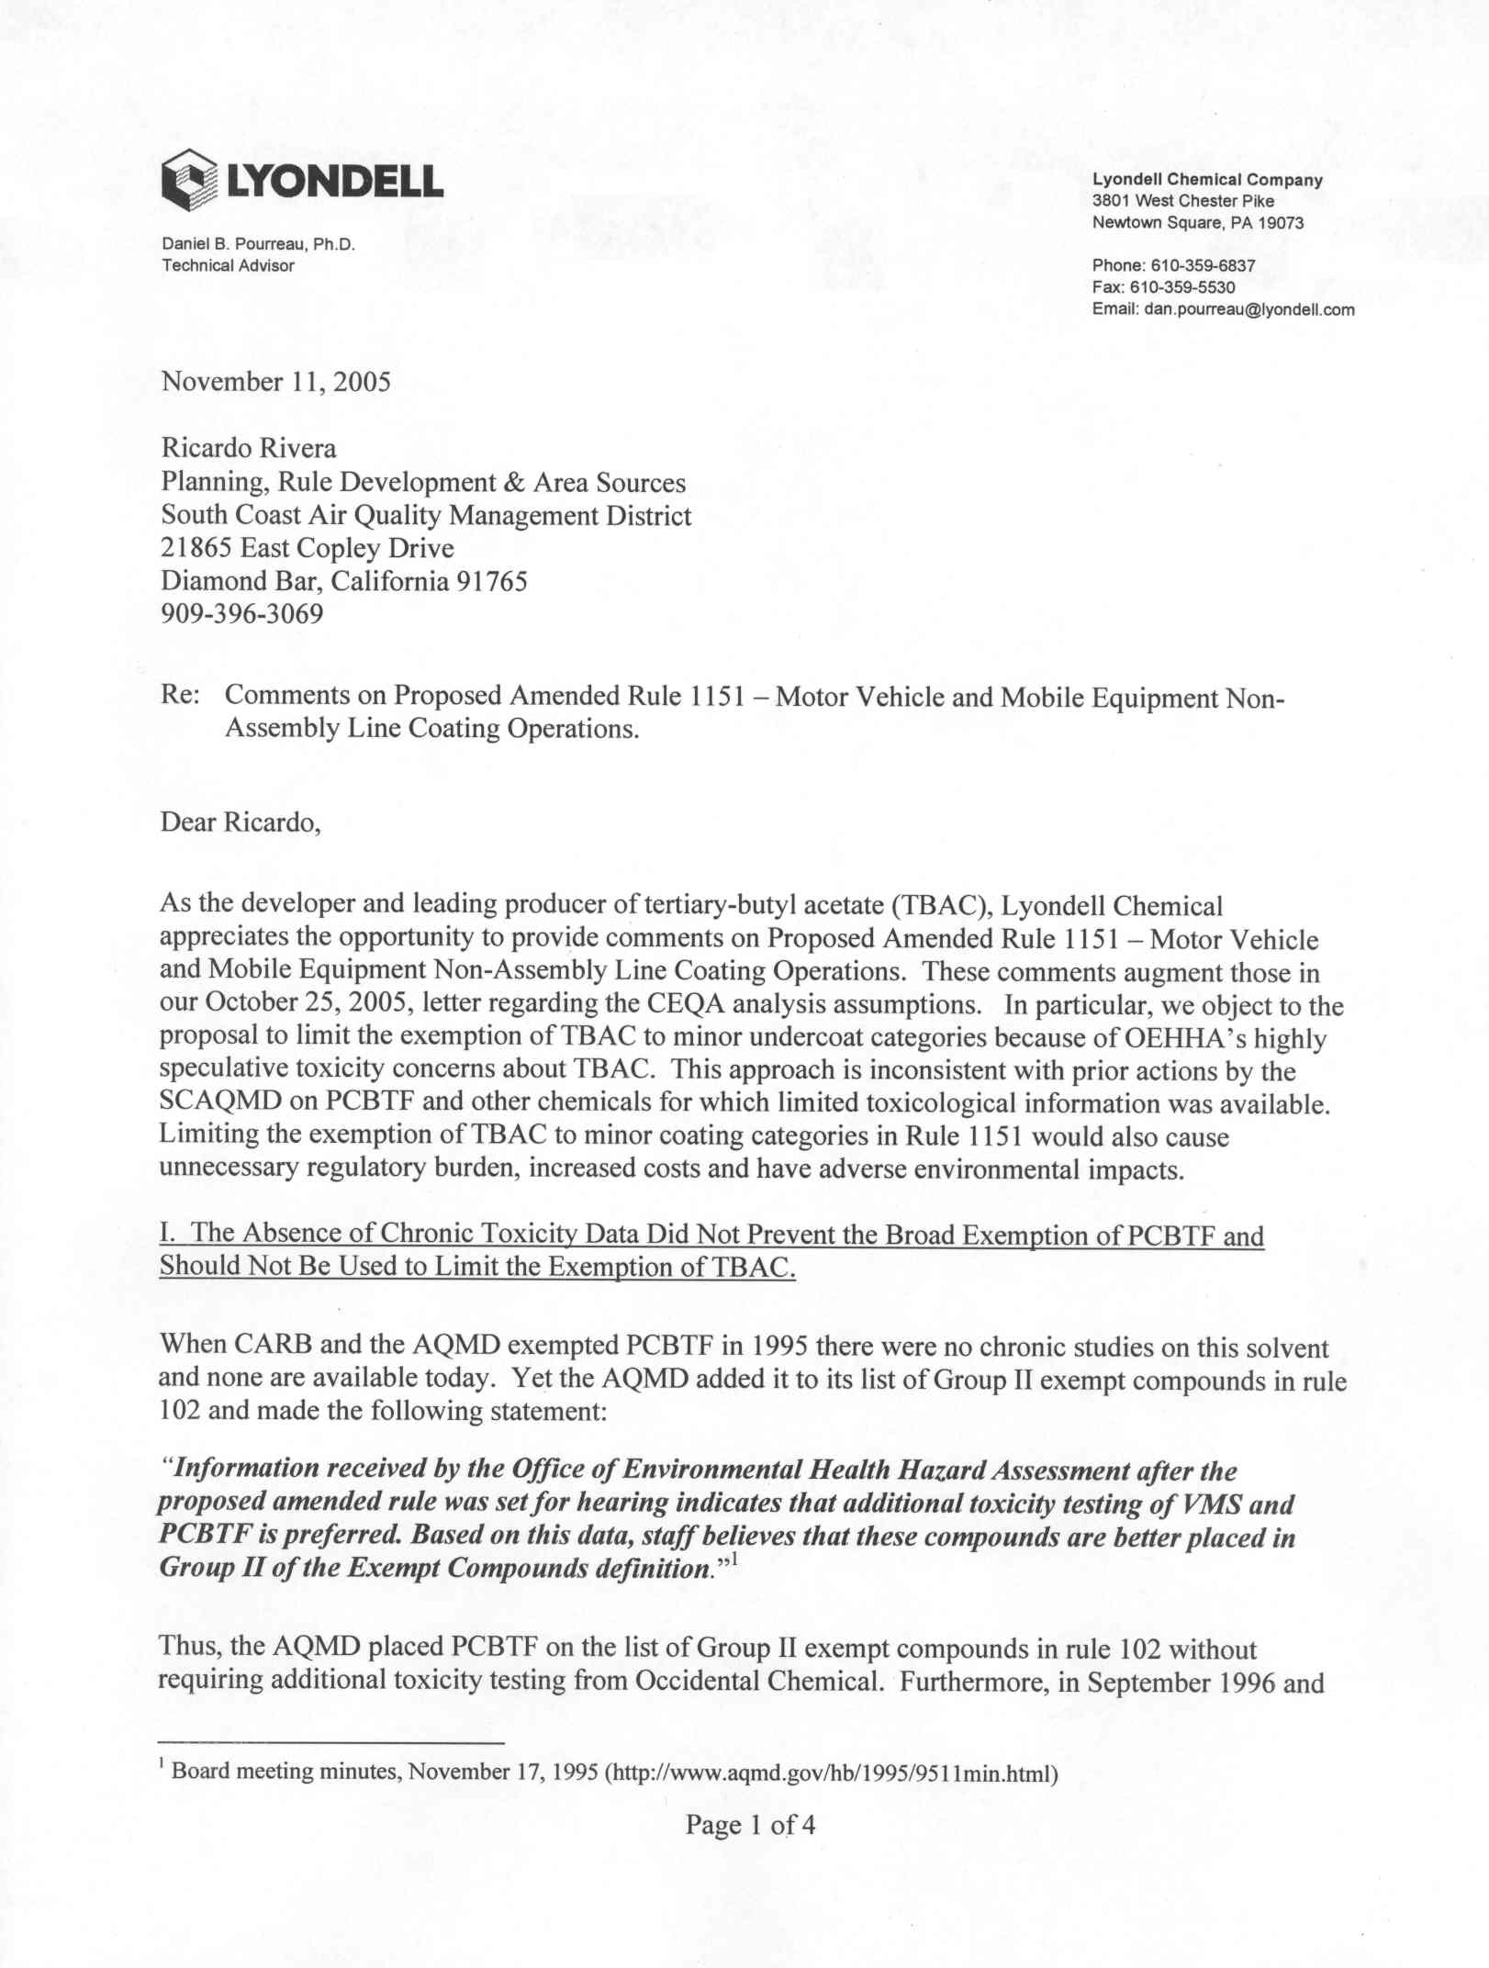
5-1
5-2
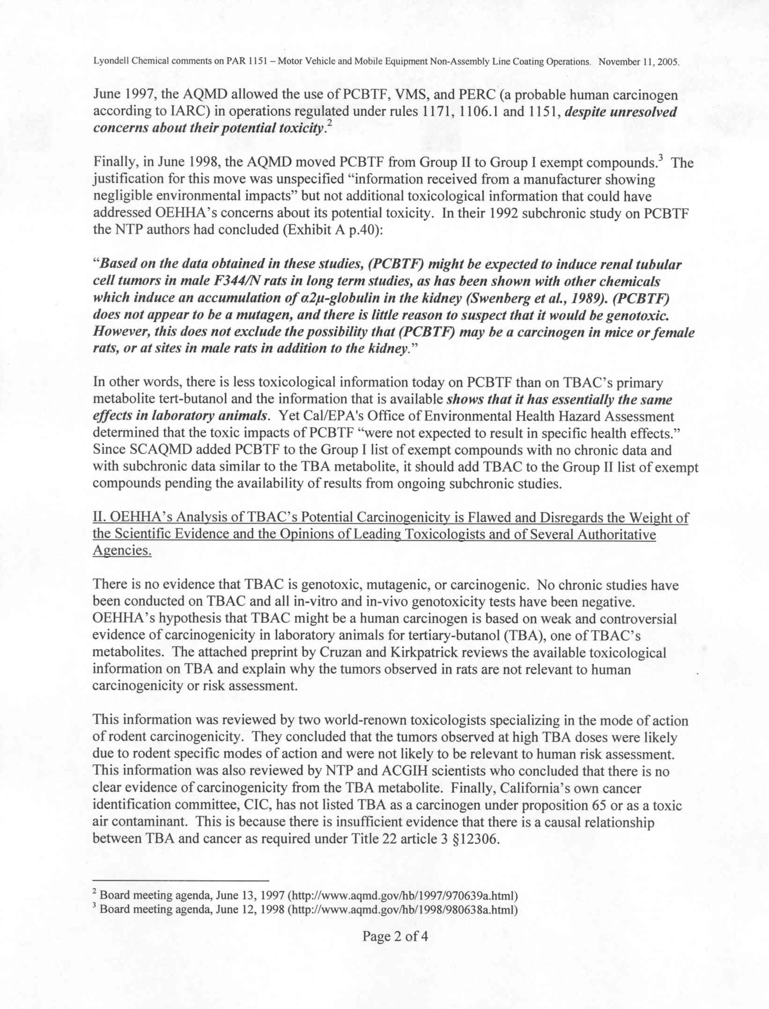
5-3
5-2
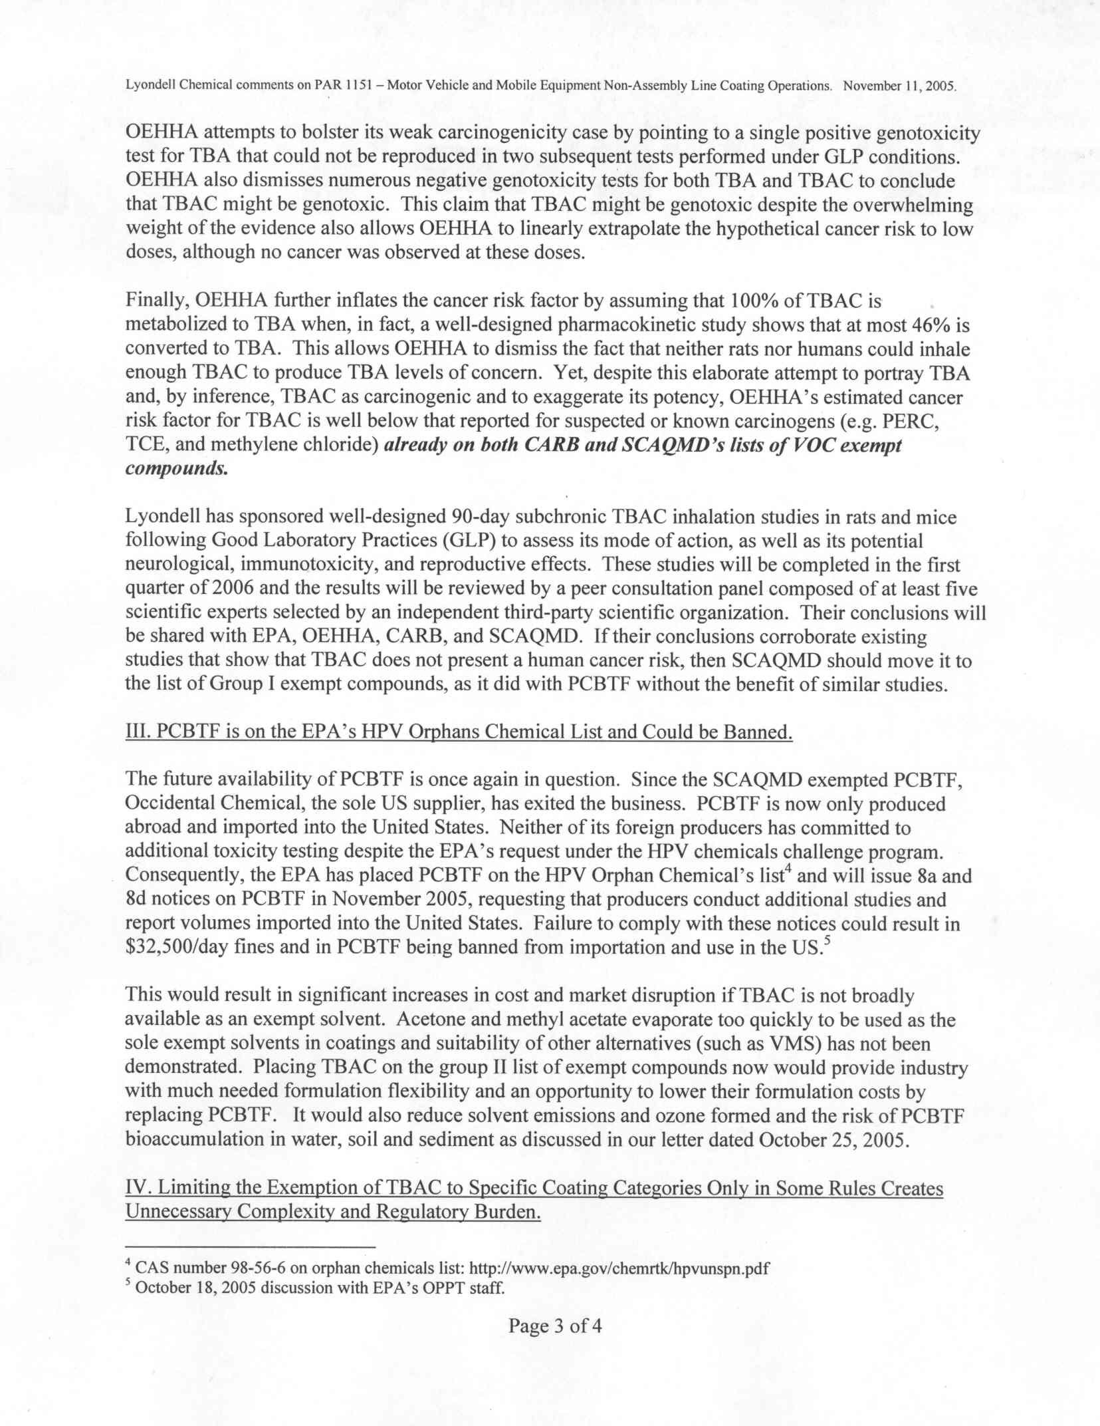
5-5
5-4
5-3
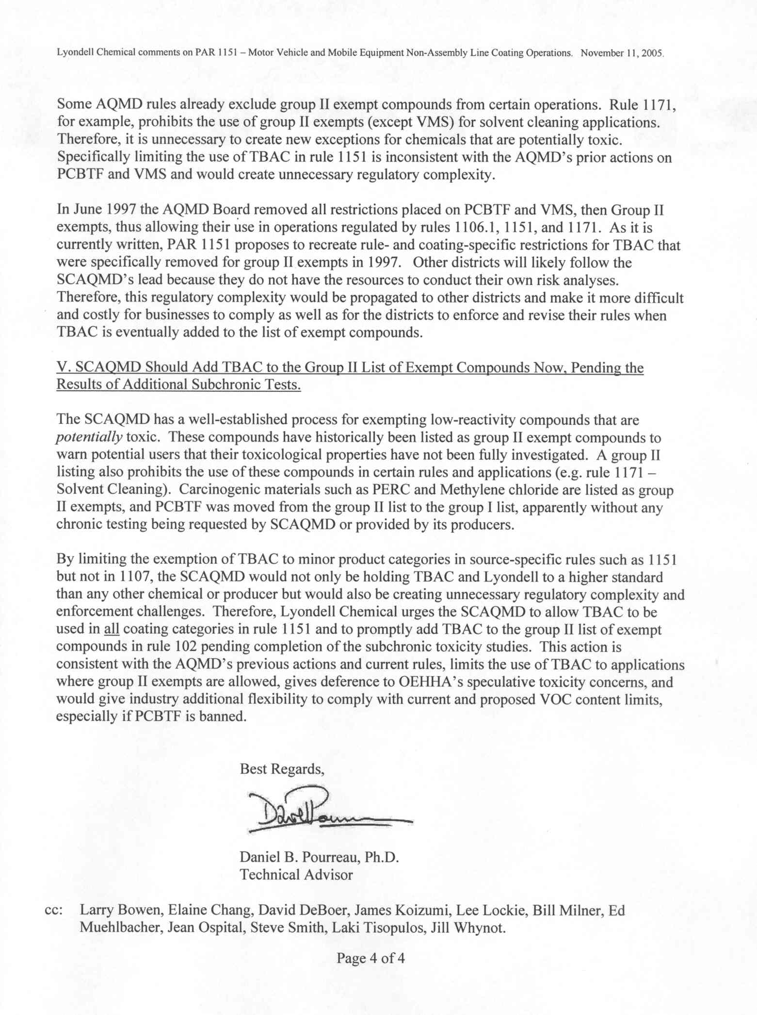
5-7
5-6
Responses to Comment Letter #5
Lyondell Chemical Company
November 15, 2005

Response 5-1
The commentator summarizes his concerns about the limited VOC exemption in PAR 1151 and the health risk analysis prepared for the draft EA. These comments are expanded in later in the letter. SCAQMD staff addresses these concerns in Response 5-2 through 5-7.

Response 5-2
The commentator states that absence of chronic toxicity data did not prevent the exemption of PCBTF from the VOC definition in Rule 102; therefore, absence of chronic toxicity data should not be used to limit the exemption of TBAc. Exempting PCBTF from the definition is not part of the currently proposed project. In addition, amending Rule 102 to modify the list of compounds exempted from definition of VOC is also not under consideration at this time. The considerations relative to exempting VOCs from the definition of VOC have changed since PCBTF was originally exempted from the definition of VOC in 1995. Please refer to response #3-6 for additional information relative to exempting PCBTF from the definition of VOC.

No health risk values are available from OEHHA for PCBTF. Should OEHHA provided health risk values for PCBTF, SCAQMD staff will appropriately assess such data.

SCAQMD staff prepared the TBAc health risk analysis for PAR 1151 based upon health risk values and associated parameters and methodology provided by OEHHA staff. ARB staff had completed health risk analysis on TBAc and SCAQMD staff used a similar methodology to evaluate the expected incremental TBAc health risk from PAR 1151. See also response #2-2.

Response 5-3
The commentator states that the OEHHA analysis of TBAc’s potential carcinogenicity is flawed. SCAQMD staff does not develop health risk values or associated parameters. For additional information, see responses #1-1 and 3-1.

The commentator states further that Lyondell has sponsored a 90-day sub chronic TBAc inhalation study and states that if the study does not demonstrate carcinogenic risk, then SCAQMD staff should include TBAc in the Group II exemption compound category of Rule 102. SCAQMD staff appreciates Lyondell’s commitment to complete a 90-day sub chronic study. If the results of Lyondell’s sub chronic toxicity testing are available, they will be included as part of the technology assessment presented to the Governing Board by July 1, 2007. SCAQMD staff requests that Lyondell complete a long-term toxicity study on TBAc to evaluate carcinogenic risk in addition to the 90-day sub chronic study.

Since OEHHA has developed risk factors for use in the evaluation of health risk from TBAc exposure; therefore, SCAQMD staff believes that the health risk evaluation in the Draft EA was prudent.

Response 5-4
The commentator states that PCBTF may be banned because of failure of suppliers to comply with EPA HPV 8a and 8d notices. The commentator makes cost and market conclusions based upon this assumption that PCBTF would be banned. The commentator’s concern about the banning of PCBTF is speculative. It is not clear that the suppliers would resist the EPA’s request for further information or testing of PCBTF to the point that EPA would levy fines or ban PCBTF. Since PCBTF is listed as a HPV chemical, the suppliers would have an economic incentive to continue supplying PCBTF. See also response #3-5.

Response 5-5
The commentator states that placing TBAc in the Group II exempt compounds definition would provide industry formulation flexibility, lower costs, reduce emissions and ozone formation, and lower the risk of PCBTF bioaccumulation in water, soil and sediment. With regard to these issues, refer to responses #3-3, #3-4, and #3-7.

Response 5-6
The commentator states that by providing exemptions within individual rules such as PAR 1151, SCAQMD staff would add unnecessary complexity and regulatory burden, which would potentially influence other air districts to make similar amendments to their rules. The commentator states that SCAQMD staff should instead add TBAc to the Group II exempt compounds definition in Rule 102, which is constant with past staff action.

SCAQMD staff used the ARB Automotive Refinishing Coating SCM as guidance in developing PAR 1151. ARB exempted TBAc from its VOC definition only for automotive refinishing coatings. SCAQMD staff used a similar approach, but further narrowed the exemption of TBAc from the VOC definition by limiting the exemption only to color and clear coat categories. The limited exemption for TBAc limits public exposure to TBAc, while providing a solvent that will assist manufacturers with formulating coatings that would comply with the proposed VOC content limits in PAR 1151.

The scope of this CEQA project is PAR 1151 and does not include amendments to Rule 102 or consideration of exempting PCBTF from the definition of VOC. Please refer to response #3-6 for additional information relative to exempting PCBTF from the definition of VOC.

Response 5-7
The commentator states that SCAQMD staff should add TBAc to the Group II exempt compounds definition in Rule 102. The commentator states that by exempting TBAc from the VOC definition under PAR 1151, SCAQMD staff holds Lyondell/TBAc to a higher standard than other producer/chemical. The commentator’s comments about adding TBAc to the Group II exempt compounds definition in Rule 102 are addressed in the Response 5-6.

SCAQMD staff has evaluated TBAc according to guidance provided by OEHHA and ARB. OEHHA has advised evaluating the health risk impacts from TBAc usage with toxic values and associated parameters developed by their staff. ARB staff included a VOC exemption for TBAc in their SCM for Automotive Coatings. Using the SCM as guidance, SCAQMD staff has proposed a limited VOC exemption for TBAc. SCAQMD staff has evaluated health risk from increased TBAc use expected by the limited VOC exemption in PAR 1151, because OEHHA has provided toxic values for TBAc and ARB staff has completed health risk assessments on TBAc. The procedure follow by SCAQMD staff would have been similar for any chemical with similar guidance, parameters and methodology provided by OEHHA and ARB.

The Lewis-Presley Air Quality Management Act, 1976 Cal. Stats., ch 324 (codified at Health & Safety Code, §§40400-40540).
Health & Safety Code, §40460 (a).
Health & Safety Code, §40440 (a).
Revision to Definition of Volatile Organic Compounds – Exclusion of t-Butyl Acetate, 40 CFR Part 51, Federal Register 69298, November 29, 2004
Formaldehyde, toluene, and xylene are classified as having both chronic and acute health effects; ethylbenzene as having chronic health effects and zinc oxide proposed as having chronic health effects; MEK as having acute health effects with future proposed risk value for chronic; and, cobalt compounds as having future proposed risk values. Toluene diisocyanates have both chronic and carcinogenic health effects. In addition, MIBK is classified by EPA as a HAP but the toxicology assessment is not finalized. Exposure to these substances has been demonstrated to cause adverse health effects such as irritation of the lung, skin, and mucous membranes, and effects on the central nervous system, liver, and heart.
TACs and HAPs are used interchangeably throughout this document.
Revision to Definition of Volatile Organic Compounds – Exclusion of t-Butyl Acetate, 40 CFR Part 51, Federal Register 69298, November 29, 2004
In a letter dated June 30, 2005 which discusses the status of TBAc use in California, CARB stated, “we encourage air districts, as they update applicable rules, to determine whether or not (the) use of TBAc would pose unacceptable exposures.”
Group I vehicles include large trucks, buses, and mobile equipment.
Group II vehicles include passenger cars, small-sized trucks and vans, medium-sized trucks and vans, motor homes, and motorcycles.
The VOC limit for spot repairs on Group I vehicles is 3.5 lb/gal.
Assuming a 2.1 lbs/gal clear coat VOC limit, the existing color coat VOC limits are 4.2 and 6.3 lbs/gal for Groups I and II vehicles, respectively.
Revision to Definition of Volatile Organic Compounds – Exclusion of t-Butyl Acetate, 40 CFR Part 51, Federal Register 69298, November 29, 2004
In a letter dated June 30, 2005 which discusses the status of TBAc use in California, CARB stated, “we encourage air districts, as they update applicable rules, to determine whether or not (the) use of TBAc would pose unacceptable exposures.”
Revision to Definition of Volatile Organic Compounds – Exclusion of t-Butyl Acetate, 40 CFR Part 51, Federal Register 69298, November 29, 2004.
Telephone conversation from James Koizumi to Richard Barca, Southern California Gas, September 17, 2003.
Although not currently exempt from the definition of VOC, staff is proposing a limited exemption for TBAc for specific coating categories.
Los Angeles County Sanitation Districts (LACSD), 1999. Letter from Charles W. Carry and Paul C. Martyn to Louis Yuhas of SCAQMD. June 29, 1999.
Increased perchloroethylene concentrations were believed to be from consumer products used by home auto maintenance as well as potential contribution from cleaners used by automotive repair facilities. Increased surfactant use was believed to be from personal care and cleaning products (Final EIR for the 2003 AQMP).
Heil, Ann, 2003. Electronic mail correspondence from Ann Heil of LACSD to Michael Krause of SCAQMD. April 2, 2003.

