SOUTH COAST AIR QUALITY MANAGEMENT DISTRICT

Addendum to the Final Environmental Impact Report for the

Chevron Products Company - El Segundo Refinery
Heavy Crude Project

SCH. No. 2005091152

[Final EIR Certified August 9, 2006]

December 2006
Executive Officer
Barry R. Wallerstein, D.Env.
Deputy Executive Officer
Planning, Rule Development, and Area Sources
Elaine Chang, DrPH
Assistant Deputy Executive Officer
Planning, Rule Development, and Area Sources
Laki Tisopulos, Ph.D., P.E.
Planning and Rules Manager
Planning, Rule Development and Area Sources
Susan Nakamura

Prepared by: ENSR Corporation

Reviewed by: Michael Krause - Air Quality Specialist, CEQA
Steve Smith, Ph.D. – Program Supervisor, CEQA
Mike Harris – Senior Deputy District Counsel, SCAQMD
Cher Snyder – Senior Enforcement Manager, SCAQMD
SOUTH COAST AIR QUALITY MANAGEMENT DISTRICT GOVERNING BOARD

Chairman: WILLIAM A. BURKE, Ed.D.
Speaker of the Assembly Representative

Vice Chairman: S. ROY WILSON, Ed.D.
Supervisor, Fourth District
Riverside County Representative

MEMBERS:

MICHAEL D. ANTONOVICH
Supervisor, Fifth District
Los Angeles County Representative

JANE CARNEY
Senate Rules Committee Appointee

RONALD O. LOVERIDGE
Mayor, City of Riverside
Cities Representative, Riverside County

GARY OVITT
Supervisor, Fourth District
San Bernardino County Representative

JAN PERRY
Councilmember, 9th District
Cities Representative, Los Angeles County, Western Region

MIGUEL A. PULIDO
Mayor, City of Santa Ana
Cities Representative, Orange County

TONIA REYES URANGA
Councilwoman, City of Long Beach
Cities Representative, Los Angeles County, Eastern Region

VACANT
Orange County Representative

CYNTHIA VERDUGO-PERALTA
Governor's Appointee

DENNIS YATES
Mayor, City of Chino
Cities Representative, San Bernardino County

EXECUTIVE OFFICER
BARRY WALLERSTEIN, D.Env.
TABLE OF CONTENTS

CHEVRON PRODUCTS COMPANY EL SEGUNDO REFINERY

DECEMBER 2006 ADDENDUM TO THE AUGUST 2006 FINAL EIR FOR THE HEAVY CRUDE PROJECT

Page No.
1.0 INTRODUCTION 1
2.0 Basis for Decision to Prepare an Addendum 2
3.0 BACKGROUND CEQA DOCUMENTS 4
4.0 PROJECT LOCATION 5
5.0 Project Description 5
5.1 Project as Analyzed in August 2006 Final EIR 5
5.2 Current Proposed Project Modification 10
6.0 IMPACT ANALYSIS 12
6.1 Summary of Impacts in August 2006 Final EIR 14
6.2 Analysis of Impacts from the Current Proposed Project Modification 15
7.0 TOPIC AREAS FOUND NOT TO BE POTENTIALLY SIGNIFICANT 24
7.1 August 2006 Final EIR 24
7.2 Current Proposed Project Modification 30
8.0 CONCLUSIONS 34
9.0 REFERENCES 34

TABLES

Table 6-1 SCAQMD Air Quality Significance Thresholds 16
Table 6-2 Peak Daily Mitigated Construction Emissions from August 2006 Final EIR 17
Table 6-3 Emission Reductions from Proposed Revised Mitigation Measure AQ-1 18
Table 6-4 Revised Peak Daily Mitigated Construction Emissions 19
Table 6-5 Comparison of August 2006 Final EIR Peak Daily Mitigated Construction Emissions with the Current Proposed Project Modification Peak Daily Construction Emissions 21
Table 6-6 Summary of Mitigated Localized Construction Air Quality Impacts Analysis from August 2006 Final EIR 22
Table 6-7 Summary of Revised Mitigated Localized Construction Air Quality Impacts Analysis 22
Table 6-8 Comparison of August 2006 Final EIR and Current Proposed Project Modification Mitigated Localized Construction Air Quality Impacts Analysis 23

FIGURES

Figure 4-1 Regional Location Map (August 2006 Final EIR Figure 2-1) 6
Figure 4-2 Site Location Map Chevron El Segundo Refinery (August 2006 Final EIR Figure 2-2) 7
Figure 4-3 Site Plan Showing Locations of Project Components (August 2006 Final EIR Figure 2-4) 8
Figure 5-1 Site Plan Showing Locations of Equipment to be Shutdown During No. 4 Crude Unit and Coker Turnarounds 13

APPENDIX
Appendix A AUGUST 2006 FINAL EIR - CHAPTER 1 - INTRODUCTION AND EXECUTIVE SUMMARY
Appendix B REVISED CONSTRUCTION EMISSIONS

INTRODUCTION
The Chevron Products Company - El Segundo Refinery Heavy Crude Project involves modifications to the Chevron Products Company (Chevron) El Segundo Refinery to enable the refinery to maintain or slightly increase its current production levels of saleable products while processing more heavy crude oil and less light crude oil than it currently processes. Maintaining current production levels of saleable products while processing more heavy crude oil will require an annual increase of approximately five percent in the total amount of crude oil processed by the refinery. The project will also reduce sulfur dioxide (SO₂) emissions from refinery fuel gas combustion.
The refinery processes crude oil to produce motor fuels and other saleable petroleum products. The refinery processes both heavy and light crude oils. Heavy crude oils are more dense and viscous than light crude oils and generally produce smaller amounts of motor fuels per barrel than light crude oils. Because most new crude oil discoveries in the world are heavier than historic crude oil supplies, Chevron proposed modifications to the refinery to maintain or slightly increase its current production levels of saleable petroleum products by being able to process more heavy crude oil and less light crude oil than it currently processes. To process more heavy crude oil, the refinery operators proposed modifications to the No. 4 Crude Distillation Unit and the Delayed Coking Unit (Coker). Chevron also proposed modifications to the No. 6 H₂S Plant to improve the removal efficiency of sulfur compounds from refinery fuel gas to assist the refinery in complying with South Coast Air Quality Management District (SCAQMD) Regulation XX - Regional Clean Air Incentives Market (RECLAIM), and to increase the reliability of the removal process.
As lead agency, the SCAQMD, prepared the August 2006 Final Environmental Impact Report for the Chevron Products Company - El Segundo Refinery Heavy Crude Project [SCAQMD, SCH No. 2005091152] (August 2006 Final EIR), which was certified in August 2006, to evaluate the potential environmental impacts associated with the proposed modifications to the El Segundo Refinery.
The Chevron El Segundo Refinery has recently commenced the construction of the Heavy Crude Project as described in the certified August 2006 Final EIR. Refinery operators are now proposing a modification that requires changing a mitigation measure specified in the August 2006 Final EIR. Specifically, Chevron has determined that it will not be feasible to continue to implement Mitigation Measure AQ-1, which requires the use of PuriNOx water-emulsified diesel fuel in construction equipment during construction of the Heavy Crude Project, after December 2006. Lubrizol, the producer of PuriNOx, will no longer produce PuriNOx after December 2006. Chevron cannot acquire and store PuriNOx before the end of 2006 for use during the entire construction period, which is anticipated to end in early 2008, because PuriNOx degrades with time and cannot be used after approximately one month of storage. In order to compensate for the emission reductions that will not be achieved when PuriNOx can no longer be obtained, Chevron is proposing to revise Mitigation Measure AQ-1. Chevron will discontinue use of PuriNOx after December 2006 and cease operation of various refinery process units during the peak construction periods, which will offset project construction emissions by eliminating air pollutant emissions from those process units during peak construction.
Chevron is not proposing any changes to the Heavy Crude Project refinery modifications evaluated in the August 2006 Final EIR, nor to the construction requirements or schedules.
The details of the proposed changes to air quality Mitigation Measure AQ-1 are explained in Section 5.2 of this Addendum.
The SCAQMD has evaluated the proposed changes to Mitigation Measure AQ-1 as required in the Heavy Crude Project at the Chevron El Segundo Refinery (as detailed in Section 5.2 of this Addendum) and determined that the proposed modification to Mitigation Measure AQ-1 does not create any new significant adverse environmental impacts or make substantially worse any existing significant adverse environmental impacts, and only minor additions or changes are necessary to make the previous August 2006 Final EIR adequate for the revised project. Therefore, when considering the effects of the current proposed project modification, the SCAQMD has concluded that an Addendum is the appropriate document to be prepared in accordance with the California Environmental Quality Act (CEQA) in order to evaluate potential environmental impacts associated with the current proposed project modification.

Basis for Decision to Prepare an Addendum
The SCAQMD was the lead agency responsible for preparing the August 2006 Final EIR and is the public agency that has the primary responsibility for approving the current proposed project modification. Therefore, the SCAQMD is the appropriate lead agency to evaluate the potential environmental effects of the current proposed project modification that is the subject of this Addendum.
Based on the analysis of the current proposed project modification that follows in Sections 6.0 and 7.0, the SCAQMD has concluded that the only environmental area affected by the current proposed project modification is air quality during construction. The August 2006 Final EIR identified significant adverse project air quality impacts during construction. The current proposed project modification does not change this conclusion: significant adverse air quality impacts of the Heavy Crude Project would still occur during construction under the proposed change to Mitigation Measure AQ-1. However, as shown in Subsection 6.2.1 of this Addendum, the current proposed project modification, which is the revision to Mitigation Measure AQ-1, will not result in new significant adverse air quality impacts or increase the severity of significant adverse air quality impacts previously identified in the August 2006 Final EIR.
The August 2006 Final EIR analyzed the construction impacts during each month of the construction period, because construction activities and the resulting emissions vary from one month to another. The month with the highest emissions was identified to determine the anticipated peak daily emissions during construction, which were anticipated to occur during October 2007. The analysis in the August 2006 Final EIR indicated that unmitigated peak daily emissions of carbon monoxide (CO), volatile organic compounds (VOC), nitrogen oxides (NO_{x}) and particulate matter with an aerodynamic diameter less than or equal to 10 microns (PM10) were anticipated to exceed the respective SCAQMD CEQA significance thresholds for construction. Therefore, feasible mitigation measures were identified. The analysis of monthly construction emissions was then repeated with the effects of the mitigation measures on emissions included. This analysis of mitigated construction emissions indicated that peak daily CO, VOC and NO_{x} emissions, which were still anticipated to occur during October 2007, would continue to exceed the respective CEQA significance thresholds, but peak daily mitigated PM10 emissions would be reduced to less than the CEQA significance threshold.
The construction air quality impacts analysis for the current proposed modification to air quality Mitigation Measure AQ-1 includes discontinuing the use of PuriNOx emulsified diesel fuel after December 2006, and ceasing operation of various refinery process units during peak construction periods, which will occur from late-March 2007 through early-May 2007 and from mid-September 2007 through November 2007 (see discussion in Section 6.0). During the first of these two peak construction periods, construction activities for modifications to the No. 4 Crude Unit will be at their peak, and the No. 4 Crude Unit and other associated refinery process units will be shutdown. During the second peak construction period, construction activities for modifications to the Coker will be at their peak, and the Coker and other associated refinery process units will be shutdown. The results indicate that peak daily mitigated CO, VOC, SO_{x} and PM10 construction emissions associated with the current proposed revision to air quality Mitigation Measure AQ-1 are less than the peak daily construction emissions for the project shown in the August 2006 Final EIR (see Section 6.0, Table 6-5). Peak daily mitigated NO_{x} emissions will be higher than peak daily mitigated NO_{x} emissions in the August 2006 Final EIR, but the increase is not considered to be a substantial increase and, therefore, less than significant. Thus, no new significant adverse impacts from construction activities are expected from the current proposed project modification, and existing significant adverse impacts previously identified in the August 2006 Final EIR will not be made substantially worse.
Therefore, it can be concluded that the current proposed project modification does not create new significant adverse impacts or increase the severity of significant impacts previously identified in the August 2006 Final EIR. As a result, pursuant to CEQA Guidelines §15164(a), this document constitutes an Addendum to the August 2006 Final EIR for the Chevron Products Company - El Segundo Refinery Heavy Crude Project. Section 6.0 of this Addendum further explains the basis for the determination to prepare an Addendum.
CEQA Guidelines §15164(a) allows a lead agency to prepare an Addendum to a Final EIR if all of the following conditions are met.
- Substantial changes with respect to the circumstances under which the project is undertaken do not require major revisions to the previous Final EIR due to the involvement of new significant environmental effects or a substantial increase in the severity of previously identified significant effects.
- No new information becomes available which shows new significant effects or significant effects substantially more severe than previously discussed.
- The project proponent agrees to adopt mitigation measures which are different from those analyzed in the previous EIR that would substantially reduce one or more significant effects on the environment.
- Only minor technical changes or additions are necessary to make the Final EIR under consideration adequate under CEQA.
- The changes to the Final EIR made by the Addendum do not raise important new issues about the significant effects on the environment.
The current proposed project modification will result in no new significant adverse effects or substantially increased severity of significant effects previously identified. Further, the current proposed project modification consists of only minor changes to the August 2006 Final EIR that do not raise important new issues about the previously analyzed significant environmental effects. Thus, the current proposed project modification meets all of the conditions in the CEQA Guidelines for the preparation of an Addendum.

BACKGROUND CEQA DOCUMENTS
The activities associated with the Chevron Products Company - El Segundo Refinery Heavy Crude Project were evaluated sequentially in the following CEQA documents. Summaries of each of these CEQA documents are provided below. The August 2006 Final EIR can be obtained by contacting the SCAQMD's Public Information Center at (909) 396-2039 or it can be downloaded from the SCAQMD’s CEQA Webpages at the following Internet address:
http://www.aqmd.gov/ceqa/documents/2006/nonaqmd/chevron/chev_feir.html
Notice of Preparation and Initial Study for the Draft Environmental Impact Report For Proposed Chevron Products Company - El Segundo Refinery Heavy Crude Project (SCAQMD, September 2005): A Notice of Preparation (NOP) and Initial Study for the Chevron - El Segundo Refinery Heavy Crude Project were released for a 30-day public review and comment period on September 29, 2005. The Initial Study included a project description, project location, an environmental checklist, and a discussion of potential adverse environmental impacts. The NOP solicited input from public agencies and other interested parties on the scope and content of the environmental information to be evaluated in the Draft EIR.
Draft Environmental Impact Report for Chevron Products Company - El Segundo Refinery Heavy Crude Project (SCAQMD, April 2006): The Draft EIR was released for a 45-day public review and comment period on April 25, 2006. The Draft EIR included a comprehensive project description, a description of the existing environmental setting that could be adversely affected by the proposed project, analysis of potential adverse environmental impacts (including cumulative impacts), mitigation measures, project alternatives, and all other topics required by CEQA. The Draft EIR also included a copy of the NOP and Initial Study, copies of comment letters received on the NOP and Initial Study, and responses to all comment letters received on the NOP and Initial Study. The Draft EIR concluded that the El Segundo Refinery Heavy Crude Project may generate significant adverse impacts, following mitigation, in two environmental areas: air quality and hazards.
Final Environmental Impact Report for Chevron Products Company - El Segundo Refinery Heavy Crude Project (SCAQMD, August 2006): The Final EIR was prepared by revising the Draft EIR to incorporate applicable updated information and to respond to comments received on the Draft EIR. The Final EIR contained comment letters and responses to comments received on the Draft EIR. The changes included in the Final EIR did not constitute significant new information relating to the environmental analysis or mitigation measures. The Final EIR was certified on August 9, 2006.

PROJECT LOCATION
The current proposed project modification applies only during construction of modifications to the No. 4 Crude Unit, the Coker and the No. 6 H₂S Plant at Chevron’s El Segundo Refinery; no changes are planned for other process units or support facilities at the refinery. The location of the refinery within the overall southern California region is shown in Figure 4-1. The refinery is located at 324 West El Segundo Boulevard in the City of El Segundo, California, as shown in Figure 4-2. The refinery occupies an irregularly shaped parcel of land, between Vista Del Mar on the west, El Segundo Boulevard on the north, Sepulveda Boulevard on the east, and Rosecrans Avenue on the south. All proposed modifications will occur within the confines of the existing refinery. The locations of the No. 4 Crude Unit, the Coker and the No. 6 H₂S Plant within the refinery are shown in Figure 4-3.

Project Description
This section presents a description of the Chevron Heavy Crude Project as evaluated in the August 2006 Final EIR, as well as a description of the current proposed project modification. Although the current proposed project modification only affects one air quality mitigation measure during the construction phase, a full description of the entire project analyzed in the August 2006 Final EIR is provided to present a clear understanding of the previously proposed project as compared with the current proposed modification to the project.

Project as Analyzed in August 2006 Final EIR
Processing more heavy crude oil will increase the quantity of vacuum residuum produced from each barrel of crude oil. The No. 4 Crude Unit would not be able to handle the increase, so Chevron proposed modifications to the No. 4 Crude Unit to handle the increased vacuum residuum production. The design changes required to handle the increased vacuum residuum production will result in an overall increase in the crude-oil processing capacity of the No. 4 Crude Unit of approximately five percent, while resulting in a reduction in the amount of light crude oil processed.
Proposed modifications to the No. 4 Crude Unit included modifying internal components of the atmospheric and vacuum distillation columns to improve distillation efficiency; replace steam ejectors on the vacuum distillation column to increase column production capacity; modify and add new heat exchangers to increase heat recovery and reduce pressure drop; modify pumps to handle higher viscosity material; replace piping with larger diameter pipes to reduce pressure drop; and install additional automated controls for existing equipment to improve emergency response and normal operating efficiency.
The current annual average vacuum residuum feed capacity of the Coker is 60 thousand barrels per operating day (MBPOD). Chevron proposed modifications to increase the annual average capacity of the Coker to 75 MBPOD to accommodate the increase in vacuum residuum production when more heavy crude oil is processed. Petroleum coke production will increase by 510 tons per day, from an annual average of 3,950 tons per day to 4,460 tons per day. Approximately 20 additional truck trips per day are required to export the increased quantities of petroleum coke from the refinery. The production of light products by the Coker will also increase.
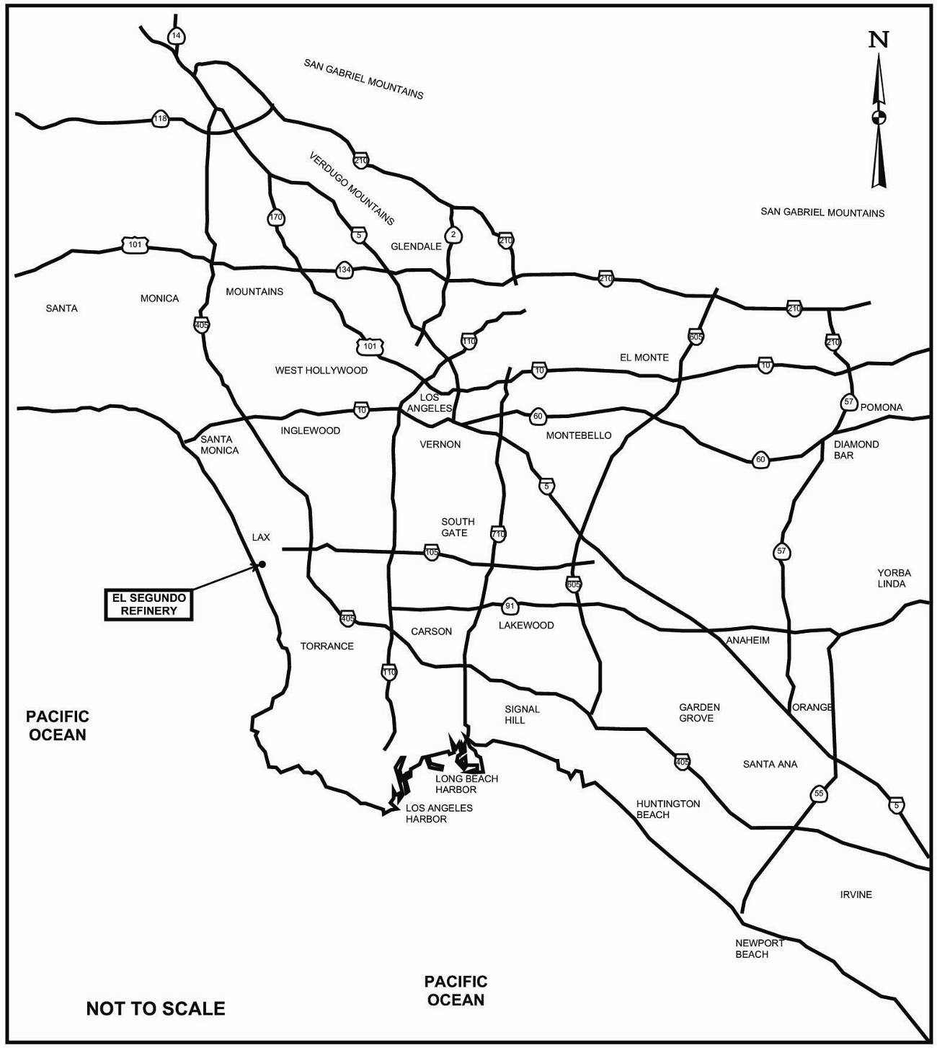
Figure 4-1 Regional Location Map
(August 2006 Final EIR Figure 2-1)

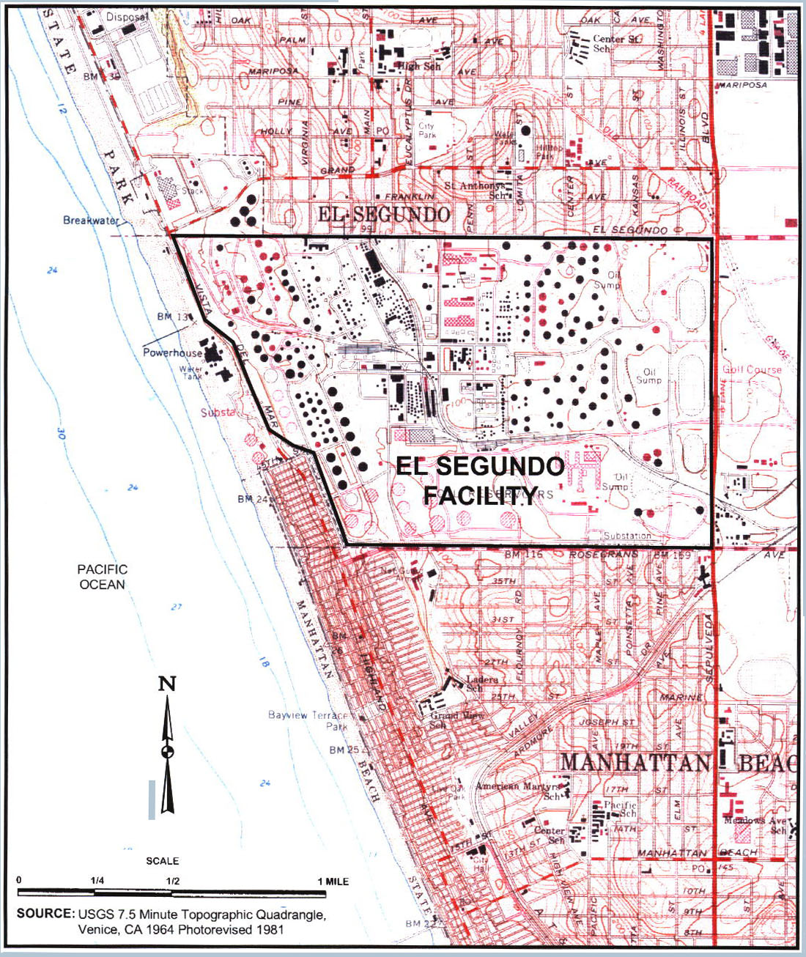
Figure 4-2 Site Location Map Chevron El Segundo Refinery
(August 2006 Final EIR Figure 2-2)
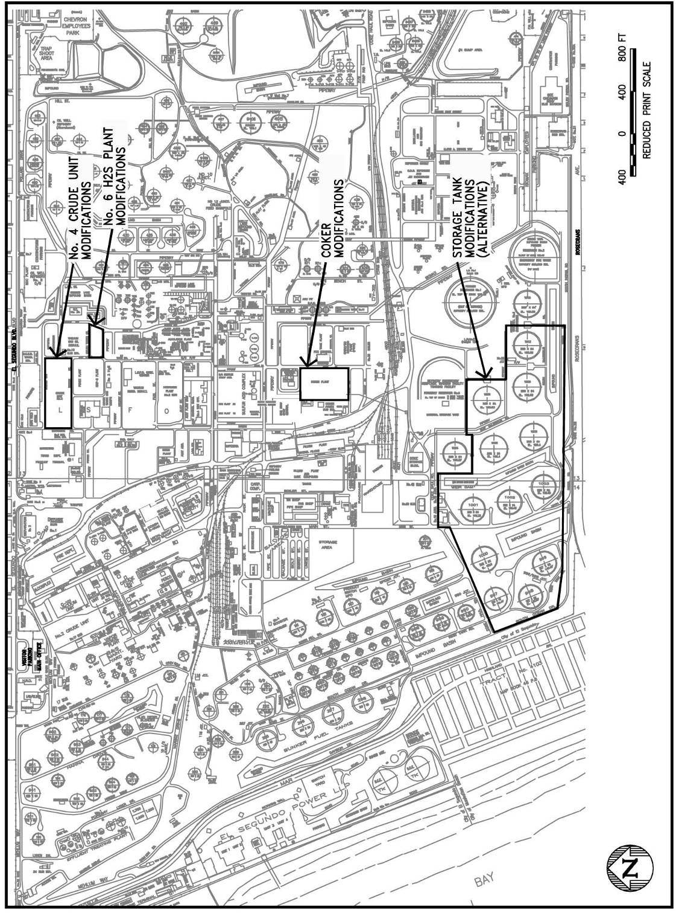
Figure 4-3 Site Plan Showing Locations of Project Components
(August 2006 Final EIR Figure 2-4)
Proposed modifications to the Coker included the installation of new heat exchangers to increase heat transfer; installation of a new cooling water supply and return system from Cooling Tower No. 9 to the Coker to increase coke-drum cooling capacity; replacement of an existing depropanizer with a larger depropanizer to increase propane removal capacity; replacement of the Coker Main Fractionator column with a larger column to increase light-product separation capacity; installation of new pumps and upgrades to existing pumps to increase pumping capacity; upgrades to the gas compression equipment at the Coker to increase capacity; modifications to the coke drums and coke drilling systems to reduce the cycle time from 15 hours to 12 hours; and installation of additional automated controls for existing equipment to improve emergency response and normal operating efficiency. Chevron proposed to install a control device to reduce emissions when the coke drums are depressurized before they are opened.
The current capacity of the petroleum coke conveying system is adequate to accommodate the proposed increase in petroleum coke production, and Chevron did not propose to increase the conveying system’s capacity. Chevron did, however, propose to modify portions of the petroleum coke conveying system to allow more efficient handling of the petroleum coke and to reduce particulate matter emissions during petroleum coke transport and export truck loading operations.
Chevron proposed to install a new diethanol amine (DEA) Regenerator in the No. 6 H₂S Plant, which will regenerate the rich DEA from the No. 6 H₂S Plant and eliminate the need to send the rich DEA to the No. 5 H₂S Plant for regeneration, as is currently done. The hydrogen sulfide (H₂S) produced by the regenerator will be processed by the refinery’s Sulfur Recovery Units to remove the H₂S and convert it to elemental sulfur, which is subsequently exported from the refinery for sale. Chevron proposed to install a new Relief Caustic Scrubber in the No. 6 H₂S Plant to remove H₂S from the acid gas produced by the proposed new DEA regenerator in case of an emergency that would prevent the Sulfur Recovery Units from processing the acid gas. Chevron also proposed to install a new Jet Wash Column to absorb any remaining carbonyl sulfide (COS) from the process gas stream leaving the Merox section of the No. 6 H₂S Plant. The proposed Jet Wash column will use circulating jet or diesel fuel to absorb COS from the gas stream.
The overall construction period for the proposed project is expected to continue into March 2008. Peak overall construction employment is anticipated to be 694 workers during October 2007, and average construction employment over the entire 22-month construction period is estimated at about 242 workers.
During most of the construction period, construction will take place 10 hours per day, from 6:30 a.m. to 5:00 p.m., five days per week, Monday through Friday. Turnarounds, which are times when refinery equipment is removed from service for maintenance activities, are scheduled for the No. 4 Crude Unit from late-March 2007 through early-May 2007 and for the Coker from mid-September 2007 through November 2007. A substantial amount of the construction for the proposed modifications to the No. 4 Crude Unit and the Coker, such as replacement of internal components, can only take place during these turnarounds when the units are out of service. Therefore, to minimize the amount of time that the units are out of service, construction during the turnarounds will take place in two 10-hour shifts, from 6:30 a.m. to 5:00 p.m. and from 6:30 p.m. to 5:00 a.m., six days per week, Monday through Saturday.

Current Proposed Project Modification
The current proposed modification involves changes to one air quality construction mitigation measure, and does not modify any other aspects of the construction or operation of the proposed project as analyzed in the August 2006 Final EIR.
The Chevron El Segundo Refinery has recently commenced the construction of the Heavy Crude Project as described in the certified Final EIR. The current proposed modification will involve changes to a mitigation measure specified in the August 2006 Final EIR. Specifically, Chevron has determined that it will not be feasible to continue to implement Mitigation Measure AQ-1 after December 2006. AQ-1 requires the use of PuriNOx water-emulsified diesel fuel in construction equipment during construction of the Heavy Crude Project after December 2006. Lubrizol, the producer of PuriNOx, will no longer produce PuriNOx after December 2006. Chevron cannot acquire and store PuriNOx before the end of 2006 for use during the entire construction period, which is anticipated to end in early 2008, because PuriNOx degrades with time and cannot be used after approximately one month of storage. Additionally, the additives blended with diesel fuel and water to produce PuriNOx degrade after approximately three months of storage. Therefore, Chevron cannot acquire the additives before the end of 2006 and blend them with water and diesel fuel for use during the remainder of the construction period.
The use of PuriNOx as required by Mitigation Measure AQ-1 was estimated to reduce emissions of NO_{x} and PM10 from construction equipment exhaust by 14 percent and 62.9 percent, respectively. In order to compensate for the emission reductions that will not be achieved when PuriNOx is no longer used after December 2006, Chevron is proposing to revise mitigation measure AQ-1. The revised mitigation measure will require Chevron to cease operation of various refinery process units, which will eliminate air pollutant emissions from those process units, during the peak construction periods. These peak construction periods will occur during the No. 4 Crude Unit turnaround, which will occur from late-March 2007 through early May 2007, and during the Coker turnaround, which will occur from mid-September 2007 through November 2007.
Mitigation Measure AQ-1 in the August 2006 Final EIR (page 4-35) is written as follows:
AQ-1) Diesel-powered construction equipment will be fueled with emulsified diesel fuel throughout construction of the proposed project.
The California Air Resources Board has established an interim procedure for verification of emission reductions for alternative diesel fuels. This procedure has been used to verify emission reductions from the use of four alternative diesel fuels: PuriNOx diesel fuel developed by Lubrizol Corporation, Aquazole fuel developed by TotalFinaElf, Clean Fuels Technology’s emulsified diesel fuel, and O₂ Diesel Fuel developed by O2 Diesel, Inc. Specifically, Lubrizol’s water-emulsified PuriNOx diesel fuel has been verified to reduce NO_{x} emissions by 14 percent and PM10 emissions by 62.9 percent (ARB, 2001).
Chevron supplies PuriNOx to customers in the South Coast Air Basin from its Montebello distribution terminal. Chevron will ensure that the quantities of PuriNOx required for construction equipment for the proposed project will be available.
Prior to the start of construction for the proposed project, Chevron will verify that the construction equipment operates properly when fueled with PuriNOx diesel fuel. Minor modifications to the equipment will be made, if necessary, to enable it to operate properly using PuriNOx diesel fuel.
Mitigation measure AQ-1 is proposed to be revised to read as follows:
AQ-1) Diesel-powered construction equipment will be fueled with emulsified diesel fuel during construction of the proposed project through December 2006.
The California Air Resources Board has established an interim procedure for verification of emission reductions for alternative diesel fuels. This procedure has been used to provide interim verification for emission reductions from the use of four alternative diesel fuels: PuriNOx diesel fuel developed by Lubrizol Corporation, Aquazole fuel developed by TotalFinaElf, Clean Fuels Technology’s emulsified diesel fuel, and O₂ Diesel Fuel developed by O2 Diesel, Inc. Specifically, Lubrizol’s water-emulsified PuriNOx diesel fuel has been verified to reduce NO_{x} emissions by 14 percent and PM10 emissions by 62.9 percent (ARB, 2001).
Chevron supplies PuriNOx to customers in the South Coast Air Basin from its Montebello distribution terminal. Chevron will ensure that the quantities of PuriNOx required for construction equipment for the proposed project will be available through December 2006.
Prior to the start of construction for the proposed project, Chevron will verify that the construction equipment operates properly when fueled with PuriNOx diesel fuel. Minor modifications to the equipment will be made, if necessary, to enable it to operate properly using PuriNOx diesel fuel. Chevron will use PuriNOx through the end of December 2006.
The following refinery equipment will not be operated during the period of the No. 4 Crude Unit turnaround (late-March 2007 through early-May 2007):
- No. 4 Crude Unit furnaces F-1100 and F-1160
- No. 3 Naphtha Hydrotreater (NHT3) furnaces F-1000 and F-1010
- No. 2 Naphtha Hydrotreater (NHT2) furnace F-1210
- Steam Methane Reformer (SMR) furnace F-1330
- Vacuum Gas Oil Hydrotreater (VGO) furnaces F-1610 and F-1660
- Vacuum Resid Desulfurizer (VRDS) furnaces F-1510 and F-1520
The following refinery equipment will not be operated during the period of the Coker turnaround (mid-September 2007 through November 2007):
- No. 3 Caustic Treating Plant
- Coker furnaces F-501A, F-501B and F-501C
- Coke drums
The locations of the refinery equipment that will not be operated are shown in Figure 5-1.
These revisions to Mitigation Measure AQ-1 do not change the proposed modifications to the refinery that were analyzed in the August 2006 Final EIR, nor do they change the activities, equipment and personnel required to construct the proposed modifications or the manner in which the proposed modifications will be operated.
As stated in the second paragraph of Mitigation Measure AQ-1, interim verification for emission reductions from the use of four alternative diesel fuels has been provided. However, only one of these four alternative diesel fuels, O₂ Diesel Fuel developed by O2 Diesel, Inc., will be commercially available after December 2006. O₂ Diesel Fuel has been verified to reduce NO_{x} emissions by 1.6 percent (ARB, 2003), which is substantially less than the 14 percent reduction achieved by the use of PuriNOx, and PM10 emissions by 20 percent (ARB, 2003), which is also substantially less than the 62.9 percent reduction achieved by the use of PuriNOx. Because the emission reductions that would be achieved by the use of O₂ Diesel Fuel in construction equipment after December 2006 would be less than would have been achieved by the use of PuriNOx if it were still available, Chevron has not proposed to revise Mitigation Measure AQ-1 to require the use of O₂ Diesel Fuel after December 2006.
As shown in the following discussion, the SCAQMD has evaluated the proposed changes to the air quality construction Mitigation Measure AQ-1 and determined that the current proposed project modification does not create any new significant adverse environmental impacts or make substantially worse any existing significant adverse environmental impacts that were previously identified in the August 2006 Final EIR.

IMPACT ANALYSIS
This section presents a description of the impact analysis contained in the August 2006 Final EIR, as well as the analysis of the impacts of the current proposed project modification. Although the current proposed modification affects only one portion of the overall project evaluated in the August 2006 Final EIR, a full description of the impacts evaluated in the August 2006 Final EIR is presented to provide a clear understanding of the previously proposed project as well as the current proposed project.
This section sequentially presents the initial project evaluated in the August 2006 Final EIR and the current proposed project to show the chronology of the impact analysis, and to show the comparison of the current proposed modification with the August 2006 Final EIR project.
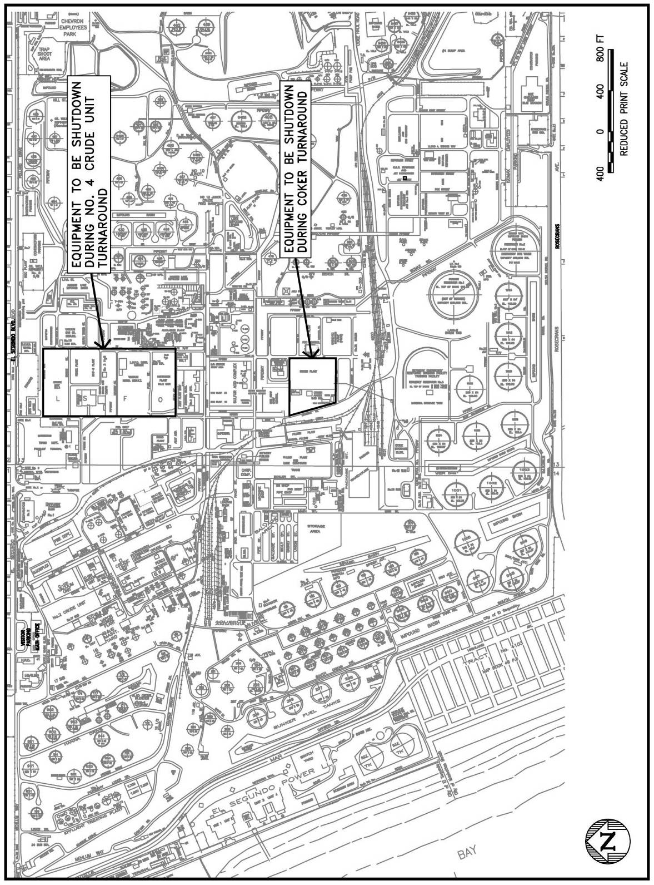
Figure 5-1 Site Plan Showing Locations of Equipment to be
Shutdown During No. 4 Crude Unit and Coker Turnarounds

Summary of Impacts in August 2006 Final EIR
The NOP/IS for the August 2006 Final EIR project evaluated all 17 of the environmental topics in accordance with CEQA and determined that 11 of the 17 environmental topics would not be significantly adversely affected by the proposed project. These topics were aesthetics, agricultural resources, biological resources, cultural resources, energy, geology and soils, land use and planning, mineral resources, population and housing, public services, and recreation. Two comment letters were received on the NOP/IS. However, none of the comments received expressed concerns about the 11 topics that the IS/NOP determined would not be significantly affected by the proposed project. Thus, these topics were not addressed further in the Draft EIR or the Final EIR.
Six of the 17 environmental topics required further evaluation in the EIR. The August 2006 Final EIR concluded that the following four of the six environmental topics evaluated in the EIR would not be significantly adversely affected by the proposed project or could be mitigated to a level of insignificance: hydrology/water quality, noise, solid and hazardous waste, and transportation and traffic. Section 7.0 of this Addendum discusses the effects of the current proposed project modification on the environmental topics not found to be significant and the environmental topics mitigated to a level of insignificance as concluded in the August 2006 Final EIR. The analysis shows that these environmental areas would not be substantially affected by the current proposed project modification. Therefore, the conclusions for these environmental topic areas from the August 2006 Final EIR do not change as a result of implementing the current proposed project modification.
As discussed in the following paragraphs, the August 2006 Final EIR identified potentially significant adverse impacts after the implementation of available mitigation measures for two environmental topic areas: 1) air quality (construction emissions), and 2) hazards (from the operation of a new DEA regenerator in the No. 6 H₂S Plant).
The August 2006 Final EIR indicated that the Chevron Heavy Crude Project would result in the following significant unavoidable adverse impacts:
- Emissions of CO, VOC and NO_{x} will exceed mass daily significance thresholds during construction; therefore, construction air quality impacts were considered to be significant.
- The hazard analysis showed that the proposed modifications to the No. 6 H₂S Plant could result in potential public exposure to significant adverse H₂S concentrations under “worst-case” consequence analysis conditions. As a result, the potential consequences of a release of H₂S associated with these modifications are significant.
The analysis in the August 2006 Final EIR also indicated that the proposed project would result in the following potentially significant but mitigable impacts:
- PM10 emissions during construction could potentially exceed the mass daily emissions threshold; mitigation measures were identified that would reduce the impacts to less-than-significant levels.
- Noise during construction activities could have potentially significant adverse impacts; mitigation measures were identified that would reduce the impacts to less-than-significant levels.

Analysis of Impacts from the Current Proposed Project Modification
This Addendum evaluated all 17 of the environmental topics as required by CEQA, and concluded that one environmental topic area would be affected by the current proposed project modification - air quality during construction. The primary reason is that the current proposed modification replaces an air quality mitigation measure which, in turn, affects only air quality and no other environmental topic. The following subsection presents the results of the evaluation of the air quality impacts associated with the current proposed project modification. Additionally, Subsection 6.2.2 presents the evaluation of hazard impacts associated with the current proposed project modification, since the August 2006 Final EIR concluded that the proposed project could result in significant adverse hazard impacts. Section 7.2 presents the analysis of the remaining 15 environmental topic areas where the impacts of the current proposed project modification were evaluated in the Addendum and found not to be potentially significant.
6.2.1 Air Quality
Both construction and operational air quality impacts were evaluated in the August 2006 Final EIR. Air quality impacts that equal or exceed the significance thresholds identified in Table 6-1 are considered to be significant adverse air quality impacts.

Construction Emissions - Regional Impacts
August 2006 Final EIR
The August 2006 Final EIR evaluated construction activities and emissions during each month of the entire construction period for the proposed modifications. The months with the highest emissions of each pollutant were then identified to determine the peak daily construction emissions of each pollutant. The August 2006 Final EIR concluded that peak daily emissions of CO, VOC, NO_{x} and PM10 would exceed the CEQA significance thresholds for construction. The peak daily construction emissions were anticipated to occur in October 2007, during the Coker turnaround. Feasible mitigation measures to reduce emissions during construction were identified. Peak daily mitigated construction emissions from the August 2006 Final EIR, which were also anticipated to occur in October 2007, are summarized in Table 6-2. Table 6-2 shows that mitigated peak daily CO, VOC and NO_{x} emissions would continue to exceed the CEQA significance thresholds for construction, but mitigated peak daily PM10 emissions would be below the significance threshold.

Table 6-1
SCAQMD Air Quality Significance Thresholds
Mass Daily Thresholds
Pollutant |  |  | Construction |  | Operation
NO_{x} |  |  | 100 lb/day |  | 55 lb/day
VOC |  |  | 75 lb/day |  | 55 lb/day
PM10 |  |  | 150 lb/day |  | 150 lb/day
PM2.5 |  |  | 55 lb/day |  | 55 lb/day
SO_{x} |  |  | 150 lb/day |  | 150 lb/day
CO |  |  | 550 lb/day |  | 550 lb/day
Lead |  |  | 3 lb/day |  | 3 lb/day
Toxic Air Contaminants (TACs) and Odor Thresholds
TACs  (including carcinogens  and non-carcinogens) |  |  | Maximum Incremental Cancer Risk ≥ 10 in 1 million  Hazard Index ≥ 1.0 (project increment)  Hazard Index ≥ 3.0 (facility-wide)
Odor |  |  | Project creates an odor nuisance pursuant to SCAQMD Rule 402
Ambient Air Quality for Criteria Pollutants ª
NO₂  1-hour average  annual average |  |  | District is in attainment; project is significant if it causes or contributes to an exceedance of the following attainment standards:  0.25 ppm (state)  0.053 ppm (federal)
PM10  24-hour average  annual geometric average  annual arithmetic mean |  |  | 10.4 μg/m³ (construction) ^{b}  2.5 μg/m³ (operation)  1.0 μg/m³  20 μg/m³
PM2.5  24-hour average |  |  | 10.4 μg/m³ (construction)^{b} & 2.5 μg/m³ (operation)
Sulfate  24-hour average |  |  | 1 μg/m³
CO  1-hour average  8-hour average |  |  | Although not designated attainment, the District meets the definition of attainment; project is significant if it causes or contributes to an exceedance of the following attainment standards:  20 ppm (state)  9.0 ppm (state/federal)
ª Ambient air quality thresholds for criteria pollutants based on SCAQMD Rule 1303, Table A-2 unless otherwise stated.
^{b} Ambient air quality threshold based on SCAQMD Rule 403.

KEY | lbs/day = pounds per day | ppm = parts per million |  | μg/m³ = microgram per cubic meter |  | ≥ greater than or equal to

Table 6-2
Peak Daily Mitigated Construction Emissions from August 2006 Final EIR
Source | CO  (lb/day) | VOC  (lb/day) | NO_{X}  (lb/day) | SO_{X}  (lb/day) | PM10  (lb/day)
Unmitigated Emissionsª | 927.8 | 273.2 | 1,526.8 | 2.4 | 185.3
CEQA Significance Level | 550 | 75 | 100 | 150 | 150
Significant? (Yes/No) | Yes | Yes | Yes | No | Yes
Mitigation Measures
Use PuriNOx emulsified diesel fuel^{b} | -- | -- | -193.8 | -- | -47.5
Use architectural coatings with 100 g/l VOC^{c} | -- | -52.7 | -- | -- | --
Increase watering to three times per day^{d} | -- | -- | -- | -- | -0
Total Reductions | 0 | -52.7 | -193.8 | 0 | -47.5
Mitigated Emissions | 927.8 | 220.5 | 1,333.0 | 2.4 | 137.8
CEQA Significance Level | 550 | 75 | 100 | 150 | 150
Significant after Mitigation? (Yes/No) | Yes | Yes | Yes | No | No
Month when Peak Daily Mitigated Emissions Occur | Oct ‘07 | Oct ‘07 | Oct ‘07 | Oct ‘07 | Oct ‘07
ª Emissions prior to mitigation during the month when peak daily mitigated emissions occur
^{b} Reductions of 14 percent for NO_{x} and 62.9 percent for PM10 are based on January 31, 2001, verification letter from Dean C. Simeroth, California Air Resources Board, to Thomas J. Sheahan, Lubrizol Corp.
^{c} Reduction from 250 g/l to 100 g/l reduces emissions by 60 percent.
^{d} Excavation does not occur during construction period with peak daily PM10 emissions. Therefore, increasing watering does not reduce peak daily PM10 emissions.
Negative numbers represent emission reductions.
Source: August 2006 Final EIR, Table 4.1-18.
Current Proposed Modification
Mitigated construction emissions with the proposed revision to Mitigation Measure AQ-1 were analyzed in this Addendum.
Emission reductions that will result from shutting down the furnaces and the No. 3 Caustic Treating Plant during the No. 4 Crude Unit and Coker turnarounds were assumed to equal the average daily emissions from the furnaces and the No. 3 Caustic Treating Plant based on historical data for the two-year period from July 2004 through June 2006, calculated from Chevron’s Annual Emissions Reports.
Emissions from coke drum operations are not included in Chevron’s historical Annual Emissions Reports because a method to calculate these emissions was not available until recently. The method was described and applied to calculate emissions from coke drum operations in the August 2006 Final EIR. As described in the August 2006 Final EIR (page 4-14), VOC and PM10 are emitted during coke drum operation at the end of the coke drum depressurization operation, before the coke drums are opened to remove the coke. The August 2006 Final EIR calculated VOC and PM10 emissions during coke drum depressurization using emissions of 11.16 pounds of VOC and 13.75 pounds of PM10 during one depressurization operation (see August 2006 Final EIR page 4-14). Currently, an average of 4.8 coke drum depressurization operations occur during a 24-hour period. Therefore, the daily reductions in VOC and PM10 emissions that will occur when coke drum operations cease during the Coker turnaround were calculated by multiplying the emissions from one coke drum depressurization operation by 4.8 operations per day.
Emission reductions that will occur from the proposed revised Mitigation Measure AQ-1 and the time periods when they will occur are listed in Table 6-3. As specified in the proposed revised AQ-1 and listed in Table 6-3, PuriNOx emulsified diesel fuel will be used in diesel construction equipment from the start of construction through December 2006, which will reduce NO_{x} and PM10 emissions from diesel construction equipment exhaust by 14 percent and 63 percent, respectively during this time period. By ceasing operations of equipment listed in revised Mitigation Measure AQ-1 during the No. 4 Crude Unit turnaround, from late-March 2007 through early-May 2007, and during the Coker turnaround, from mid-September 2007 through November 2007, the emission reductions listed in Table 6-3 will occur during those time periods. As indicated in Table 6-3, proposed revised Mitigation Measure AQ-1 does not specify mitigation activities to be conducted between January 2007 and late-March 2007, between early-May 2007 and mid-September 2007, or between December 2007 and the end of construction activities in March 2008. Therefore, proposed revised Mitigation Measure AQ-1 will not reduce construction emissions during those time periods.
Table 6-3
Emission Reductions from Proposed Revised Mitigation Measure AQ-1
Time Period | Mitigation Activities | Emission Reduction
Time Period | Mitigation Activities | CO | VOC | NO_{x} | SO_{x} | PM10
Start -  December 2006 | Use PuriNOx emulsified diesel fuel | None | None | -14% of diesel equipment exhaust | None | -63% of diesel equipment exhaust
January 2007 -  Late-March 2007 | None | None | None | None | None | None
Late-March 2007 -  Early-May 2007 | Shutdown Furnaces F-1100, F-1160, F-1000, F-1010, F-1210, F-1330, F-1610, F-1660, F-1510 and F-1520 during No. 4 Crude Unit Turnaround | -504.1 lb/day | -140.8 lb/day | -612.0 lb/day | -296.8 lb/day | -159.9 lb/day
Early-May 2007 -  Mid-September 2007 | None | None | None | None | None | None
Mid-September 2007 -  November 2007 | Shutdown No. 3 Caustic Treating Plant, Furnaces F-501A, F-501B and F-501C and coke drums during Coker Turnaround | -276.4 lb/day | -108.8 lb/day | -130.3 lb/day | -173.1 lb/day | -125.2 lb/day
December 2007 -  March 2008 | None | None | None | None | None | None
Note: Negative numbers represent emission reductions
The emission reductions listed in Table 6-3 were applied to unmitigated emissions during the construction period months specified in Table 6-3 to calculate daily mitigated emissions during each month. The months with the highest daily mitigated emissions of each pollutant were identified to determine the peak daily mitigated emissions associated with the current proposed revision to Mitigation Measure AQ-1. The detailed calculations can be found in Appendix B to this Addendum.
The resulting revised peak daily mitigated emissions are listed in Table 6-4. Unmitigated emissions during the months when the revised peak daily mitigated emissions are anticipated to occur and the emission reductions from the mitigation measures during those months are also listed in Table 6-4. Because emission reductions from revised Mitigation Measure AQ-1 vary from month to month, as indicated in Table 6-3, revised peak daily mitigated emissions do not necessarily occur during the month when peak daily unmitigated emissions occur, which is October 2007 for all five pollutants listed in Table 6-4. Although revised peak daily mitigated CO and NO_{x} emissions are anticipated to occur in October 2007, revised peak daily mitigated VOC and SO_{x} emissions are anticipated to occur in November 2006, and revised peak daily mitigated PM10 emissions are anticipated to occur in January 2007.
Table 6-4
Revised Peak Daily Mitigated Construction Emissions
Source | CO  (lb/day) | VOC  (lb/day) | NO_{X}  (lb/day) | SO_{X}  (lb/day) | PM10  (lb/day)
Unmitigated Emissionsª | 927.8 | 108.3 | 1,526.8 | 2.2 | 126.1
Mitigation Measures
Use PuriNOx emulsified diesel fuel^{b} | -- | -- | -- | -- | --
Use architectural coatings with 100 g/l VOC^{c} | -- | -- | -- | -- | --
Increase watering to three times per day | -- | -- | -- | -- | -0.4
Shutdown refinery equipment during No. 4 Crude Unit and Coker turnarounds^{d} | -276.4 | 0.0 | -130.3 | 0.0 | 0.0
Total Reductions | -276.4 | 0.0 | -130.3 | 0.0 | 0.0
Mitigated Emissions | 651.4 | 108.3 | 1,396.5 | 2.2 | 125.7
CEQA Significance Level | 550 | 75 | 100 | 150 | 150
Significant after Mitigation? (Yes/No) | Yes | Yes | Yes | No | No
Month when Peak Daily Mitigated Emissions Occur | Oct ‘07 | Nov ‘06 | Oct ‘07 | Nov ‘06 | Jan ‘07
ª Emissions prior to mitigation during the month when peak daily mitigated emissions occur
^{b} Peak daily mitigated NO_{x} and PM10 emissions occur after December 2006, when PuriNOx will no longer be used. Therefore, using PuriNOx through December 2006 does not reduce NO_{x} or PM10 emissions during the months when peak daily mitigated NO_{x} and PM10 emissions occur.
^{c} Architectural coating does not occur during construction period with peak daily mitigated VOC emissions. Therefore, using coatings with 100 g/l VOC does not reduce VOC emissions during the month when peak daily mitigated VOC emissions occur.
^{d} Peak daily mitigated VOC, SO_{x} and PM10 emissions do not occur during the No. 4 Crude Unit or Coker turnarounds. Therefore, shutting down refinery equipment during the turnarounds does not reduce VOC, SO_{x} or PM10 emissions during the months when peak daily mitigated VOC, SO_{x} and PM10 emissions occur.
The proposed revision to Mitigation Measure AQ-1 requires the use of PuriNOx emulsified diesel fuel to reduce diesel construction equipment exhaust NO_{x} and PM10 emissions through December 2006 (see Table 6-3). Table 6-4 shows that revised peak daily mitigated NO_{x} and PM10 emissions are anticipated to occur after December 2006. Therefore, the proposed revision to Mitigation Measure AQ-1 will not reduce NO_{x} or PM10 emissions by the use of PuriNOx during the months when revised peak daily mitigated NO_{x} and PM10 are anticipated emissions occur.
The proposed revision to Mitigation Measure AQ-1 requires the shutdown of refinery process equipment to reduce CO, VOC, NO_{x}, SO_{x} and PM10 emissions during the No. 4 Crude Unit and Coker turnarounds (see Table 6-3). Table 6-4 shows that revised peak daily mitigated CO and NO_{x} emissions are anticipated to occur in October 2007, which is during the Coker turnaround. Therefore, the proposed revision to Mitigation Measure AQ-1 will reduce CO and NO_{x} emissions during the month when revised peak daily mitigated CO and NO_{x} emissions are anticipated to occur. However, Table 6-4 also shows that revised peak daily mitigated VOC and SO_{x} emissions occur during November 2006, and revised peak daily mitigated PM10 emissions occur during January 2007. Neither the No. 4 Crude Unit nor the Coker turnaround will occur during these months. Therefore, the proposed revision to Mitigation Measure AQ-1 will not reduce VOC, SO_{x} or PM10 emissions by shutting down refinery process equipment during the months when revised peak daily mitigated VOC, SO_{x} and PM10 emissions are anticipated to occur.
Table 6-4 shows that, similar to the conclusion regarding construction air quality impacts in the August 2006 Final EIR, revised peak daily mitigated CO, VOC and NO_{x} emissions exceed the SCAQMD’s CEQA significance thresholds, but revised peak daily mitigated SO_{x} and PM10 emissions are less than the significance thresholds.
Table 6-5 presents a comparison of the peak daily construction emissions (mitigated) from the August 2006 Final EIR and the revised peak daily construction emissions (mitigated) associated with the current proposed project modification. Table 6-5 demonstrates that mitigated construction emissions from the current proposed project modification do not cause new significant adverse impacts, because peak daily mitigated CO, VOC and NO_{x} emissions were already determined to exceed the CEQA significance thresholds for the August 2006 Final EIR and the current proposed modification. Peak daily mitigated SO_{x} and PM10 emissions are below the CEQA significance thresholds for both the current proposed project modification and the August 2006 Final EIR. Table 6-5 also demonstrates mitigated construction emissions from the current proposed project modification do not substantially worsen significant adverse impacts, because peak daily mitigated CO and VOC emissions for the current proposed modification are less than the peak daily mitigated emissions in the August 2006 Final EIR. Further, peak daily mitigated NO_{x} emissions for the current proposed project modification are higher than emissions for the August 2006 Final EIR by 63.5 pounds per day, which is less than the CEQA significance threshold for construction of 100 pounds per day and, therefore, is not considered to be a substantial increase. Daily mitigated NO_{x} emissions for the current proposed project modification were also compared with daily mitigated NO_{x} emissions from the August 2006 Final EIR during each construction month. Details of these comparisons are in Appendix B. The largest difference between the current proposed project modification and the August 2006 Final EIR was 72.6 lb/day, which is also less than the CEQA significance threshold for construction of 100 pounds per day and, therefore, is not considered to be a substantial increase.

Table 6-5
Comparison of August 2006 Final EIR Peak Daily Mitigated Construction Emissions with the Current Proposed Project Modification Peak Daily Construction Emissions
Activity | CO  (lb/day) |  | VOC  (lb/day) | NO_{x}  (lb/day) | SO_{x}  (lb/day) | PM10  (lb/day)
August 2006 Final EIR Peak Daily Mitigated Construction Emissions | 927.8 | 220.5 |  | 1,333.0 | 2.4 | 137.8
CEQA Significance Level | 550 | 75 |  | 100 | 150 | 150
Significant? (Yes/No) | Yes | Yes |  | Yes | No | No
Current Proposed Project Modification Peak Daily Mitigated Construction Emissions | 651.4 | 108.3 |  | 1,396.5 | 2.2 | 125.7
CEQA Significance Level | 550 | 75 |  | 100 | 150 | 150
Significant? (Yes/No) | Yes | Yes |  | Yes | No | No
Do the current proposed project emissions cause new significant adverse impacts? | No | No |  | No | No | No
Difference between Current Proposed Project Emissions and August 2006 Final EIR Emissions | -276.4 | -112.2 |  | 63.5 | -0.2 | -12.1
Does difference between current proposed project emissions and August 2006 emissions exceed CEQA significance threshold for construction? | No | No |  | No | No | No
This analysis of construction-related air quality impacts associated with the current proposed project modification contributes to the conclusion that an Addendum is the appropriate CEQA document for the current proposed project modification.
Construction Emissions - Localized Impacts
August 2006 Final EIR
The SCAQMD (2003) staff has developed a localized significance threshold (LST) methodology and mass rate look-up tables by source receptor area (SRA) that can be used to determine whether or not a project may generate significant adverse localized air quality impacts. LSTs represent the maximum emissions from a project that will not cause or contribute to an exceedance of the most stringent applicable federal or state ambient air quality standard, and are developed based on the ambient concentrations of that pollutant for each source receptor area.
Maximum daily mitigated on-site construction emissions were compared with the LSTs in the August 2006 Final EIR to evaluate the potential for emissions during construction of the project to cause significant localized CO, NO₂ or PM10 impacts. Because the No. 4 Crude Unit is close to the No. 6 H₂S Plant (see Figure 4-3 for the locations of the modifications), emissions from construction of the modifications to these two units were combined for a more conservative analysis of the localized impacts. Because the Coker is approximately 500 meters from the No. 6 H₂S Plant and the No. 4 Crude Unit, the localized impacts were analyzed separately.
Maximum daily mitigated on-site emissions from the August 2006 Final EIR and the LSTs are summarized in Table 6-6. Table 6-6 shows that the CO and PM10 LSTs were not exceeded, but the maximum daily NO_{x} LSTs were exceeded. Therefore, emissions during construction of the project were not expected to cause significant adverse localized impacts to CO or PM10 air quality, but they may cause significant impacts to localized NO₂ air quality.
Table 6-6
Summary of Mitigated Localized Construction Air Quality Impacts Analysis from August 2006 Final EIR
 | CO | NO_{x} | PM10
No. 4 Crude Unit and No. 6 H₂S Plant Modifications
Maximum Daily On-Site Emissions (lb/day) | 320 | 621 | 55
Localized Significance Threshold (lb/day) | 1,400 | 234 | 102
Threshold Exceeded? | No | Yes | No
Coker Modifications
Maximum Daily On-Site Emissions (lb/day) | 580 | 1,233 | 108
Localized Significance Threshold (lb/day) | 6,370 | 377 | 221
Threshold Exceeded? | No | Yes | No
Source: August 2006 Final EIR, Table 4.1-19.
Current Proposed Modification
Maximum daily mitigated on-site construction emissions with the proposed revision to Mitigation Measure AQ-1 were compared with the LSTs in this Addendum. The detailed calculations can be found in Appendix B to this Addendum. Maximum daily on-site mitigated emissions with the proposed revision to Mitigation Measure AQ-1 and the LSTs are summarized in Table 6-7. Table 6-7 shows that revised on-site CO, NO_{x} and PM10 emissions during construction for the No. 4 Crude Unit and No. 6 H₂S Plant modifications and on-site CO and PM10 emissions during construction for the Coker modifications do not exceed the respective LSTs. However, revised maximum daily on-site NO_{x} emissions during construction of the Coker modifications exceed the LST. Therefore, similar to the conclusions regarding localized construction air quality impacts in the August 2006 Final EIR, emissions during construction of the project with the proposed revision to Mitigation Measure AQ-1 are not expected to cause significant localized impacts to CO or PM10 air quality, but they may cause significant impacts to localized NO₂ air quality during construction of the modifications to the Coker.
Table 6-7
Summary of Revised Mitigated Localized Construction Air Quality Impacts Analysis
 | CO | NO_{x} | PM10
No. 4 Crude Unit and No. 6 H₂S Plant Modifications
Maximum Daily On-Site Emissions (lb/day) | 79 | 112 | 25
Localized Significance Threshold (lb/day) | 1,400 | 234 | 102
Threshold Exceeded? | No | No | No
Coker Modifications
Maximum Daily On-Site Emissions (lb/day) | 303 | 1,296 | 83
Localized Significance Threshold (lb/day) | 6,370 | 377 | 221
Threshold Exceeded? | No | Yes | No
Table 6-8 presents a comparison of the results of the mitigated localized construction air quality impacts analyses from the August 2006 Final EIR and the current proposed project modification. Table 6-8 demonstrates that mitigated construction emissions from the current proposed project modification do not cause new significant adverse impacts, because maximum daily mitigated NO_{x} emissions were already determined to exceed the LST for the August 2006 Final EIR and the current proposed modification. Maximum daily mitigated CO and PM10 emissions are below the LST for both the current proposed project modification and the August 2006 Final EIR. This analysis of construction-related localized air quality impacts associated with the current proposed project modification contributes to the conclusion that an Addendum is the appropriate CEQA document for the current proposed project modification.
Table 6-8
Comparison of August 2006 Final EIR and Current Proposed Project Modification Mitigated Localized Construction Air Quality Impacts Analysis
 | CO | NO_{x} | PM10
Do August 2006 Final EIR on-site construction emissions exceed localized significance threshold? | No | Yes | No
Do current proposed project on-site construction emissions exceed localized significance threshold? | No | Yes | No
Do the current proposed project on-site construction emissions cause new significant adverse localized impacts? | No | No | No

Operational Impacts
The August 2006 Final EIR concluded that operation of the proposed project will not cause significant adverse air quality impacts and that mitigation measures for air quality impacts during operation of the proposed project are not required. The current proposed project modification only involves revision to one air quality construction mitigation measure and does not affect any other aspects of operation of the proposed project. Therefore, emissions of both criteria pollutants and toxic air contaminants during operation of the current proposed project will be the same as during operation of the project as analyzed in the August 2006 Final EIR, and will not cause significant adverse impacts. This analysis of operation-related air quality impacts associated with the current proposed project modification contributes to the conclusion that an addendum is the appropriate CEQA document for the current proposed project modification.
6.2.2 Hazards
The impacts associated with hazards will be considered significant if any of the following occur:
- Non-compliance with any applicable design code or regulation.
- Non-conformance to National Fire Protection Association standards
- Non-conformance to regulations or generally accepted industry practices related to operating policies and procedures concerning the design, construction, security, leak detection, spill containment or fire protection.
- Exposure to hazardous chemicals in concentrations equal to or greater than the Emergency Planning Guideline (EPRG) 2 levels.
These are the same hazards significance criteria used in the August 2006 Final EIR.
The August 2006 Final EIR included an evaluation of potential hazards and risk of upset scenarios, and the potential impacts on the community and environment if an upset were to occur. No significant hazard impacts were identified during construction. During operation, several upset scenarios were evaluated based on “worst-case” conditions, and feasible mitigation measures were included. The August 2006 Final EIR concluded that the project posed increased risks that were significant from a potential catastrophic release of H₂S from the No. 6 H₂S Plant.
The current proposed project modification only involves revisions to one air quality construction mitigation measure and does not affect any other aspects of either the construction or operation of the proposed project. Therefore, the current proposed project modification does not affect the potential hazards that were analyzed in the August 2006 Final EIR and does not change the conclusions from those analyses regarding potential adverse hazard impacts.

TOPIC AREAS FOUND NOT TO BE POTENTIALLY SIGNIFICANT
Section 7.0 discusses the areas found not to be potentially significant in both the August 2006 Final EIR for the Chevron Heavy Crude Project and in this Addendum. The environmental topic areas found not to be potentially significant in the August 2006 Final EIR are addressed in Section 7.1. Section 7.2 discusses the same areas found not to be potentially significant, but for the current proposed modification to Mitigation Measure AQ-1.

August 2006 Final EIR
The Initial Study/Notice of Preparation (IS/NOP) for the Chevron Products Company - El Segundo Refinery Heavy Crude Project evaluated the 17 environmental topics in accordance with CEQA. The IS/NOP determined 11 environmental topics did not warrant further consideration in the Draft EIR. The following paragraphs present the 11 environmental topics that were determined not to have a significant adverse impact in the IS/NOP, along with brief summaries of why project impacts in each of these topics were found not to be potentially significant, and thus the topics were excluded from further consideration.
Aesthetics - The IS for the Chevron Heavy Crude Project concluded that there would be no significant adverse aesthetic impacts from the project, because all project activities will take place within the boundaries of the existing refinery, and the new refinery equipment to be installed as part of the proposed project will be similar in size, appearance, and profile to the existing facilities and equipment at the refinery. The primary change with a potential for visual resources impacts will be the proposed replacement of the existing Main Fractionator column at the Coker, which is 118 feet tall, with a new Main Fractionator column, which will be 170 feet tall. Although the upper portion of the proposed new Main Fractionator column is expected to be visible from most off-site locations, there are other existing tall towers in the immediate vicinity of the proposed new Main Fractionator column, including the coke drums and drilling structures on top of the coke drums (340 feet high) and the Fluid Catalytic Cracking (FCC) Unit Reactor (332 feet high). As a result, the new Main Fractionator column will not be noticeably different compared to other similar tall structures.
Additional permanent lighting will be installed on the proposed new Coker Main Fractionator column. This new lighting will be consistent in intensity and type with the existing lighting on equipment and other refinery structures in the vicinity of the proposed new Coker Main Fractionator column, including the taller drilling structures on top of the coke drums and the taller Fluid Catalytic Cracking (FCC) Unit Reactor. Additionally, the proposed new Coker Main Fractionator column will be located in the middle of the refinery property. Thus, no new areas would be illuminated on-site or off-site by permanent additional lighting.
For 16 months of the anticipated 22-month construction period, construction activities associated with the project are planned to occur only during daylight hours, which will eliminate the need for additional night lighting during most of the construction activities. Temporary lighting will be required during the six-week period when nighttime construction is anticipated to occur for the No. 4 Crude Unit modifications and the three months when nighttime construction is anticipated to occur for the Coker modifications. Project construction activities associated with the proposed Coker modifications will take place in the interior of the refinery, and the temporary lighting associated with these activities is not expected to be discernible from the existing refinery lighting from off-site locations. However, the No. 4 Crude Unit is near the northern boundary of the refinery, and the No. 4 Crude Unit and its existing lighting are visible from off-site locations across El Segundo Boulevard and from a hilly area north of the refinery, although some limited screening is provided by existing trees along El Segundo Boulevard. The temporary construction lighting will be discernible from the normal lighting at the No. 4 Crude Unit from these locations. However, typical stanchion-mounted banks of lights will be used to provide the temporary lighting, and standard practice at the refinery is to place construction lighting so that it faces toward the interior of the refinery, particularly when working near the periphery of the refinery property, to shield and focus the lights so that they point downward or parallel to the ground, and to limit the amount of lighting to what is needed to adequately illuminate the specific locations where the night work is occurring. Additionally, the proposed nighttime construction activities at the No. 4 Crude Unit will occur during a currently scheduled turnaround (routine maintenance) for the unit, which is necessary even if the proposed project were not to occur. This turnaround will also include nighttime activities, which will require temporary lighting similar to the temporary lighting required for the proposed project. Thus, increased lighting levels at the No. 4 Crude Unit would occur during this six-week period in the absence of the proposed project. Based on these considerations, the proposed project is not expected to create substantial new sources of light or glare which would adversely affect day or nighttime views in the area.
In summary, no significant adverse impacts on aesthetics or impacts from light and glare were expected from the proposed project and were not evaluated further in the August 2006 Final EIR.
Agricultural Resources - The IS concluded that there would be no significant adverse impacts on agricultural resources, because the construction and operational activities associated with the proposed project would occur within the existing Chevron El Segundo Refinery boundaries, and there are no agricultural uses at the refinery. For these reasons, the August 2006 Final EIR did not further analyze potential adverse impacts to agricultural resources.
Biological Resources - The refinery is zoned and has been used for heavy industrial purposes since 1911, and has already been disturbed. The refinery site does do not support riparian habitat, federally protected wetlands (as defined by §404 of the Clean Water Act), or migratory corridors. With the exception of some decorative landscaping, plants are removed from operating areas for safety reasons.
There are three special-status species that have been reported in the immediate vicinity of the refinery: two animal species (the El Segundo blue butterfly and the Pacific pocket mouse) and one plant species (the beach spectaclepod). The El Segundo blue butterfly was listed as an endangered species by the federal government in 1976. The butterfly was discovered on an undeveloped portion of the refinery property in 1975, and, shortly thereafter, the area where the butterfly was found in the northwest portion of the refinery property was voluntarily fenced by Chevron to protect the butterfly’s habitat. The proposed project modifications will occur 3,000 feet or more from the Chevron butterfly sanctuary, and, therefore, will not impact the El Segundo blue butterfly. The Pacific pocket mouse was last reported in the area of the refinery in 1938, and, thus, is not expected to exist at the refinery at present. The only reported occurrence for the beach spectaclepod at the refinery site was in 1884, and the species is not expected to exist at the refinery at present.
For these reasons, the August 2006 Final EIR did not further address potential impacts to biological resources.
Cultural Resources - CEQA Guidelines §15064.5 states that resources listed in the California Register of Historical Resources or in a local register of historical resources are considered “historical resources.” A records search was conducted at the South Central Coastal Information Center (SCCIC) in August 2005 of all recorded archaeological sites and survey reports within a 0.5 mile radius of the refinery. The research revealed that the listings of the National Register of Historic Places, California Historical Landmarks, California State Historic Resources Inventory, California Points of Historical Interest, and Los Angeles County Landmarks include no properties within the refinery. Based on the results of these records searches, the proposed project will not cause an adverse change in the significance of a resource listed in the California Register of Historical Resources or in a local register of historical resources.
The more than 90 years of operations at the refinery have included extensive ground disturbance associated with the construction and operation of refinery facilities and equipment. Proposed project activities will take place in areas where the ground surface has been previously disturbed. However, it is possible that intact prehistoric deposits may occur below the disturbed horizon, although the proposed project will not involve extensive subsurface construction activities. While the likelihood of encountering cultural resources is low, if such resources were to be encountered unexpectedly during construction of the proposed project, there would be the potential for significant adverse impacts. To minimize the risk of adverse impacts occurring, project construction will incorporate a number of standard protective measures during earth-disturbing activities. For these reasons, the August 2006 Final EIR did not further address potential impacts to cultural resources.
Energy - The proposed project is not expected to conflict with energy conservation plans or energy standards. It is in Chevron’s economic interest to conserve energy and comply with existing energy standards in order to minimize operating costs. New equipment installed as part of the proposed modifications will be as efficient or more efficient than replaced equipment. It is not expected that natural gas-fired or electrically powered construction equipment or vehicles will be used and, thus, there will be no need for new or substantially altered power or natural gas utility systems during construction of the proposed project. The proposed project will not result in the need for new or substantially altered power or natural gas utility systems during operation, because the power and natural gas needed to operate the proposed new and modified equipment are available from the existing refinery utility system. Operation of the proposed project is not expected to require additional staffing at the refinery, and thus there will be no additional fuel use associated with worker commute trips. No additional truck deliveries to the refinery are expected during project operations. Although up to 20 additional truck shipments per day of petroleum coke from the refinery are expected during operation, the additional diesel fuel required for these truck trips can be accommodated within existing supplies. Project operation will require the use of additional refinery fuel gas and electrical power in the new and modified refinery equipment, such as pumps, but these requirements can also be accommodated within existing supplies. For these reasons, the August 2006 Final EIR did not further address potential impacts to energy.
Geology and Soils - The proposed project will be constructed in an area of known seismic activity. The proposed construction activities will conform to the Uniform Building Code and other applicable codes. The City of El Segundo General Plan - Public Safety Element includes Goal PS1: Geology and Soils to “protect the public health and safety and minimize the social and economic impacts associated with geologic hazards,” and Goal PS2: Faulting and Seismicity/Structural Hazards to “minimize injury and loss of life, property damage, and social, cultural and economic impacts caused by earthquake hazards.” The Public Safety Element includes a number of policies and programs to implement these goals. These programs require review of building and developmental plans by the City of El Segundo to ensure that they are consistent with the policies that implement Goals PS1 and PS2. The City of El Segundo will act as the responsible agency for discretionary permits and approvals, if any, required by the City. Therefore, the proposed project will comply with the requirements of this element through the issuance of permits and approvals by the City. Additionally, the refinery site has not been identified as an area where liquefaction (transformation of loose, water-saturated soils to a liquid state during earthquakes) is considered a significant potential risk. With adherence to proper design and construction practices, no significant impacts from seismic ground shaking would be expected.
Erosion from wind or water could occur during construction of the proposed project as soils are exposed at the locations where new or modified equipment are proposed to be sited. However, the areas of project-related ground disturbance are expected to be small, and standard construction grading practices and retention features will contain runoff. A construction plan will be prepared that includes guidance for construction phase erosion control, and a Storm Water Pollution Prevention Plan (SWPPP) will be developed for project construction to minimize storm water and sediment from the locations where project activities are planned. The proposed project will also comply with SCAQMD Rule 403, which requires various measures to control fugitive dust, and these measures will minimize wind erosion. For these reasons, potential erosion impacts are expected to be less than significant.
Based on the above information, the August 2006 Final EIR did not further address potential impacts to geology and soils.
Land Use and Planning - The refinery is zoned by the City of El Segundo as Heavy Industrial (M-2) and used for heavy manufacturing. The overall activities and products produced at the refinery will remain the same, and the proposed modifications would not conflict with the City of El Segundo General Plan land use designation for the refinery site nor would they conflict with the Downtown Specific Plan for the area north of the refinery site. The proposed project would not require zoning or land use changes. Additionally, no established communities are located on the refinery property, and consequently, the proposed project will not physically divide an established community. Furthermore, because the location of the proposed project is in an industrialized area for which no habitat or natural community conservation plans exist, the proposed project will not conflict with local habitat conservation plans or natural community conservation plans. For these reasons, the August 2006 Final EIR did not further address potential impacts to land use and planning.
Mineral Resources - There are no known mineral resources on the refinery site. Any potential loss of mineral resources from the extraction of the crude oil processed by the refinery takes place off-site and will continue regardless of the proposed project. Therefore, the proposed project will not result in the loss of a known mineral resource that would be of value locally or to the region and residents of the state. Therefore, no adverse impacts to mineral resources are expected from the construction and operation of the proposed project. For these reasons, the August 2006 Final EIR did not further address potential impacts to mineral resources.
Population and Housing - Construction of the proposed project will take place at a facility located in a highly urbanized and populous area of southern California. At the peak of construction, approximately 694 temporary construction jobs will be created by the proposed project. Because of the large size of the construction work force available in the southern California area, all 694 temporary construction jobs are expected to be filled from the existing regional labor pool. Once construction is completed, no additional staff is expected to be needed at the refinery for operation of the proposed project. Thus, the proposed project will not induce substantial growth either directly or indirectly. For these reasons, the August 2006 Final EIR did not further address potential impacts to population and housing.
Public Services - To respond to emergency situations, the Chevron El Segundo Refinery maintains an on-site fire department, which is capable of responding to petroleum and structure fires, hazardous materials releases, and confined-space rescues. The on-site fire department holds regular training sessions and drills in conjunction with local fire departments, including the City of El Segundo Fire Department. The refinery is also active in the Beach Cities Community Awareness and Emergency Response organization, where industry and local government agencies coordinate emergency response activities, and is a sponsor of the Community Alert Network telephone call-out system.
The refinery is also served by the City of El Segundo Fire Department, which maintains two fire stations within the city and, as mentioned above, cooperates in emergency response planning with industrial facilities in the community, such as the refinery. The refinery notifies the City of El Segundo Fire Department when an incident occurs at the refinery that might affect the environment or pose a safety hazard to employees or the public. The refinery also maintains a mutual aid agreement with other Los Angeles area refineries, under which Chevron can request the assistance of other refineries’ resources to assist in managing and controlling a major incident. The proposed project during both construction and operation will not substantially change the load on the refinery’s fire fighting and emergency response resources and would not be expected to create the need for additional fire protection services or resources by Chevron or the City of El Segundo.
The refinery has an on-site security department that provides protective services for people and property within the refinery bounds. Because the proposed project will not change refinery staffing during operation or substantially expand the existing facilities within the refinery, there is expected to be no need for new or expanded police protection.
Because the proposed project will not require additional operational staffing at the refinery, there will be no increase in local population, and no impacts are expected to schools, parks, or other public facilities as a result of the proposed project.
For these reasons, the August 2006 Final EIR did not further address potential impacts to population and housing.
Recreation - There will be no changes in population size or densities resulting from the proposed project and, thus, implementation of the proposed project will not cause an increase in the use of existing neighborhood and regional parks or other recreational facilities. Further, the proposed project will be located at an established industrial facility and will have no effect on existing nearby parks or other recreational facilities. The proposed project also will not require the construction or expansion of recreational facilities and, thus, will not have an adverse physical effect on the environment. For these reasons, the August 2006 Final EIR did not further address potential impacts to recreation.
The August 2006 Final EIR evaluated the six remaining environmental topics as potentially significant impacts and concluded that four of the six environmental topic areas would not be adversely affected by the proposed project. These four environmental topic areas are listed below, along with a summary as to why they were found not to be potentially significant.
Hydrology and Water Quality - The August 2006 Final EIR concluded that there would be no significant adverse impacts to water quality and supply for several reasons: 1) existing water supply and wastewater disposal systems were determined to be adequate to meet the proposed project demand; 2) storm water would be controlled per the Storm Water Pollution Prevention Plan (SWPPP) developed for the project and the overall refinery SWPPP (modified to incorporate the project as needed); and, 3) no significant adverse impacts would be expected to surface or groundwater quality following implementation of surface water runoff control measures. Because no anticipated significant adverse impacts were identified for hydrology and water quality, no specific mitigation measures were identified or required.
Noise - The August 2006 Final EIR concluded that the construction activities associated with the proposed modifications to the No. 4 Crude Unit would have the potential to cause significant adverse noise impacts. A mitigation measure that will reduce these impacts to less than significant was included in the August 2006 Final EIR. As a result, mitigated construction noise will not cause significant adverse impacts. The August 2006 Final EIR concluded that operational activities resulting from the Chevron Heavy Crude Project would have no significant adverse noise impacts. Operational noise levels were expected to result in an increase in Community Noise Environment Levels (CNEL) in the refinery area of less than one decibel (A-weighted) (dBA), which would not be expected to be audible over the existing noise at the refinery.
Solid/Hazardous Waste - The August 2006 Final EIR concluded that the volumes of both non-hazardous and hazardous wastes that potentially would be generated by the overall Chevron Heavy Crude Project during construction and operation would have no significant adverse impacts on the capacity of waste disposal facilities currently used by the El Segundo refinery to dispose of such wastes.
Transportation/Traffic - The August 2006 Final EIR concluded that the Chevron Heavy Crude Project would not have significant adverse traffic impacts for the following reasons: 1) incremental construction traffic would not change traffic flow conditions near the refinery; 2) operation of the proposed project will not require additional on-site refinery employees, so operation of the proposed project will not increase employee traffic, and 3) the small estimated increase in truck traffic during the operation phase would have no significant impacts on traffic conditions.

Current Proposed Project Modification
This Addendum evaluated the 17 environmental topics as required by CEQA and eliminated 15 of the 17 topics from further consideration. The 15 topic areas found not to be significant are presented below, along with a summary of the basis for this finding in each topic.
Aesthetics - The proposed modification to air quality Mitigation Measure AQ-1 that is the subject of this Addendum would not change the visual appearance of new or modified equipment that were evaluated in the IS for the proposed project or the manner in which they are constructed or operated. All project activities will take place within the boundaries of the existing refinery, and the new refinery equipment to be installed as part of the proposed project will be similar in size, appearance, and profile to the existing facilities and equipment at the refinery. Although temporary lighting will be required during nighttime construction for a portion of the construction schedule, lighting will be directed to minimize potential impacts to off-site locations. Therefore, the proposed modification to AQ-1 will not alter the conclusion from the IS that the proposed project will not cause significant adverse aesthetic impacts.
Agricultural Resources - The current proposed modification to air quality Mitigation Measure AQ-1 that is the subject of this Addendum will only affect activities that will occur within the boundaries of the existing refinery. Neither the refinery nor the surrounding industrial area contains agricultural resources and, thus, the current proposed modification will not result in significant adverse impacts on agricultural resources.
Biological Resources - The current proposed modification to air quality Mitigation Measure AQ-1 that is the subject of this Addendum will not change the locations of new or modified equipment that were evaluated in the IS for the proposed project, or the manner in which they are constructed or operated. The refinery is highly disturbed, and only one special-status species, the El Segundo blue butterfly, has been reported at the refinery within the past 68 years. The El Segundo blue butterfly is located in a protected habitat at the refinery more than 3,000 feet from the proposed modifications. Therefore, the proposed modification to AQ-1 will not alter the potential for the proposed project to impact biological resources or the conclusion from the IS that the proposed project will not cause significant adverse impacts to biological resources.
Cultural Resources – The current proposed modification to air quality Mitigation Measure AQ-1 that is the subject of this Addendum would not change the locations of new or modified equipment that were evaluated in the IS for the proposed project, or the manner in which they are constructed or operated. Proposed project activities will take place in areas where the ground surface has been previously disturbed. The research revealed that the listings of the National Register of Historic Places, California Historical Landmarks, California State Historic Resources Inventory, California Points of Historical Interest, and Los Angeles County Landmarks include no properties within the refinery. However, it is possible that intact prehistoric deposits may occur below the disturbed horizon, although the proposed project will not involve extensive subsurface construction activities. While the likelihood of encountering cultural resources is low, if such resources were to be encountered unexpectedly during construction of the proposed project, there would be the potential for significant adverse impacts. To minimize the risk of adverse impacts occurring, project construction will continue to incorporate a number of standard protective measures during earth-disturbing activities. Therefore, the proposed modification to AQ-1 will not alter the potential for the proposed project to impact cultural resources or the conclusion from the IS that the proposed project will not cause significant adverse impacts to cultural resources.
Energy - The current proposed modification to air quality Mitigation Measure AQ-1 that is the subject of this Addendum would not change energy requirements during the construction or operation of the new or modified equipment that were evaluated in the IS for the proposed project. Construction of the project will require the same number and types of construction equipment as evaluated in the August 2006 Final EIR. New equipment installed as part of the proposed modifications will be as efficient or more efficient than replaced equipment. The proposed project will not result in the need for new or substantially altered power or natural gas utility systems during operation, because the power and natural gas needed to operate the proposed new and modified equipment are available from the existing refinery utility system. Operation of the proposed project is not expected to require additional staffing at the refinery, and thus there will be no additional fuel use associated with worker commute trips. No additional truck deliveries to the refinery are expected during project operations. Although up to 20 additional truck shipments per day of petroleum coke from the refinery are expected during operation, the additional diesel fuel required for these truck trips can be accommodated within existing supplies. Therefore, the proposed modification to AQ-1 will not alter the conclusion from the IS that the proposed project will not cause significant adverse impacts to energy.
Geology and Soils - The current proposed modification to air quality Mitigation Measure AQ-1 that is the subject of this Addendum would not change locations or the manner in which the new or modified equipment that were evaluated in the IS for the proposed project are constructed or operated. The proposed project will use standard construction practices that would adequately control erosion and runoff, and will adhere to the requirements of the Uniform Building Code for Seismic Zone 4. Therefore, the proposed modification to AQ-1 will not alter the conclusion from the IS that the proposed project will not cause significant adverse impacts to geology and soils.
Land Use and Planning - The current proposed modification to air quality Mitigation Measure AQ-1 that is the subject of this Addendum would not change locations or the manner in which the new or modified equipment that were evaluated in the IS for the proposed project are constructed or operated. The overall activities and products produced at the refinery will remain the same, and the proposed modifications would not conflict with the City of El Segundo General Plan land use designation for the refinery site nor would they conflict with the Downtown Specific Plan for the area north of the refinery site. The proposed project would not require zoning or land use changes. Therefore, the proposed modification to AQ-1 will not alter the conclusion from the IS that the proposed project will not cause significant adverse impacts to land use and planning.
Mineral Resources - There are no known mineral resources at the Chevron El Segundo refinery. Because the current proposed modification to air quality Mitigation Measure AQ-1 that is the subject of this Addendum will only affect activities during construction that will occur within the boundaries of the existing refinery, there would be no significant adverse impacts on mineral resources.
Population and Housing - The current proposed modification to air quality Mitigation Measure AQ-1 that is the subject of this Addendum would not change manpower requirements for the construction or operation of the proposed project that were evaluated in the IS. The large construction work force in the greater Los Angeles area can accommodate the proposed project’s labor requirements during construction without requiring in-migration of workers and their families that would represent population growth. No additional employees will be required for the operation of the proposed project. Therefore, the proposed modification to AQ-1 will not alter the conclusion from the IS that the proposed project will not cause significant adverse impacts to population and housing.
Public Services - The current proposed modification to air quality Mitigation Measure AQ-1 that is the subject of this Addendum would not change requirements for public services during the construction or operation of the proposed project that were evaluated in the IS. The Chevron El Segundo Refinery maintains an on-site fire department, which is capable of responding to petroleum and structure fires, hazardous materials releases, and confined-space rescues. The refinery is also served by the City of El Segundo Fire Department, which maintains two fire stations within the city and cooperates in emergency response planning with industrial facilities in the community, such as the refinery. The refinery has an on-site security department that provides protective services for people and property within the refinery bounds. Because the proposed project will not change refinery staffing during construction or operation or substantially expand the existing facilities within the refinery, there is expected to be no need for new or expanded police protection. Therefore, the proposed modification to AQ-1 will not alter the conclusion from the IS that the proposed project will not cause significant adverse impacts to public services.
Recreation - The current proposed modification to air quality Mitigation Measure AQ-1 that is the subject of this Addendum would not involve changes in population that would increase demand on recreational facilities or cause negative effects on existing recreational facilities. Therefore, the proposed modification to AQ-1 will not alter the conclusion from the IS that the proposed project will not cause significant adverse impacts to recreation.
Hydrology and Water Quality - The current proposed modification to air quality Mitigation Measure AQ-1 that is the subject of this Addendum would not change water use or wastewater generation and treatment during construction or operation of the proposed project that were evaluated in the August 2006 Final EIR. The August 2006 Final EIR concluded that there would be no significant adverse impacts to water quality and supply for several reasons: 1) existing water supply and wastewater disposal systems were determined to be adequate to meet the proposed project demand; 2) storm water would be controlled per the SWPPP developed for the project and the overall refinery SWPPP (modified to incorporate the project as needed); and, 3) no significant adverse impacts would be expected to surface or groundwater quality because of surface water runoff control measures.
Noise - The current proposed modification to air quality Mitigation Measure AQ-1 that is the subject of this Addendum would not change noise levels generated from construction or operation of the proposed project that were evaluated in the August 2006 Final EIR. The August 2006 Final EIR concluded that the construction activities associated with the proposed modifications to the No. 4 Crude Unit would have the potential to cause significant adverse noise impacts. A mitigation measure that will reduce these impacts to less than significant was included in the August 2006 Final EIR. As a result, mitigated construction noise will not cause significant adverse impacts. The August 2006 Final EIR concluded that operational activities resulting from the Chevron Heavy Crude Project would have no significant adverse noise impacts. Operational noise levels were expected to result in an increase in CNEL in the refinery area of less than one dBA, which would not be expected to be audible over the existing noise at the refinery.
Solid/Hazardous Waste - The current proposed modification to air quality Mitigation Measure AQ-1 that is the subject of this Addendum would not change the quantities of solid or hazardous waste generated during construction or operation of the proposed project that were evaluated in the August 2006 Final EIR. The August 2006 Final EIR concluded that the volumes of both non-hazardous and hazardous wastes that potentially would be generated by the overall Chevron Heavy Crude Project during construction and operation would have no significant adverse impacts on the capacity of waste disposal facilities currently used by the El Segundo refinery to dispose of such wastes.
Transportation/Traffic - The current proposed modification to air quality Mitigation Measure AQ-1 that is the subject of this Addendum would not change the traffic volumes during construction or operation of the proposed project that were evaluated in the August 2006 Final EIR. The August 2006 Final EIR concluded that the Chevron Heavy Crude Project would not have significant adverse traffic impacts for the following reasons: 1) incremental construction traffic would not change traffic flow conditions near the refinery; 2) operation of the proposed project will not require additional on-site refinery employees, so operation of the proposed project will not increase employee traffic, and 3) the small estimated increase in truck traffic during the operation phase would have no significant impacts on traffic conditions.

CONCLUSIONS
In December 2006, Chevron proposed revision to air quality Mitigation Measure AQ-1 in the August 2006 Final EIR. As shown in Sections 6.0 and 7.0, the analysis of the current proposed project modification indicated that it will not create new significant adverse impacts in any environmental areas analyzed in the August 2006 Final EIR or make substantially worse any existing significant adverse impacts. Based on the environmental analysis prepared for the current proposed project modification, the SCAQMD has quantitatively and qualitatively demonstrated that the proposed project modification qualifies for an Addendum to make the previously certified August 2006 Final EIR complete.

REFERENCES
California Air Resources Board, 2001. January 31, 2001, verification letter from Dean C. Simeroth, California Air Resources Board, to Thomas J. Sheahan, Lubrizol Corp.
California Air Resources Board, 2003. September 23, 2003, verification letter from Dean C. Simeroth, California Air Resources Board, to James E. Peeples, O₂ Diesel, Inc.
South Coast Air Quality Management District, 2003. Final Localized Significance Threshold Methodology. June 2003 Available for download at http://www.aqmd.gov/ceqa/handbook/LST/LST.html.
South Coast Air Quality Management District. 2005. Initial Study for the Draft Environmental Impact Report for the Chevron Products Company - El Segundo Refinery Heavy Crude Project. September.
South Coast Air Quality Management District. 2006a. Draft Environmental Impact Report for the Chevron Products Company - El Segundo Refinery Heavy Crude Project. April.
South Coast Air Quality Management District. 2006b. Final Environmental Impact Report for the Chevron Products Company - El Segundo Refinery Heavy Crude Project. August.

APPENDIX A

AUGUST 2006 FINAL EIR - CHAPTER 1 - INTRODUCTION AND EXECUTIVE SUMMARY

APPENDIX B

REVISED CONSTRUCTION EMISSIONS

