C O M M E N T L E T T E R 6

Pacific Merchant Shipping Association
May 22, 2003

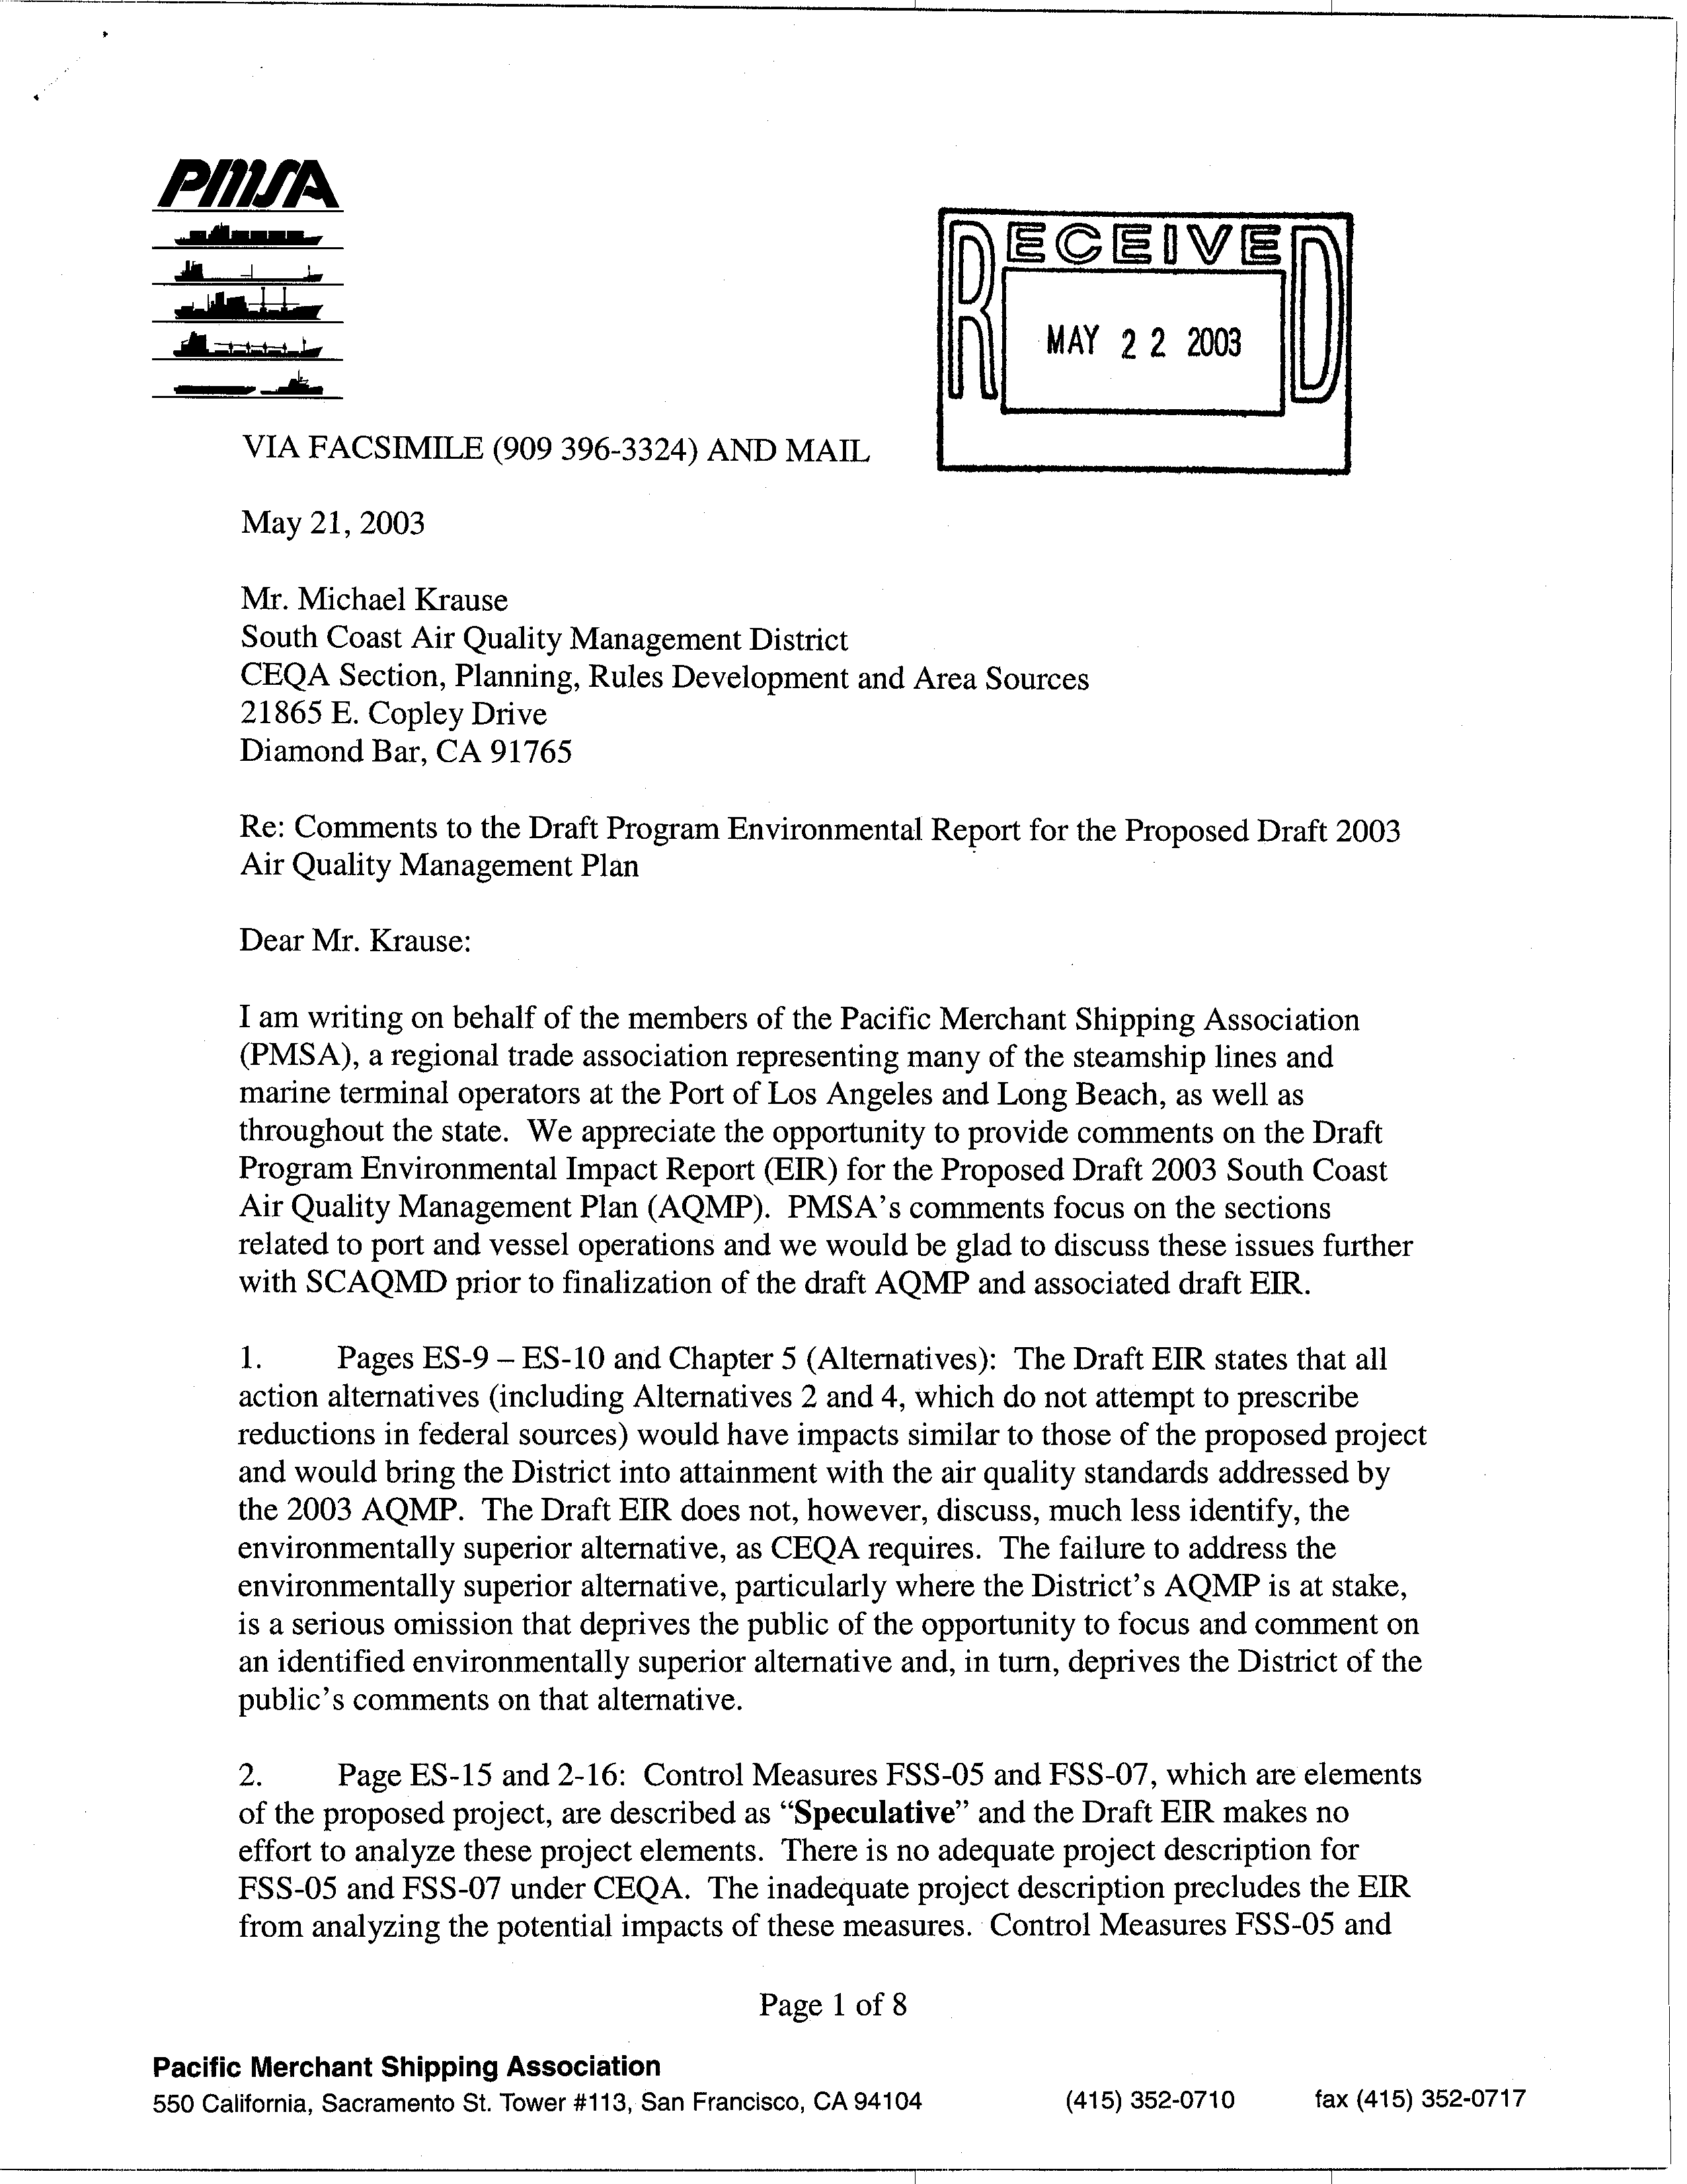
6-1
6-2
6-3
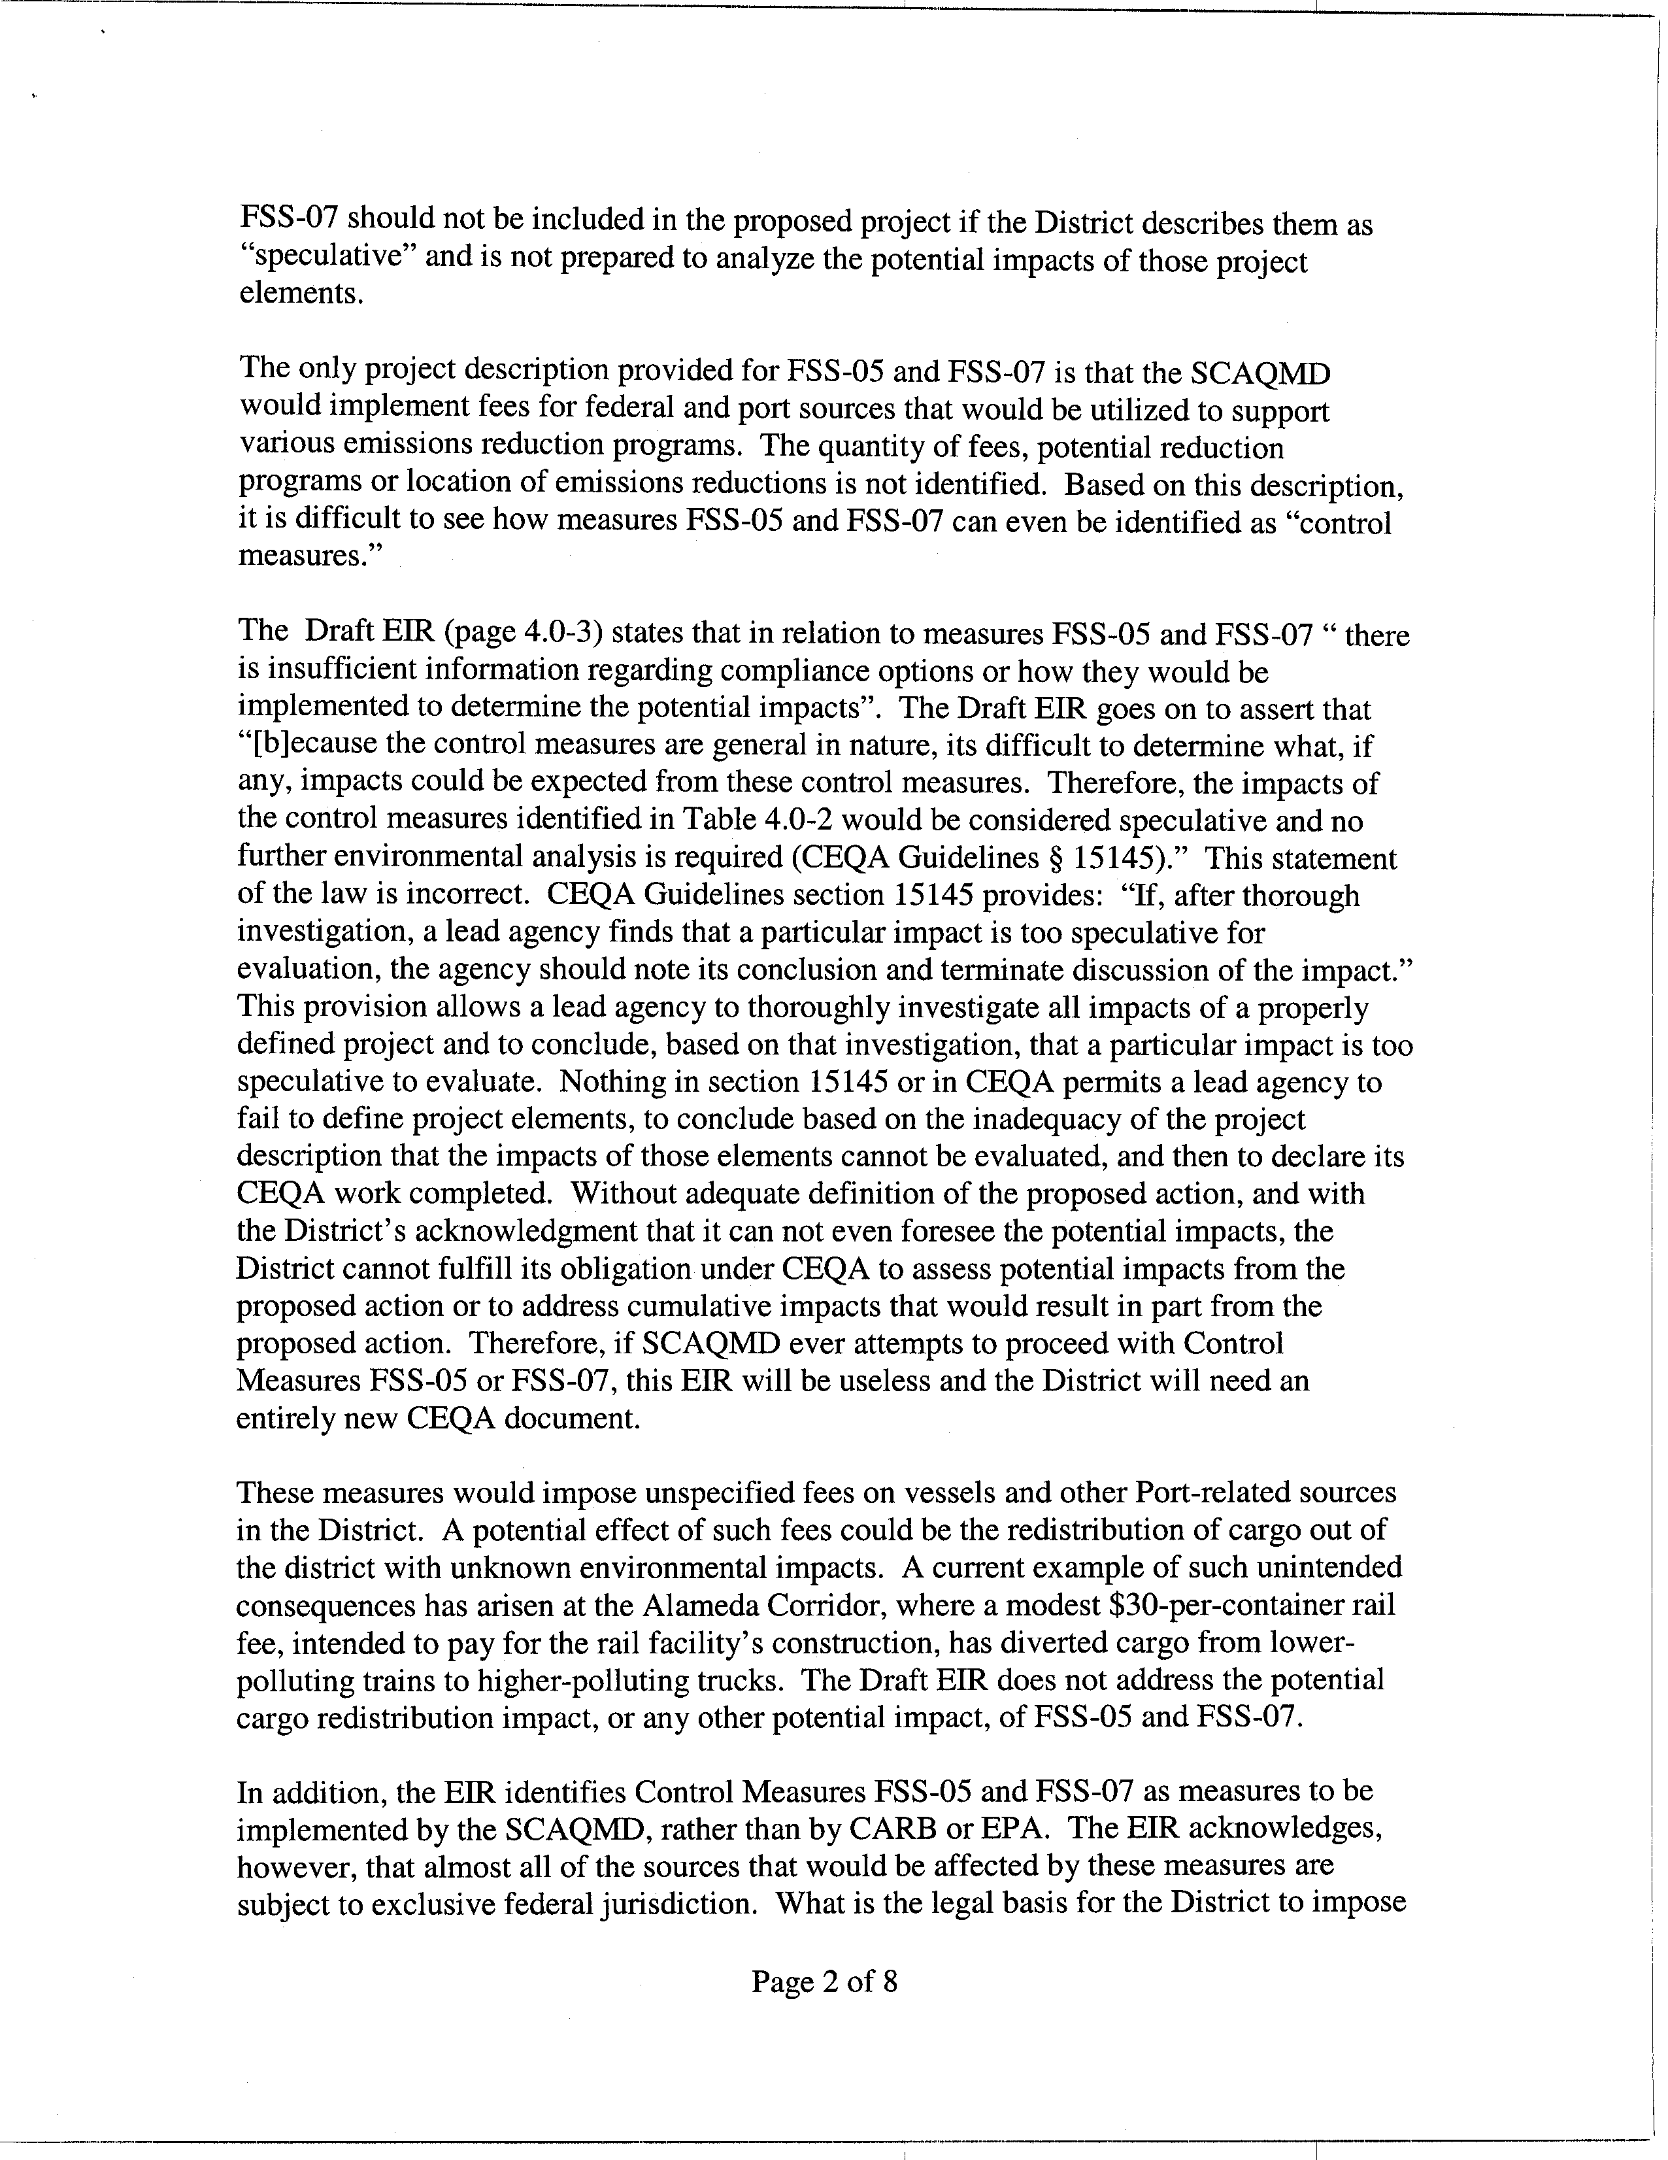
6-3
cont.
6-4
6-5
6-6
6-7
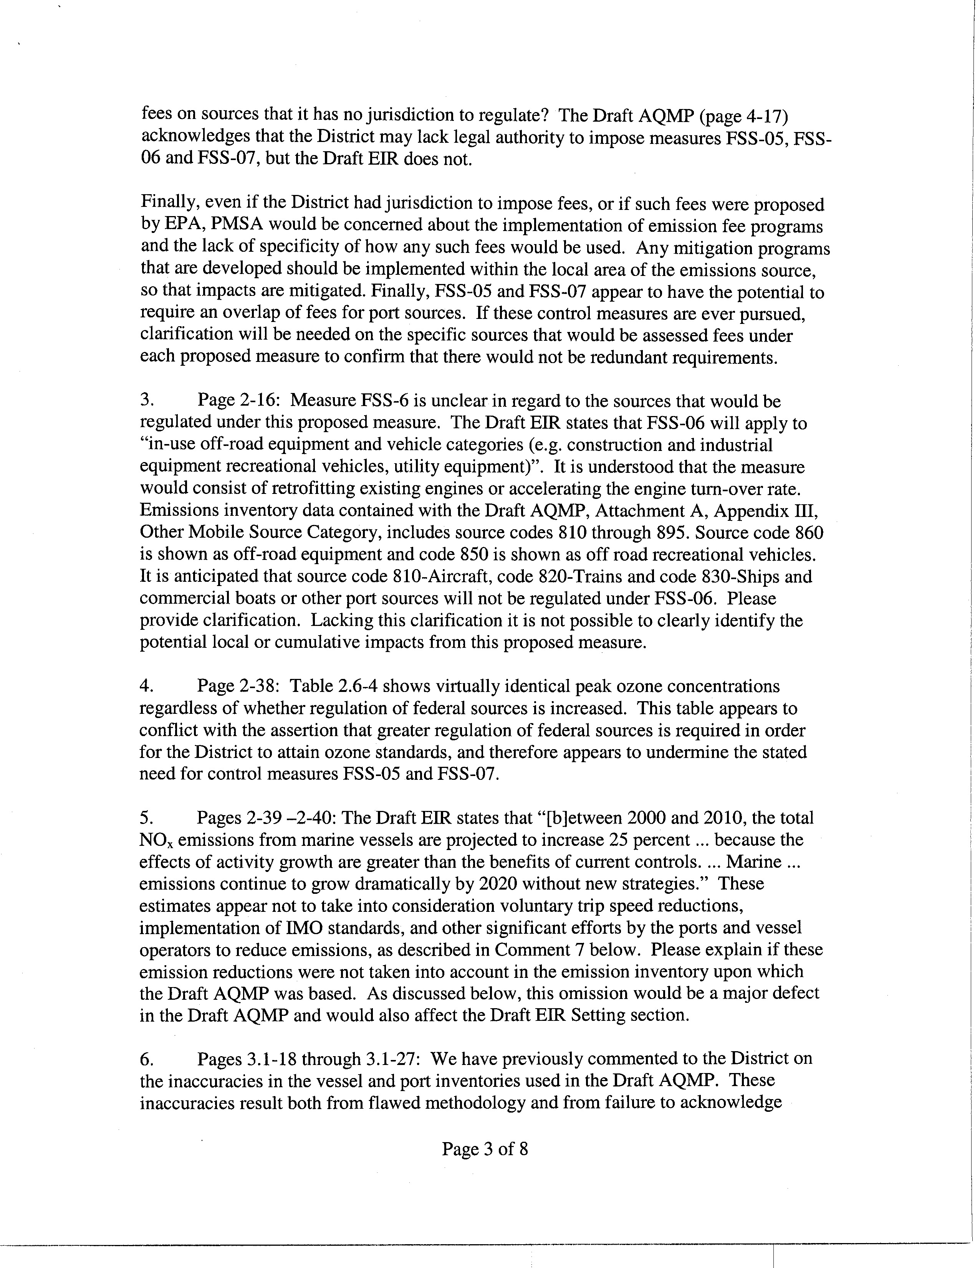
6-7
cont.
6-8
6-9
6-10
6-11
6-12
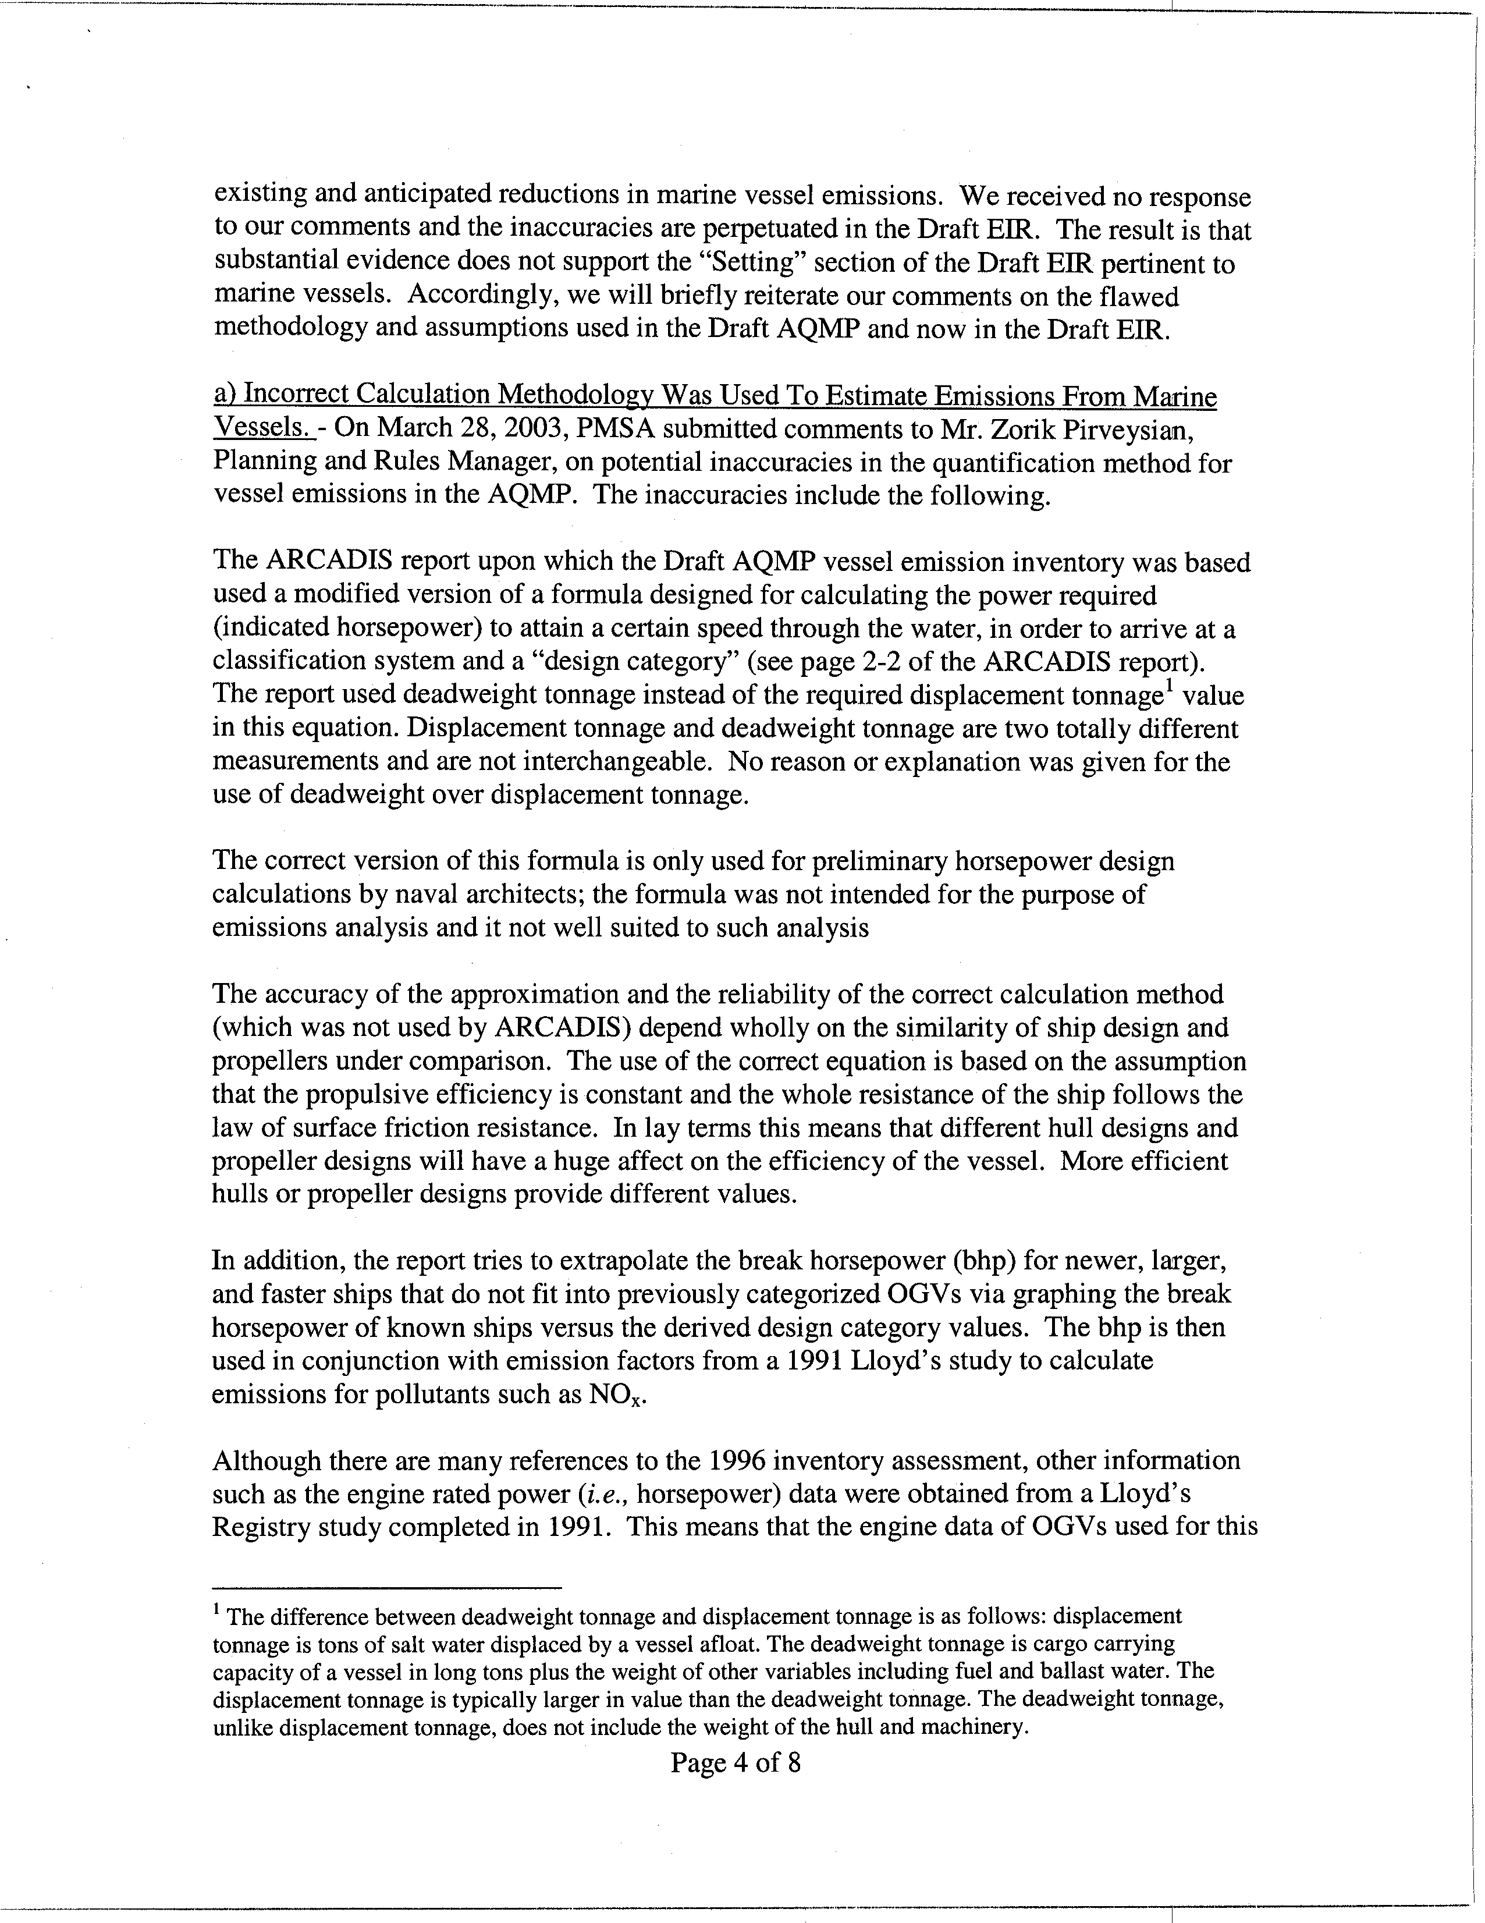
6-12
cont.
6-13
6-14
6-15
6-16
6-17
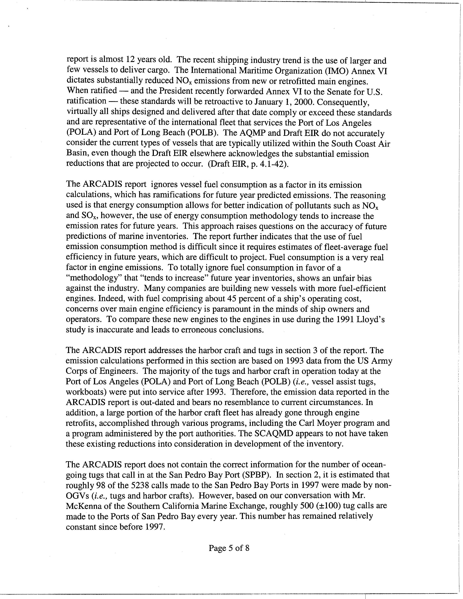
6-17
cont.
6-18
6-19
6-20
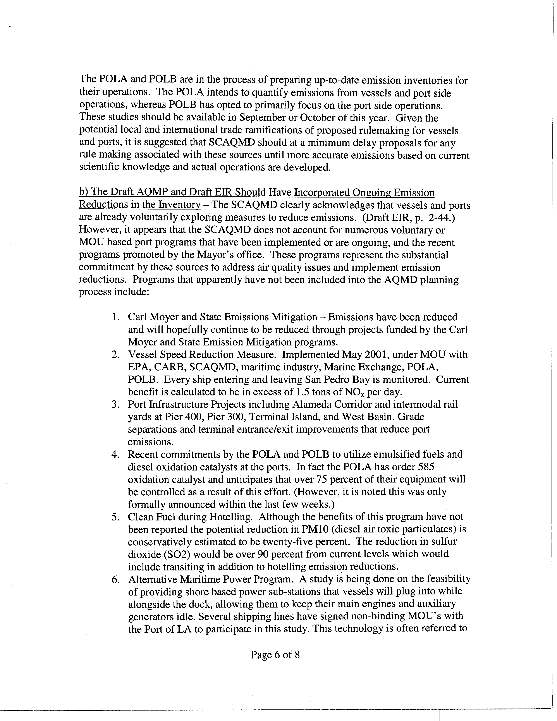
6-21
6-22
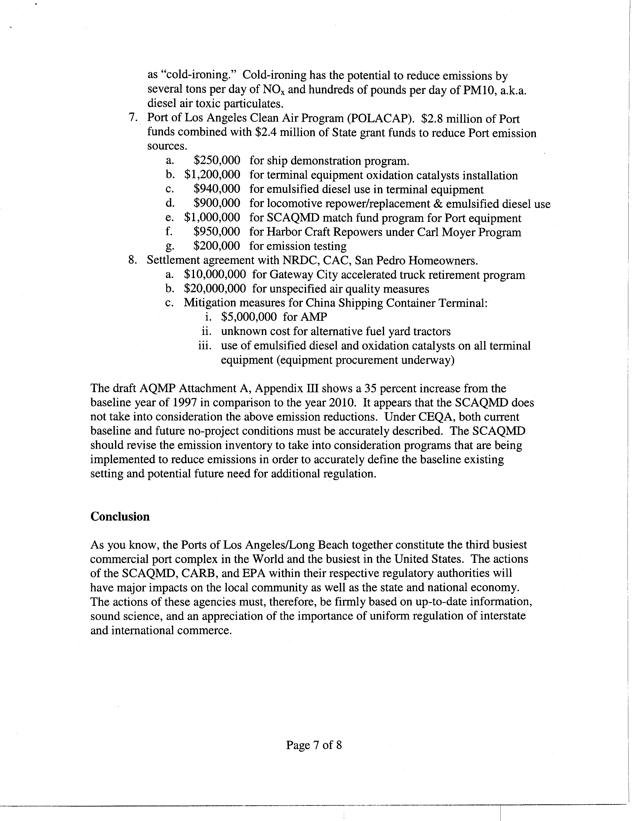
6-22
cont.
6-23
6-24
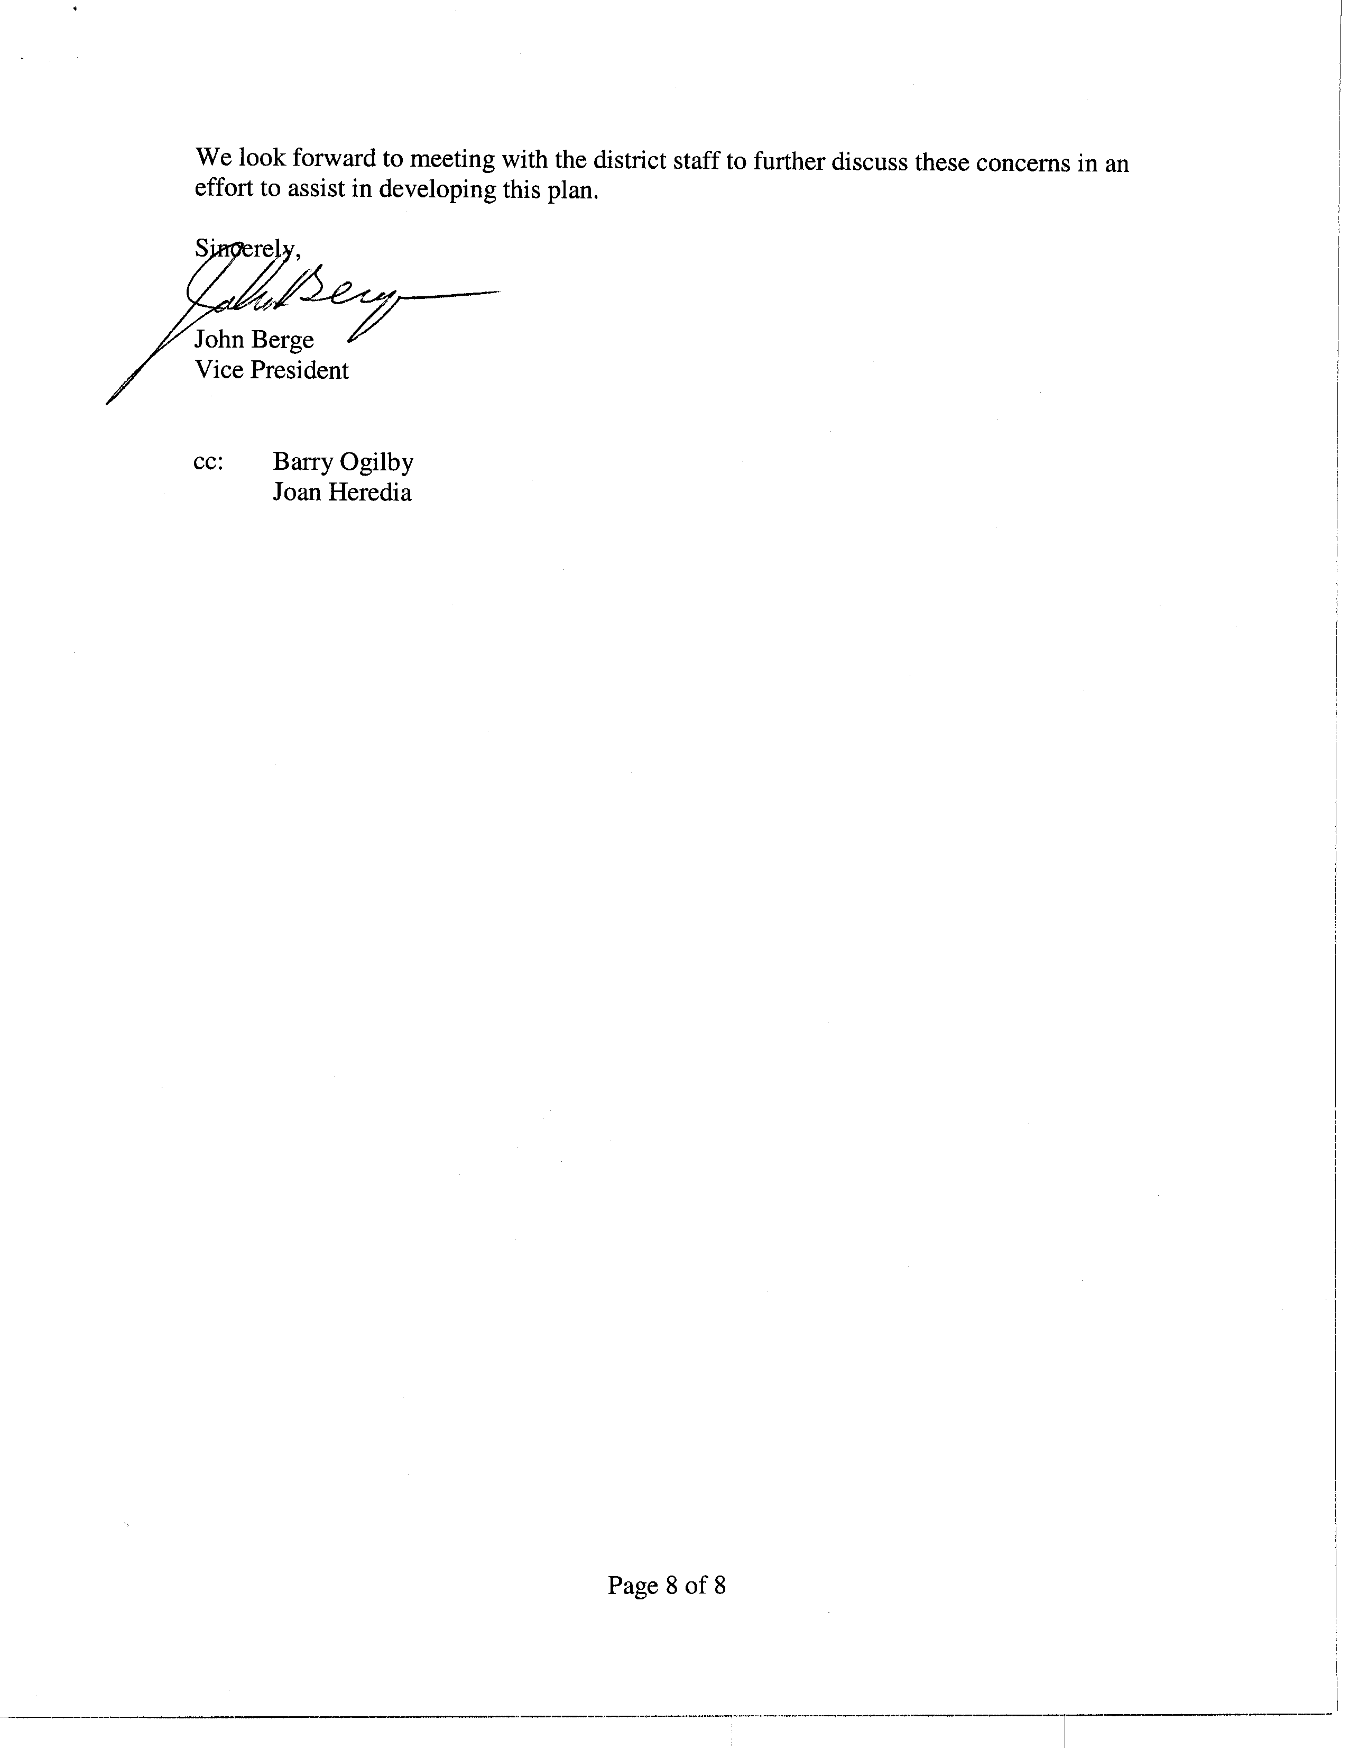
COMMENT LETTER # 6
FROM PACIFIC MERCHANT SHIPPING ASSOCIATION

John Berge

May 22, 2003

Response 6-1

The SCAQMD staff understands that the Pacific Merchant Shipping Association’s (PMSA) comments on the AQMP and AQMP PEIR are related to port and vessel operations.

Response 6-2

The CEQA Guidelines state “if the environmentally superior alternative is the “no project” alternative, the EIR shall also identify an environmentally superior alternative among the other alternatives” (CEQA Guidelines §15126.6(e)(2)). Based on the analysis of the relative merits of the project alternatives in the Draft PEIR, it was apparent that the No Project Alternative is not the environmentally superior alternative. Even though the No Project Alternative is not the environmentally superior alternative, Alternative 3 has been identified in the Final PEIR as the environmentally superior alternative because it achieves more VOC emission reductions and equal NOx emission reductions compared to the proposed project. Impacts to other environmental topics are comparable among all the alternatives. No further modifications are required to the alternatives analysis.

Response 6-3

The descriptions of the AQMP and the Control Measures in the Draft PEIR were only summaries of the proposed project. The 2003 AQMP and Appendices with the full descriptions of each Control Measure were available during the public comment period for the Draft PEIR. The commentator, therefore, had other sources of information to supplement the information in the Draft PEIR.

See Response 1-3 regarding comments on FSS-05 and FSS-07. See also Responses 1-23 through 1-25 regarding FSS-05 and Responses 1-28 through 1-30 regarding FSS-07. The actual specific details on how Control Measures FSS-05 and FSS-07 would be structured is beyond the scope of the control measure write-up. The details of such a program would be thoroughly evaluated and analyzed during the rule development process. However, the control measures have been revised to include criteria for establishing the emissions fee and for selecting emission reduction projects. The SCAQMD staff considers the need to develop these mobile source control strategies in the Plan to be necessary because of the significant level of emission reductions required to demonstrate attainment with the 1-hour ozone standard by 2010 while making progress towards federal PM2.5 standards. See Response 6-10 which concedes ozone can be attained without regulating federal sources. Refer to Response 5-3.

Response 6-4

See Response 1-3 regarding comments on FSS-05 and FSS-07. See also Responses 1-23 through 1-25 regarding FSS-05 and Responses 1-28 through 1-30 regarding FSS-07. Please refer to the response for comment #6-3 with regard to the details of FSS-05 and FSS-07.

Response 6-5

See also Responses 1-23 through 1-25 regarding FSS-05 and Responses 1-28 through 1-30 regarding FSS-07. The PEIR does exactly as suggested in this comment, i.e., identifies the Control Measure (FSS-05), explains why the impacts are speculative (see page 4.0-3 which has been revised to include FSS-05), and terminates the discussion of these impacts. The PEIR has complied with the CEQA Guidelines regarding speculative impacts. During the rulemaking process the SCAQMD staff will prepare the appropriate CEQA document. See Response 1-3 regarding comments on the FSS-05 and FSS-07.

The degree of specificity of the environmental analysis in this PEIR is commensurate with the degree of specificity of the proposed project. It is expected that subsequent projects to implement AQMP control measures will undergo an environmental analysis that tiers off of this PEIR pursuant to CEQA Guidelines §15152.

Response 6-6

The control measures are revised to include criteria for establishing the emissions fee and for selecting emission reduction projects. However, the impacts from Control Measures FSS-05 and FSS-07 are speculative, and would be further evaluated during the rule development of each control measure. See also Response 1-47 regarding diversion of cargo.

Response 6-7

Control Measure FSS-05 has been revised in the 2003 AQMP to indicate that the SCAQMD is currently seeking to obtain broader legal authority to regulate mobile sources to the extent feasible. The control measure has also been revised to indicate that it would need to be adopted by the U.S. EPA and the mitigation fee to be paid by federal sources through U.S. EPA rulemaking and/or U.S. EPA grants to the SCAQMD.

Relative to Control Measure FSS-07, the authority to regulate indirect, area-wide and fleet sources are set forth under California Health and Safety Code Sections 40440, 40447.5, 40716 and 40522.5. Although there are restrictions in state and federal law regarding the SCAQMD’s authority to directly regulate emissions from non-road sources through establishing emissions standards, the SCAQMD’s has the authority to adopt in use restrictions on these sources. The SCAQMD’s can require a permit, impose a limitation on the number of hours a source can operate and cap emissions, among other things. Therefore, it would be reasonable for the SCAQMD’s to establish a fee program to support the costs of in-use programs or to implement alternatives to those measures. Likewise, the SCAQMD’s may adopt fleet rules and impose indirect source regulations and fees, and therefore may establish fee programs to support or substitute for those programs.

The PEIR has been revised to reflect these revisions to the AQMP. Please note that the PEIR summarizes the AQMP in the Project Description portion of the PEIR and does not reiterate all portions of the AQMP. The AQMP should be consulted for the detailed information regarding the plan.

Control Measure FSS-05 – Mitigation Fee Program for Federal Sources District is to be adopted by U.S. EPA and the mitigation fee to be paid by federal sources through U.S. EPA rulemaking and/or U.S. EPA grants to the District.

Response 6-8

See Response 1-3 regarding comments on FSS-05 and FSS-07. See Response 1-3 regarding comments on FSS-05 and FSS-07. See also Responses 1-23 through 1-25 regarding FSS-05 and Responses 1-28 through 1-30 regarding FSS-07. See Response 1-24 regarding potential overlap between the two control measures. Language has been added to the control measure that establishes criteria that will be used in establishing the emissions fee and in selecting the emission reduction projects that will funded with the mitigation fee. The program design and implementation details will be developed during the rule development stage, where a thorough and collaborative effort will be initiated involving the SCAQMD staff, regulated entities, and other interested stakeholders.

Although, there is overlap between the types of sources subject to control measures FSS-05 and FSS-07, during rule development, these overlaps will be taken into account to ensure that the same categories are not subject to multiple requirements. In order to address these potential overlaps, the control measures have been revised to indicate that staff will conduct further analysis during rule implementation to identify the most feasible control strategy for each source category (e.g., reduction controls, mitigation fee).

Response 6-9

The commenter is correct. Control Measure FSS-06 does not apply to aircraft, trains, and ships. As described in Appendix IV-A, FSS-06 applies to off-road vehicles and equipment such as construction equipment, small utility engines, lawn and garden equipment, off-road recreational vehicles, recreational marine vessels, and other non-highway mobile equipment.

Response 6-10

Based on the modeling analysis conducted in the draft 2003 AQMP, the Basin could still demonstrate attainment with the federal 1-hour ozone standard without further reductions from federal sources (i.e., less NOx reductions). However, this strategy will jeopardize the attainment of the new standards (i.e., PM2.5 and ozone 8-hour standards) since NOx contributes to formation of both ozone and PM2.5. Therefore, because of the significant contribution of federal sources to emissions (i.e., 34 percent in 2010), Control Measures FSS-05 and FSS-07 must be pursued to achieve the maximum level of reductions achievable from these sources by 2010.

Response 6-11

The marine vessel emissions inventory in the 2003 AQMP is based on the ARCADIS report, completed in 1999. This report did not take into account the recent voluntary speed reductions program for marine vessels since these reductions from voluntary actions are not federally enforceable. However, IMO standards were taken into consideration. SCAQMD staff recognizes that refinements to the marine vessel inventory are certainly possible (e.g., updated methodology and activity data) and would be considered during rule development. However, the overall inventory for marine vessels is not expected to be significantly different than the current estimates and the marine vessels would still represent one of the largest under-controlled emission source categories. SCAQMD staff welcomes the participation of PMSA and other stakeholders in refining the emissions inventory for this source category in the future.

Response 6-12

Please see response to comment #6-11.

Response 6-13

SCAQMD staff recognizes that the ARCADIS report uses a modified version of a formula designed for calculating power requirements in ship design as a classification scheme to estimate the average rated power of ships that call and operate within South Coast waters. However, SCAQMD staff disagrees that the use of the modified equation invalidates the emissions inventory for this source category. As stated in the report, the deadweight tonnage was used as a surrogate for the displacement tonnage because a strong correlation was found between these two values and also because of the unavailability of the displacement weight data for a large fraction of ships. Since displacement tonnage is typically larger than the deadweight tonnage, as noted by the commentor, it could also be inferred that power requirements based on displacement tonnage would be larger than the when deadweight tonnage is used. Therefore, the emission inventory may be potentially underestimated using deadweight tonnage instead of displacement weight. The marine vessel inventory will be updated in the future to reflect updated activity data and improved methodologies.

Response 6-14

Please see response to comment #6-13.

Response 6-15

Please see response to comment #6-13.

Response 6-16

Please see response to comment #6-13.

Response 6-17

The marine vessel emissions inventory study included 1991, 1993, and 1995 data from the Lloyd’s Marine Exhaust Emissions Research Programme and also used the 1998 data from Mercer Management and Standard & Poor. In addition, the study considered and evaluated the emissions limits finalized in 1997 by the International Maritime Organization (IMO) and changes in NOx emission rates due to IMO standards were incorporated into the emissions forecast.

SCAQMD staff recognizes that refinements including data and methodology improvements may be warranted in future updates to the marine vessels emissions inventory and welcomes the participation of all stakeholders including, PMSA and the ports.

Response 6-18

The SCAQMD disagrees with the opinion expressed in this statement. The 1999 ARCADIS report did not ignore fuel consumption as a factor of emissions calculations. This was a specific methodology change from the 1996 emission inventory study and was intended to improve the analysis by eliminating the need to estimate fleet-average fuel efficiencies. The 1999 ARCADIS report calculates energy consumption instead of fuel consumption. Both methodologies are valid and have precedent in emissions inventory calculations. However, the energy consumption method was chosen because NOx emissions may better be indicated by energy rather than fuel consumption. The fuel consumption method requires estimates of fleet-average fuel efficiency in future years which are difficult to project. The energy consumption method avoids the need for such projections. Also please refer to response to comment 6-17.

Response 6-19

Please refer to Response 6-17 with regards to out-dated data.

During rule development, the SCAQMD will consider the implementation of voluntary measures by port terminal operators. In order for these reductions to be credited toward SIP commitments, they have to be federally enforceable through a District, state, or federal rule and credit can be provided if the emission reductions already occurred.

Response 6-20

The 1999 emissions inventory study for marine vessels (i.e., by ARCADIS) was developed based on available data at the time of the study from various sources cited in the report. Please also see the response to comment #6-11.

Response 6-21

The SCAQMD is aware of the current emission studies being conducted by the ports and is looking forward to receiving the resulting emissions inventories. However, given the size of the black box and the number of years remaining to demonstrate attainment with the federal 1-hour ozone standard, delays in proposing control measures may hinder progress in attaining all standards by the dates mandated in the CAA. Any updates to the emissions inventory for the Ports can be incorporated into the analysis during the rule development of the control measures.

Response 6-22

During rule development, the SCAQMD will consider the implementation of voluntary measures by port terminal operators. In order for these reductions to be credited toward SIP commitments, they have to be federally enforceable through a District, state, or federal rule. Emission reductions already achieved, for example can be credited through the Carl Moyer Program.

Response 6-23

The ARCADIS report, used as the basis for developing the emissions inventory for ships currently represents the best available information on ship emissions for the Basin. The ARCADIS report provides an inventory study that is sufficiently accurate to support balance planning and an appropriate consideration of control strategies. The SCAQMD acknowledges that the voluntary measures listed in the comment letter were not taken into consideration in developing the baseline and projected emissions inventory for the Ports. However, the SCAQMD will consider the implementation of voluntary measures by port terminal operators during rule development of the proposed control measures.

Response 6-24

The SCAQMD staff understands that the proposed control measures in the 2003 AQMP may affect local ports and harbors. The SCAQMD looks forward to continuing to work with these entities to continue improving emission inventories and developing regulations that will result in emission reductions and assure attainment of the ambient air quality standards.

C O M M E N T L E T T E R 7

Southern California Association of Governments
May 21, 2003

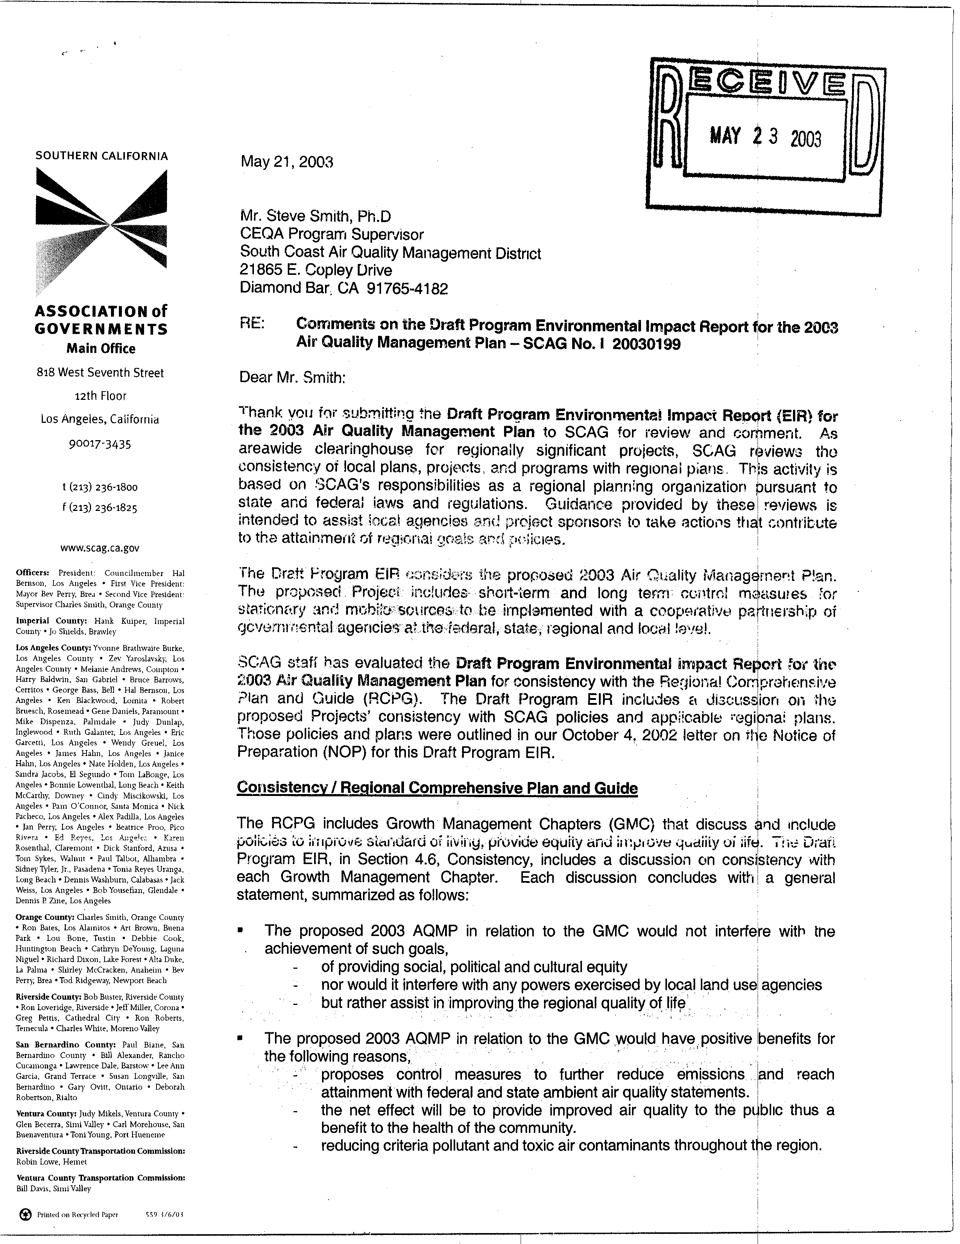
7-1
7-2
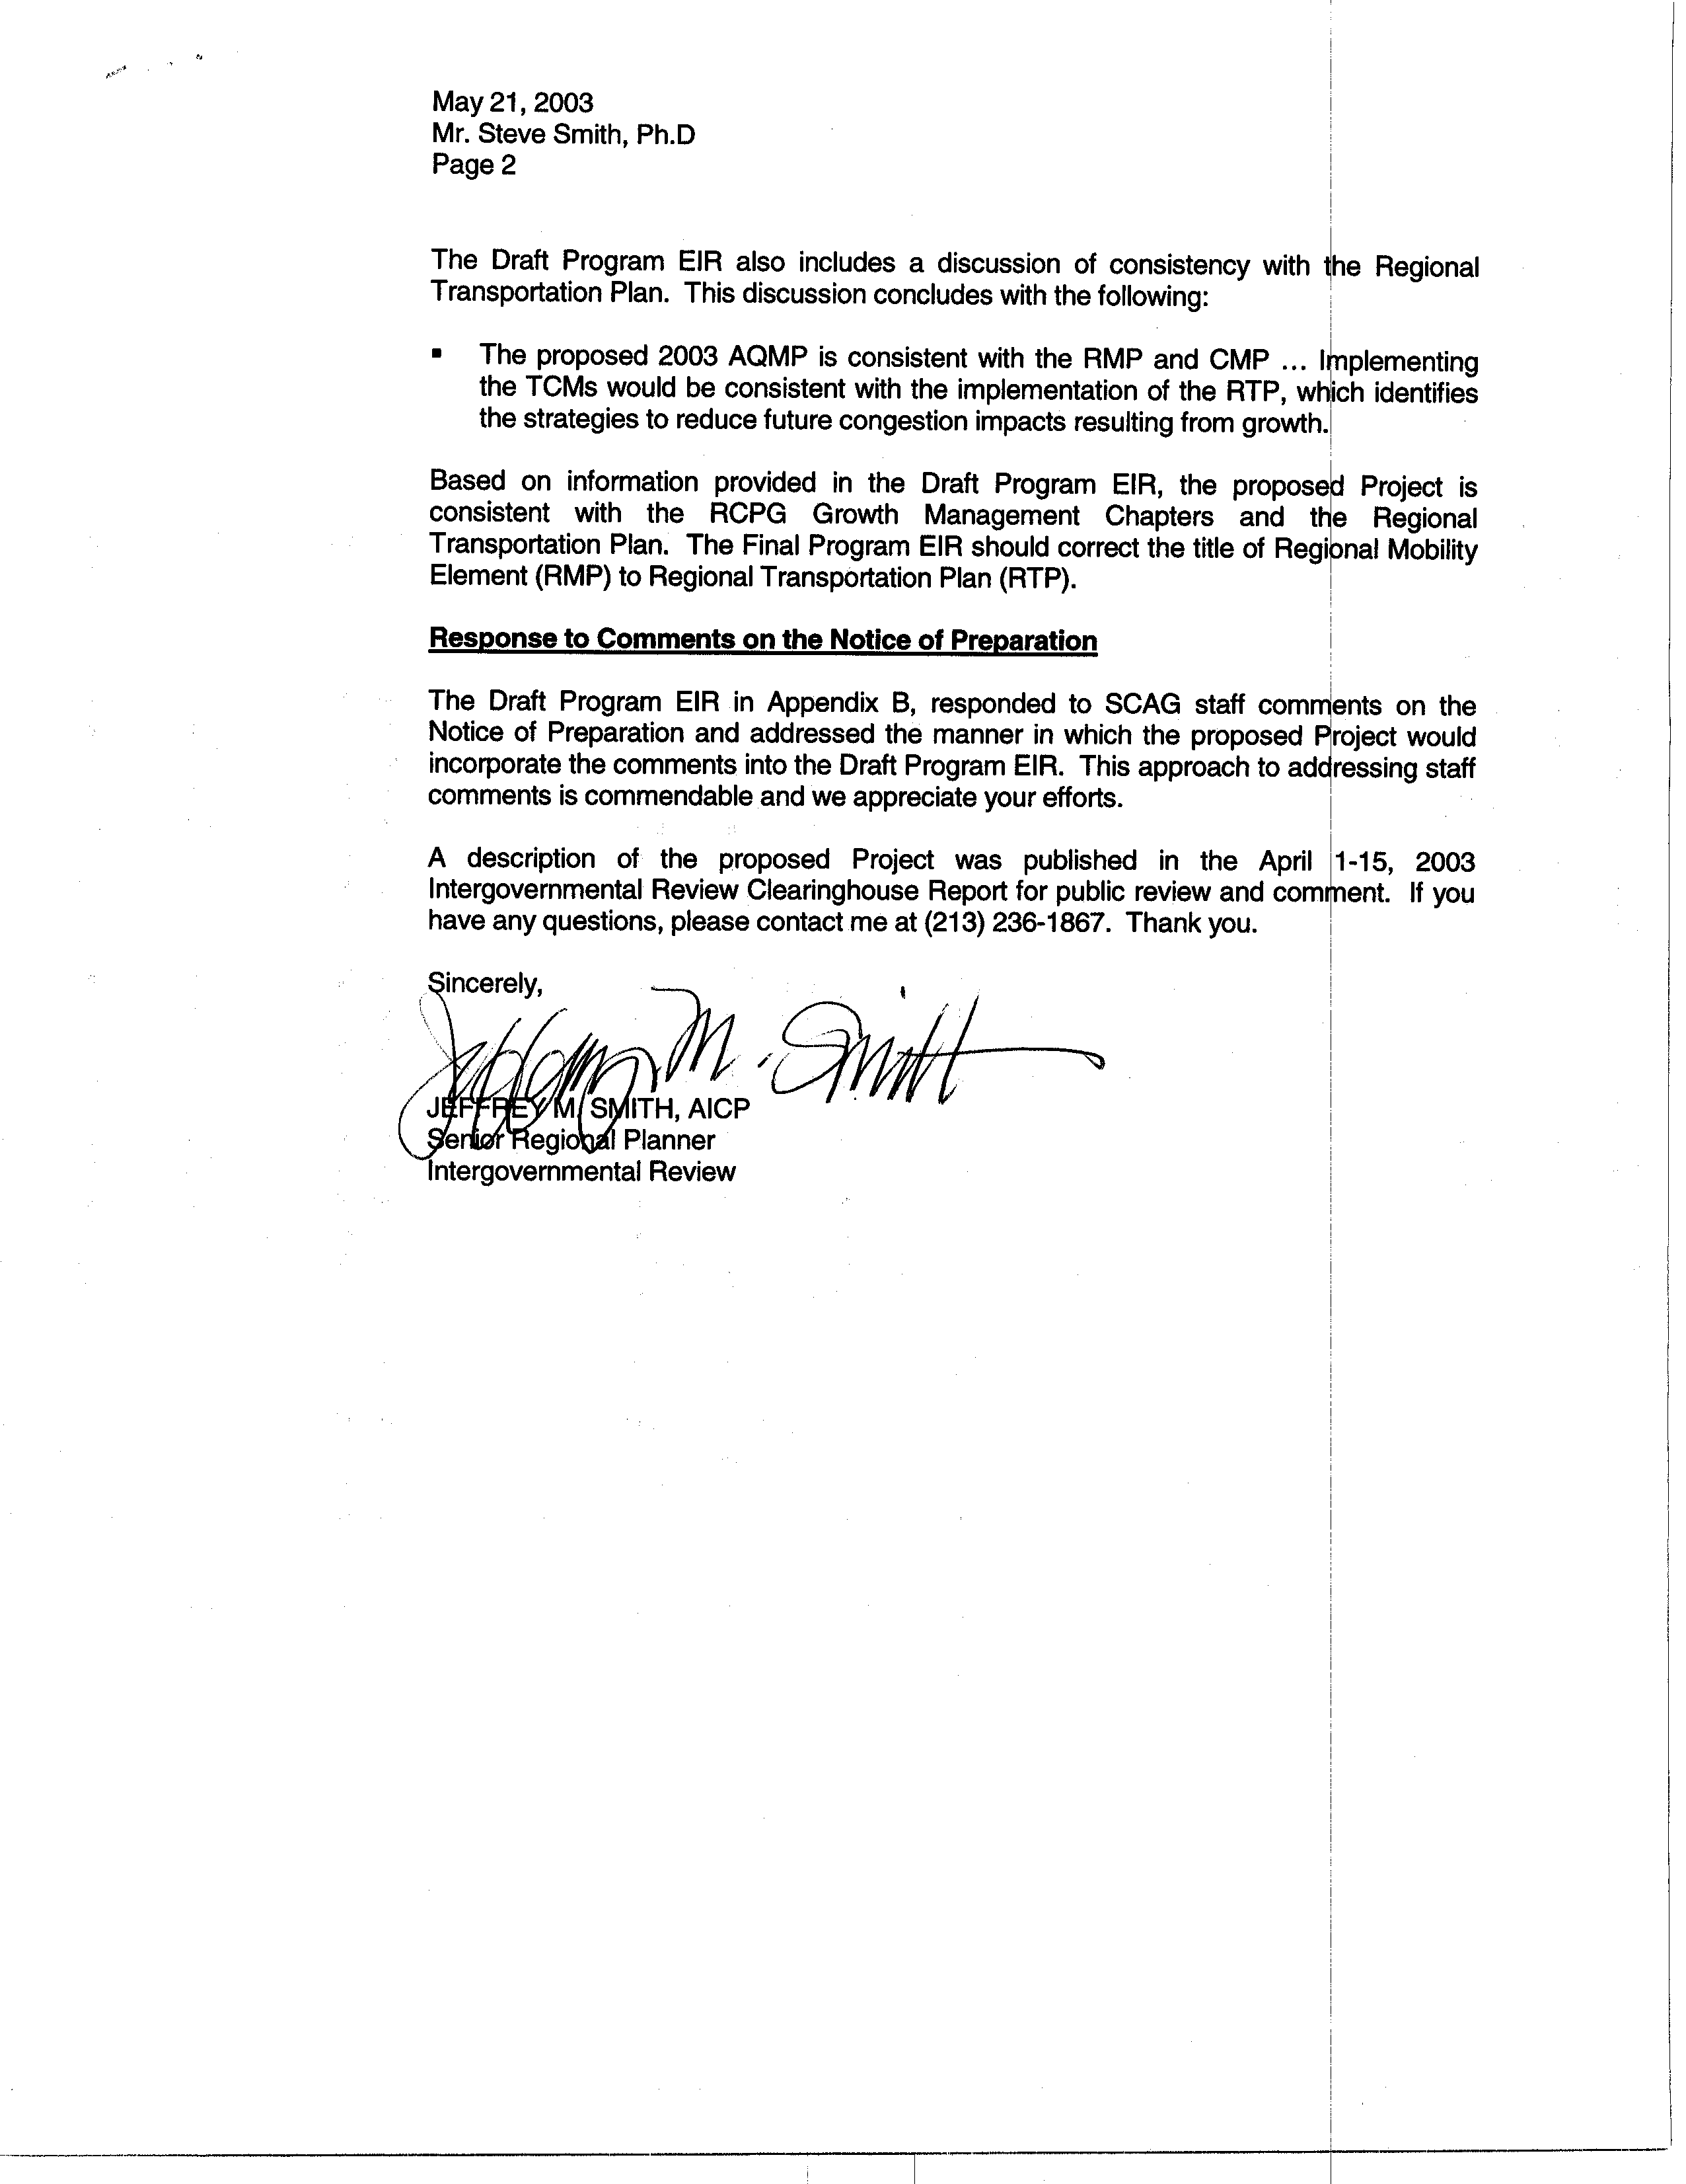
7-2
cont.
7-3
7-4
7-5
COMMENT LETTER # 7
FROM SOUTHERN CALIFORNIA ASSOCIATION OF GOVERNMENTS

Jeffery M. Smith

May 21, 2003

Response 7-1

The SCAQMD staff understands that SCAG has reviewed the 2003 AQMP Draft PEIR for consistency with SCAG policies and applicable regional plans and that SCAG acknowledges that the PEIR includes a discussion of consistency with SCAG’s policies and applicable regional plans.

Response 7-2

The SCAQMD staff agrees with SCAG’s comment that the 2003 Draft AQMP PEIR is consistent with the RCPG Growth Management Chapters and the Regional Transportation Plan.

Response 7-3

The Final PEIR has revised the title of the Regional Mobility Element to the Regional Transportation Plan.

Response 7-4

The SCAQMD staff understands that the comments submitted by SCAG on the NOP were adequately addressed and incorporated into the Draft PEIR.

Response 7-5

The SCAQMD staff understands that a description of the AQMP was published in the April 1-15, 2003 Intergovernmental Review Clearinghouse Report.

C O M M E N T L E T T E R 8

South Bay Cities Council of Governments
May 20, 2003

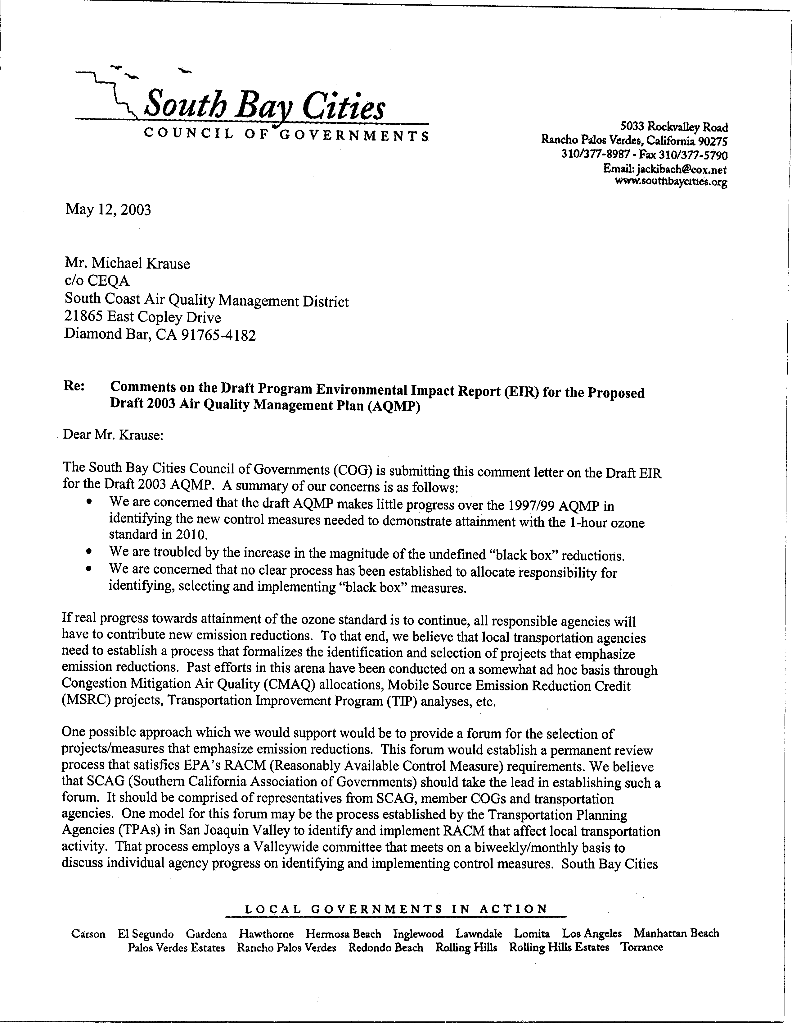
8-1
8-2
8-3
8-4
8-5

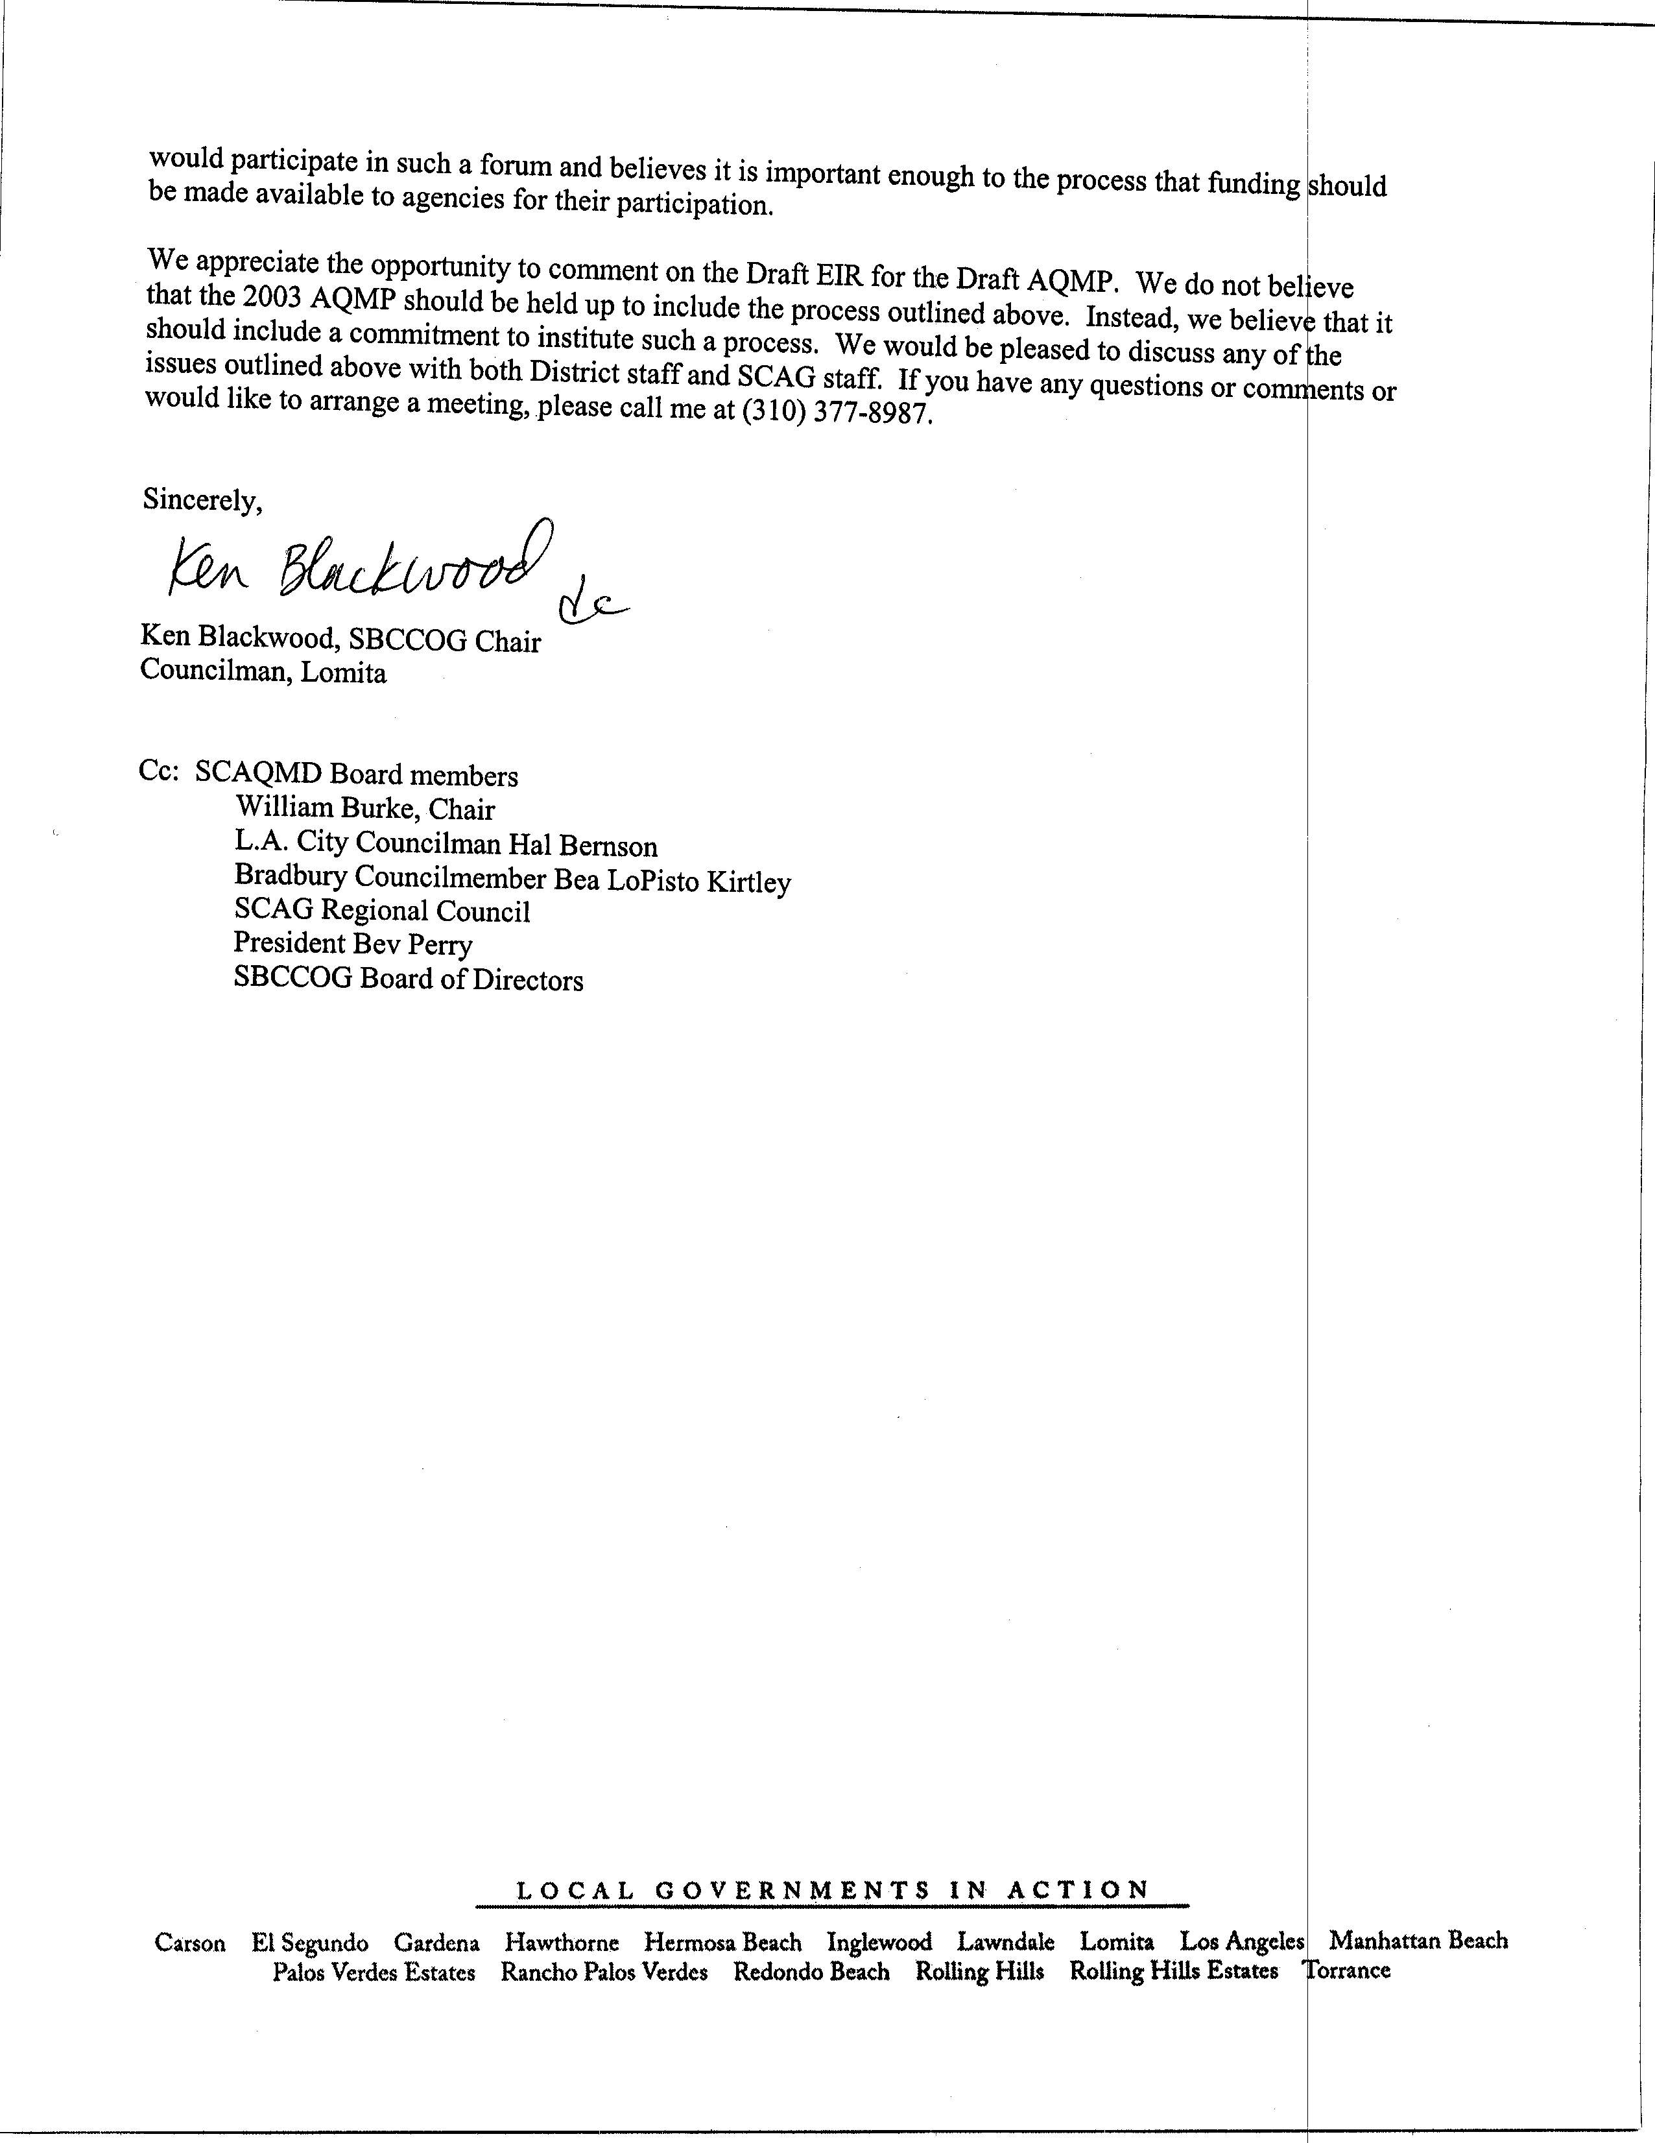
8-5
cont.
8-6
COMMENT NO. 8
FROM SOUTH BAY CITIES COUNCIL OF GOVERNMENTS

Ken Blackwood

May 20, 2003

Response 8-1

In developing the SCAQMD’s short-term measures for the 2003 AQMP, the District: 1) carried over the remaining near-term control measures from the 1997/99 SIP, 2) substituted long-term strategies in the 1997/99 with short-term control measures (i.e., for coating/solvents, fugitive sources, and industrial process operations), and identified new feasible control measures. The twelve new control measures include strategies for achieving additional reductions from stationary sources including the NOx RECLAIM program, fugitive dust sources, aggregate and cement manufacturing, ammonia sources, fireplaces and wood stoves, natural gas combustion, large VOC sources. In addition, because of the significant reductions needed for attainment demonstration, for the first time four new short-term measures targeting mobile sources are introduced in the AQMP by the SCAQMD including truck stop electrification, mitigation fees for federal sources, emission controls for in-use off-road equipment and vehicles, and an emission fee program for port-related mobile sources. It is also important to note that the SCAQMD has already exceeded its emission reduction target commitment in the 1997/99 SIP (as of Oct 2002) by 42 tons per day because of a number of SCAQMD rules adopted since 1996. The emission reductions associated with these rules are 158 tons per day of VOC and 12 tons per day of NOx emissions in 2010. The SCAQMD’s short-term control measures in the 2003 AQMP with quantifiable emission reductions are estimated to provide an additional 21.5 tons per day of VOC and five tons per day of NOx reductions by 2010. Any excess reductions from these measures as well as from other short-term measures, for which reductions are not yet quantified, will be applied toward the black box emission reductions.

The SCAQMD and CARB are working diligently to identify control measures to replace the black box measures and welcome your suggestions on feasible measures that could be identified to help demonstrate attainment with the federal ozone standard.

Response 8-2

The size of the black box emissions has grown for a number of reasons, with the primary reason being improvements in the mobile source emissions inventory. Thus, these emissions were actually in the air in previous AQMPs, and would have been included in the black box if they had been identified at that time. Another reason for the increase in the size of the black box is the selection of a new and more restrictive episode day and improved air quality modeling.

The SCAQMD also shares your concern regarding the size of the black box and believes that state and federal agencies which have jurisdiction over mobile sources constituting 70 percent the VOC and 89 percent of the NOx emissions by 2010 (Modifications to the AQMP, 2003, Figure 3-5A) should commit to their fair share of reductions just as the SCAQMD is committing to specific reduction targets from sources under its jurisdiction.

Response 8-3

Control measure LTM-All which represents the SCAQMD long-term measure, has been modified to add clarification on the process the SCAQMD will use to identify new control strategies to reduce the black box. The SCAQMD’s process to identify new control strategies would include Annual Technology Assessment workshops, AQMP Advisory Group Technical Subcommittee process as well as studies conducted as part of implementing the Annual Emissions Reporting Program to identify new emission reduction strategies. Periodic BACT updates can also be used to identify new emission reduction strategies that may result from add-on controls or process changes. Future evaluations on VOC reactivity of various compounds may also provide a basis for establishing control strategies that substitute highly-reactive VOCs with low reactive VOCs. New control measures identified through any of the mechanisms will be reported to the Governing Board in December of every year, as part of the SCAQMD’s Annual Rule and Control Measure Forecast Report. This report will also provide a preliminary estimate of the expected emission reductions from each newly identified measure along with the proposed rule adoption calendar. Furthermore, in January of each year, the SCAQMD will provide a summary of the emission reductions achieved through adoption of the control measures by the Governing Board in the previous year(s) to track the performance of its SIP commitment.

Response 8-4

The draft AQMP sets forth a comprehensive strategy to demonstrate attainment that focuses on all emission sources – stationary as well as mobile sources. Furthermore, the SCAQMD is also recommending that the emission reductions required as part of the long-term strategy be assigned among the respective agencies based on the contribution of the sources emissions as well as the agencies commitments in the 1997/1999 SIP (i.e., Scenario 1 in Chapter 4). By recommending Scenario 1, the SCAQMD seeks to ensure that all emission sources contribute a fair share toward the attainment demonstration requirements set forth under federal and state law.

The SCAQMD does not have control over the funding or project selection process in programs mentioned by the commenter. However, any projects funded by the SCAQMD would place emphasis on emission reduction potential.

Response 8-5

The SCAQMD will take the suggestion under review. In as far as the SCAQMD’s stationary and mobile source control measures, a process for identifying the long-term measures needed to demonstrate attainment has been added to Control Measure LTM-ALL. This process can be found in the Proposed Modifications to the Draft 2003 AQMP Appendix IV-A.

Response 8-6

The SCAQMD welcomes the participation of the South Bay Cities COG in future rule development processes.

C O M M E N T L E T T E R 9

Western Propane Gas Association (Paul Hastings)
May 22, 2003

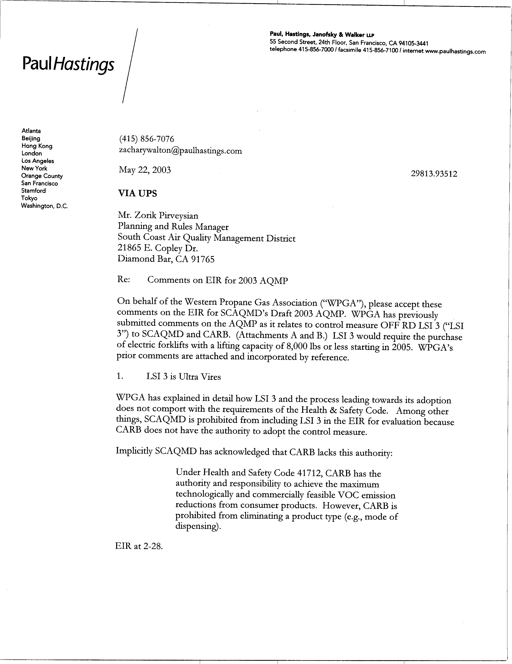
9-1
9-2
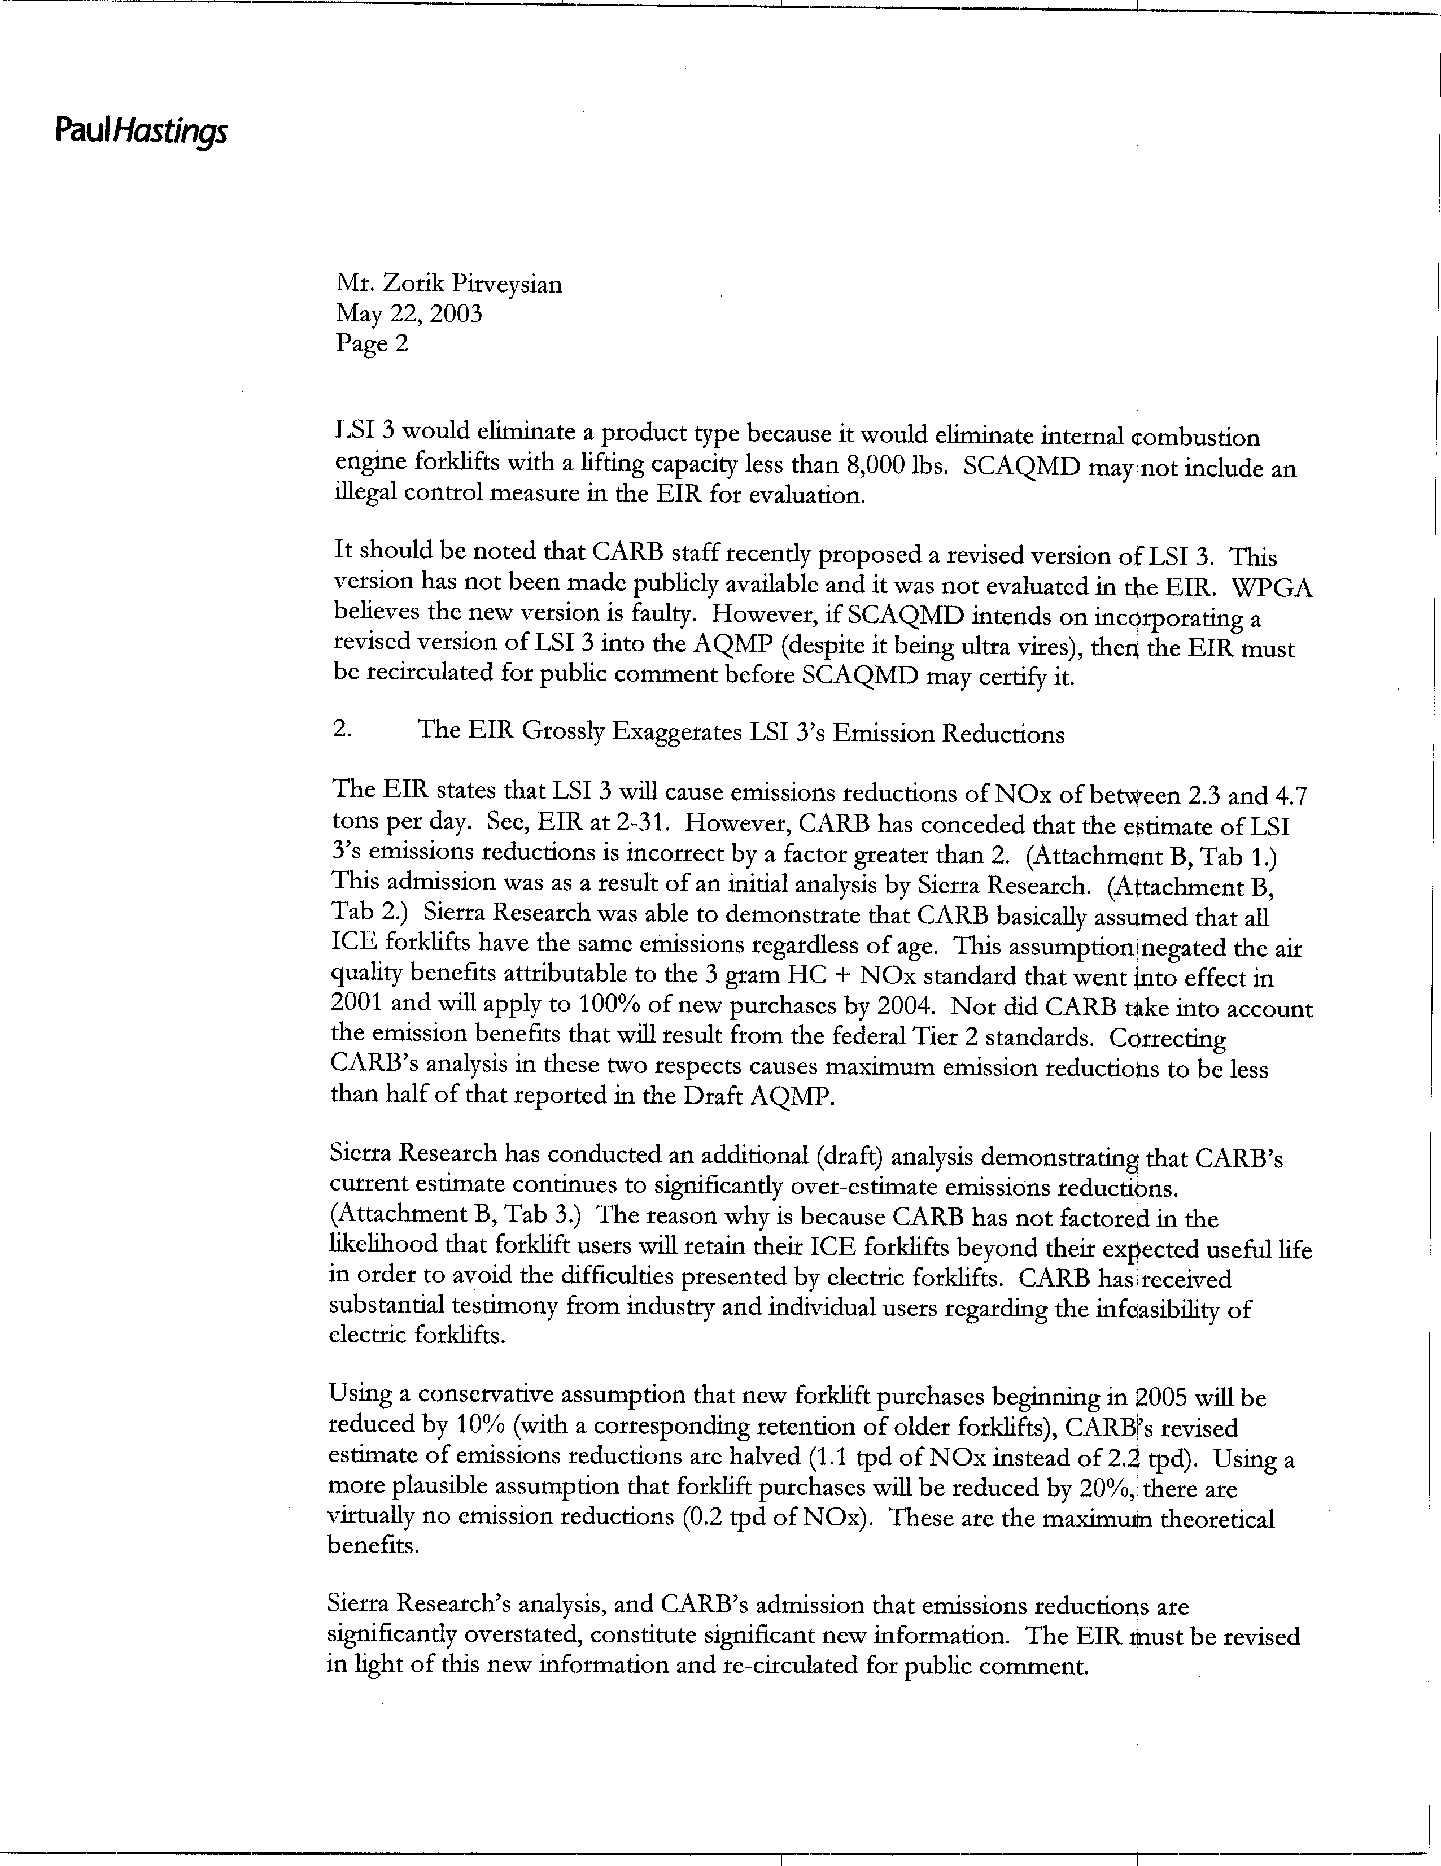
9-2
cont.
9-3
9-4
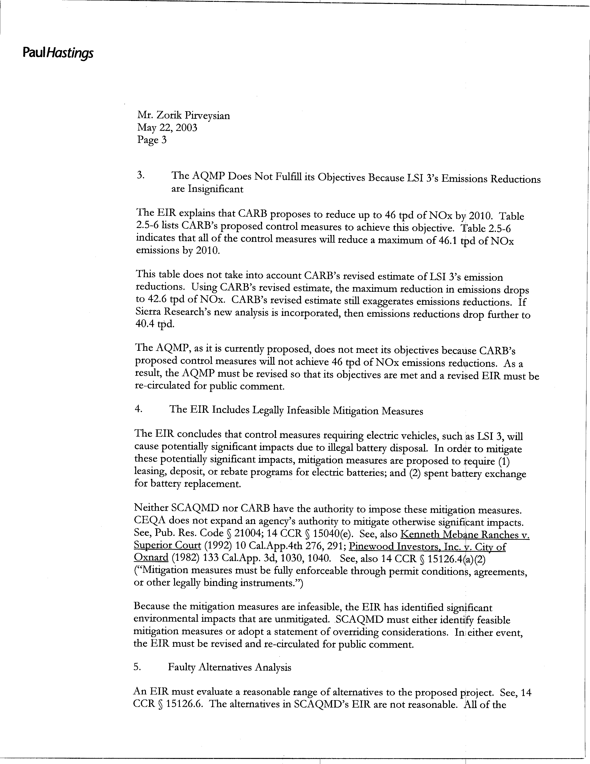
9-5
9-6
9-7
9-8
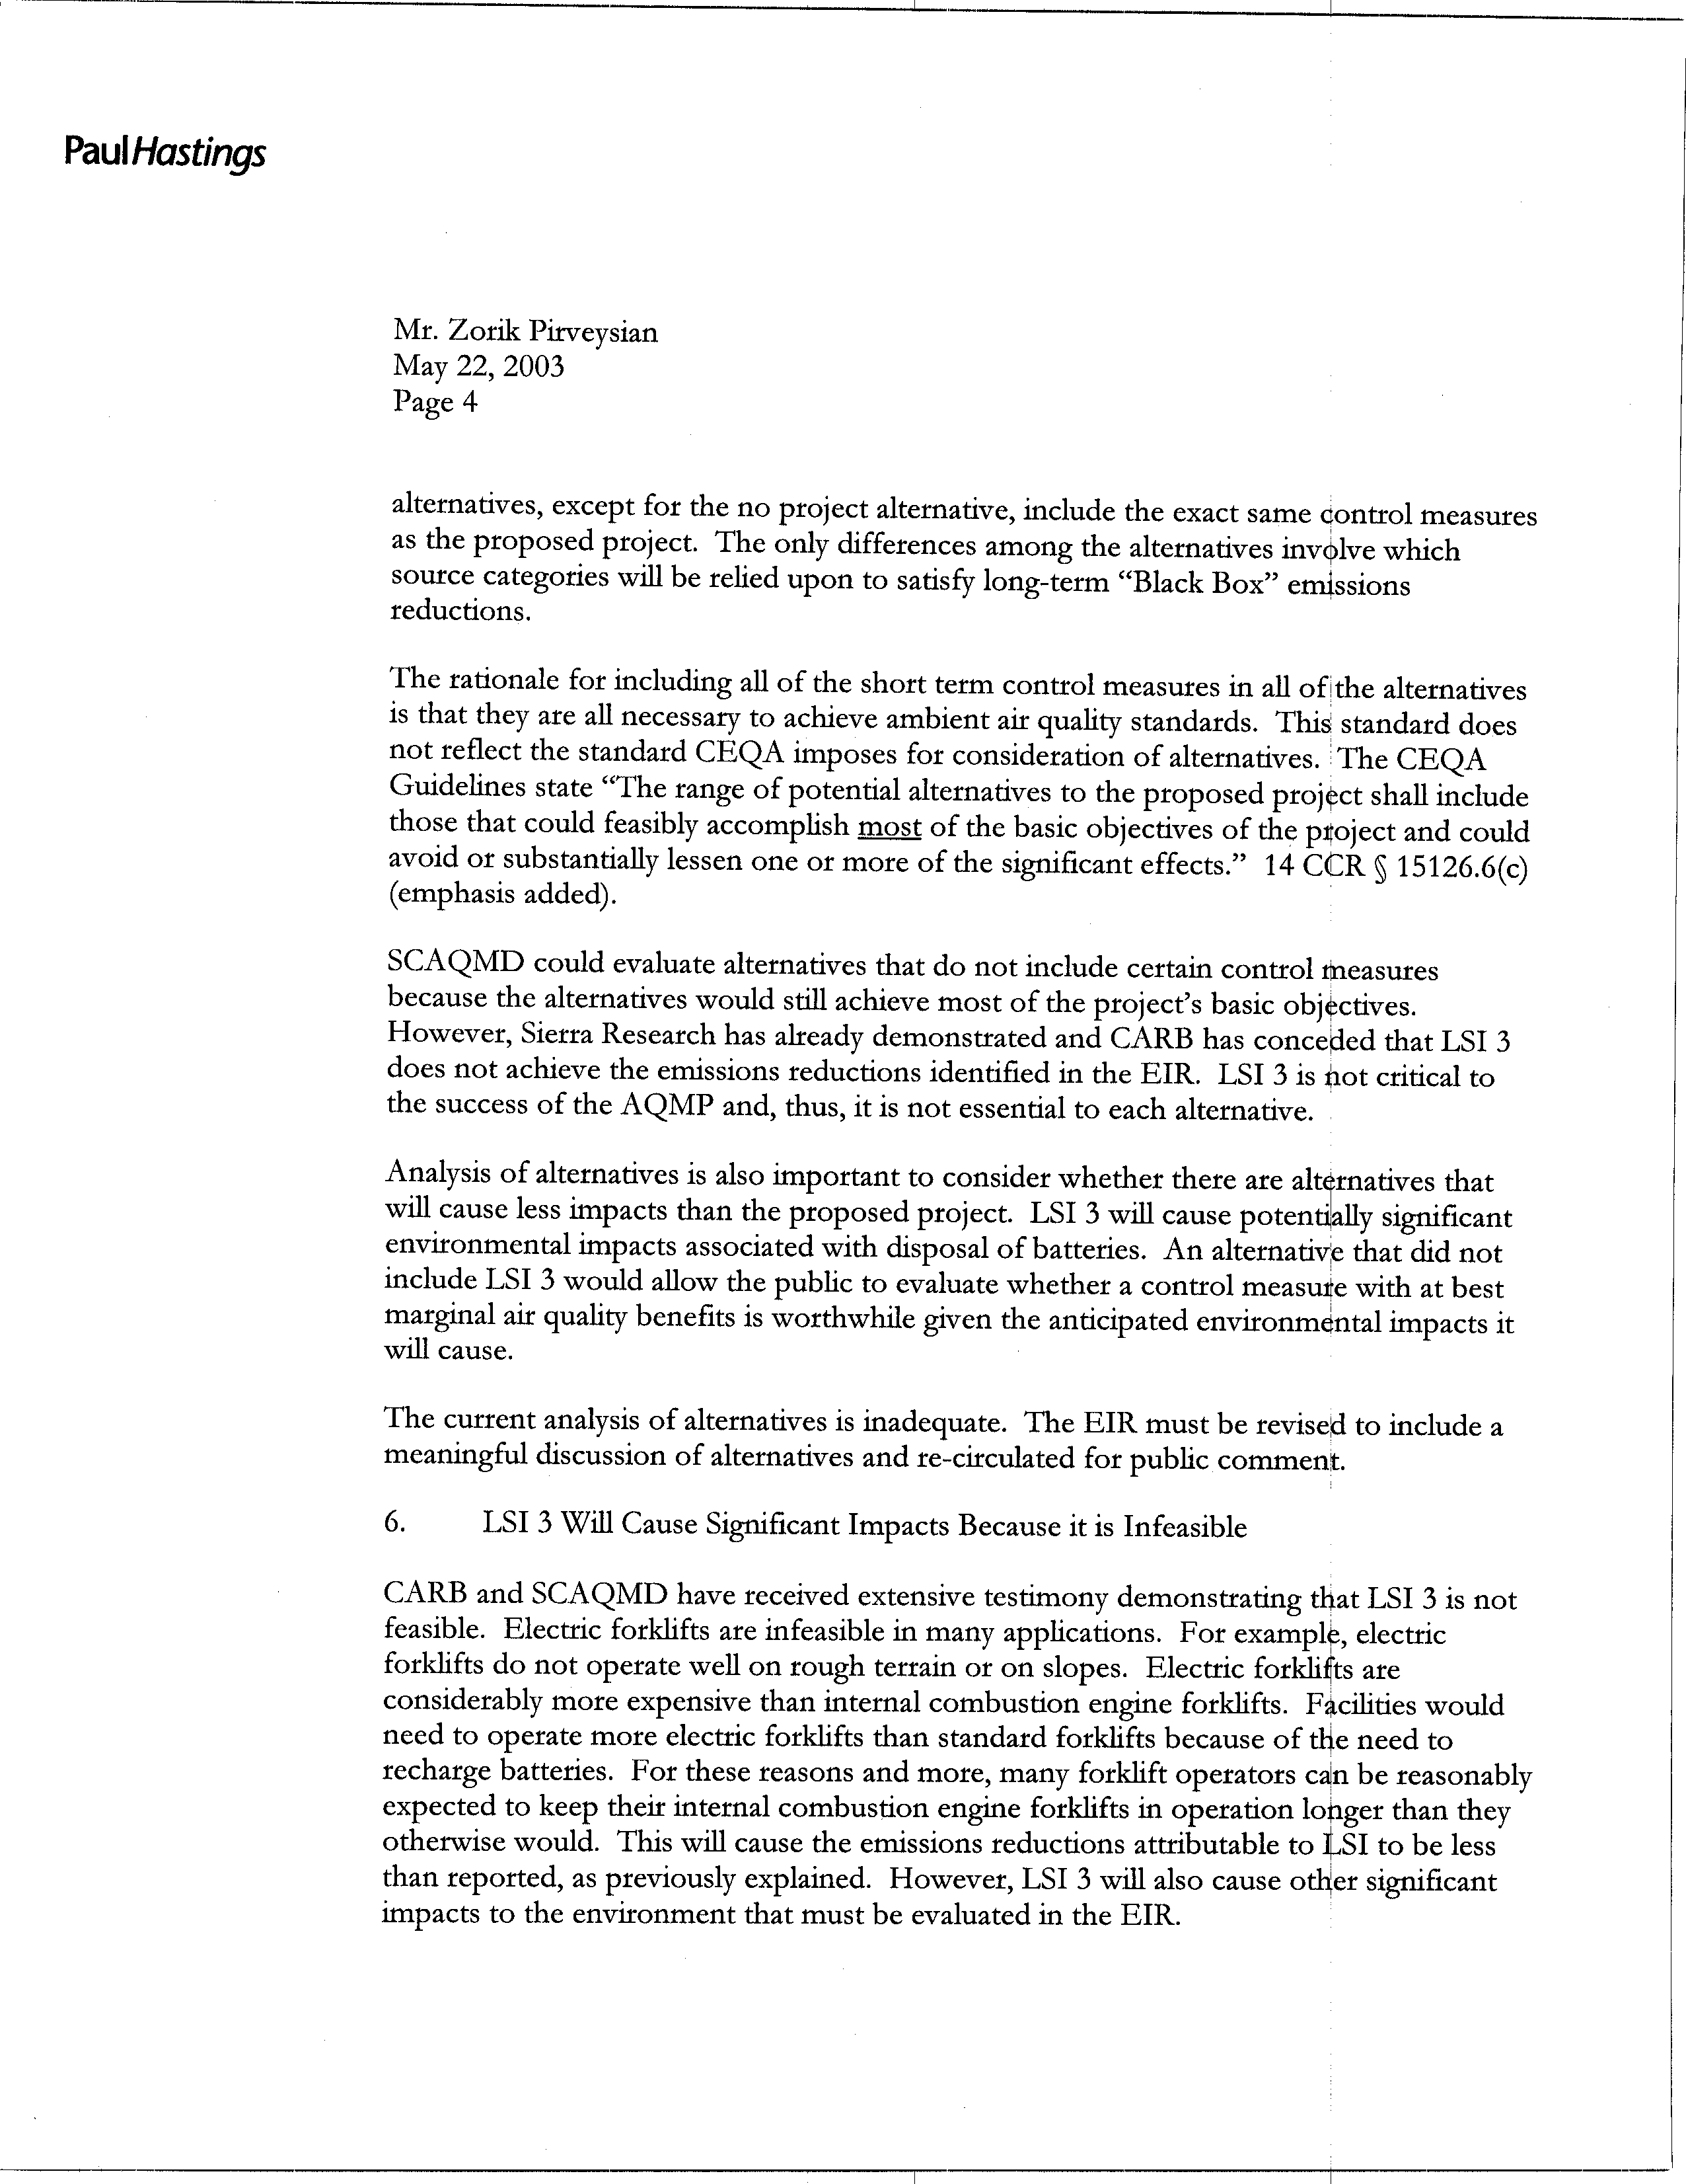
9-8
cont.
9-9
9-10
9-11
9-12
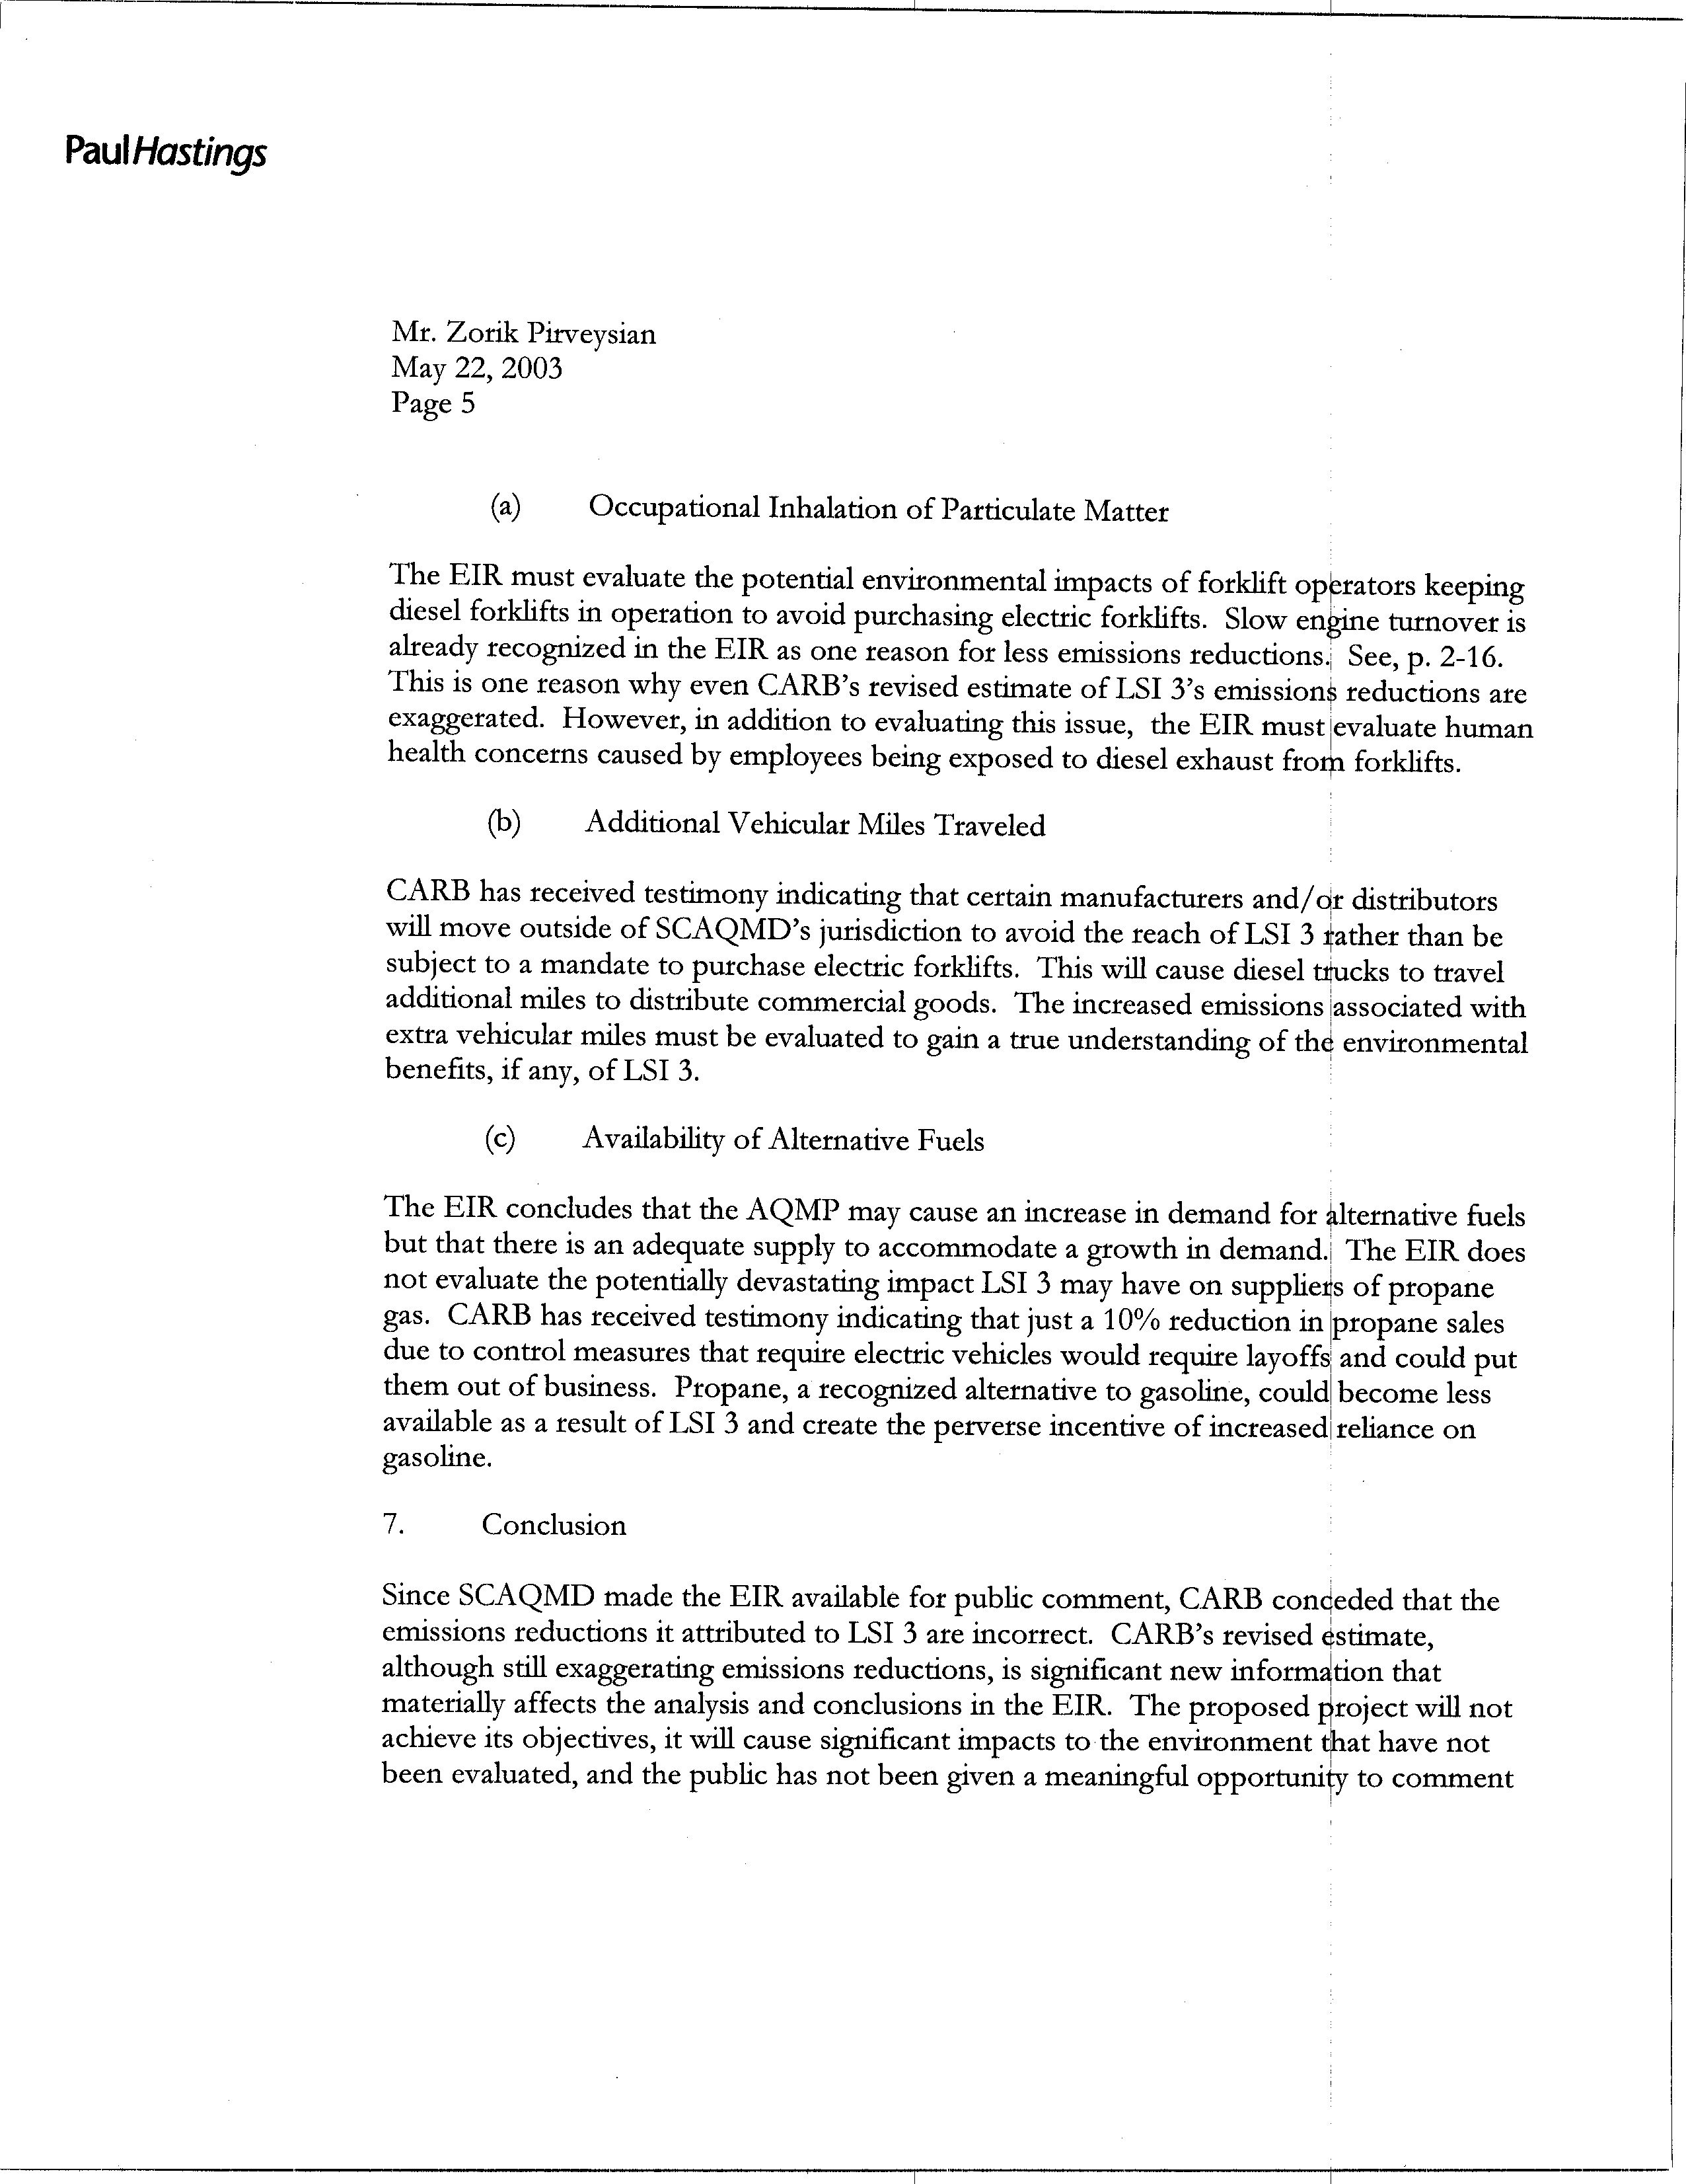
9-13
9-14
9-15
9-16
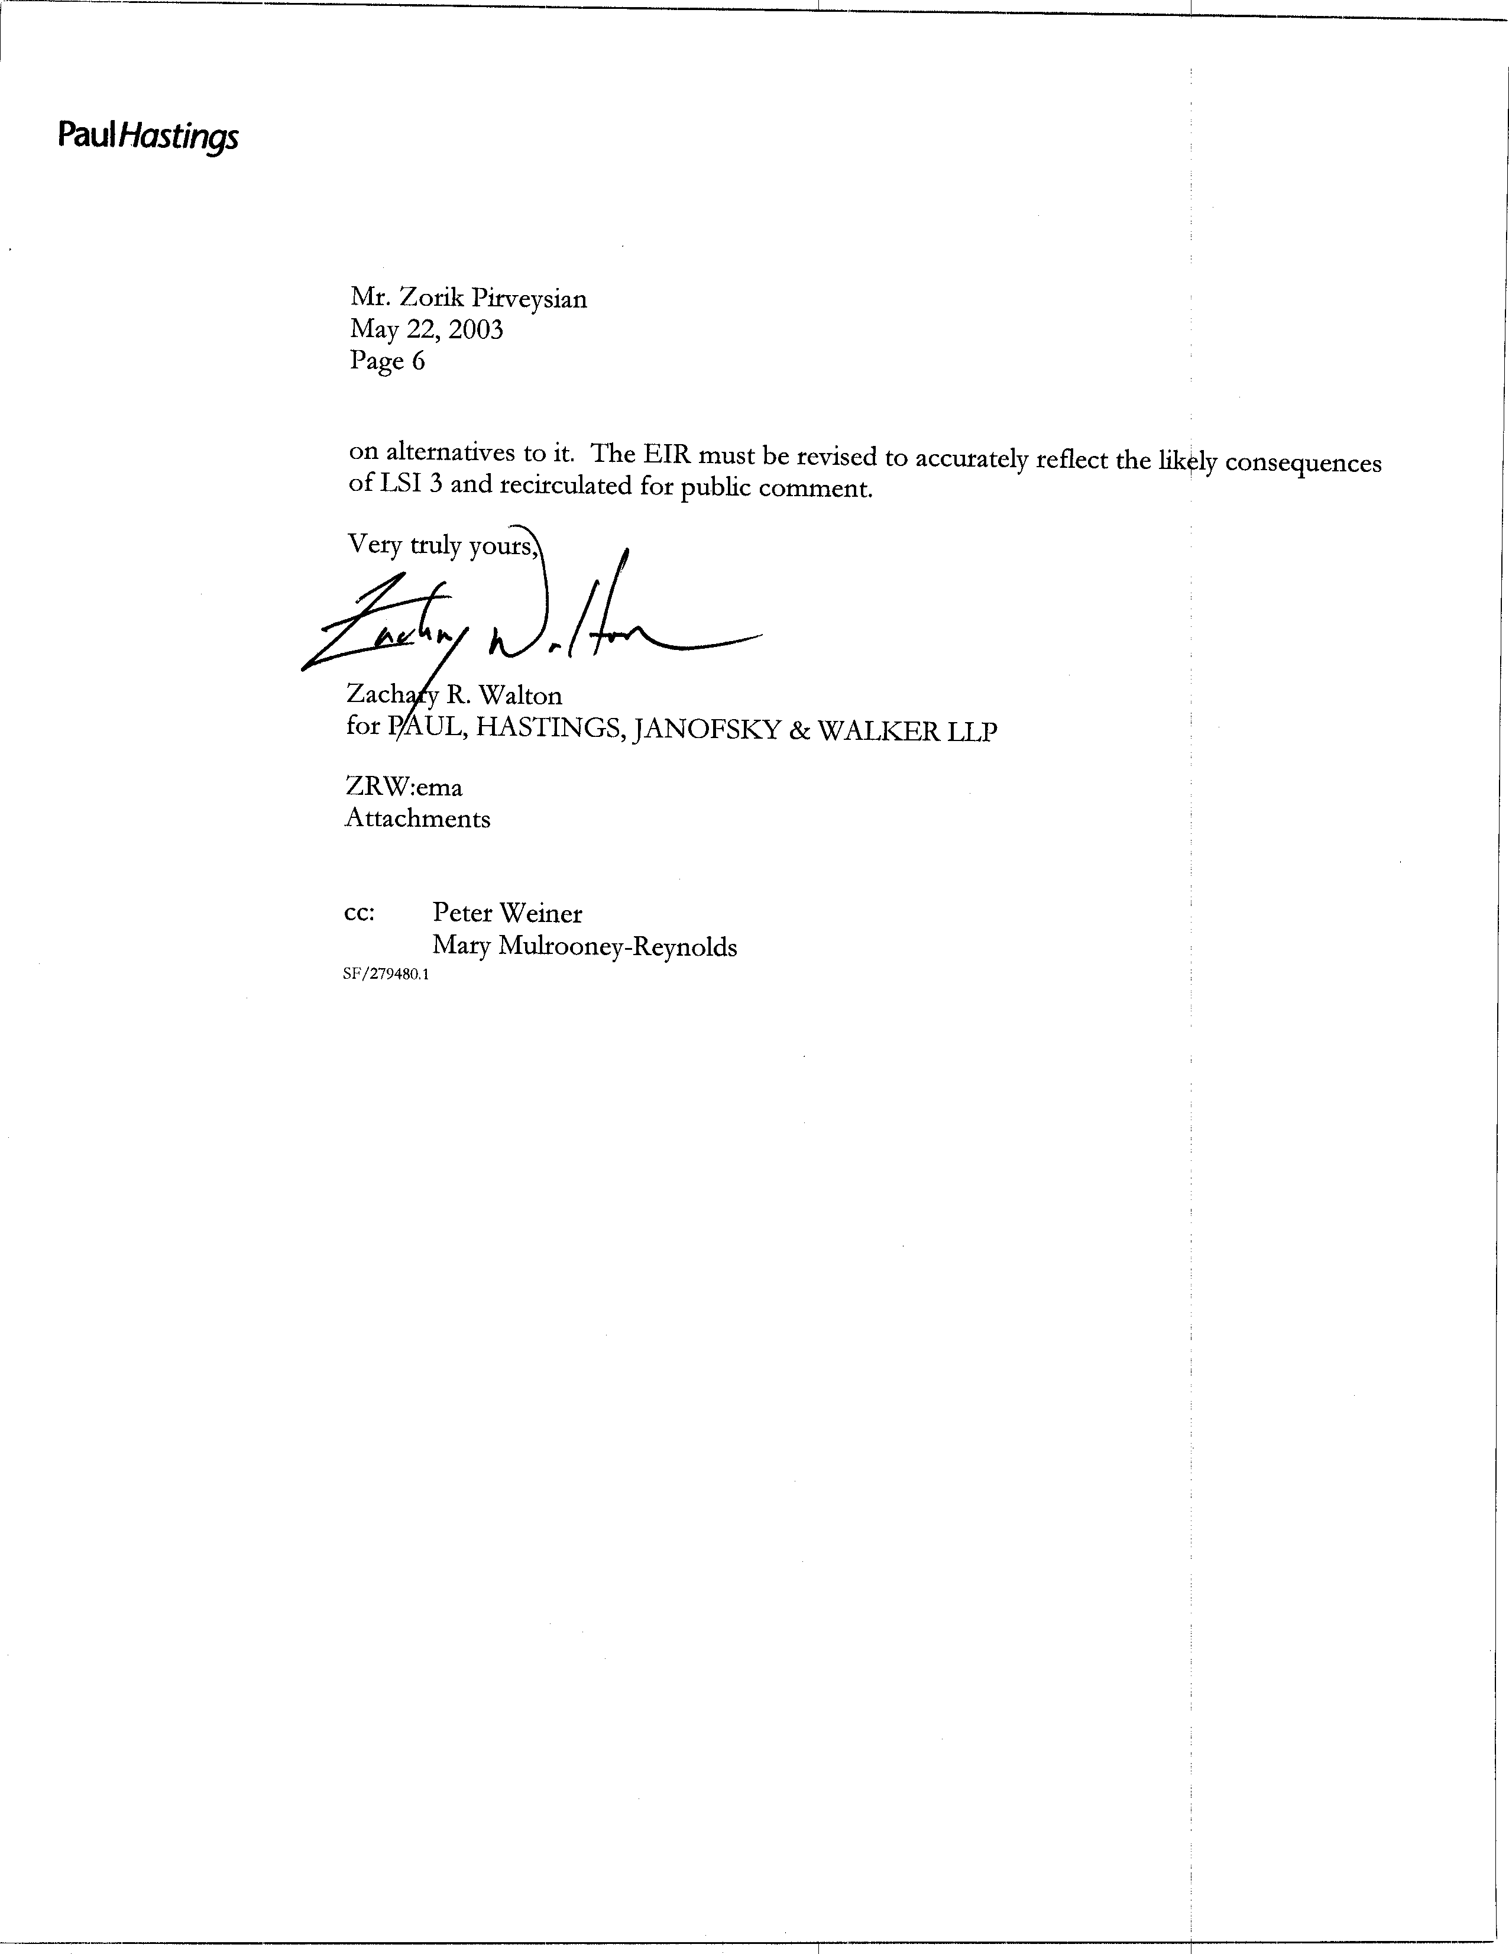
9-16
cont.
COMMENT LETTER # 9
FROM WESTERN PROPANE GAS ASSOCIATION

Paul Hastings

May 22, 2003

Response 9-1

The SCAQMD understands that this comment letter is submitted on behalf of the Western Propane Gas Association.

Response 9-2

The assertion relative to CARB being prohibited from adopting LSI-3 is erroneous since forklifts are not defined as a consumer product (Health & Safety Code §41712). Furthermore, control measure LSI-3 has been revised to require companies purchasing or leasing forklifts to select a zero-emission forklift only for those applications where zero-emission forklifts have been deemed to be suitable alternatives to internal combustion engine forklifts. Additionally, operational feasibility and economic impact to operations will be considered as part of the regulatory development.

Response 9-3

Recirculation of an EIR is required when significant new information is added to an EIR after public notice is given of the availability of the draft EIR for public review but before certification. New information added to an EIR is not "significant" unless the EIR is changed in a way that deprives the public of a meaningful opportunity to comment upon a substantial adverse environmental effect of the project or a feasible way to mitigate or avoid such an effect (including a feasible project alternative) that the project's proponents have declined to implement (CEQA Guidelines §15088.5(a)).

Recirculation is not required where the new information added to the EIR merely clarifies or amplifies or makes insignificant modifications in an adequate EIR (CEQA Guidelines §15088.5(b)). The modifications to LSI-3 do not constitute significant new information requiring recirculation of the EIR. The proposed measure has been modified to account for information provided to CARB by the public. The proposed measure provides flexibility to regulated parties by requiring companies purchasing or leasing forklifts to select a zero-emission forklift rather than requiring electric forklifts only. Furthermore, the modifications recognize that there may be applications where zero-emission forklifts are not suitable alternatives to internal combustion engine forklifts. Such clarifications to the proposed measure do not deprive the public of a meaningful opportunity to comment upon a substantial adverse environmental effect of the project or a feasible way to mitigate or avoid such an effect.

Response 9-4

The emission reductions associated with the control measures included in the AQMP are estimates based on available information at the time the measures are developed; actual reductions are identified during the promulgation of rules. Invariably, some rules achieve greater reductions than were estimated in their respective control measures, while others achieve less.

CARB has modified the emission reduction estimates presented in proposed measure LSI-3 down to 1.4 - 2.8 tons per day of NOx from 2.3 - 4.7 tons per day. Considering the Basin’s 2010 NOx emissions inventory and carrying capacity are estimated to be 764 and 530 tons per day, respectively, the revision to the emission reduction estimate of LSI-3 - on the order of a couple of tons per day - is not considered significant new information requiring recirculation of the Draft PEIR.

Response 9-5

As a blueprint for demonstrating attainment with federal and state ambient air quality standards, the AQMP includes carrying capacities for specific pollutants which become the basis for the reduction commitments from the responsible agencies. As a long-range planning document, however, the AQMP inherently includes some uncertainties relative to the control strategy. For example, it is not known at this time which source categories and to what extent they will ultimately provide reductions toward the long-term measures included in the AQMP. The NOx carrying capacity for 2010 is estimated to be 530 tons per day. Consequently, the uncertainty relative to the few tons per day emission reductions associated with LSI-3 does not imply, as asserted by the commenter, that the AQMP does not meet its objectives. Furthermore, the commenter misrepresents the information in the Draft PEIR. CARB’s emission reduction commitment is expressed as a range to account for the uncertainties that are inherent in emissions inventory and reduction projections. The Draft EIR states, in pertinent part, that “CARB staff proposes . . . to provide up to 46 tons per day of NOx reductions . . .” (page 2-30, emphasis added). The AQMP and Draft PEIR purposely provided latitude to refine the control strategy and the emission reduction estimates of the control measures as additional information is obtained. Finally, although the emission reductions anticipated for LSI-3 have been revised downword, this is a reduction in the benefit of the control measure and does not constitute a new significant adverse impact or make existing impacts substantially worse.

Based on the above, the SCAQMD staff disagrees with the assertion that “the AQMP must be revised so that its objectives are met and a revised EIR must be re-circulated for public comment.”

Please also see the response to comment 9-4.

Response 9-6

Note that LSI-3 has been revised to require zero-emission forklifts with a lift capacity of 8,000 pounds or less, where feasible. Currently the only commercially available zero-emission forklifts are electric; however, electric forklifts may not be suitable in all applications. Consideration of operational feasibility and economic impact to operations will enter into the regulatory development for implementation of this control measure.

CARB has the legal authority to include the recommended mitigation measures when the rules that implement Control Measure LSI-3 are developed, therefore, the comment that the mitigation measures are potentially unenforceable is incorrect.

Response 9-7

Mitigation measures are required if they are feasible. CEQA defines feasible as “capable of being accomplished in a successful manner talking into account economic, environmental, legal, social and technological factors. Note that the statement of overriding considerations is not a required component of an EIR. However, the SCAQMD will prepare a Statement of Overriding Considerations for several of the significant impacts identified in the Draft PEIR where it was concluded that significant impacts would remain following mitigation. As indicated in Response 9-3, the commentator has provided no substantive information or data that would warrant recirculation of the Draft PEIR pursuant to CEQA Guidelines, § 15088.5.

Response 9-8

The SCAQMD staff disagrees with the opinion in this statement. Because the district is in severe ozone non-attainment, the SCAQMD is required to implement all feasible measure in compliance with the California Clean Air Act and the Health and Safety Code. Since the short-term measures are considered to be feasible measures, the SCAQMD is required to implement them, so they have to be included in all project alternatives. As noted by the commentator, the long-term measures are different for each alternative as the carrying capacities change with each alternative. The federal long-term black box measures are excluded from Alternatives 2 and 4. In addition, the toxic-PM control measure is excluded from all the alternatives except Alternative 5. The alternatives will vary with the number of black box measures to be implemented, the expected emission reductions from each measure, the federal and state involvement, etc. As recognized by the alternatives analysis, virtually all the control measures, including long-term control measures, identified for inclusion in the AQMP are necessary to achieve compliance with the ambient air quality standards.

Response 9-9
The alternative analyzed by the SCAQMD comply with the criterion identified by the commentator. In this case the SCAQMD must meet all of the standards required by state or federal laws. There is no lee way to meet “most” of the standards. Further, the only alternative that does not comply with all of the standards is the No Project Alternative because it has fewer control measures than the AQMP and the other alternatives. As a result, an alternative that does “not include certain control measures” as suggested would likely not be a feasible alternative if it does not attain all state and federal standards.

The information regarding Control Measure LSI-3 has been modified in the AQMP (see Appendix IV-B) and AQMP PEIR (see Chapter 2). The emission reductions expected from LSI-3 are 0.3 to 0.6 ton per day of ROG, 1.4 to 2.8 tons per day of NOx, and 10.8 to 21.6 tons per day of CO n 2010. All identified emission reductions are important to the success of the AQMP since additional emission reductions (Black Box or long-erm strategies) are required (over and above the emission reductions identified in the AQMP PEIR.

Response 9-10
Note that elimination of LSI-3 from the AQMP or PEIR would not eliminate the environmental impacts associated with the disposal of batteries. Electrification is being considered for other mobile sources included in the Long term strategies. This impact, however, was concluded to be insignificant.

Response 9-11
The SCAQMD staff believes that the alternatives analysis is adequate pursuant to CEQA Guidelines. The commentator not only does not say why the alternative analysis is inadequate but he does not provide substantial information or data to support this opinion. Please see Responses 9-12, 9-13 and 9-14.

Response 9-12

The proposed measure has been modified to account for information provided to CARB by the public. The proposed measure provides flexibility to regulated parties by requiring companies purchasing or leasing forklifts to select a zero-emission forklift rather than requiring electric forklifts only. Furthermore, the modifications recognize that there may be applications where zero-emission forklifts are not feasible alternatives to internal combustion engine forklifts. Consequently, the rule would be limited to forklifts used in applications where zero-emission forklifts have been deemed to be feasible. See also responses to comments 9-4 and 9-5.

Response 9-13

Proposed control measure LSI-3 would regulate large spark-ignition engines, not compression ignition (diesel) engines. Thus, those applications where diesel forklifts are currently used are not affected by the proposed control measure. Furthermore, CARB has committed in the proposed control measure that the regulatory development process will include careful consideration of diesel forklift purchases and rentals to ensure diesel equipment is not used to circumvent the regulation. Consequently, there is no substantial evidence to suggest that proposed control measure LSI-3 would cause increased exposure to diesel emissions from forklift operations.

Response 9-14

There is no substantial information to make the assumption that control measure LSI-3 would cause a significant number of manufacturers and/or distributors to move outside of the SCAQMD’s jurisdiction and that this would in turn cause diesel trucks to travel additional vehicular miles to deliver goods. There are a number of factors that affect whether or not a business will relocate. It is simplistic to assume that a business will relocate on the basis of one factor. It could reasonably be assumed that, in the event that manufacturers and/or distributors moved outside the SCAQMD’s jurisdiction, other companies would fill any void left by those who leave. In any event, the result described by the commentator is not expected to occur because of modifications to the control measure. See Response 9-6. Consequently, the opinion is speculative and does not warrant a modification to the EIR since CEQA relieves a Lead Agency from a requirement to engage in speculation (CEQA Guidelines §15145).

Response 9-15

The proposed measure provides flexibility to regulated parties by requiring companies purchasing or leasing forklifts to select a zero-emission forklift rather than requiring electric forklifts only. Furthermore, the CARB recognizes that there may be applications where zero-emission forklifts are not suitable alternatives to internal combustion engine forklifts. Consequently, the rule would be limited to forklifts used in applications where zero-emission forklifts have been deemed to be feasible. Furthermore, in the event that forklift operations moved to electric or other zero-emission technologies, there would be a corresponding reduction in demand for propane. Thus, it is unlikely that implementation of proposed control measure LSI-3 would cause propane to become less available or to create an incentive for increased reliance on gasoline. Consequently, the assertion is speculative.

Response 9-16

SCAQMD staff disagrees with the opinion in this statement. The commenter is referred to the previous responses. The information regarding Control Measure LSI-3 has been modified in the AQMP (see Appendix IV-B) and AQMP PEIR (see Chapter 2). The emission reductions identified in the Draft PEIR from LSI-3 were 0.7 to 1.4 tons per day of VOC, 2.3 to 4.7 tons per day of NOx, 0 to 0.1 tons per day of PM10, and 18 to 36.2 tons per day of CO in 2010. The revised emission reductions in the revised AQMP expected from LSI-3 are 0.3 to 0.6 tons per day of VOC, 1.4 to 2.8 tons per day of NOx, 0 tons per day of PM10, and 10.8 to 21.6 tons per day of CO n 2010. Note that the range of the emission reductions currently estimated in the revised AQMP is within the range that was previously considered in the draft AQMP. Therefore, the information is not considered to be significant new information that would require recirculation of the PEIR. Also, see Response 9-13 and 9-14 regarding impacts associated with LSI-3.

C O M M E N T L E T T E R 10

American Lung Association
May 23, 2003

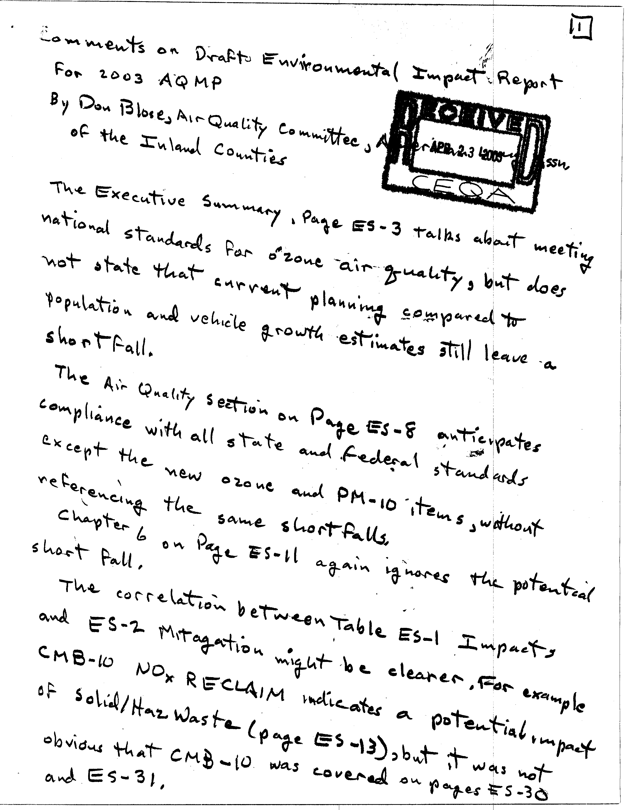
10-1
10-2
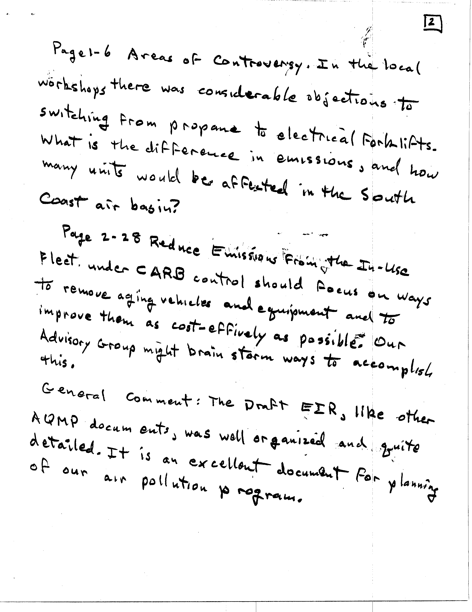
10-3
10-4
10-5
COMMENT LETTER # 10
FROM AMERICAN LUNG ASSOCIATION

Don Blose

May 23, 2003

Responses 10-1

The discussion regarding the estimated emissions reduction short fall is discussed in Chapter 2.6, District, State and Federal, Long Term Control Strategy (182(E)(5) Measures or “Black Box”) (see page 2-33 of the AQMP PEIR) and Chapter 5 – Alternatives.

Response 10-2
The data on impacts associated with implementation of the 2003 AQMP Control Measures has been addressed and summarized in several different manners and locations. In addition to the summary tables in the Executive Summary, a table that summarizes impacts for each Control Measure is provided in each impact section of the PEIR (see Table 4.1-3, Table 4.2-1, Table 4.3-1, Table 4.4-1, and Table 4.5-1. See Response 6-1 regarding the estimated emissions reduction short fall.

Response 10-3
See Responses 9-6 and 9-20 regarding the changes to Control Measure LSI-3 and the related emission estimates.

Response 10-4
The revised AQMP has included recommendations from SCAQMD’s Advisory Group (see Chapter 2 and Table ES-1 of the AQMP PEIR), including the suggestion to remove aging vehicles as early as possible.

Response 10-5
Thank you for your comment.

C O M M E N T L E T T E R 11

Department of Transportation
May 22, 2003

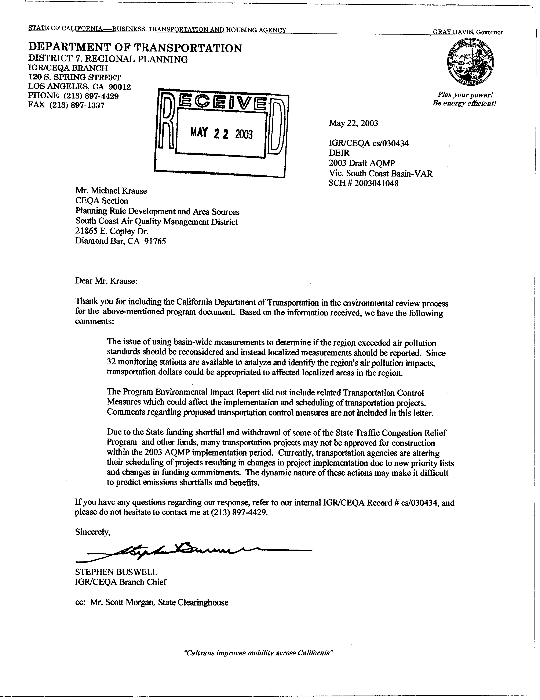
11-1
11-2
11-3
COMMENT LETTER # 11
FROM DEPARTMENT OF TRANSPORTATION

Stephen Buswell

May 22, 2003

Responses 11-1

Your comment is noted. Compliance with the ambient air quality standards is required at all monitoring stations in order for the Basin to be considered in attainment of the standards. Therefore, the data from all stations are reviewed. Modeling is provided at specified stations include the stations where the highest concentrations of contaminants are detected, e.g., Rubidoux (see AQMP PEIR, Section 4.1.6 Cumulative Air Quality Impacts).

As noted in the PEIR (see section 2.6.5), localized controls may also be considered to achieve reductions from specific areas that contribute to the exceedance of ambient air quality standards. In instances where the exceedances of the air quality standards are attributed only to emissions from a specific geographical area, it would be more effective to develop geographical regulations for the purpose of attaining the standard in a local area. For example, it appears that local PM10 sources in the eastern portion of the district are primarily responsible for the exceedance of PM10 air quality in that area. Therefore, it might be more effective and cost-effective to develop localized controls to achieve the necessary reduction rather than subject the entire district to regulations that would not necessarily benefit the attainment in the local area. As the district nears the attainment dates for federal air quality standards, localized controls may offer a more viable approach in meeting these standards.

Response 11-2

Transportation control measures are discussed in Chapter 2 of the PEIR and in Appendix IV-C. Appendix IV-C has been revised by SCAG and includes details regarding the development, implementation and funding for the transportation control measures and should be consulted for more details of program. Impacts from the transportation Control Measures can be found in Chapter 4 of the PEIR.

Response 11-3

The SCAQMD staff is aware of the concerns regarding state funds for transportation projects. SCAG has identified the appropriate sources of funding for each component of the TCM strategies (see Appendix IV-C, page 27).

C O M M E N T L E T T E R 12

Duncan McKee (Community Representative/Citizen)
May 22, 2003

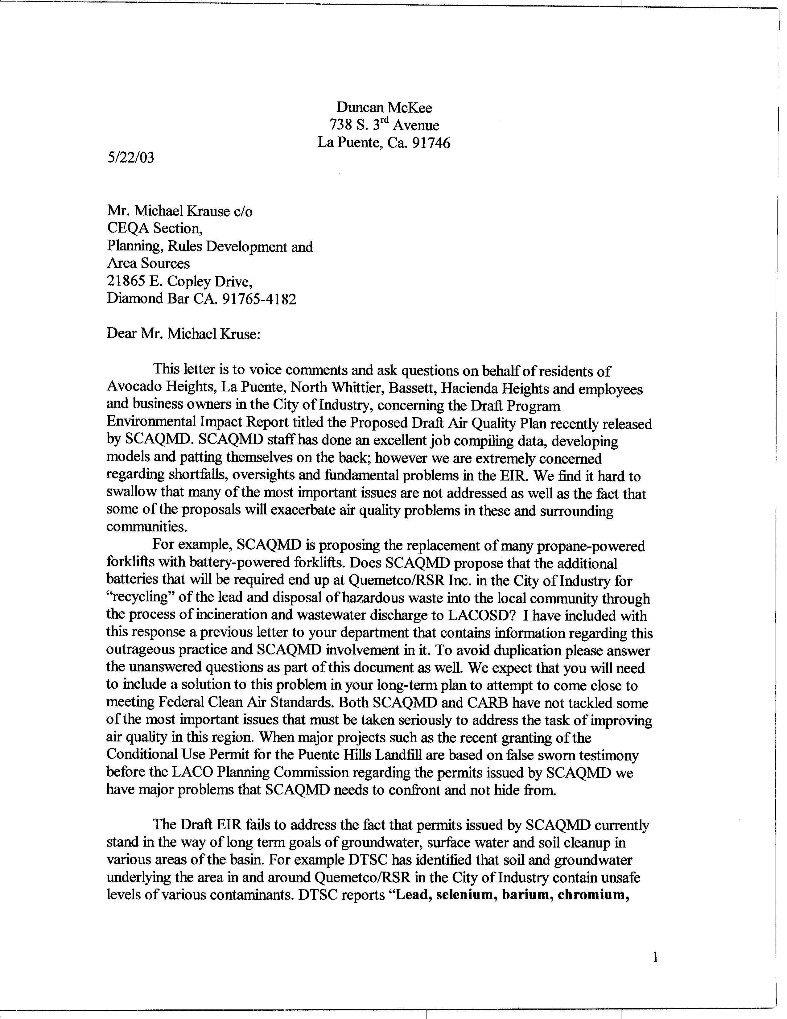
12-1
12-2
12-3
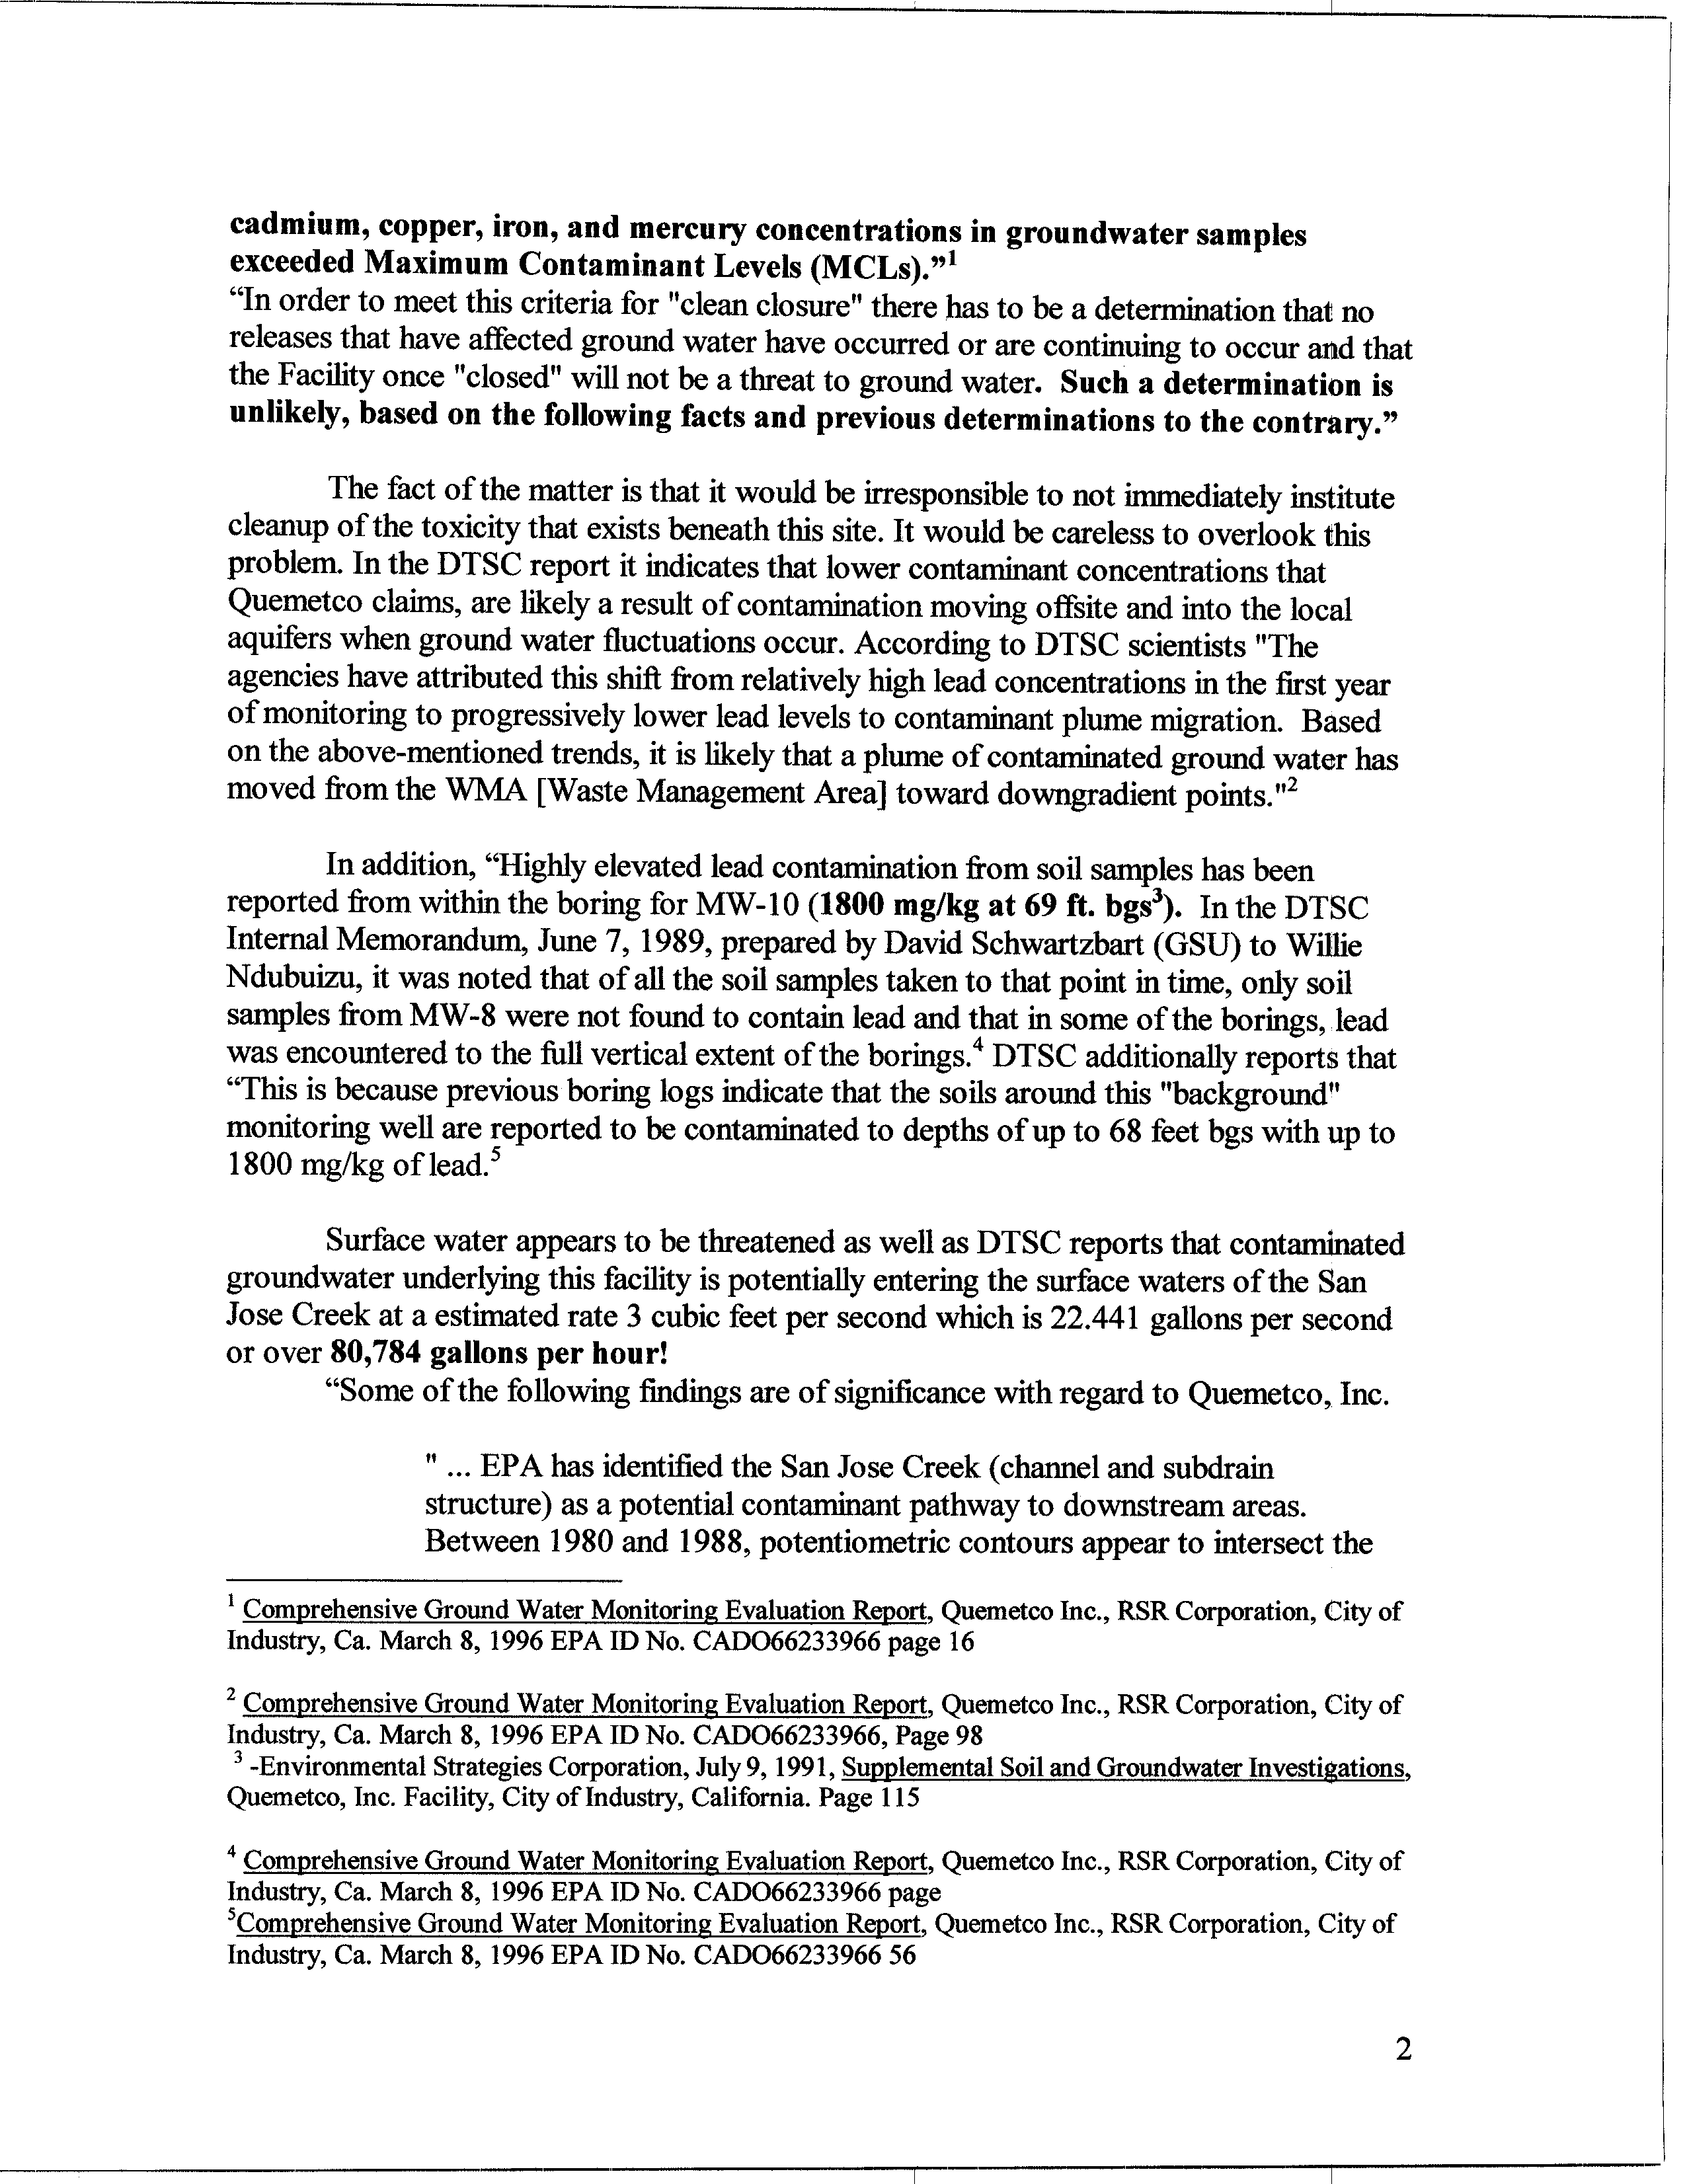
12-3
cont.
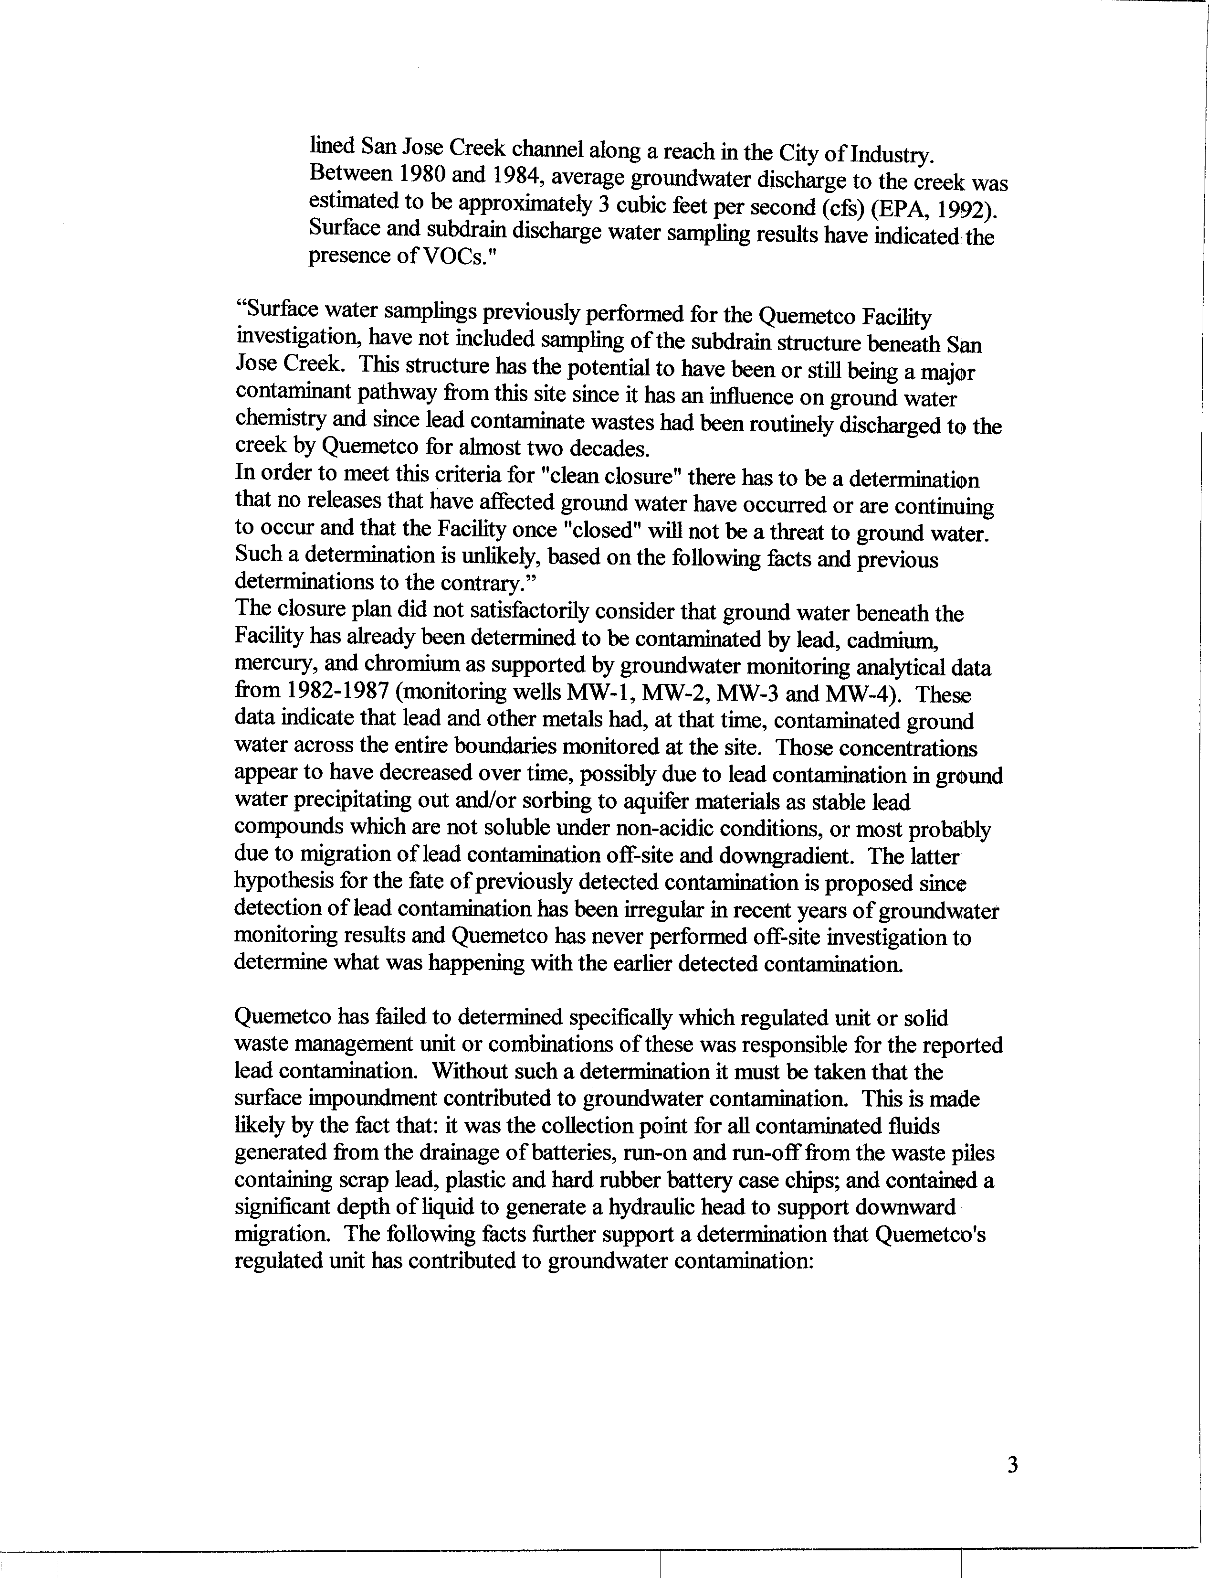
12-3
cont
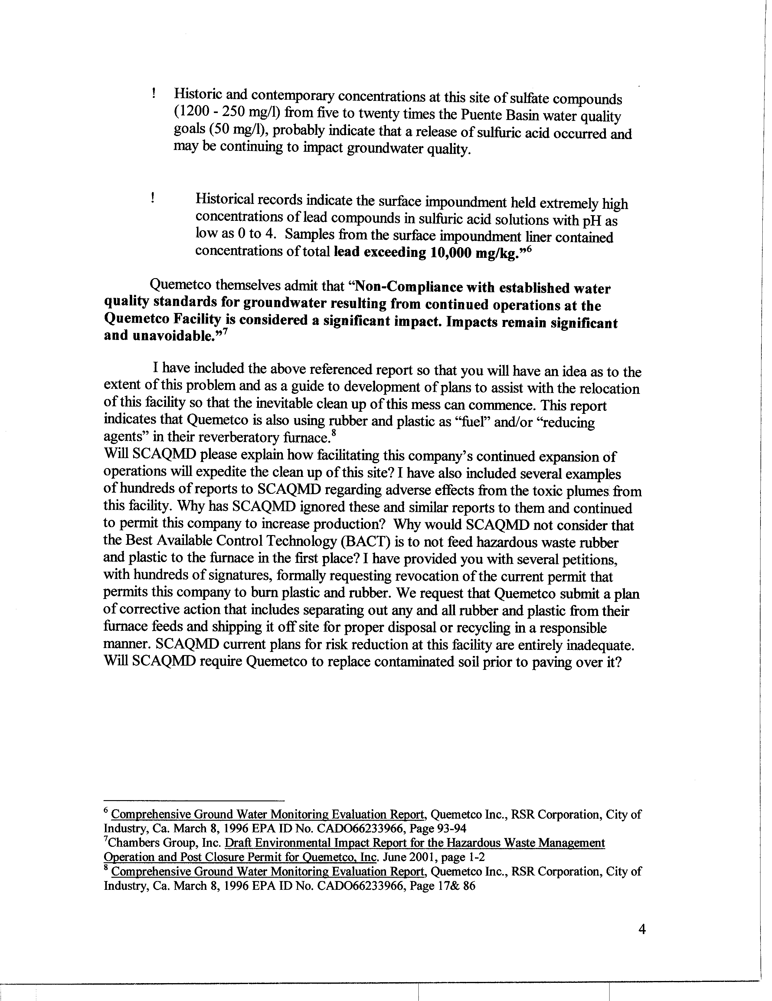
12-3
Cont.
COMMENT LETTER # 12
FROM DUNCAN McKEE

Duncan McKee

May 22, 2003

Response 12-1

The Draft PEIR is a comprehensive document that adequately evaluates the proposed project as required by the California Environmental Quality Act (Public Resources Code §§21000-21178). The SCAQMD disagrees with the commentator’s assertion that there are “shortfalls, oversights, and fundamental problems” in the Draft PEIR. The majority of comment letter #12 discusses existing permits to operate at an existing facility as opposed to inadequacies in the EIR.

Response 12-2

The Draft EIR adequately evaluates the potential for additional battery recycling/disposal due to the replacement of propane-powered forklifts with battery-powered forklifts. As part of the analysis, the Draft PEIR includes two mitigation measures to minimize any potential adverse effect:

SHW 1: Require leasing, deposit or rebate programs for electric batteries. Leasing and rebate programs can both be effective measures to increase the rate of recovery of spent batteries, and both types of measures are already proven in practice. Deposit programs can also achieve the same goals.

SHW 2: Require spent battery exchange for battery replacement. Require that ZEV service stations sell or install new batteries only on condition that they receive the spent batteries in exchange.

The SCAQMD acknowledges that implementation of LSI-3 may increase the amount of batteries sent to the battery recycling centers in the Basin. However for planning purposes, it is assumed that battery recycling facilities operating in the district meet all applicable regulatory requirements. Finally, LSI-3 has been modified to require replacement with electric forklifts where feasible, see Response 9-6.

Response 12-3

The AQMP is a statutorily mandated regional planning document that is not intended to focus on any individual facility. It should be noted that the SCAQMD has designated Hacienda Heights/La Puente/Avocado Heights as a suitable candidate for the pilot Neighborhood Environmental Justice Council. The purpose of this Council is to address the community’s environmental concerns including the issues raised regarding the Quemetco facility. Many of the concerns identified in this comment letter are being addressed in this public forum which includes representation from the community, industry, and the SCAQMD. The comments provided in this comment letter are best addressed through the existing regulatory programs such as permitting, enforcement and AB2588.

C O M M E N T L E T T E R 13

Sonia E. McIntoch (Citizen)
May 19, 2003

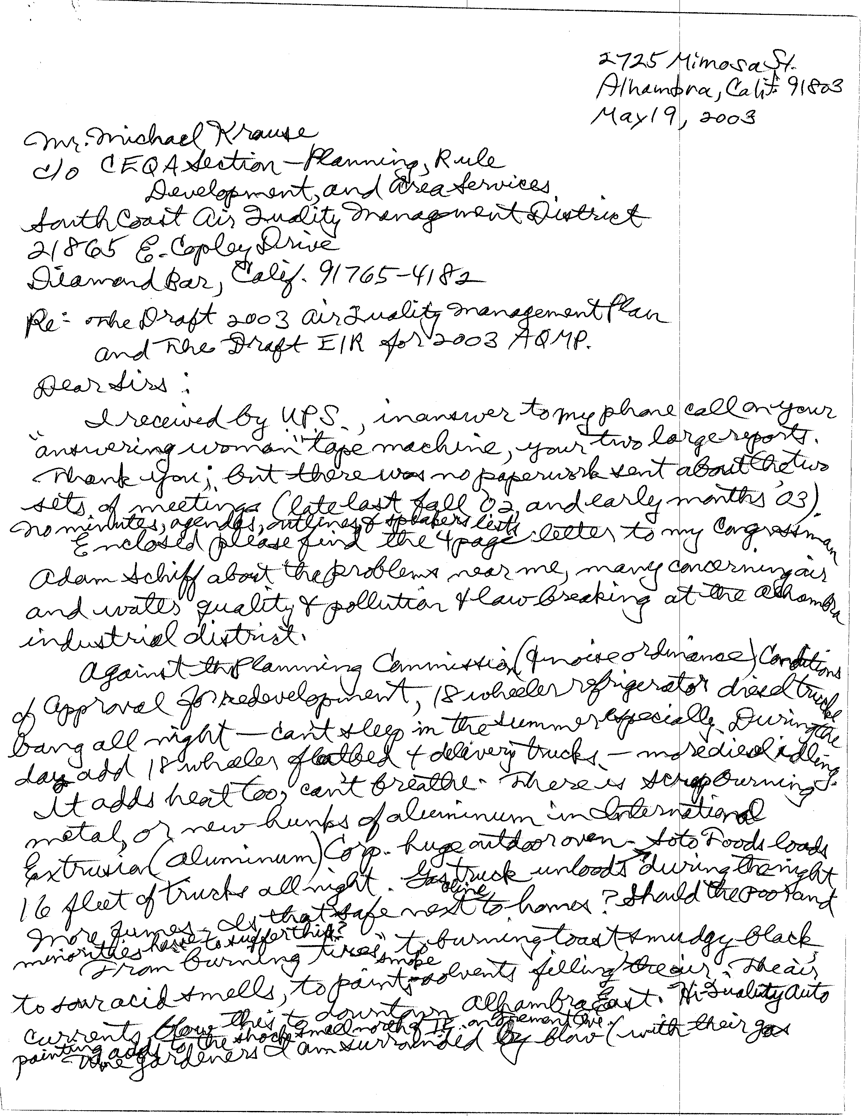
13-1
13-2
13-3
13-4
13-5
13-6
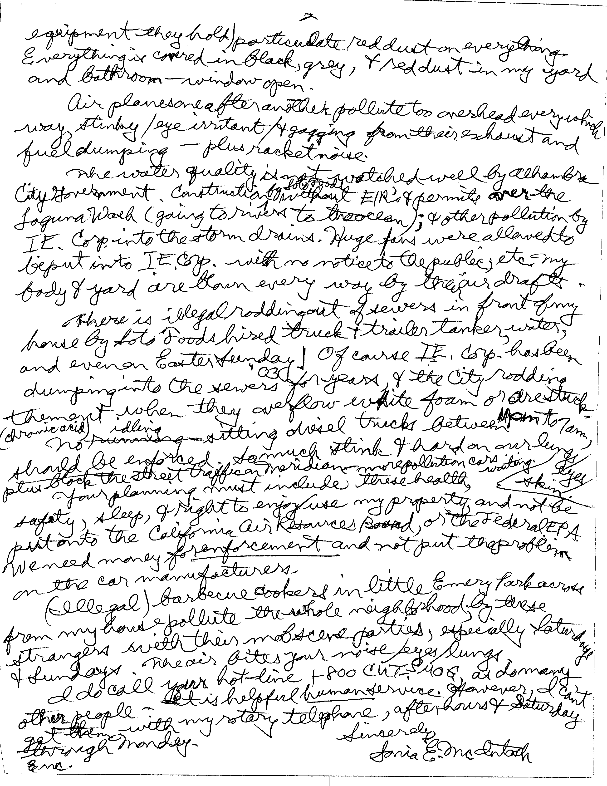
13-6
cont.
13-7
13-8
13-9
13-10
13-11
13-12
13-13
13-14
COMMENT LETTER # 13
FROM SONIA E. McINTOSH

Sonia McIntosh

May 19, 2003

Responses 13-1

The Draft AQMP PEIR was sent to you at your request. The information and comments from the previous public meetings have been incorporated into the PEIR. Information on previous meetings and upcoming meetings can be obtained at the SCAQMD Headquarters, 21865 Copley Drive, Diamond Bar, CA 91765, from the SCAQMD’s web page at http//www.aqmd.gov or by calling the Public Information office at (909) 396-2039.

Response 13-2

Your comment to your congressman is noted. Concerns regarding illegal activities should be directed to the appropriate law enforcement agencies (police or sheriff).

Response 13-3

Your comments regarding diesel trucks are noted. The enforcement of noise ordinances is the responsibility of the local city. SCAQMD has no jurisdiction over noise. The purpose of the 2003 AQMP is to reduce emissions throughout the district to comply with the ambient air quality standards. Overnight idling may be prohibited by city ordinance. The commentator should check with the city. Note that the 2003 AQMP includes control measures to reduce emissions from diesel trucks, including measures that would reduce truck idling. CARB, the agency with the primary authority over regulating diesel trucks, has proposed control measures to implement risk reductions measures (i.e., emission reductions) associated with diesel emissions. These measures will have the greatest benefits in areas with the greatest number of trucks.

Response 13-4

See Response 13-3 regarding noise issues. Comments regarding specific companies are outside of the scope of the AQMP and AQMP PEIR. The purpose of the 2003 AQMP is to reduce emissions throughout the Basin to comply with the ambient air quality standards. Note that the 2003 AQMP includes control measures aimed at reducing emissions from diesel trucks, including measures that would reduce truck idling.

Response 13-5

The purpose of the 2003 AQMP is to reduce emissions throughout the district to comply with the ambient air quality standards. The control measures proposed in the 2003 AQMP will reduce emissions from various operations throughout the district including trucks, industrial facilities, other mobile sources, and so forth. Control Measures CTS-07, CTS-10, CONS-1, CONS-2 and some of the long term control measures would require reformulating paints, solvents and other consumer products to reduce emissions.

Response 13-6

The purpose of the 2003 AQMP is to reduce emissions throughout the Basin to comply with the ambient air quality standards. Control Measure SMALL OFF-RD-1 and SMALL OFF-RD-2 would set emission standards for lawn and garden equipment including lawn movers and leaf blowers, so that emission reductions would be expected from this type of equipment.

Response 13-7

The enforcement of noise ordinances is the responsibility of the local City. Noise associated with airplanes is generally regulated by the Federal Aviation Administration. SCAQMD has no jurisdiction over noise. The AQMP includes some long-term control concepts, which would be developed and implemented by the U.S. EPA, to control emissions from airplanes.

Response 13-8

Water quality associated with individuals businesses in the City of Alhambra generally is not within the jurisdiction of the SCAQMD. Construction of new business would are generally within the jurisdiction of the City. The Regional Water Quality Control Board has primary jurisdiction over storm water control and regulation.

Response 13-9

Comments regarding specific companies are forwarded to SCAQMD’s Engineering & Compliance for follow-up.

Response 13-10

Water quality associated with individuals businesses in the City of Alhambra generally is not within the jurisdiction of the SCAQMD. The Regional Water Quality Control Board has primary jurisdiction over storm water control and regulation.

Response 13-11

See Response 13-3 regarding truck noise and Response 13-4 regarding emissions from trucks. Enforcement of the local noise ordinances is the responsibility of the City.

Response 13-12

The purpose of the 2003 AQMP is to develop control measures that would reduce emissions to the level where the SCAQMD will comply with the ambient air quality standards. Issues like sleep, safety and the right to enjoy/use properties are not part of the planning process for the AQMP. However, these issues are generally regulated and included in the local City General Plan.

The SCAQMD staff does not have the authority to regulate certain mobile sources (cars and trucks) and certain federal sources (e.g., trains, airplanes, marine vessels) of emissions. The mobile and federal sources must be regulated by either the CARB or the U.S. EPA. For some control measures, the SCAQMD is expected to request additional authority to regulate some of these sources, but currently does not have broad jurisdiction to regulate most of the mobile sources.

Response 13-13

The SCAQMD staff does not have the authority to control the people in the park. Enforcement of the various ordinances would be provided through the local City.

Response 13-14

The SCAQMD staff appreciates your comments. The 1-800-CUT-SMOG phone number operates 24-hours a day and comments can be called in and left on voice mail at any time. The SCAQMD appreciate your comment regarding using rotary phones and will investigate the limitations of this system.

(Attached to the comment letter to the SCAQMD was a copy of an assistance request form to Congressman Adam B. Schiff from the commentator. The problems cited on the assistance request form that were germane to the project were already included in the comment letter to the SCAQMD. Those comments and responses are addressed above .)

C O M M E N T L E T T E R 14

Harvey Eder (Citizen)
May 22, 2003

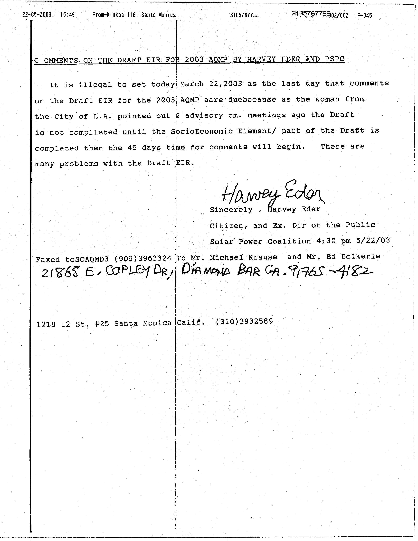
14-1
COMMENT LETTER # 14
FROM SOLAR POWER COALITION

May 22, 2003

Responses 14-1

The public comment period for the Draft PEIR was April 8, 2003 through May 22, 2003, allowing for a 45-day public comment period as required by CEQA (CEQA Guidelines §15205).

The Socioeconomic Report for the AQMP, is a document separate from the AQMP or the AQMP PEIR. The Socioeconomic Report is not part of the Draft PEIR and socioeconomic analyses are not required to be included in EIRs. There is no requirement to prepare or circulate the socioeconomic analysis as part of the Draft PEIR (14 CCR 15064(e)) and the Socioeconomic Report prepared for the AQMP is not subject to the same notice requirements as the Draft PEIR. Social changes are not treated as significant effects on the environment, unless there are related physical changes (14 CCR 15064(e)). The Socioeconomic Report prepared for the AQMP does not identify any physical effects on the environment. Since the Socioeconomic Report is not part of the Draft PEIR it is not subject to the same notification requirements. Comments on the Socioeconmic Report may be submitted at any time.

C O M M E N T L E T T E R 15

City of Riverside
May 30, 2003

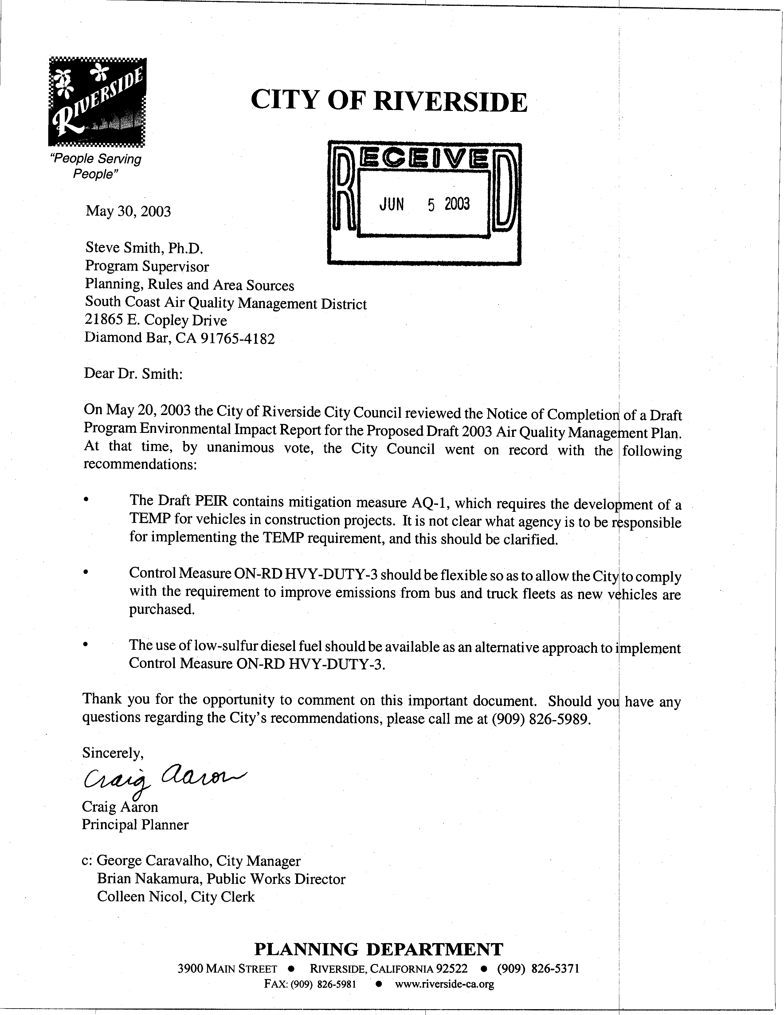
15-1
15-2
15-3

COMMENT LETTER # 15
FROM CITY OF RIVERSIDE

Craig Aaron

May 30, 2003

Response 15-1

The responsibility over the preparation of the Construction Traffic Emission Management Plan (TEMP) would be on the project proponent and the lead agency which has the most discretion over the approval of the project. The TEMP would be required for construction projects in various jurisdictions and in situations where the SCAQMD would have no jurisdiction over approval of the project. Typically, the project proponent is responsible for implementing the plan and the local lead agency is the primary oversight authority for monitoring and enforcing the TEMP. To the extent these plans relate to control fugitive dust, the SCAQMD would have enforcement authority, at least to ensure compliance with Rule 403 – Fugitive Dust.

Response 15-2

The comment is noted. In general, the Control Measures that require new equipment and technologies are expected to be phased in as older equipment is retired.

Response 15-3

The rules developed under Control Measure ON-RD HVY-DUTY-3 are expected to outline the performance standards that must be met. Control strategies are expected to include new engine standards as well as strategies to clean up existing engines, including diesel particulate filters (which requires that low sulfur diesel be used), retire older vehicles or replace vehicles with new, lower-emission models. However, depending on the strategy chosen by fleet operators, the use of low-sulfur diesel fuel may be an integral strategy component. For example, most catalyst-based diesel particulate filters provide the greatest emission reductions when used with low sulfur diesel fuel. Other control strategies are expected to include engine software upgrade, on-board diagnostics, manufacturer-required in-use vehicle testing, and reduced truck and bus idling.

SCAQMD Rule 431.2 – Sulfur content of Liquid Fuels requires refineries or importers to not produce or supply any diesel fuel for any stationary or mobile source application unless the diesel fuel is low sulfur diesel (sulfur content <15ppm weight) by June 1, 2006.

